Decision Making with Business Analytics

HW 2. Due date: 13 Oct 2019, 23.59hrs

You are required to do and submit your work in groups of (at most) two, namely the same groups as for HW 1. Your work should be handed in (via email only) no later than the due date. Late work will be accepted with a 20% penalty per day (or fraction of day) beyond the deadline.

This homework is marked over 15 points.

This homework is a continuation of Lab 5. See the description of that lab and the corresponding lecture slides for more information.

You should submit the M-files and the one double-sided A4 report to [c.dobre@uvt.nl](mailto:c.dobre@uvt.nl). The report should also contain instructions on how to run your M-files.

1. Consider the following linear programming problem written in normal form:

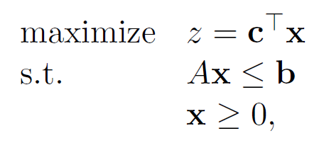

The functions “linprog” and “cplexlp” have as input the data matrices of this linear programming problem (i.e: c,A,b) and as output, among others, the optimal solution. Based on this optimal solution you should write your own M-file that:

1. Identifies the optimal basis (2 points)
2. Computes the lower and upper bounds for the entries of the **b** vector such that the optimal basis is not changed (4 p)
3. Compute the lower and upper bounds for the entries of the **c** vector such that the optimal basis is not changed (4 p)
4. Next to the M-files please write a structured report (maximum one double sided A4) explaining the steps and formulas you have used to arrive at the codes. (3 p)
5. Consider the same notation for the given data of the linear programming problem (i.e: c,A,b) but now we look at the general form of the problem.

A) Extend your previously written M-files to work for the general form (i.e. where you could have either $≤, ≥, =$ excepting the sign constraints) of the maximization problem (2 points)