|  |
| --- |
| Drexel University Graduate Thesis |
| Intent Recognition Engine (IRE) |
| Software Design Document |

|  |
| --- |
| Michael Kozak  3-5-2018 |

Contents

Common Terms 1

Overview 2

Purpose of this Document 2

Software Requirements 2

Top-Level Design 2

Second Level Design 2

Components 3

SCTechTreeManager 3

Strategy Space 3

Graph Utils 3

Terran Tree Manager 3

Strategy Reader 3

# Common Terms

|  |  |
| --- | --- |
| Term | Definition |
| Blueforce | Player or Allied army |
| Redforce | Hostile player |
| Capability | Unit, building, or upgrade |
| Research | Upgrades of unit or building capabilities purchased through an already built building |
| Strategy | A discrete collection of Capabilities in particular ratios designed to gain dominance over an opposing player with a bias towards land, hybrid, or air combat |

# Overview

The Intent Recognition Engine (IRE) is a new component in the NOVA StarCraft AI. IRE enhances NOVA’s current capabilities by reasoning on partial observability of enemy capabilities in order to infer likely strategies. These inferences are then passed to the NOVA strategy manager for preparing effective counter-strategies prior to a full-scale attack.

# Purpose of this Document

The purpose of this document is to provide background information as to the design of the system. Specifically, design decisions made within IRE in laying out the architecture, including constraints, assumptions, and reasoning behind choices made. Each component in the system is then outlined to detail its purpose, functional ins and outs, and its relation to the other components.

# Software Requirements

StarCraft Brood War v1161

Nova Master GIT pull

BWAPI v4.20

BWTA v2.2

Visual Studio 2017 (v141)

Boost v1.66.0

Apr

Apr-util

Geometry-develop

Log4cxx for Visual Studios 2010 (v100)

# Top-Level Design

# Second Level Design

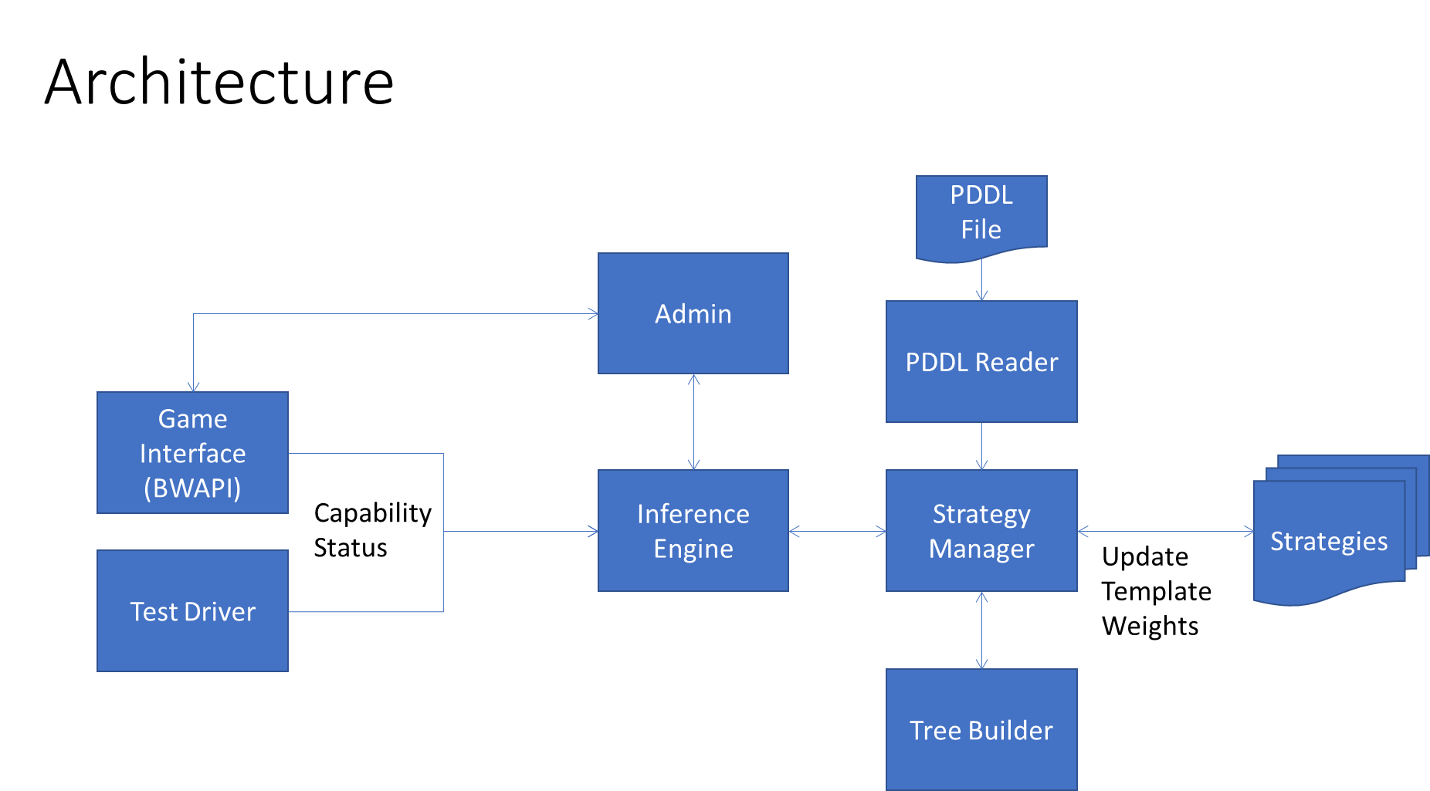

# Components

## SCTechTreeManager

**Purpose:**

**Inputs:**

**Outputs:**

**Interacts With:**

## Strategy Space

## Graph Utils

## Terran Tree Manager

## Strategy Reader

|  |  |  |  |
| --- | --- | --- | --- |
| **Name** | **A vs AA** | **G vs AG** | **Atk vs Def** |
| Bio (marines/medics) | -0.25 | 0.75 | 1 |
| Rax_fe (second base) | 0 | 0 | -1 |
| Two_facto(tanks) | 0 | 1 | 0.5 |
| Vultures | 0 | 1 | 0.75 |
| Air(wraiths) | 0.75 | -0.5 | 0.25 |
| drop | 0.25 | 0.25 | -0.25 |

|  |  |  |  |
| --- | --- | --- | --- |
| **Name** | **A vs AA** | **G vs AG** | **Atk vs Def** |
| Two_gates (zealots) | 0 | 1 | 1 |
| fast_dt (dark templars) | -0.25 | 0 | 0 |
| Templar | -0.5 | 0 | 0.5 |
| Speedzeal (zealots+upgrades) | 0 | 1 | 0.75 |
| Corsair | -1 | 0 | -0.75 |
| Nony (dragoons) | 0 | 0 | 0.5 |
| Reaver_drop | 0.25 | 0 | -0.25 |
| Two_gates (zealots) | 0 | 1 | 1 |

|  |  |  |  |
| --- | --- | --- | --- |
| **Name** | **A vs AA** | **G vs AG** | **Atk vs Def** |
| Speedlings (zerlings) | 0 | 1 | 1 |
| Fast_mutas (mutalisks) | 1 | -1 | 0.25 |
| Mutas (expand+mutas) | 0.75 | -0.75 | -0.25 |
| Lurkers | 0 | 0 | -0.25 |
| Hydras | -0.25 | 1 | 0.75 |
|  |  |  |  |