1.新建Form窗体，向其中添加ContextMenuStrip控件

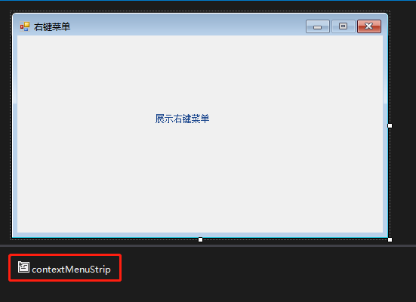

2.点击ContextMenuStrip控件属性Items，添加MenuItem或Separator组件

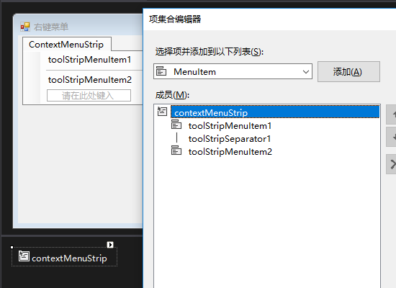

3.点击一级菜单，添加MenuItem或Separator组件，形成二级菜单

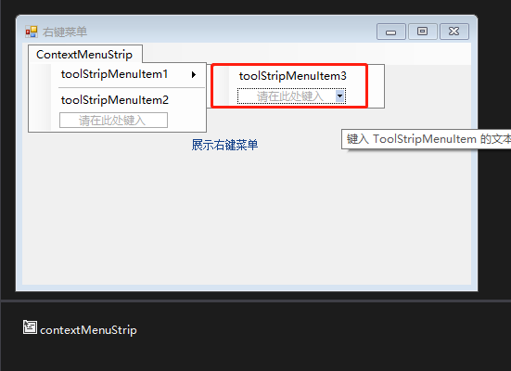

4.Demo代码

[复制代码](javascript:void(0);)

using System;

using System.Collections.Generic;

using System.ComponentModel;

using System.Data;

using System.Drawing;

using System.Linq;

using System.Text;

using System.Threading.Tasks;

using System.Windows.Forms;

namespace Contextmenu

{

public partial class frmContextmenu : Form

{

public frmContextmenu()

{

InitializeComponent();

}

private void tSMICenter_Click(object sender, EventArgs e)

{

int height =SystemInformation.WorkingArea.Height;

int width = SystemInformation.WorkingArea.Width;

int formheight = this.Size.Height;

int formwidth = this.Size.Width;

int newformx = width / 2 - formwidth / 2;

int newformy = height / 2 - formheight / 2;

this.SetDesktopLocation(newformx, newformy);

}

private void tSMILargen_Click(object sender, EventArgs e)

{

this.Width =this.Width+100;

this.Height = this.Height + 100;

}

private void tSMISmaller_Click(object sender, EventArgs e)

{

this.Width = this.Width - 100;

this.Height = this.Height- 100;

}

private void frmContextmenu_MouseClick(object sender, MouseEventArgs e)

{

if (e.Button==MouseButtons.Right)

{

contextMenuStrip.Show(MousePosition.X,MousePosition.Y);

}

}

}

}

[复制代码](javascript:void(0);)

[复制代码](javascript:void(0);)

namespace Contextmenu

{

partial class frmContextmenu

{

/// <summary>

/// 必需的设计器变量。

/// </summary>

private System.ComponentModel.IContainer components = null;

/// <summary>

/// 清理所有正在使用的资源。

/// </summary>

/// <param name="disposing">如果应释放托管资源，为 true；否则为 false。</param>

protected override void Dispose(bool disposing)

{

if (disposing && (components != null))

{

components.Dispose();

}

base.Dispose(disposing);

}

#region Windows 窗体设计器生成的代码

/// <summary>

/// 设计器支持所需的方法 - 不要修改

/// 使用代码编辑器修改此方法的内容。

/// </summary>

private void InitializeComponent()

{

this.components = new System.ComponentModel.Container();

this.labelX1 = new DevComponents.DotNetBar.LabelX();

this.contextMenuStrip = new System.Windows.Forms.ContextMenuStrip(this.components);

this.toolStripMenuItem1 = new System.Windows.Forms.ToolStripMenuItem();

this.tSMICenter = new System.Windows.Forms.ToolStripMenuItem();

this.toolStripSeparator1 = new System.Windows.Forms.ToolStripSeparator();

this.toolStripMenuItem2 = new System.Windows.Forms.ToolStripMenuItem();

this.tSMILargen = new System.Windows.Forms.ToolStripMenuItem();

this.tSMISmaller = new System.Windows.Forms.ToolStripMenuItem();

this.contextMenuStrip.SuspendLayout();

this.SuspendLayout();

//

// labelX1

//

//

//

//

this.labelX1.BackgroundStyle.CornerType = DevComponents.DotNetBar.eCornerType.Square;

this.labelX1.Location = new System.Drawing.Point(186, 100);

this.labelX1.Name = "labelX1";

this.labelX1.Size = new System.Drawing.Size(96, 23);

this.labelX1.TabIndex = 0;

this.labelX1.Text = "展示右键菜单";

//

// contextMenuStrip

//

this.contextMenuStrip.Items.AddRange(new System.Windows.Forms.ToolStripItem[] {

this.toolStripMenuItem1,

this.toolStripSeparator1,

this.toolStripMenuItem2});

this.contextMenuStrip.Name = "contextMenuStrip";

this.contextMenuStrip.Size = new System.Drawing.Size(149, 54);

//

// toolStripMenuItem1

//

this.toolStripMenuItem1.DropDownItems.AddRange(new System.Windows.Forms.ToolStripItem[] {

this.tSMICenter});

this.toolStripMenuItem1.Name = "toolStripMenuItem1";

this.toolStripMenuItem1.Size = new System.Drawing.Size(148, 22);

this.toolStripMenuItem1.Text = "窗体位置指令";

//

// tSMICenter

//

this.tSMICenter.Name = "tSMICenter";

this.tSMICenter.Size = new System.Drawing.Size(180, 22);

this.tSMICenter.Text = "窗体居中";

this.tSMICenter.Click += new System.EventHandler(this.tSMICenter_Click);

//

// toolStripSeparator1

//

this.toolStripSeparator1.Name = "toolStripSeparator1";

this.toolStripSeparator1.Size = new System.Drawing.Size(145, 6);

//

// toolStripMenuItem2

//

this.toolStripMenuItem2.DropDownItems.AddRange(new System.Windows.Forms.ToolStripItem[] {

this.tSMILargen,

this.tSMISmaller});

this.toolStripMenuItem2.Name = "toolStripMenuItem2";

this.toolStripMenuItem2.Size = new System.Drawing.Size(148, 22);

this.toolStripMenuItem2.Text = "窗体大小指令";

//

// tSMILargen

//

this.tSMILargen.Name = "tSMILargen";

this.tSMILargen.Size = new System.Drawing.Size(124, 22);

this.tSMILargen.Text = "窗体变大";

this.tSMILargen.Click += new System.EventHandler(this.tSMILargen_Click);

//

// tSMISmaller

//

this.tSMISmaller.Name = "tSMISmaller";

this.tSMISmaller.Size = new System.Drawing.Size(124, 22);

this.tSMISmaller.Text = "窗体变小";

this.tSMISmaller.Click += new System.EventHandler(this.tSMISmaller_Click);

//

// frmContextmenu

//

this.AutoScaleDimensions = new System.Drawing.SizeF(6F, 12F);

this.AutoScaleMode = System.Windows.Forms.AutoScaleMode.Font;

this.ClientSize = new System.Drawing.Size(484, 261);

this.Controls.Add(this.labelX1);

this.MaximizeBox = false;

this.Name = "frmContextmenu";

this.Text = "右键菜单";

this.MouseClick += new System.Windows.Forms.MouseEventHandler(this.frmContextmenu_MouseClick);

this.contextMenuStrip.ResumeLayout(false);

this.ResumeLayout(false);

}

#endregion

private DevComponents.DotNetBar.LabelX labelX1;

private System.Windows.Forms.ContextMenuStrip contextMenuStrip;

private System.Windows.Forms.ToolStripMenuItem toolStripMenuItem1;

private System.Windows.Forms.ToolStripMenuItem tSMICenter;

private System.Windows.Forms.ToolStripSeparator toolStripSeparator1;

private System.Windows.Forms.ToolStripMenuItem toolStripMenuItem2;

private System.Windows.Forms.ToolStripMenuItem tSMILargen;

private System.Windows.Forms.ToolStripMenuItem tSMISmaller;

}

}