**IMS 322 (Intermediate Interaction Design and Development)**

**Assignment#1 (20 pts)**

Assignment#1 is to use a partially completed **html** and **css** files and develop the Oxford Town Hall website with Home and Membership pages (see attached screens). For completing this assignment, you need to download and unzip **assignment1.zip** file from **Canvas-Assignments-Assignment1**. The detailed instruction for the assignment is as follows.

**HOME.HTML and HOME.CSS**

1. Open **home.html** and **home.css** file.
2. Add codes to **home.css** file using the following information.

<Header Style>

* header
  + 2em padding bottom
  + border bottom with 2px width, solid style and #ef9c00 color
* header h1
  + #ef9c00 color
  + 2px 3px 0 black text shadow
  + 120px left margin, and 0.25em bottom margin
* header h2
  + green color, italic font style and 120px left margin
* header img
  + left float, 80px width and 60px height

<Navigation Bar Style>: Use nav_bar for creating CSS syntax

* #nav_bar
  + clear: left
  + 0 margin and padding
  + border-bottom: 2px solid #ef9c00;
* #nav_bar ul
  + 0 left margin, 0.5em bottom margin
  + No list style
  + Padding: 0.5em 2em 0 0
* #nav_bar li
  + inline display
  + padding: 0 1.5em
  + border-right: 2px solid black
* #nav_bar a
  + Black color for <a> tag whose classname is **current**

<Section style>

* section
  + 580px width
  + 20px right padding
  + Left float
* section h1
  + 0.35em bottom margin
* section h2 {
  + 0.35em bottom margin

<Side bar style>

* aside
  + 340px width
  + 2px solid #ef9c00 left border
  + Right float
  + 20px left padding
* aside h1
  + 1.2em fontsize
  + 0.5em bottom padding
* aside h2
  + 1em font-size
  + green color
  + 0.5em bottom padding
* aside p {
  + 0.5em bottom margin
* contact_us id
  + 1em top margin-top
* date_passed class
  + gray color

<Footer style>

* footer
  + clear both
  + 1em top margin
  + border-top: 2px solid #ef9c00
  + padding-top: 0.7em
* footer p
  + 80% fontsize
  + Right text alignment

**MEMBERSHIP.HTML AND MEMBERSHIP.CSS here~~~~**

1. **MEMBERSHIP.HTML**

* Open the **membership.html** file and add html codes to create the web page attached.
* For the **Membership Type**, use <**select**> element assuming that there are three membership options such as **Bronze, Silver**, and **Gold**.
* There are two types of input fields: Required and Optional.
  + **Required** fields: E-mail, Password, Verify Password, First Name, Last Name, Phone Number.
  + **Optional** fields: Address, City, State, Zip code

You should code accordingly to reflect the required and optional fields.

* In sidebar
  + Add html code for 2021-2022 guest speakers (hint: see the completed membership image below. Refer to code in home.html)
  + Add header “**Location**” using H1 tag and Google map of Miami University. Adjust width and height of the map to fit into the sidebar (hint: see how to embed a map to html <https://support.google.com/maps/answer/144361?co=GENIE.Platform%3DDesktop&hl=en>).

1. **MEMBERSHIP.CSS**

* Open the **membership.css** file.
* Style **<legend>** element: green color and bold font weight, 85% font size and .5em bottom margin.
* Style **<label>** element: left float, 12em width and right text alignment.
* Style two types of input fields.
  + For the **required** fields, border: 3px, solid, red.
  + For the **optional** fields (i.e. address, phone number), border: 2px, solid, blue.
* Change the width of **Submit** and **Reset** button to 7em.
* Remove **underline** for hyperlinked items in the navigation bar and side bar.

**Optional Bonus Point Opportunity (max 5pts):** Please see the completed **AboutUs** page shown below. Create the page by creating aboutus.html and aboutus.css (hint: you can reuse/customize home.html and home.css). Add/adjust size images using images folder in Assignment1.

**SUBMISSION GUIDELINE:**

You need to submit the completed assignment files to Canvas. You should **zip** all html, css, and image file and create ‘**asssignment1.zip**’ file and **upload** it to Canvas-Assignments-Assignment#1 before the due date.

**Incomplete home.html**

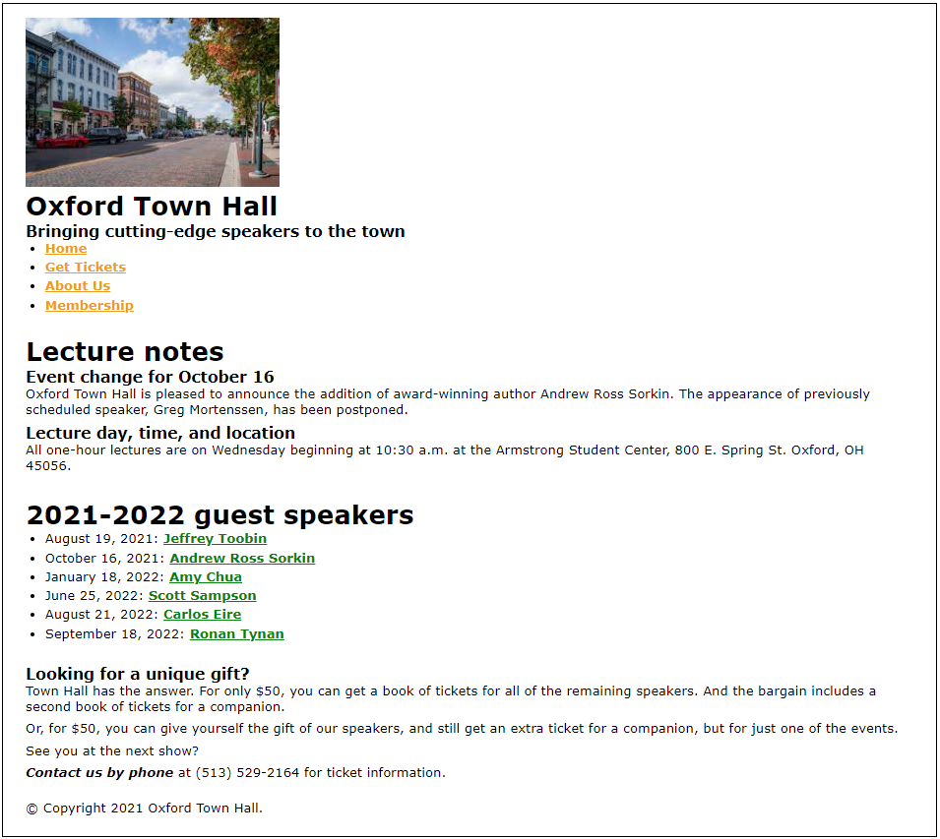

**Screen shot of the completed home.html**

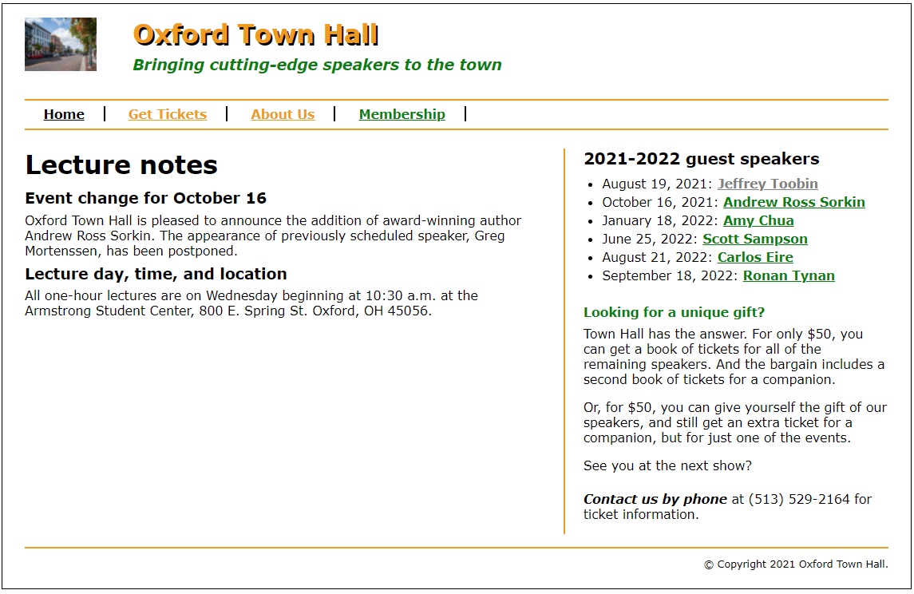

**Incomplete membership.html**

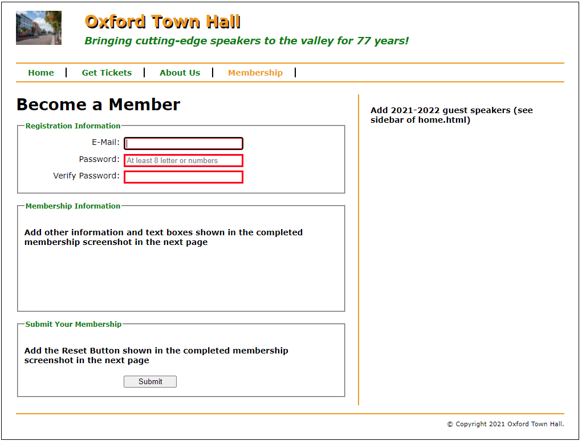

**Screen shot of the completed membership.html**

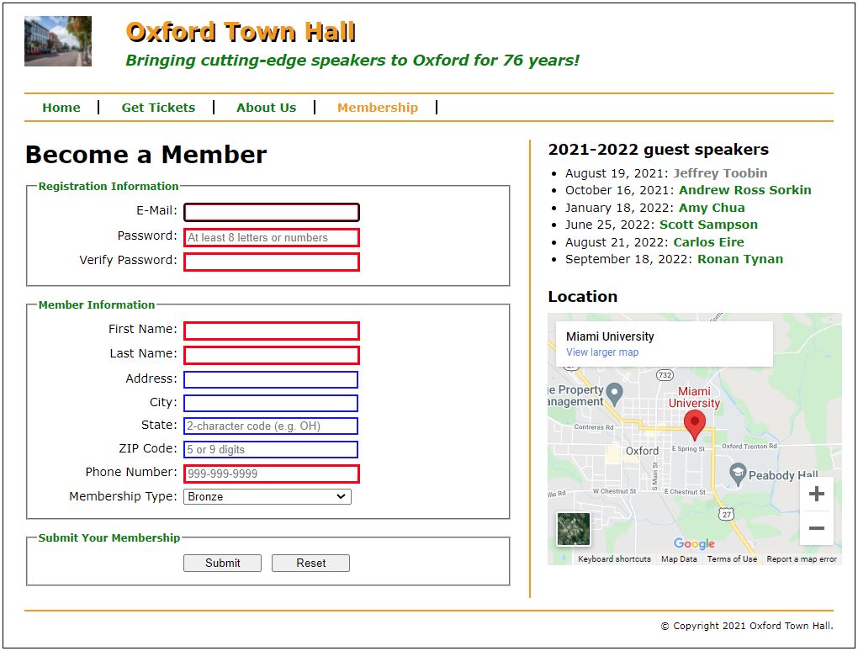

**Bonus AboutUs page**

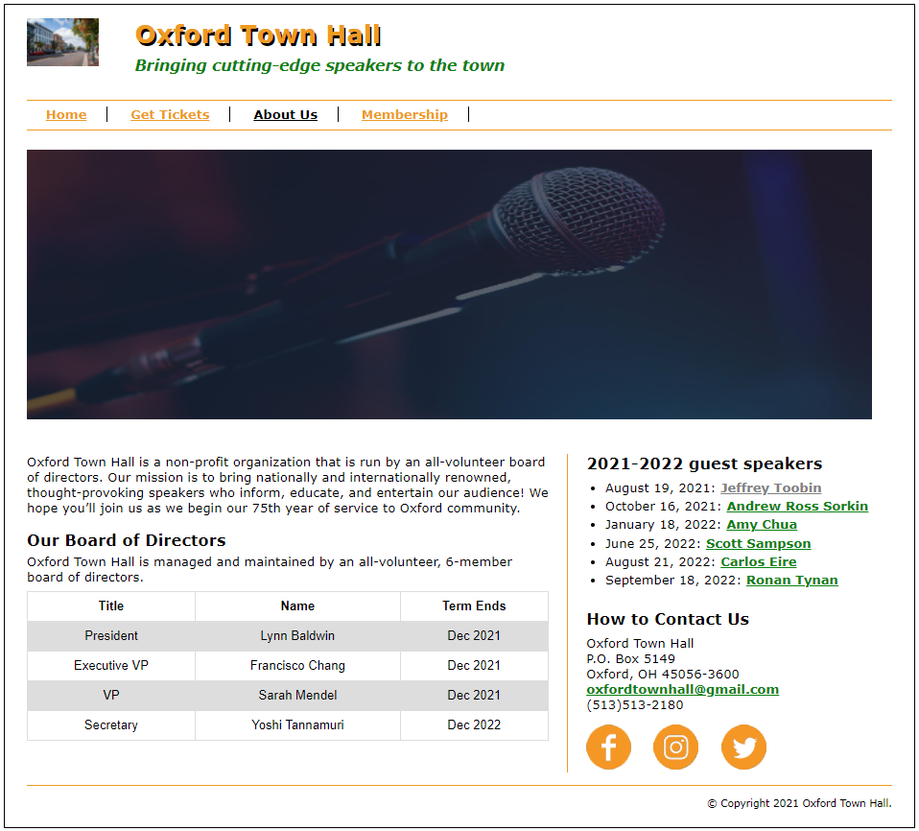

* You can find images for bonus points from the images folder.