CMP_SC 8690: Computer Vision

Homework 1A: Hybrid Images in Python

By: Mikey Joyce

Due: 2/1/2024

Abstract:

The main goal of this project was to review some of the Python modules that were utilized in digital image processing. Along with this another goal of this assignment was to perform basic image operations such as convolution and filtering.

Introduction:

In this assignment, two separate experiments were formed which allowed for the creation of four different hybrid images. An image of a dog and cat were given. The two separate experiments allowed for the testing/experimentation of utilizing different sigma values in the gaussian filter.

Experiments and Results:

Original Cat Image Original Dog Image

Blurred Cat Blurred Dog

Sharpened Cat Sharpened Dog

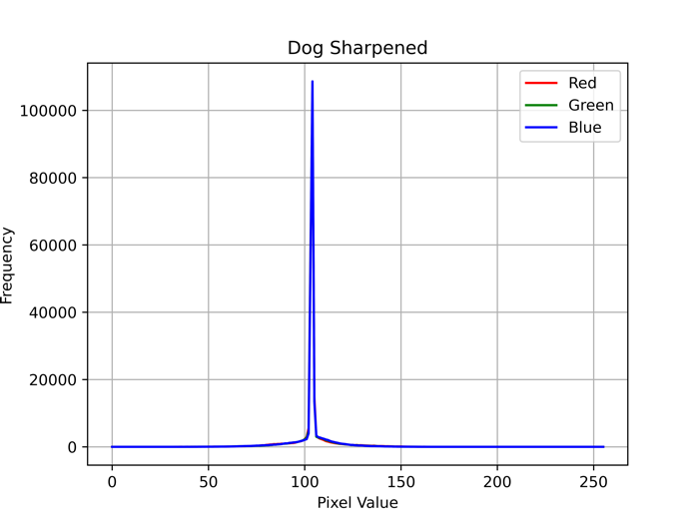

Hybrid Sigma=5 Hybrid Sigma=20

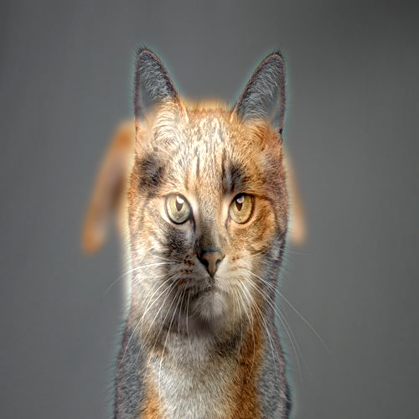

Hybrid Sigma=5 Hybrid Sigma=20

Conclusion:

In this assignment, the main objective of being able to create hybrid images was accomplished. We can see after the blurring of the image, the RGB histogram doesn’t change very much, but after the sharpening the histograms look much different. This is because the contours of the image are preserved, but not the colors, which allows itself to overlay well onto the blurred image to create the hybrid look. When we look at the resulting images in the hybrid images, the lower sigma values allow the blurred image to be more involved in the resulting image. Where a higher sigma value lets the sharpened image dominate the picture.

References:

* Libraries and tools: PyCharm, OpenCV, NumPy, Matplotlib, Preview.
* CV2024_HW1A.pdf