1050 Programming Logic

Lab 4 (20 points total)

Name: _Michael Bogacki_

Paste your code and screenshots below.

1. Describe the four basic elements of the counter-controlled repetition (2 points).

counter variable- keeps track of how many times a code is executed

initial value of the counter variable- sets the value of the variable

increment or decrement variable- sets how the variable is to increase or decrease

loop-continuation condition- describes how long the loop is supposed to run for.

1. Compare and contrast the while and for repetition statements (1 points).

The while loops is used when the number of repetitions is unknown and the for statement is used when there is a known number that the program will execute.

1. Discuss a specific example when it would be more appropriate to use a do-while statement than a while statement. Explain why (2 points).

While statements run until the value is no longer true. Do while statements check if the value is true after the program has already run at least one time, and it will run 1 time no matter what. It would be useful to use a do while statement when there aren’t many repetitions needed.

1. Create a for loop that goes from 1-100 using a variable named i as the counter. Each time through the loop, output whether or not the variable is even or odd (3 Points)

Hint: Use and if-else statement and the modulus % operator to determine whether the variable is even or odd. Example: if ((i % 2) == 0) // it’s even

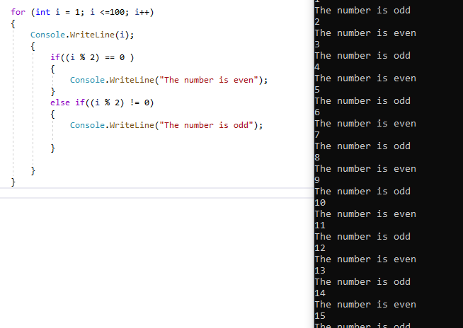

1. Use an if…else-if…else statement to output the following based on an int temp that is input by the user (3 Points) Prompt the user with “Please enter a temperature”.

Input output

< 10 Polar Bear

< 20 Penguin

< 40 Moose

< 50 Reindeer

< 60 Deer

< 70 Turtle

< 80 Lion

< 90 Fish

Default Bug

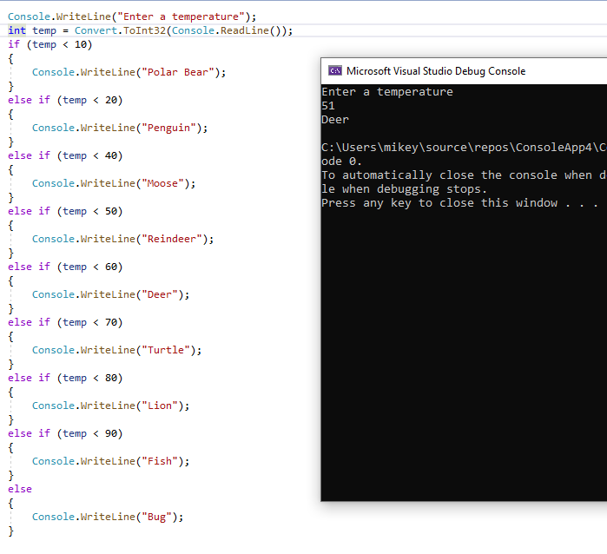

1. Use a switch statement to output the following based on an int input that corresponds to an exhibit at the zoo (3 points). Prompt the user with “Please enter the exhibit number: “

Input output

1 Polar Bear

2 Penguin

3 Moose

4 Reindeer

5 Deer

6 Turtle

7 Lion

8 Fish

9 Bug

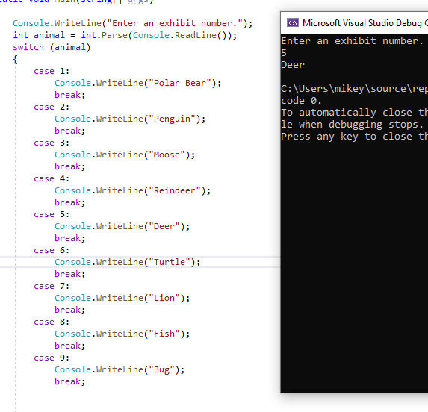

1. The following code is meant to loop and output 10-20, each number on a separate line. What’s wrong? Fix the problem. (3 points)

int i = 10;

while (i < 21)

{

Console.WriteLine(i);

}

Example output:



FIX

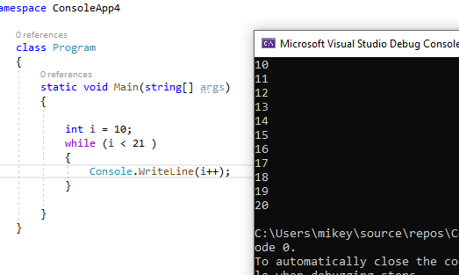

1. The following statement is supposed to output every number from 0-100 separated by a line with asterisks on it. What is wrong with the code? Fix it. (3 points)

for (int i = 0; i < 101; i++)

Console.WriteLine(i);

Console.WriteLine("********");

Example output:

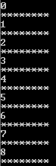

Fix

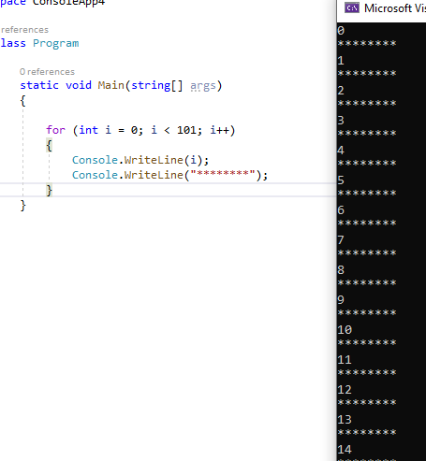

1. Extra Credit: Write an application that displays the following patterns separately, one below the other. Use for loops to generate the patterns. All asterisks (*) should be displayed by a single statement of the form Console.Write( '*' ); which causes the asterisks to display side by side. A statement of the form Console.WriteLine(); can be used to move to the next line. A statement of the form Console.Write( ' ' ); can be used to display a space for the last two patterns. There should be no other output statements in the application. [Hint: The last two patterns require that each line begin with an appropriate number of blank spaces.] (4 Points – 1 per correct solution)

