**1050 Programming Logic**Lab 5 (23 points total)

Name: ________Mikey Bogacki___________________

1. **Identify and describe the following elements of the method header given the following method called getArea(). You must identify where they are in the method header example, other possible values and what the significance of each is (what does it mean?) (12 points – 2 points each)**

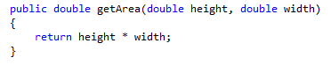

1. **Scope – used to see the paramater**
2. **Static vs. Non-Static- static means that the output is one copy. Non-static is that a program will be run more than one time.**
3. **Return Type- height/ width, what the desired output is**
4. **Method Name (Identifier)- getArea, used to name methods**
5. **Parameters- want double the height and double the width of getArea.- used for setting values that you would like to see output from the program**
6. **Method Body- where the action takes place.**
7. **Explain the difference between a user-defined method and a method that is provided with a framework. What should we consider when creating a user-defined method? (3 points)**

* **User-defined methods are methods written by a user and are kept hidden from other methods. Methods with framework are able to be used several times from different places in a program.**

1. **Discuss the difference between a static and non-static method (2 points)**

* **A static method belongs to a class while a non-static method belongs to an object of the class. Statics are shared while non statics only belong to one instance.**

1. **Use the attached code. Note: you will have to extract the code and open it in Visual Studio before starting. Add a method to the Dog class called bark(). It should have the following characteristics: (3 points)**
   1. Zero parameters
   2. No return value
   3. Should execute Console.WriteLine("{0} is Barking...", name);

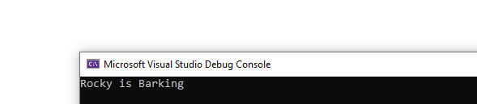

1. **Add a method to the Dog class called doTrick(). It should have the following characteristics: (3 points)**

* Should accept a single string parameter called trickName
* No return value
* Should execute:

Console.WriteLine("{0} is so smart! {0} is doing a(n) {1}", name, trickName);

