**1050 Programming Logic**

Lab 6 (20 points total)

Name: _______Michael Bogacki__________

***Instructions:*** *Complete the following exercises. Paste your code into this document and submit this Word document to Blackboard when complete.*

1. Fill in the blanks in the following statement (2 points):

A one-dimensional array p contains four elements. The array access expressions to access each of the elements in p are ___p[0]___, __p[1]__,_p[2]____ and __p[3]__.

1. Create a 12-element array called months. Set each element to the name of each month.

For example months[0] = “January”. Use a for loop to display the number and name of each month. (4 points)

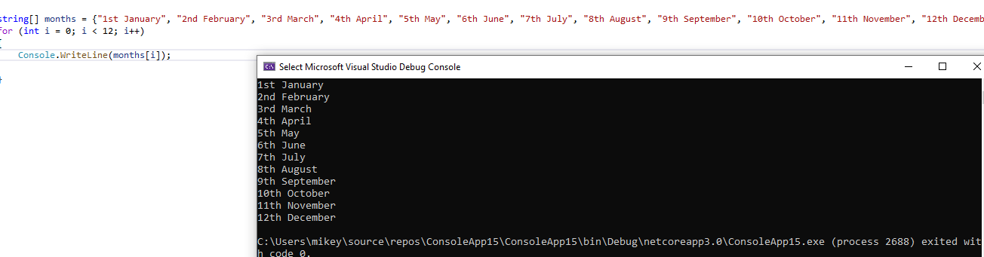

1. Create a 4-element array to store the names of 4 seasons. Use a foreach loop to display the name of each season. (4 points)

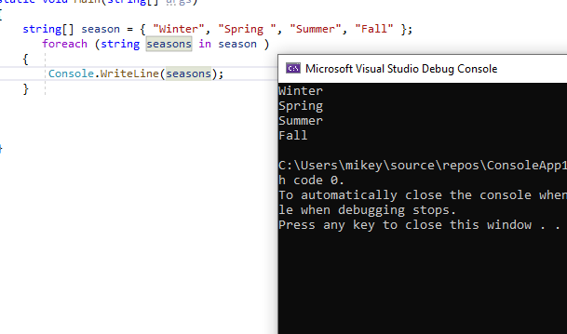

1. Create an array of integers with 1000 elements. Fill the array with random numbers. Use a foreach loop to print all integers in the array (4 points).

Random random = new Random();  
int randomNumber

randomNumber = random.Next(0, 100); // place this line in the loop

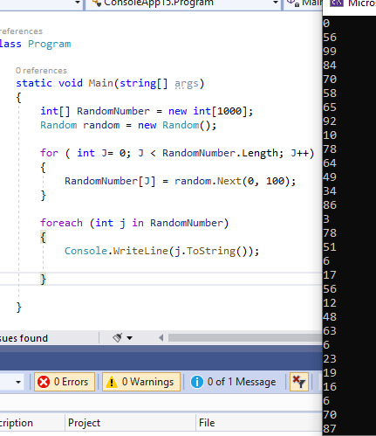

1. Paste the following code into the main() method. Modify the code; so that it works (You’ll have to make 2 small modifications). It should output the value of each string in the array called names (2 points).

string[] names = { "Al Dente", "Anna Graham", "Earle Bird", "Ginger Rayle", "Iona Ford" };

int i = 0;

while (i < names.Length)

{

Console.WriteLine(names[0]);

}

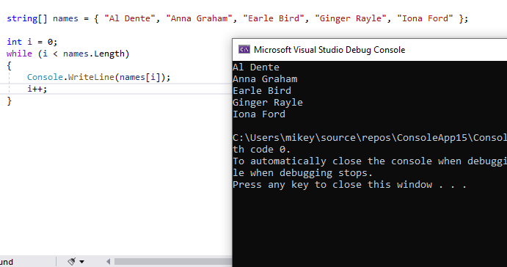

1. Modify the code from problem 5, so that it outputs a number and then a person’s name using the following output statement (1 point).

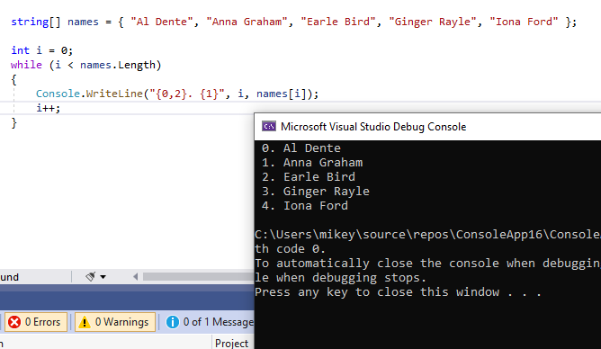

1. Modify the code from problem 6, so that it uses a *foreach loop* as opposed to a while loop. The output should appear exactly the same as it did after step 2 (3 points).

