**1050 Programming Logic**

Lab 7 (20 points total)

Name: ________Michael Bogacki______________

*Please paste all of your code into this Word document and submit a single Word document for your solution. Please enter your answers in bolded or a different color font, so they’re easy to find - thanks! Note that the PowerPoint and the MSDN website resource on Object-Oriented Programming for this week might be helpful.*

1. Create a class called Book defines properties Title, Author and Year. Add a method called Display() that outputs the Title and Author (4 points) 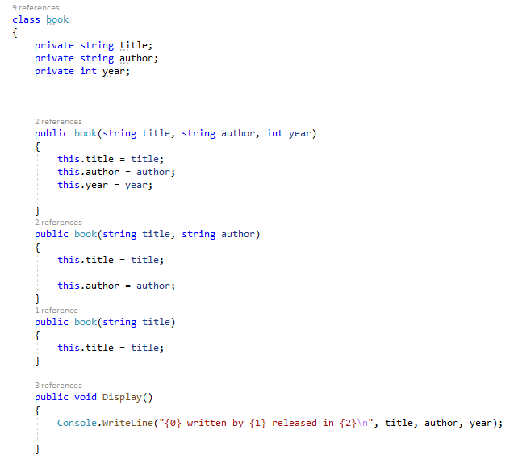
2. Create a class called BookTest that uses an object initializer to create an object of class Book (from step 1) and initialize all of its properties. Note: you will need to create a constructor method to do this (4 points)

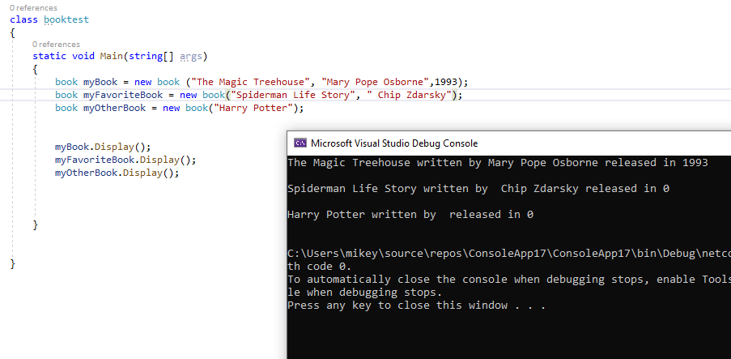

*Answer the following in essay form:*

1. Before adding a constructor method, describe what is called when we create an instance of type Book? (2 points)

* We are creating objects and variables.

1. What concept would we be practicing if we created two new constructor methods? (2 points)

* Overloading

1. Why is it important to use exception handling? (2 points)

* It’s important to use exception handling to maintain the flow of a program. Errors could happen which would disrupt a program’s running.

1. What’s the purpose of private vs. public when we’re adding new properties and/or methods to our class? How does this apply to information hiding? (2 points)

* Private variables are only visible in the class which they are in, public variables are available in any class that uses the already created variables. It applies to information hiding because you can keep an instance of something hidden from other parts of the class by making it private in a class.

1. What is composition? How could we use Composition in our Book class? (2 points)

* Composition describes one or more objects of other classes in instance variables. We could use composition in our book class by adding a string of code that would take information from a separate class, BookTest.

1. What is data abstraction? (2 points)

* Data abstraction is programming a class that hides some data in order to make it easier to work with.