**QsARC**

Software Design Document

Version 1.0

November 12, 2014

**Project Manager**

Hulices Lopez

**Team Member**

Miguel A. Garza

**Prepared for**

UTB COSC 4346- Software Engineering

Instructor: Mahmoud K. Quweider, Ph.D.

Fall 2014

Two Sequence Diagrams

1. Add Accreditation Data
2. Generate Report
3. **Add Accreditation Data- Sequence Diagram**

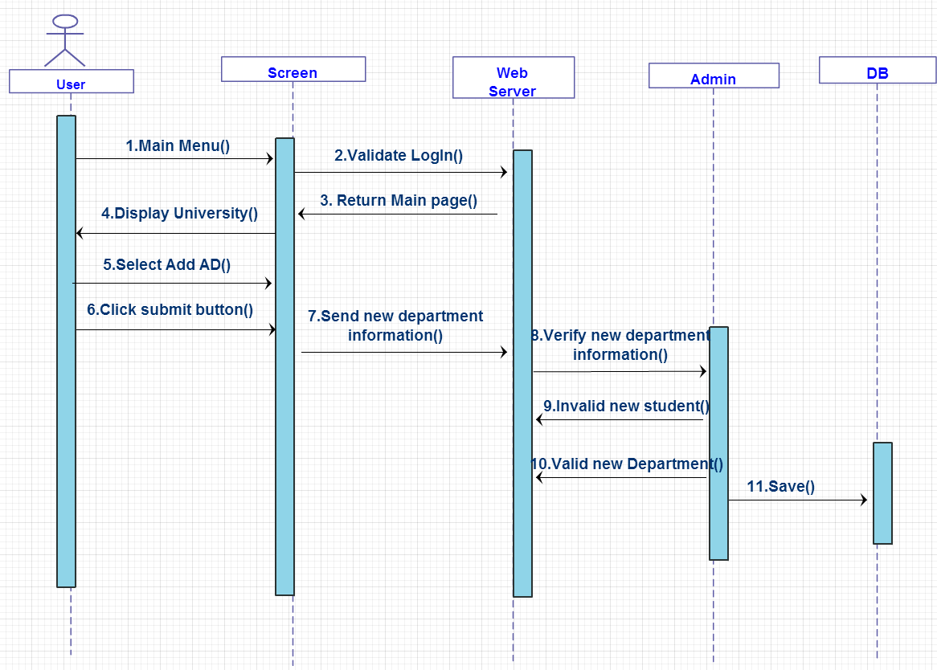

1. **Generate Report**

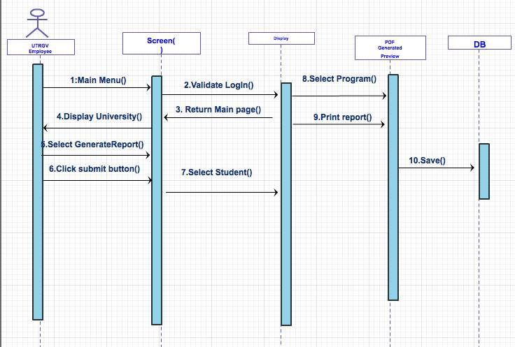

**Class Diagram**

