maven安装

　　安装过程挺简单的，去apache下载apache-maven的zip包，解压到一个目录下，如下图

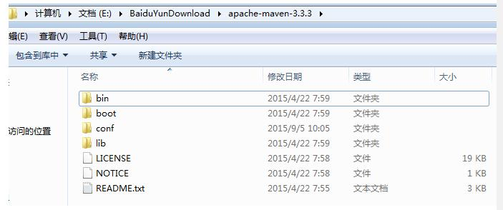

　　接下来配置windows环境，右击我的电脑--》属性--》高级系统设置--》环境变量--》系统变量--》新建，如下图

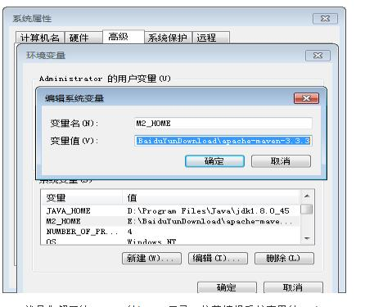

就是你解压的maven的home目录；接着编辑系统变量的Path，如图

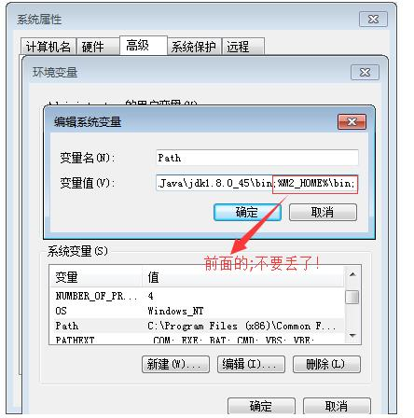

　　其实跟配置java环境是一样的，最后几个连续确定之后就好了，这几个确定一定要点，不然配置不会保存，更不会生效！ home路径一定要写自己的，别搬我的呀！路径最好是拷贝，手动输入太容易出错了。

接下来验证环境是否配置成功，打开命令行，输入mvn -v 如果出现下图的信息，那么恭喜你，配置成功了！当然，信息可能有些许出入，如版本不同等，这些不用在意。

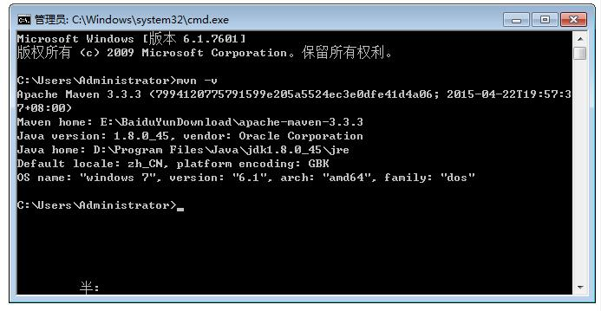

Eclipse（java ee版）集成maven

一般而言，新的eclipse都已经集成了maven，如果没有那么就安装，点击eclipse菜单栏Help->Eclipse Marketplace搜索关键字maven到插件Maven Integration for Eclipse 并点击安装即可，接下来将eclipse集成的maven换成我们自己的，而不用eclipse自带的，重新定位，点击Window -> Preference -> Maven -> Installation -> Add进行设置，如下图

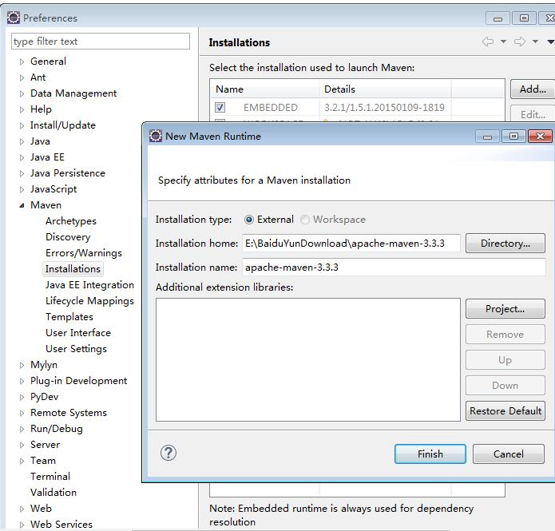

　　设置完成，那么eclipse配置maven就完成了，myeclipse配置和这个是一样的。

创建ssm项目

选择建立Maven Project 选择File -> New -> Other，在New窗口中选择 Maven -> Maven Project；点击next，如下图

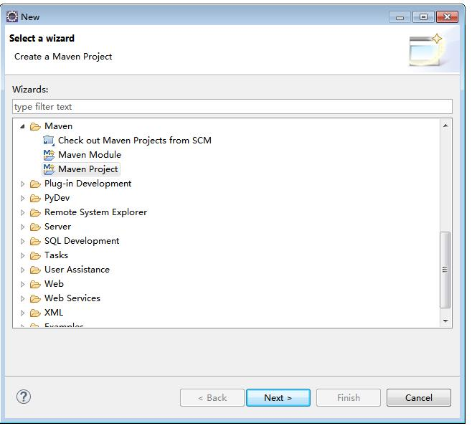

选择项目路径，如下图，然后next

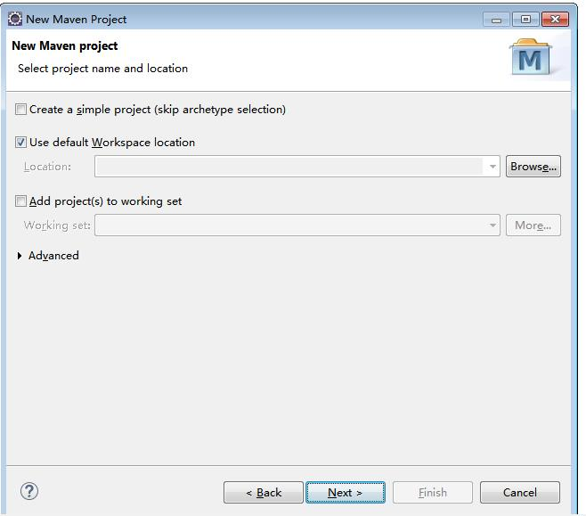

选择项目类型 选择Artifact Id为maven-archetype-webapp那一项，如下图

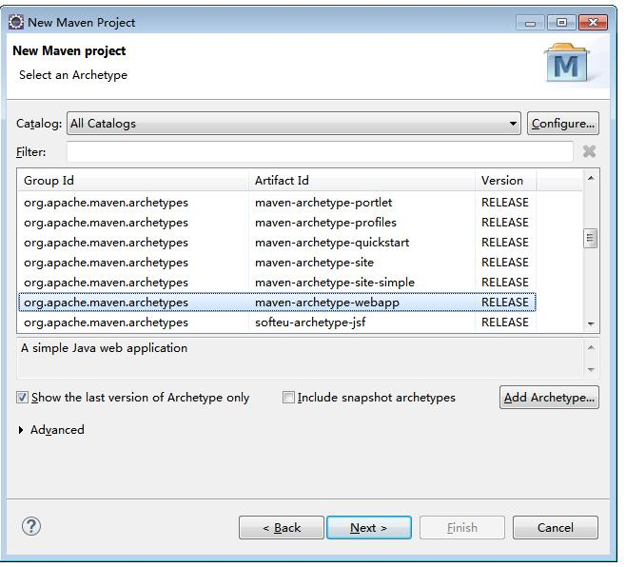

　　输入Group ID和 Artifact ID，以及Package，具体Group ID和 Artifact ID代表什么，可以去阅读《Maven 实战》，Group ID相当于一个组织，而Artifact ID相当于这个组织下的一个具体项目，Packege的话会根据你的Group ID和Artifact ID生成一个默认的名称，就用默认的就可以，如下图

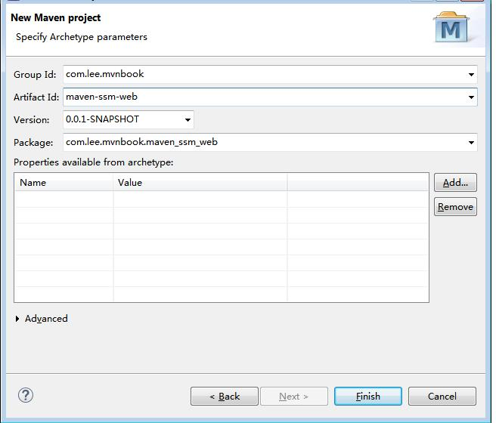

若目录结构和上面的有差别，那么将perspective改成Java模式就好了。上面的目录结构离标准的maven web结构还有一点差别，少了一个文件夹src/test/resources，我们手动创建下，右键项目根目录点击New -> Source Folder，建出这个文件夹，如下图：

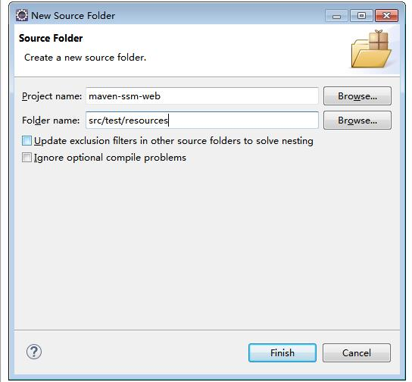

Finish之后，项目结构图如下所示：

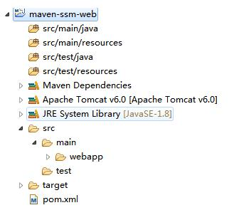

　　把项目变成Dynamic Web项目右键项目，properties --》Project Facets，点击Convert to faceted fro，勾上Dynamic Web Module，并将Version为2.3。(3.0为Java7的)。

　　设置部署程序集(Web Deployment Assembly)  
        上面步骤设置完成后，点击OK，再右键项目，选择properties --》Deployment Assembly，如下图

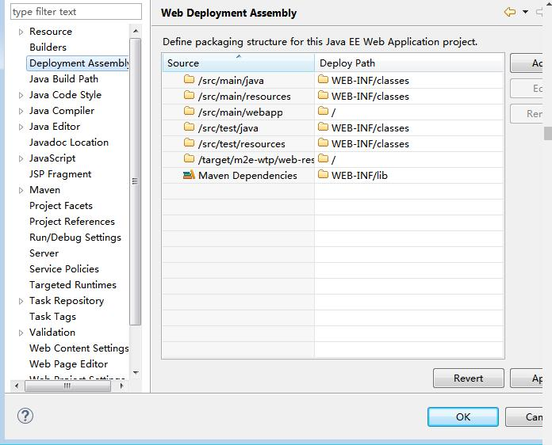

　　此处列表是，部署项目时，文件发布的路径。

        （1）我们删除test的两项，因为test是测试使用，并不需要部署。

        （2）设置将Maven的jar包发布到lib下。

        Add -> JavaBuild Path Entries -> Maven Dependencies -> Finish

        设置完成效果图

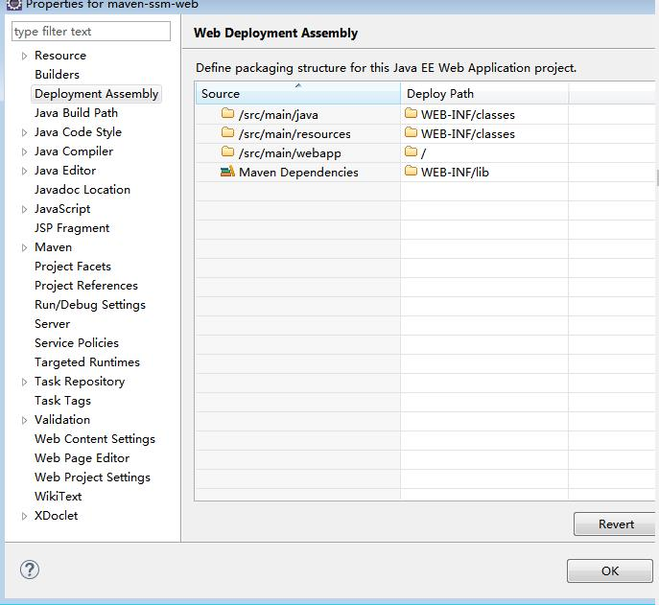

构建框架

　　在pom.xml中添加所需要的jar包，内容如下图

http://images.cnblogs.com/OutliningIndicators/ExpandedBlockStart.gif

[复制代码](javascript:void(0);)

<project xmlns="http://maven.apache.org/POM/4.0.0" xmlns:xsi="http://www.w3.org/2001/XMLSchema-instance"

xsi:schemaLocation="http://maven.apache.org/POM/4.0.0 http://maven.apache.org/maven-v4\_0\_0.xsd">

<modelVersion>4.0.0</modelVersion>

<groupId>com.lee.mvnbook</groupId>

<artifactId>maven-ssm-web</artifactId>

<packaging>war</packaging>

<version>0.0.1-SNAPSHOT</version>

<name>maven-ssm-web Maven Webapp</name>

<url>http://maven.apache.org</url>

<properties>

<!-- spring版本号 -->

<spring.version>4.0.2.RELEASE</spring.version>

</properties>

<dependencies>

<!-- spring核心包 -->

<dependency>

<groupId>org.springframework</groupId>

<artifactId>spring-core</artifactId>

<version>${spring.version}</version>

</dependency>

<dependency>

<groupId>org.springframework</groupId>

<artifactId>spring-web</artifactId>

<version>${spring.version}</version>

</dependency>

<dependency>

<groupId>org.springframework</groupId>

<artifactId>spring-oxm</artifactId>

<version>${spring.version}</version>

</dependency>

<dependency>

<groupId>org.springframework</groupId>

<artifactId>spring-tx</artifactId>

<version>${spring.version}</version>

</dependency>

<dependency>

<groupId>org.springframework</groupId>

<artifactId>spring-jdbc</artifactId>

<version>${spring.version}</version>

</dependency>

<dependency>

<groupId>org.springframework</groupId>

<artifactId>spring-webmvc</artifactId>

<version>${spring.version}</version>

</dependency>

<dependency>

<groupId>org.springframework</groupId>

<artifactId>spring-aop</artifactId>

<version>${spring.version}</version>

</dependency>

<dependency>

<groupId>org.springframework</groupId>

<artifactId>spring-context-support</artifactId>

<version>${spring.version}</version>

</dependency>

<dependency>

<groupId>org.springframework</groupId>

<artifactId>spring-test</artifactId>

<version>${spring.version}</version>

</dependency>

<!-- 添加MyBatis依赖 -->

<dependency>

<groupId>org.mybatis</groupId>

<artifactId>mybatis</artifactId>

<version>3.3.0</version>

</dependency>

<dependency>

<groupId>mysql</groupId>

<artifactId>mysql-connector-java</artifactId>

<version>5.0.8</version>

</dependency>

<!-- 阿里巴巴的数据库连接池 -->

<dependency>

<groupId>com.alibaba</groupId>

<artifactId>druid</artifactId>

<version>1.0.16</version>

</dependency>

<!-- spring结成mybatis -->

<dependency>

<groupId>org.mybatis</groupId>

<artifactId>mybatis-spring</artifactId>

<version>1.2.3</version>

</dependency>

<!-- jsp标准标签库 -->

<dependency>

<groupId>javax.servlet</groupId>

<artifactId>jstl</artifactId>

<version>1.2</version>

</dependency>

<dependency>

<groupId>log4j</groupId>

<artifactId>log4j</artifactId>

<version>1.2.16</version>

</dependency>

<dependency>

<groupId>org.slf4j</groupId>

<artifactId>slf4j-api</artifactId>

<version>1.6.1</version>

</dependency>

<dependency>

<groupId>org.slf4j</groupId>

<artifactId>slf4j-nop</artifactId>

<version>1.6.4</version>

</dependency>

<dependency>

<groupId>junit</groupId>

<artifactId>junit</artifactId>

<version>4.7</version>

<scope>test</scope>

</dependency>

</dependencies>

<build>

<finalName>maven-ssm-web</finalName>

</build>

</project>

[复制代码](javascript:void(0);)

　　如果依赖不知道怎么写，比如groupId、artifactId、version不知道填什么，那么直接上[http://search.maven.org/](http://search.maven.org/" \t "_blank)搜，对应着填写就可以了，如下图

　　保存pom.xml,maven就会帮我们下载我们配置的所有jar包了，jar包依赖的jar包也会自动下载，是不是很方便！当然，这个下载可能需要较长的时间，不要急，当eclipse右下角的百分比进度没有了，就下载好了。jar包下载完成后，项目结构图如下

配置文件

　　web.xml

http://images.cnblogs.com/OutliningIndicators/ExpandedBlockStart.gif

[复制代码](javascript:void(0);)

<?xml version="1.0" encoding="UTF-8"?>

<web-app xmlns:xsi="http://www.w3.org/2001/XMLSchema-instance" xmlns="http://java.sun.com/xml/ns/javaee" xsi:schemaLocation="http://java.sun.com/xml/ns/javaee http://java.sun.com/xml/ns/javaee/web-app\_2\_5.xsd" id="WebApp\_ID" version="2.5">

<display-name>SSM configuration</display-name>

<!-- 解决工程编码过滤器 -->

<filter>

<filter-name>characterEncodingFilter</filter-name>

<filter-class>org.springframework.web.filter.CharacterEncodingFilter</filter-class>

<init-param>

<param-name>encoding</param-name>

<param-value>UTF-8</param-value>

</init-param>

</filter>

<filter-mapping>

<filter-name>characterEncodingFilter</filter-name>

<url-pattern>/\*</url-pattern>

</filter-mapping>

<!-- 配置文件所在位置 -->

<context-param>

<param-name>contextConfigLocation</param-name>

<param-value>classpath:spring.xml,classpath:mybatis-spring.xml</param-value>

</context-param>

<!-- Spring配置（监听器） -->

<listener>

<listener-class>org.springframework.web.context.ContextLoaderListener</listener-class>

</listener>

<!-- SpringMVC配置 -->

<servlet>

<servlet-name>springDispatcherServlet</servlet-name>

<servlet-class>org.springframework.web.servlet.DispatcherServlet</servlet-class>

<init-param>

<param-name>contextConfigLocation</param-name>

<param-value>classpath:spring-mvc.xml</param-value>

</init-param>

<load-on-startup>1</load-on-startup>

</servlet>

<servlet-mapping>

<servlet-name>springDispatcherServlet</servlet-name>

<url-pattern>/</url-pattern>

</servlet-mapping>

<welcome-file-list>

<welcome-file>index.html</welcome-file>

<welcome-file>index.jsp</welcome-file>

</welcome-file-list>

</web-app>

[复制代码](javascript:void(0);)

　　spring.xml

http://images.cnblogs.com/OutliningIndicators/ExpandedBlockStart.gif

[复制代码](javascript:void(0);)

<?xml version="1.0" encoding="UTF-8"?>

<beans xmlns="http://www.springframework.org/schema/beans"

xmlns:xsi="http://www.w3.org/2001/XMLSchema-instance" xmlns:context="http://www.springframework.org/schema/context"

xmlns:aop="http://www.springframework.org/schema/aop" xmlns:tx="http://www.springframework.org/schema/tx"

xsi:schemaLocation="http://www.springframework.org/schema/beans

http://www.springframework.org/schema/beans/spring-beans.xsd

http://www.springframework.org/schema/context

http://www.springframework.org/schema/context/spring-context.xsd

http://www.springframework.org/schema/aop

http://www.springframework.org/schema/aop/spring-aop.xsd

http://www.springframework.org/schema/tx

http://www.springframework.org/schema/tx/spring-tx.xsd">

<!-- 自动注入 -->

<context:component-scan base-package="com.huawei.service.impl" />

<!-- 加载properties文件 -->

<!-- <bean id="configProperties" class="org.springframework.beans.factory.config.PropertiesFactoryBean">

<property name="locations">

<list>

<value>classpath:mysqldb.properties</value>

</list>

</property>

</bean> -->

</beans>

[复制代码](javascript:void(0);)

　　mybatis-spring.xml

http://images.cnblogs.com/OutliningIndicators/ContractedBlock.gif View Code

　　spring-mvc.xml

http://images.cnblogs.com/OutliningIndicators/ContractedBlock.gif View Code

 　　mybatis-config.xml

http://images.cnblogs.com/OutliningIndicators/ContractedBlock.gif View Code

　　log4j.properties

http://images.cnblogs.com/OutliningIndicators/ContractedBlock.gif View Code

　　mysqldb.properties

http://images.cnblogs.com/OutliningIndicators/ContractedBlock.gif View Code

 　　项目结构图如下

java文件与jsp文件

　　PersonController.java

http://images.cnblogs.com/OutliningIndicators/ContractedBlock.gif View Code

　　PersonMapper.java

http://images.cnblogs.com/OutliningIndicators/ContractedBlock.gif View Code

　　PersonMapper.xml

http://images.cnblogs.com/OutliningIndicators/ContractedBlock.gif View Code

　　Person.java

http://images.cnblogs.com/OutliningIndicators/ContractedBlock.gif View Code

　　IPersonService.java

http://images.cnblogs.com/OutliningIndicators/ContractedBlock.gif View Code

　　PersonServiceImpl.java

http://images.cnblogs.com/OutliningIndicators/ContractedBlock.gif View Code

　　showperson.jsp

http://images.cnblogs.com/OutliningIndicators/ContractedBlock.gif View Code

mysql数据库表

最终效果

　　那么恭喜你，也恭喜我，搭建ssm成功了！

后话

　　用心的小伙伴应该发现了，前面的windows配置maven和我们用eclipse搭建ssm没有一点关系，确实和ssm搭建没有什么卵关系，我写出来是为什么了，就是有时候我们不用IDE工具，而在dos命令下利用maven搭建我们的项目的时候，那么windows配置maven就需用到了！

分类: [maven](http://www.cnblogs.com/youzhibing/category/761400.html" \t "_blank),[mybatis](http://www.cnblogs.com/youzhibing/category/702844.html),[spring MVC](http://www.cnblogs.com/youzhibing/category/702843.html)

标签: [maven](http://www.cnblogs.com/youzhibing/tag/maven/), [mybatis](http://www.cnblogs.com/youzhibing/tag/mybatis/), [spring mvc](http://www.cnblogs.com/youzhibing/tag/spring%20mvc/), [druid](http://www.cnblogs.com/youzhibing/tag/druid/)

[**好文要顶**](javascript:void(0);) [**关注我**](javascript:void(0);) [**收藏该文**](javascript:void(0);) **[http://common.cnblogs.com/images/icon_weibo_24.png](javascript:void(0);)** **[http://common.cnblogs.com/images/wechat.png](javascript:void(0);)**

[http://pic.cnblogs.com/face/sample_face.gif](http://home.cnblogs.com/u/youzhibing/)

[youzhibing2904](http://home.cnblogs.com/u/youzhibing/)  
[关注 - 22](http://home.cnblogs.com/u/youzhibing/followees)  
[粉丝 - 19](http://home.cnblogs.com/u/youzhibing/followers)

[+加关注](javascript:void(0);)

7

0

[«](http://www.cnblogs.com/youzhibing/p/4993070.html)上一篇：[排序之归并排序](http://www.cnblogs.com/youzhibing/p/4993070.html" \o "发布于2015-11-24 22:19)  
[»](http://www.cnblogs.com/youzhibing/p/5021224.html)下一篇：[主从热备+负载均衡（LVS + keepalived）](http://www.cnblogs.com/youzhibing/p/5021224.html" \o "发布于2015-12-08 00:03)

posted @ 2015-12-01 22:27 [youzhibing2904](http://www.cnblogs.com/youzhibing/) 阅读(3721) 评论(43) [编辑](https://i.cnblogs.com/EditPosts.aspx?postid=5004619) [收藏](http://www.cnblogs.com/youzhibing/p/5004619.html)

**评论列表**

[#1楼](http://www.cnblogs.com/youzhibing/p/5004619.html#3320632) 2015-12-04 11:42 [java\_lover](http://www.cnblogs.com/haha12/" \t "_blank) 

本地搭建成功了，多谢楼主分享，学习啦

[支持(0)反对(0)](javascript:void(0);)

[#2楼](http://www.cnblogs.com/youzhibing/p/5004619.html#3320749)[楼主] 2015-12-04 13:59 [youzhibing2904](http://www.cnblogs.com/youzhibing/) 

[@](http://www.cnblogs.com/youzhibing/p/5004619.html#3320632) java\_lover  
恭喜恭喜！

[支持(0)反对(0)](javascript:void(0);)

[#3楼](http://www.cnblogs.com/youzhibing/p/5004619.html#3335315) 2015-12-26 20:52 [獵人](http://www.cnblogs.com/baipyuamd/) 

楼主，我照抄没成功，就改了一下命名空间，tomcat运行时出现下面错误，能不能指导下  
  
org.apache.catalina.core.StandardContext listenerStart  
严重: Exception sending context initialized event to listener instance of class org.springframework.web.context.ContextLoaderListener  
org.springframework.beans.factory.BeanCreationException: Error creating bean with name 'personService': Injection of autowired dependencies failed; nested exception is org.springframework.beans.factory.BeanCreationException: Could not autowire method: public void com.mytest.service.impl.PersonServiceImpl.setPersonMapper(com.mytest.dao.PersonMapper); nested exception is org.springframework.beans.factory.NoSuchBeanDefinitionException: No qualifying bean of type [com.mytest.dao.PersonMapper] found for dependency: expected at least 1 bean which qualifies as autowire candidate for this dependency. Dependency annotations: {}  
at org.springframework.beans.factory.annotation.AutowiredAnnotationBeanPostProcessor.postProcessPropertyValues(AutowiredAnnotationBeanPostProcessor.java:292)  
at org.springframework.beans.factory.support.AbstractAutowireCapableBeanFactory.populateBean(AbstractAutowireCapableBeanFactory.java:1185)  
at org.springframework.beans.factory.support.AbstractAutowireCapableBeanFactory.doCreateBean(AbstractAutowireCapableBeanFactory.java:537)  
at org.springframework.beans.factory.support.AbstractAutowireCapableBeanFactory.createBean(AbstractAutowireCapableBeanFactory.java:475)  
at org.springframework.beans.factory.support.AbstractBeanFactory$1.getObject(AbstractBeanFactory.java:304)  
at org.springframework.beans.factory.support.DefaultSingletonBeanRegistry.getSingleton(DefaultSingletonBeanRegistry.java:228)  
at org.springframework.beans.factory.support.AbstractBeanFactory.doGetBean(AbstractBeanFactory.java:300)  
at org.springframework.beans.factory.support.AbstractBeanFactory.getBean(AbstractBeanFactory.java:195)  
at org.springframework.beans.factory.support.DefaultListableBeanFactory.preInstantiateSingletons(DefaultListableBeanFactory.java:700)  
at org.springframework.context.support.AbstractApplicationContext.finishBeanFactoryInitialization(AbstractApplicationContext.java:760)  
at org.springframework.context.support.AbstractApplicationContext.refresh(AbstractApplicationContext.java:482)  
at org.springframework.web.context.ContextLoader.configureAndRefreshWebApplicationContext(ContextLoader.java:403)  
at org.springframework.web.context.ContextLoader.initWebApplicationContext(ContextLoader.java:306)  
at org.springframework.web.context.ContextLoaderListener.contextInitialized(ContextLoaderListener.java:106)  
at org.apache.catalina.core.StandardContext.listenerStart(StandardContext.java:4812)  
at org.apache.catalina.core.StandardContext.startInternal(StandardContext.java:5255)  
at org.apache.catalina.util.LifecycleBase.start(LifecycleBase.java:150)  
at org.apache.catalina.core.ContainerBase$StartChild.call(ContainerBase.java:1408)  
at org.apache.catalina.core.ContainerBase$StartChild.call(ContainerBase.java:1398)  
at java.util.concurrent.FutureTask.run(FutureTask.java:266)  
at java.util.concurrent.ThreadPoolExecutor.runWorker(ThreadPoolExecutor.java:1142)  
at java.util.concurrent.ThreadPoolExecutor$Worker.run(ThreadPoolExecutor.java:617)  
at java.lang.Thread.run(Thread.java:745)

[支持(0)反对(0)](javascript:void(0);)

[#4楼](http://www.cnblogs.com/youzhibing/p/5004619.html#3335321)[楼主] 2015-12-26 21:02 [youzhibing2904](http://www.cnblogs.com/youzhibing/) 

[@](http://www.cnblogs.com/youzhibing/p/5004619.html#3335315) 獵人  
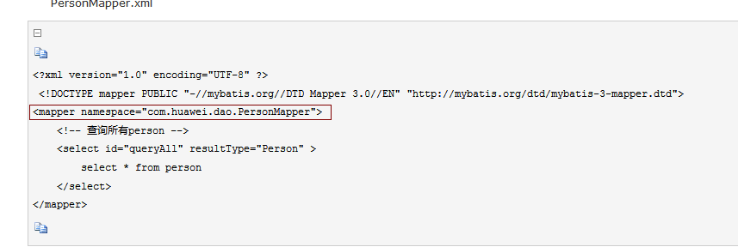  
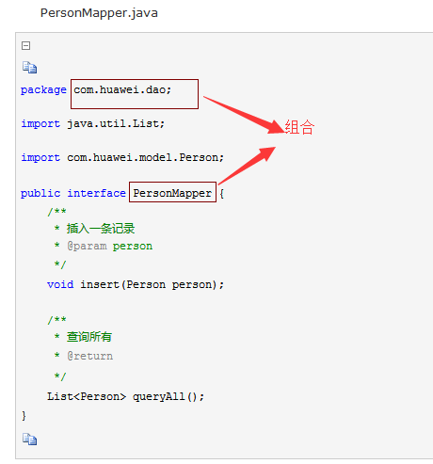  
两个框的内容要一样，命名空间需要修改的话，需要另外配置

  com.alibaba.druid.pool.vendor.MySqlValidConnectionChecker: Cannot resolve com.mysq.jdbc.Connection.ping method. Will use 'SELECT 1' instead.  
  
楼主请问下这个是什么问题？第一次启动会提示这个后面不会，是阿里巴巴连接池的问题？

[支持(0)反对(0)](javascript:void(0);)

[#8楼](http://www.cnblogs.com/youzhibing/p/5004619.html#3373290)[楼主] 2016-03-07 09:16 [youzhibing2904](http://www.cnblogs.com/youzhibing/) 

[@](http://www.cnblogs.com/youzhibing/p/5004619.html#3372942) Comup你将select \* 换成select 1

[支持(0)反对(0)](javascript:void(0);)

[#9楼](http://www.cnblogs.com/youzhibing/p/5004619.html#3389916) 2016-03-23 23:19 [默认区域](http://home.cnblogs.com/u/920417/) 

楼主 请问下 我按照步骤搭建的启动项目不报错，但是跳转就报404,求楼主指点下

[支持(0)反对(0)](javascript:void(0);)

[#10楼](http://www.cnblogs.com/youzhibing/p/5004619.html#3390039)[楼主] 2016-03-24 08:53 [youzhibing2904](http://www.cnblogs.com/youzhibing/) 

[@](http://www.cnblogs.com/youzhibing/p/5004619.html#3389916) 默认区域  
404 资源没找到，你spring mvc 配置有问题

[支持(0)反对(0)](javascript:void(0);)

[#11楼](http://www.cnblogs.com/youzhibing/p/5004619.html#3390483) 2016-03-24 12:43 [默认区域](http://home.cnblogs.com/u/920417/) 

[@](http://www.cnblogs.com/youzhibing/p/5004619.html#3390039) youzhibing2904  
对照您的配置，没有发现我这边有什么问题，您可以看下我的代码吗？  
pan.baidu.com/s/1o6QZSOM

[支持(0)反对(0)](javascript:void(0);)

[#12楼](http://www.cnblogs.com/youzhibing/p/5004619.html#3390989)[楼主] 2016-03-24 18:58 [youzhibing2904](http://www.cnblogs.com/youzhibing/) 

[@](http://www.cnblogs.com/youzhibing/p/5004619.html#3390483) 默认区域  
回去了我看下，现在在公司

[支持(0)反对(0)](javascript:void(0);)

[#13楼](http://www.cnblogs.com/youzhibing/p/5004619.html#3390999) 2016-03-24 19:18 [默认区域](http://home.cnblogs.com/u/920417/) 

[@](http://www.cnblogs.com/youzhibing/p/5004619.html#3390989) youzhibing2904  
嗯 嗯 好的 好的 谢谢

[支持(0)反对(0)](javascript:void(0);)

[#14楼](http://www.cnblogs.com/youzhibing/p/5004619.html#3391141)[楼主] 2016-03-24 21:10 [youzhibing2904](http://www.cnblogs.com/youzhibing/) 

[@](http://www.cnblogs.com/youzhibing/p/5004619.html#3390999) 默认区域  
兄弟，你web.xml没有配置哦！

[支持(0)反对(0)](javascript:void(0);)

[#15楼](http://www.cnblogs.com/youzhibing/p/5004619.html#3391236) 2016-03-24 22:27 [默认区域](http://home.cnblogs.com/u/920417/) 

[@](http://www.cnblogs.com/youzhibing/p/5004619.html#3391141) youzhibing2904  
[引用](http://www.cnblogs.com/youzhibing/p/5004619.html#3391141)@默认区域  
兄弟，你web.xml没有配置哦！  
配置了了啊  
  
<display-name>SSM configuration</display-name>  
<!-- 解决工程编码过滤器 -->  
<filter>  
<filter-name>characterEncodingFilter</filter-name>  
<filter-class>org.springframework.web.filter.CharacterEncodingFilter</filter-class>  
<init-param>  
<param-name>encoding</param-name>  
<param-value>UTF-8</param-value>  
</init-param>  
</filter>  
<filter-mapping>  
<filter-name>characterEncodingFilter</filter-name>  
<url-pattern>/\*</url-pattern>  
</filter-mapping>  
  
<!-- 配置文件所在位置 -->  
<context-param>  
<param-name>contextConfigLocation</param-name>  
<param-value>classpath:spring.xml,classpath:mybatis-spring.xml</param-value>  
</context-param>  
<!-- Spring配置（监听器） -->  
<listener>  
<listener-class>org.springframework.web.context.ContextLoaderListener</listener-class>  
</listener>  
  
<!-- SpringMVC配置 -->  
<servlet>  
<servlet-name>springDispatcherServlet</servlet-name>  
<servlet-class>org.springframework.web.servlet.DispatcherServlet</servlet-class>  
<init-param>  
<param-name>contextConfigLocation</param-name>  
<param-value>classpath:spring-mvc.xml</param-value>  
</init-param>  
<load-on-startup>1</load-on-startup>  
</servlet>  
<servlet-mapping>  
<servlet-name>springDispatcherServlet</servlet-name>  
<url-pattern>/</url-pattern>  
</servlet-mapping>  
  
<welcome-file-list>  
<welcome-file>index.html</welcome-file>  
<welcome-file>index.jsp</welcome-file>  
</welcome-file-list>  
</web-app>

[支持(0)反对(0)](javascript:void(0);)

[#16楼](http://www.cnblogs.com/youzhibing/p/5004619.html#3391292)[楼主] 2016-03-24 23:25 [youzhibing2904](http://www.cnblogs.com/youzhibing/) 

[@](http://www.cnblogs.com/youzhibing/p/5004619.html#3391236) 默认区域  
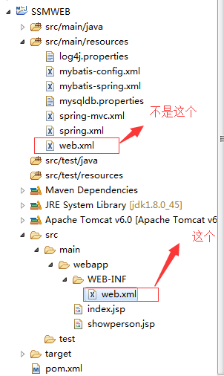

[支持(0)反对(0)](javascript:void(0);)

[#17楼](http://www.cnblogs.com/youzhibing/p/5004619.html#3391328) 2016-03-24 23:53 [默认区域](http://home.cnblogs.com/u/920417/) 

哦 明白了 明白了 刚开始学maven还太明白这些配置是怎么回事，谢谢 楼主

[支持(0)反对(0)](javascript:void(0);)

[#18楼](http://www.cnblogs.com/youzhibing/p/5004619.html#3391480)[楼主] 2016-03-25 08:46 [youzhibing2904](http://www.cnblogs.com/youzhibing/) 

[@](http://www.cnblogs.com/youzhibing/p/5004619.html#3391328) 默认区域  
慢慢来

[支持(0)反对(0)](javascript:void(0);)

[#19楼](http://www.cnblogs.com/youzhibing/p/5004619.html#3409388) 2016-04-15 17:55 [日月光](http://home.cnblogs.com/u/937621/) 

我代码照抄，tomcat启动出错  
  
四月 15, 2016 5:40:28 下午 org.apache.catalina.core.StandardContext listenerStart  
严重: Error configuring application listener of class org.springframework.web.context.ContextLoaderListener  
java.lang.ClassNotFoundException: org.springframework.web.context.ContextLoaderListener  
at org.apache.catalina.loader.WebappClassLoaderBase.loadClass(WebappClassLoaderBase.java:1858)  
at org.apache.catalina.loader.WebappClassLoaderBase.loadClass(WebappClassLoaderBase.java:1701)  
at org.apache.catalina.core.DefaultInstanceManager.loadClass(DefaultInstanceManager.java:504)  
at org.apache.catalina.core.DefaultInstanceManager.loadClassMaybePrivileged(DefaultInstanceManager.java:486)  
at org.apache.catalina.core.DefaultInstanceManager.newInstance(DefaultInstanceManager.java:113)  
at org.apache.catalina.core.StandardContext.listenerStart(StandardContext.java:4984)  
at org.apache.catalina.core.StandardContext.startInternal(StandardContext.java:5584)  
at org.apache.catalina.util.LifecycleBase.start(LifecycleBase.java:147)  
at org.apache.catalina.core.ContainerBase$StartChild.call(ContainerBase.java:1572)  
at org.apache.catalina.core.ContainerBase$StartChild.call(ContainerBase.java:1562)  
at java.util.concurrent.FutureTask.run(FutureTask.java:266)  
at java.util.concurrent.ThreadPoolExecutor.runWorker(ThreadPoolExecutor.java:1142)  
at java.util.concurrent.ThreadPoolExecutor$Worker.run(ThreadPoolExecutor.java:617)  
at java.lang.Thread.run(Thread.java:745)  
  
四月 15, 2016 5:40:28 下午 org.apache.catalina.core.StandardContext listenerStart  
严重: Skipped installing application listeners due to previous error(s)  
四月 15, 2016 5:40:28 下午 org.apache.catalina.core.StandardContext startInternal  
严重: One or more listeners failed to start. Full details will be found in the appropriate container log file  
四月 15, 2016 5:40:28 下午 org.apache.catalina.core.StandardContext startInternal  
严重: Context [/song] startup failed due to previous errors  
四月 15, 2016 5:40:28 下午 org.apache.coyote.AbstractProtocol start  
信息: Starting ProtocolHandler ["http-bio-8080"]  
四月 15, 2016 5:40:28 下午 org.apache.coyote.AbstractProtocol start  
信息: Starting ProtocolHandler ["ajp-bio-8009"]  
四月 15, 2016 5:40:28 下午 org.apache.catalina.startup.Catalina start  
信息: Server startup in 847 ms