/***********************************************
* Final Project: Hotel Reservation System - Project Documentation
* Course: APD545 NAA - Winter 2026
* This assignment represents our own work in accordance with Seneca Academic Policy.
* Name: Dohyun Lim, Phuong Bac Nguyen, Eunki Kim
* Group: #18
* Date: Apr 6, 2026
***********************************************/

NewnhamNexus Hotel Reservation System

Project Documentation

Table of Contents
NewnhamNexus Hotel Reservation System 1
Project Documentation 1
1. Project Overview 1
1.1 Summary 1
1.2 Key Features 2
1.3 Technologies Used 2
2. Architecture Summary 3
2.1 Three-Tier Architecture 3
2.2 Cross-Cutting Concerns 3
2.3 MVC Pattern 3
2.4 Dependency Injection 4
2.5 ORM Implementation 4
3. Design Artifacts 5
3.1 Class Diagram 5
3.2 Sequence Diagram - Kiosk Booking Flow 7
3.3 Deployment Diagram 8
3.4 Package Diagram 8
3.5 UI Screenshots 10
4. Entity and Relationship Mapping 21
4.1 Entities (9 Tables + 2 Join Tables) 21
4.2 Relationships 21
4.3 Key JPA Annotations Used 22
4.4 Cascade and Fetch Strategy Notes 23
5. Pattern Usage 23
5.1 Singleton Pattern 23
5.2 Factory Pattern 24
5.3 Strategy Pattern 24
5.4 Observer Pattern 25
5.5 Decorator Pattern 26
6. Business Rules 27
6.1 Room Occupancy Rules 27
6.2 Pricing Rules 27
6.3 Discount Rules 27
6.4 Loyalty Program Rules (Nexus Rewards) 28
6.5 Feedback Rules 28
6.6 Reservation Status Flow 28
7. Security and Logging 28
7.1 Authentication 28
7.2 Role-Based Access Control 28
7.3 Logging Configuration 29
7.4 Exception Handling 29
8. Export and Reporting 30
8.1 Report Types 30
8.2 Export Formats 30
8.3 Sample Report Structure 30
8.4 PDF Export Implementation 31
9. Challenges and Learnings 31
9.1 Team Challenges 31
9.2 Individual Reflections 32
9.3 Suggestions for Future Improvements 33
Appendices 33
A. File Structure 33
B. How to Run 34
C. References 34

1. Project Overview

1.1 Summary
NewnhamNexus Hotel is a famous tourist hotel in North York, Toronto. This project replaces the existing manual reservation system with a computerized solution to address the following problems:
- Records vulnerable to destruction by fire/disaster or theft
- Storage requiring extra cabinet space
- Difficult and time-consuming record searches
- Error-prone manual billing system
The system includes 2 self-service kiosks for contactless booking, an admin management portal, and a guest feedback system.

1.2 Key Features
Module | Features
Kiosk | 6-step booking flow, room selection, add-on services, loyalty enrollment
Admin Portal | CRUD operations, payments, checkout, waitlist management, reporting
Feedback | 1-5 star ratings, comments, sentiment tagging
Loyalty Program | Nexus Rewards - earn/redeem points
Reporting | Revenue, occupancy, feedback reports with CSV/PDF export

1.3 Technologies Used
Technology | Version | Purpose
Java | 17+ | Core programming language
JavaFX | 21 | Desktop UI framework
Hibernate | 6.4.4 | JPA/ORM implementation
H2 Database | 2.2.224 | Embedded file-based database
BCrypt (jbcrypt) | 0.4 | Password hashing
Apache PDFBox | 2.0.31 | PDF report generation
Maven | 3.6+ | Build and dependency management

2. Architecture Summary

2.1 Three-Tier Architecture
┌─────────────────────────────────────────────────────────────┐
│ PRESENTATION TIER │
│ JavaFX UI (Kiosk, Admin, Feedback) │
│ Controllers + FXML Views │
└─────────────────────────────────────────────────────────────┘
│
▼
┌─────────────────────────────────────────────────────────────┐
│ APPLICATION/BUSINESS TIER │
│ Services, Business Rules, Design Patterns │
│ (Pricing, Discounts, Loyalty, Waitlist Notifications) │
└─────────────────────────────────────────────────────────────┘
│
▼
┌─────────────────────────────────────────────────────────────┐
│ DATA TIER │
│ ORM-backed Repositories + H2 Database │
│ (Persistence, Queries, Transactions) │
└─────────────────────────────────────────────────────────────┘

2.2 Cross-Cutting Concerns
Concern | Implementation
Logging | Rotating file logs (1MB limit, 10 files max) in /logs directory
Security | BCrypt password hashing, role-based access control
Configuration | persistence.xml for JPA, styles.css for UI theming
Exception Handling | Try-catch blocks with user-friendly error alerts

2.3 MVC Pattern
Component | Implementation
Model | JPA Entity classes (Guest, Room, Reservation, etc.)
View | FXML files in /resources/view/
Controller | KioskController, AdminController, FeedbackController

2.4 Dependency Injection
The AppContext class serves as a simple dependency injection container:
public class AppContext {
private static final RoomRepository roomRepository = new RoomRepository();
private static final GuestRepository guestRepository = new GuestRepository();
private static final ReservationRepository reservationRepository = new ReservationRepository();
// ... other repositories
private static final ReservationService reservationService = new ReservationService(
reservationRepository, roomRepository, guestRepository, addonRepository);
private static final PricingService pricingService = new PricingService();
// ... other services
// Getters for each dependency
public static ReservationService getReservationService() { return reservationService; }
}

2.5 ORM Implementation
- Framework: Hibernate 6.4.4 with Jakarta Persistence API
- Database: H2 embedded (file: ./data/hoteldb.mv.db)
- Schema Generation: hibernate.hbm2ddl.auto = update
- Connection Pooling: Hibernate default connection provider

3. Design Artifacts

3.1 Class Diagram
┌─────────────────────────────────────────────────────────────────────────────────────┐
│ ENTITY CLASS DIAGRAM │
└─────────────────────────────────────────────────────────────────────────────────────┘
┌──────────────────┐ ┌──────────────────┐
│ User │ │ AuditLog │
├──────────────────┤ ├──────────────────┤
│ - id: Long │ │ - id: Long │
│ - username: String│ │ - timestamp: DateTime│
│ - passwordHash: String│ │ - actor: String │
│ - role: UserRole │ │ - action: String │
│ - active: boolean│ │ - entityType: String│
├──────────────────┤ │ - entityId: String│
│ + getRole() │ │ - message: String│
│ + isActive() │ └──────────────────┘
└──────────────────┘
┌──────────────────┐
┌────────────────────►│ Guest │◄────────────────────┐
│ ├──────────────────┤ │
│ 1 │ - id: Long │ 1 │
│ │ - firstName: String│ │
│ │ - lastName: String│ │
│ │ - email: String │ │
│ │ - phone: String │ │
│ │ - loyaltyNumber: String│ │
│ │ - loyaltyPoints: int│ │
│ ├──────────────────┤ │
│ │ + getFullName() │ │
│ │ + isLoyaltyMember()│ │
│ └────────┬─────────┘ │
│ │ │
│ │ 1 │
│ │ │
│ N ▼ N │ N
┌───────┴──────────┐ ┌──────────────────┐ ┌─────────┴────────┐
│ Waitlist │ │ Reservation │ │ Feedback │
├──────────────────┤ ├──────────────────┤ ├──────────────────┤
│ - id: Long │ │ - id: Long │ │ - id: Long │
│ - guest: Guest │ │ - confirmationNumber│ │ - guest: Guest │
│ - roomType: RoomType│ │ - guest: Guest │ │ - reservation: Reservation│
│ - desiredCheckIn: Date│ │ - checkInDate: Date│ │ - rating: int │
│ - desiredCheckOut: Date│ │ - checkOutDate: Date│ │ - comment: String│
│ - createdAt: DateTime│ │ - adults: int │ │ - sentimentTag: String│
│ - notified: boolean│ │ - children: int │ │ - submittedAt: DateTime│
│ - converted: boolean│ │ - status: ReservationStatus│├──────────────────┤
├──────────────────┤ │ - subtotal: double│ │ + getRatingStars()│
│ + isActive() │ │ - tax: double │ └──────────────────┘
└──────────────────┘ │ - total: double │ ▲
│ - amountPaid: double│ │
│ - rooms: List<Room>│ │ 1
│ - addons: List<Addon>│ │
│ - createdAt: DateTime│ │
├──────────────────┤ │
│ + getBalance() │ │
│ + getNights() │ │
└─────┬───┬───┬────┴─────────────────────┘
│ │ │
┌─────────────┘ │ └─────────────┐
│ N:M │ N:M │
▼ │ ▼
┌──────────────────┐ │ ┌──────────────────┐
│ Room │ │ │ Addon │
├──────────────────┤ │ ├──────────────────┤
│ - id: Long │ │ │ - id: Long │
│ - roomNumber: String│ │ │ - name: String │
│ - type: RoomType │ │ │ - price: double │
│ - status: RoomStatus│ │ │ - pricingModel: PricingModel│
│ - floor: int │ │ ├──────────────────┤
│ - basePrice: double│ │ │ + isPerNight() │
│ - maxOccupancy: int│ │ └──────────────────┘
├──────────────────┤ │
│ + isAvailable() │ │
└──────────────────┘ │
│
│ 1
┌─────────┴────────┐
│ │
▼ N │
┌──────────────────┐ │
│ Payment │ │
├──────────────────┤ │
│ - id: Long │ │
│ - reservation: Reservation│
│ - paymentMethod: PaymentMethod│
│ - amount: double │ │
│ - paymentDate: DateTime│ │
│ - processedBy: String│ │
│ - transactionRef: String││
├──────────────────┤ │
│ + isRefund() │───────┘
└──────────────────┘
┌─────────────────────────────────────────────────────────────────────────────────────┐
│ RELATIONSHIP SUMMARY │
├─────────────────────────────────────────────────────────────────────────────────────┤
│ Guest (1) ────────< (N) Reservation : One guest can have many reservations │
│ Guest (1) ────────< (N) Feedback : One guest can leave many feedbacks │
│ Guest (1) ────────< (N) Waitlist : One guest can have many waitlist entries │
│ Reservation (1) ──< (N) Payment : One reservation can have many payments │
│ Reservation (1) ──< (1) Feedback : One reservation has one feedback │
│ Reservation (N) >──< (M) Room : Many-to-many via reservation_rooms │
│ Reservation (N) >──< (M) Addon : Many-to-many via reservation_addons │
└─────────────────────────────────────────────────────────────────────────────────────┘

3.2 Sequence Diagram - Kiosk Booking Flow
┌─────────┐ ┌──────────────┐ ┌──────────────┐ ┌─────────────┐ ┌────────┐
│ User │ │KioskController │BookingSession│ │ReservService│ │Database│
└────┬────┘ └──────┬───────┘ └───────┬──────┘ └──────┬──────┘ └───┬────┘
│ │ │ │ │
│ Select Guests│ │ │ │
│─────────────►│ │ │ │
│ │ setGuestCount() │ │ │
│ │─────────────────►│ │ │
│ │ │ │ │
│ Select Dates │ │ │ │
│─────────────►│ │ │ │
│ │ setDates() │ │ │
│ │─────────────────►│ │ │
│ │ │ │ │
│ Select Room │ │ │ │
│─────────────►│ │ │ │
│ │ findAvailable() │ │ │
│ │────────────────────────────────────────────────► │
│ │ │ │ │
│ Select Addons│ │ │ │
│─────────────►│ │ │ │
│ │ setAddons() │ │ │
│ │─────────────────►│ │ │
│ │ │ │ │
│ Enter Details│ │ │ │
│─────────────►│ │ │ │
│ │ setGuestDetails()│ │ │
│ │─────────────────►│ │ │
│ │ │ │ │
│ Confirm │ │ │ │
│─────────────►│ │ │ │
│ │ createReservation() │ │
│ │───────────────────────────────────►│ │
│ │ │ │ persist() │
│ │ │ │────────────►│
│ │ │ │ │
│◄─────────────│ Confirmation # │ │ │
│ │ │ │ │

3.3 Deployment Diagram
See: UML-deployment-diagram.png
┌────────────────────────────────────────────────────────────────┐
│ DEPLOYMENT ENVIRONMENT │
├────────────────────────────────────────────────────────────────┤
│ │
│ ┌─────────────────┐ ┌─────────────────┐ │
│ │ Kiosk 1 │ │ Kiosk 2 │ │
│ │ (JavaFX) │ │ (JavaFX) │ │
│ └────────┬────────┘ └────────┬────────┘ │
│ │ │ │
│ └──────────┬───────────┘ │
│ │ │
│ ▼ │
│ ┌─────────────────────┐ │
│ │ Admin Workstation │ │
│ │ (JavaFX Desktop) │ │
│ └─────────┬───────────┘ │
│ │ │
│ ▼ │
│ ┌─────────────────────┐ │
│ │ H2 Database │ │
│ │ (Embedded File) │ │
│ │ ./data/hoteldb │ │
│ └─────────────────────┘ │
│ │
└────────────────────────────────────────────────────────────────┘

3.4 Package Diagram
See: package-diagram.png
com.hotel
├── app/ # Application bootstrap
│ ├── Main.java
│ ├── AppContext.java
│ ├── DatabaseInitializer.java
│ └── EntityManagerFactoryProvider.java
│
├── controller/ # JavaFX Controllers
│ ├── KioskController.java
│ ├── AdminController.java
│ └── FeedbackController.java
│
├── model/ # JPA Entities
│ ├── Guest.java
│ ├── Room.java
│ ├── Reservation.java
│ ├── Payment.java
│ ├── Addon.java
│ ├── User.java
│ ├── Feedback.java
│ ├── Waitlist.java
│ ├── AuditLog.java
│ └── enums/
│
├── repository/ # Data Access Layer
│ ├── GenericRepository.java
│ └── *Repository.java
│
├── service/ # Business Logic
│ ├── ReservationService.java
│ ├── PricingService.java
│ ├── LoyaltyService.java
│ └── ...
│
├── events/ # Observer Pattern
│ ├── RoomAvailabilityEvent.java
│ ├── RoomAvailabilityNotifier.java
│ └── RoomAvailabilityObserver.java
│
└── util/ # Utilities
└── PdfExportUtil.java

3.5 UI Screenshots
The application consists of three main interfaces:
- Launcher Screen - Entry point with options for Kiosk, Admin, and Feedback
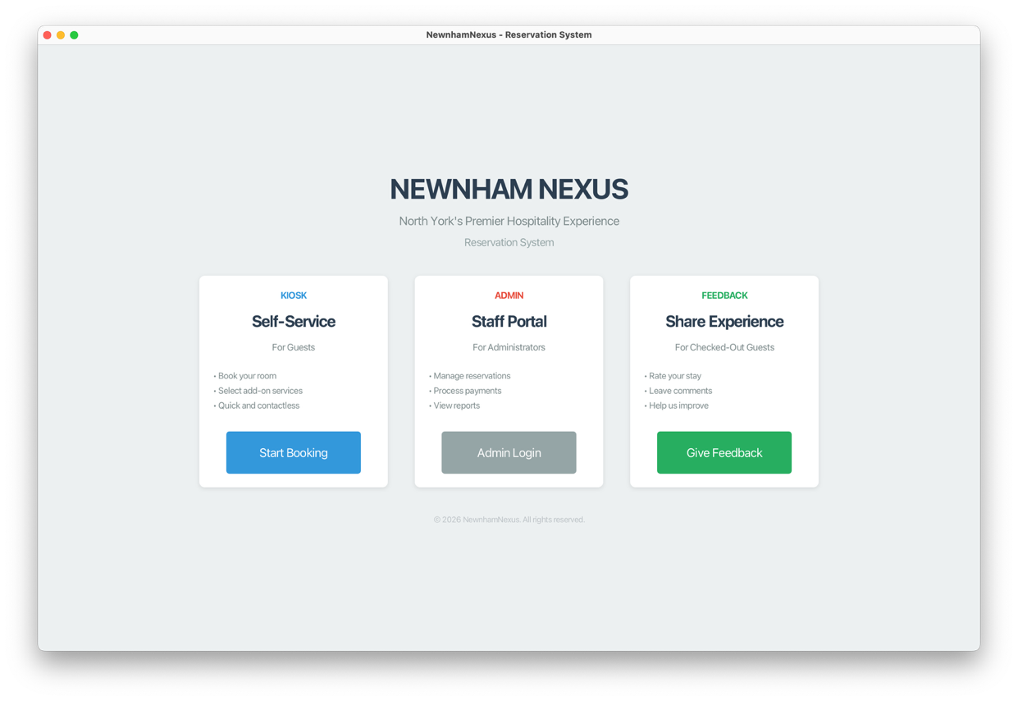

- Kiosk Screens (6 steps) - Guest count, dates, room, add-ons, details, confirmation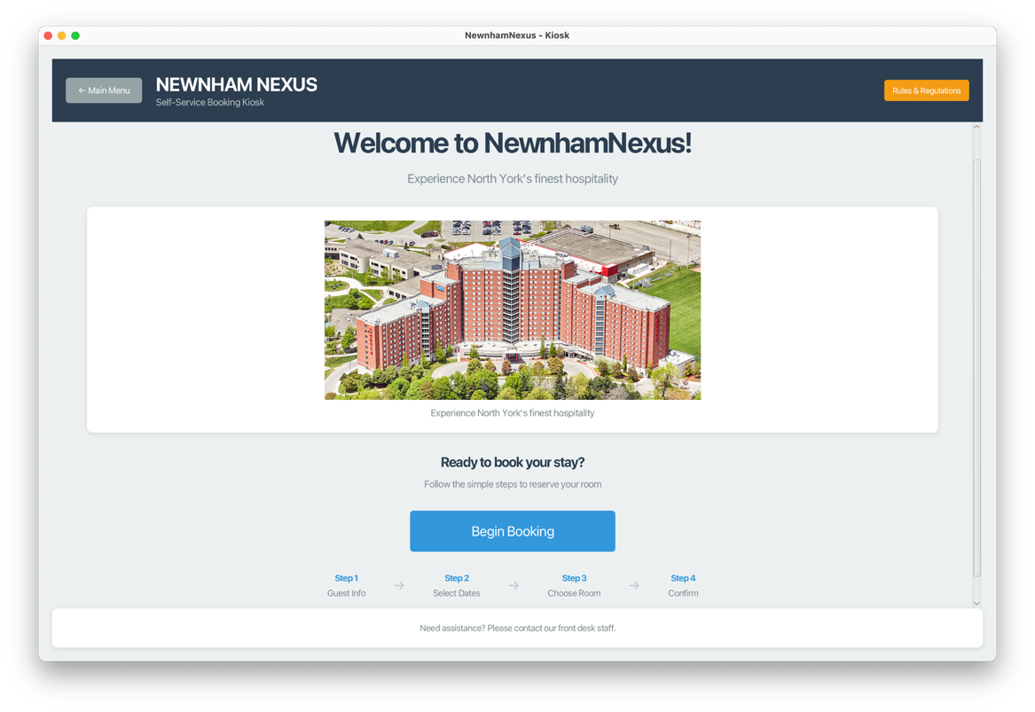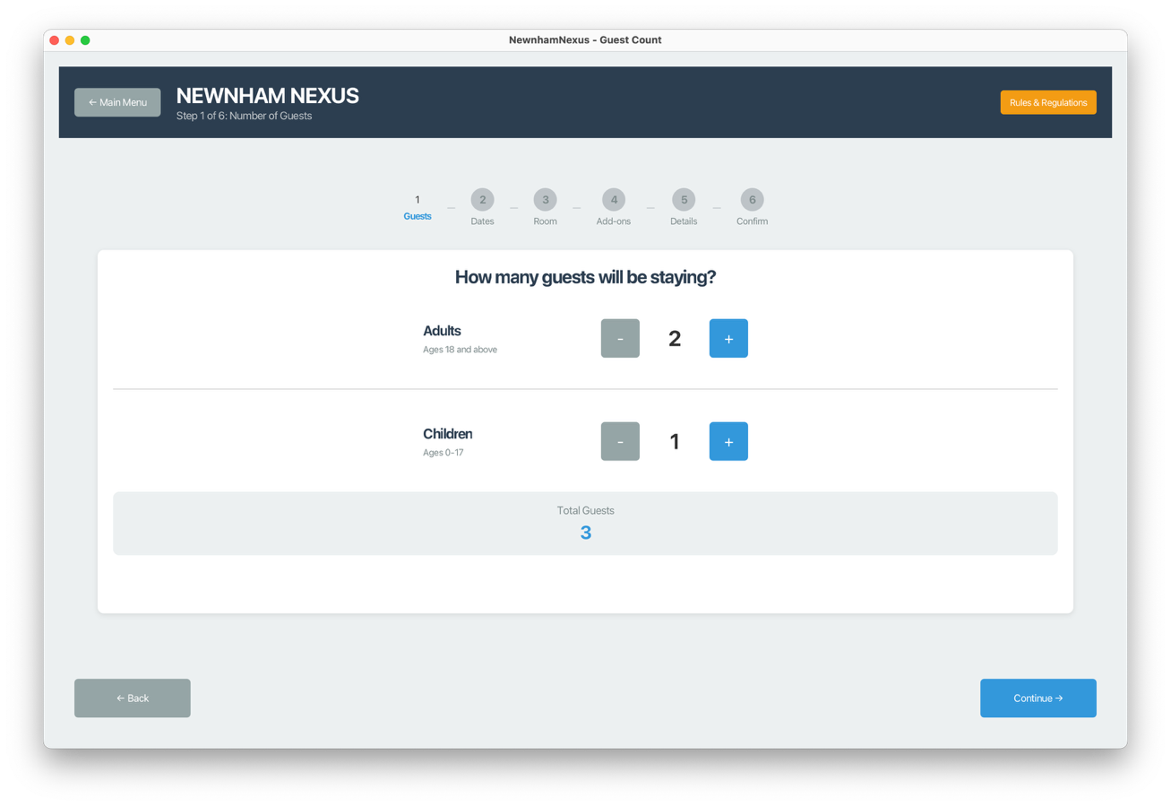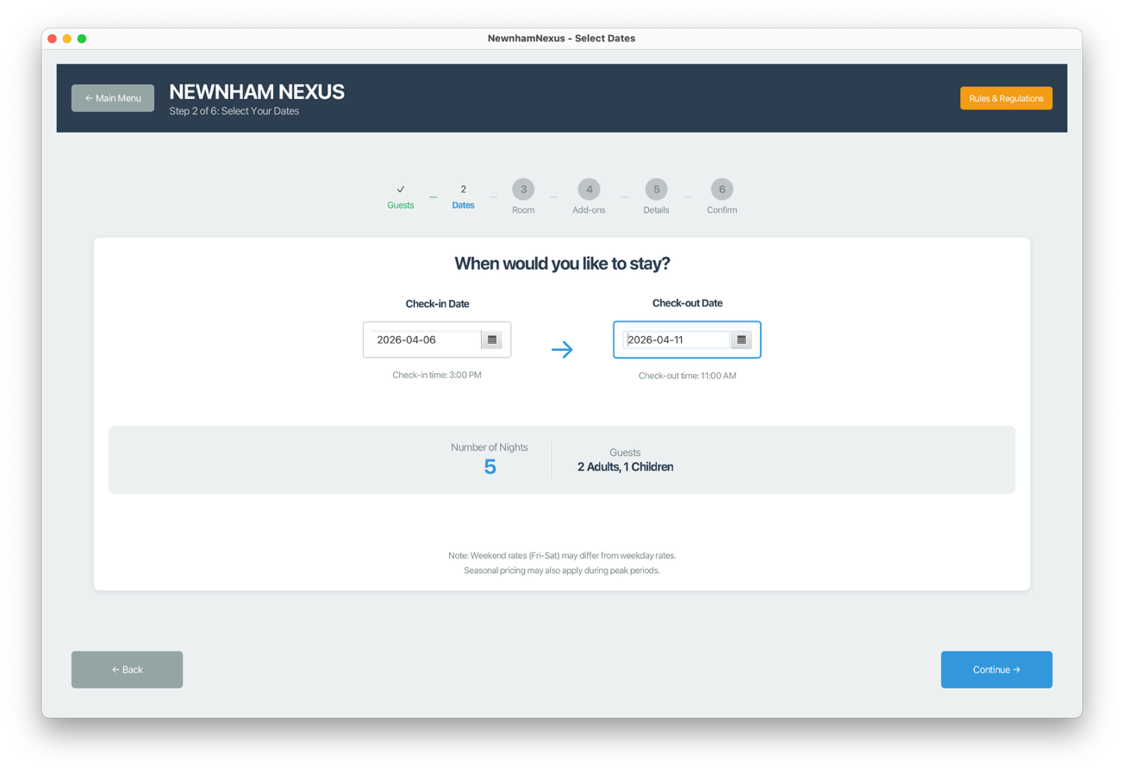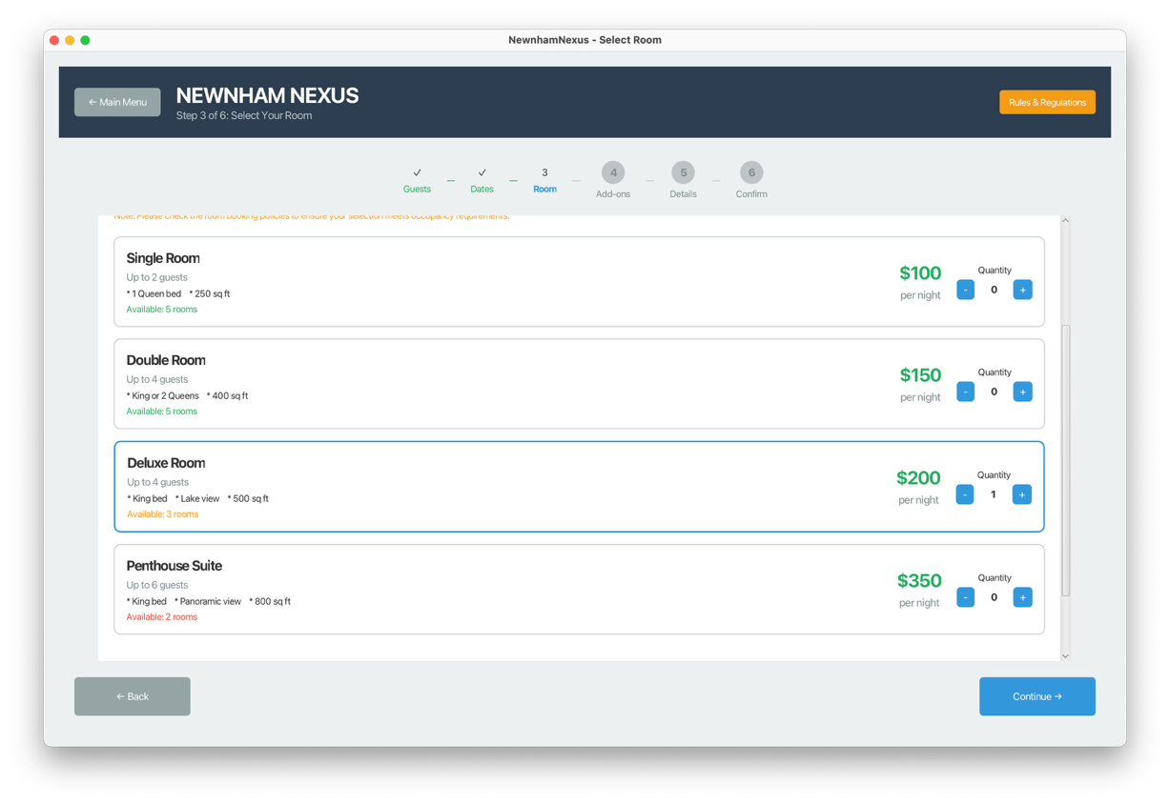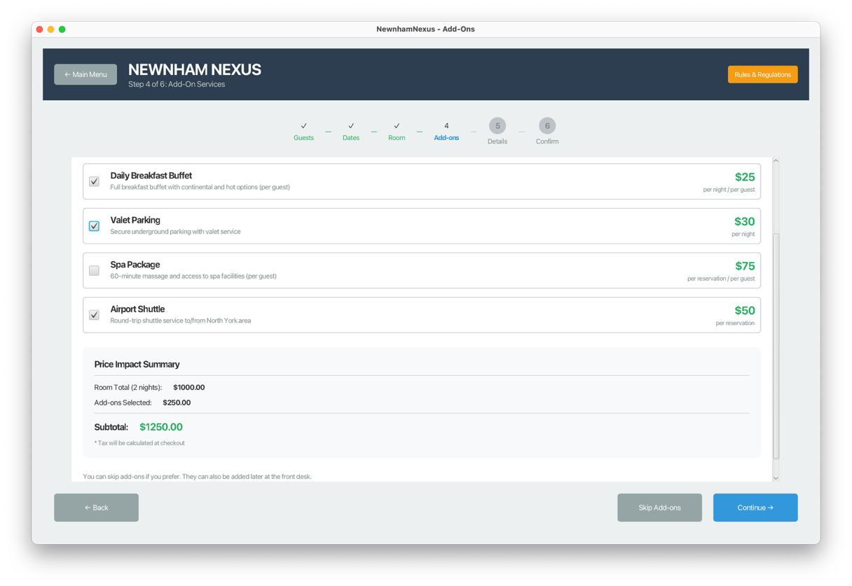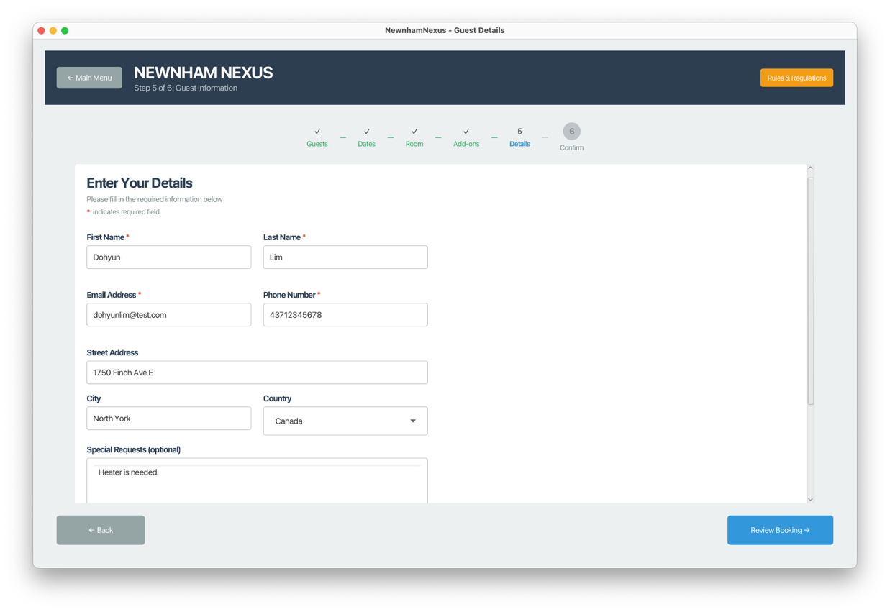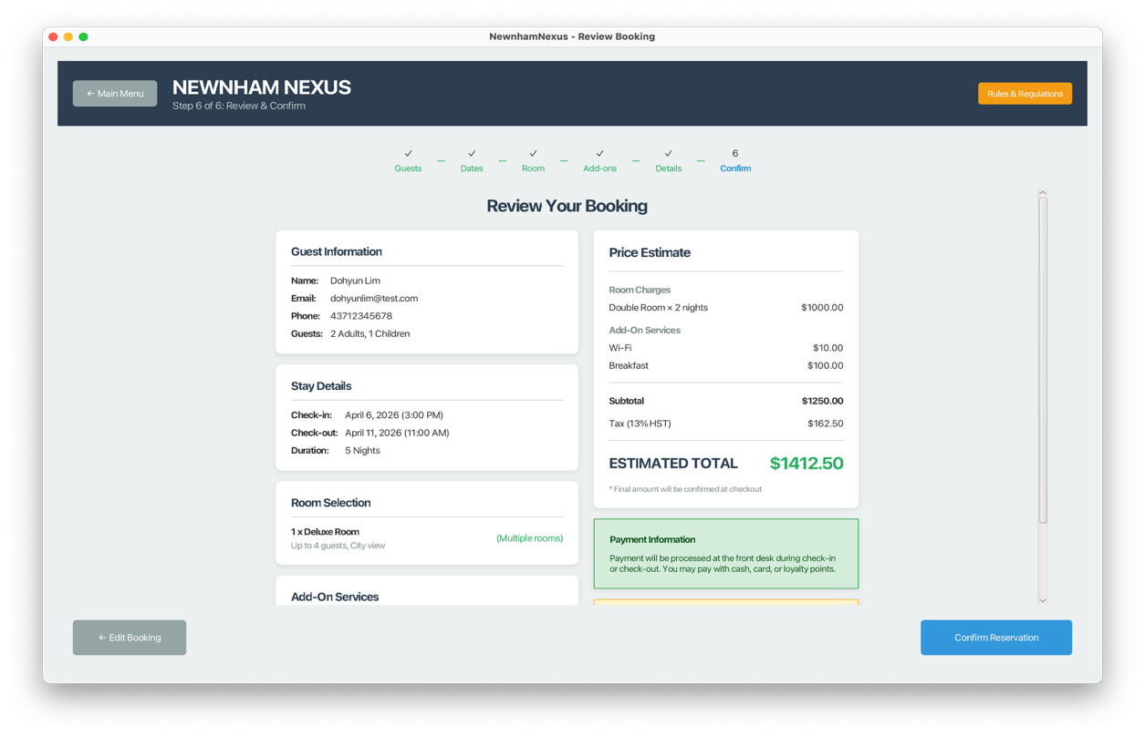

- Admin Dashboard - Navigation to all management screens
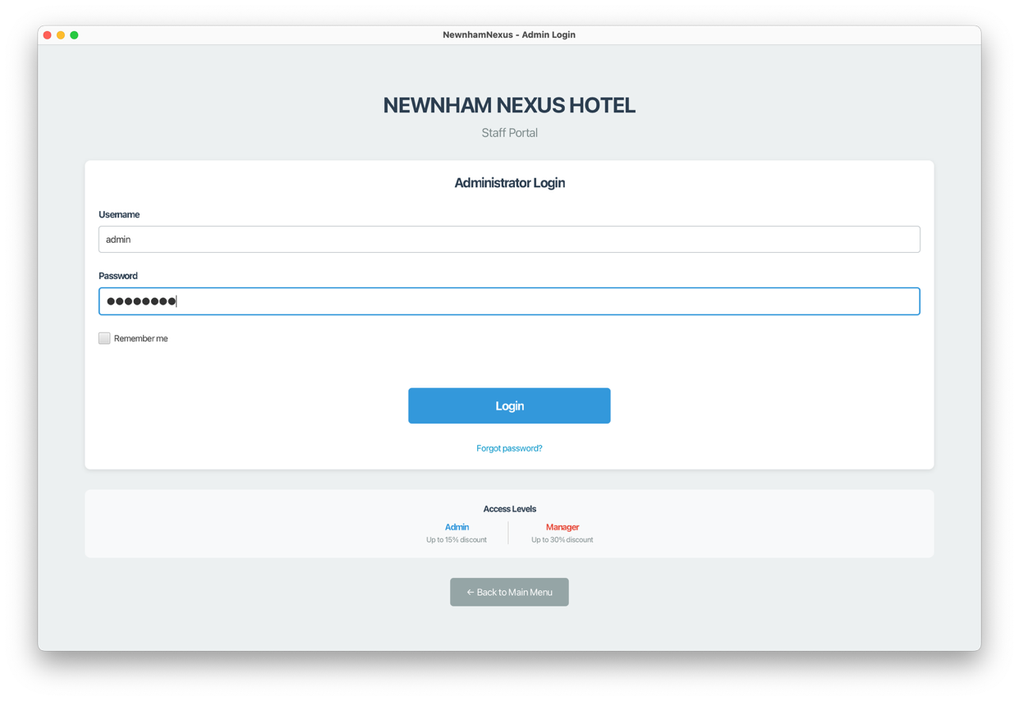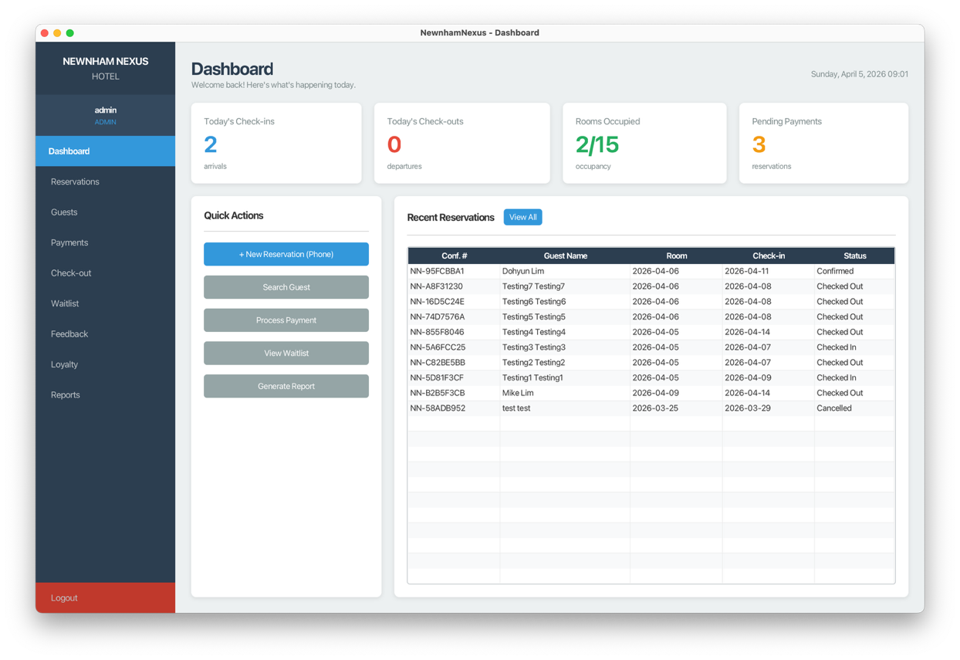

- Admin Screens - Reservations, Guests, Payments, Checkout, Waitlist, Feedback, Loyalty, Reports
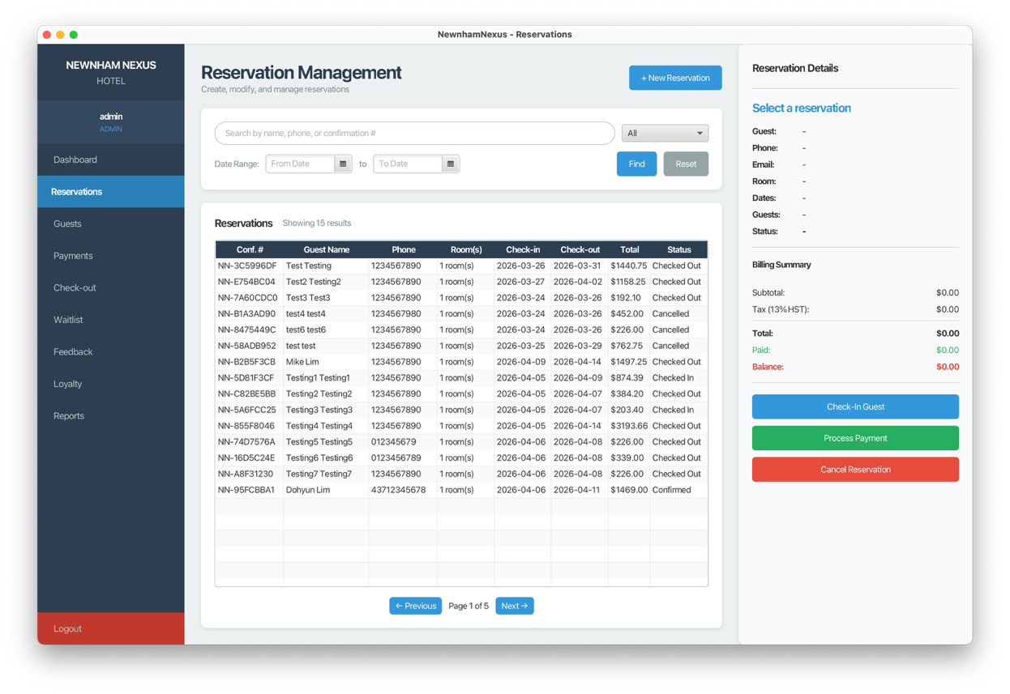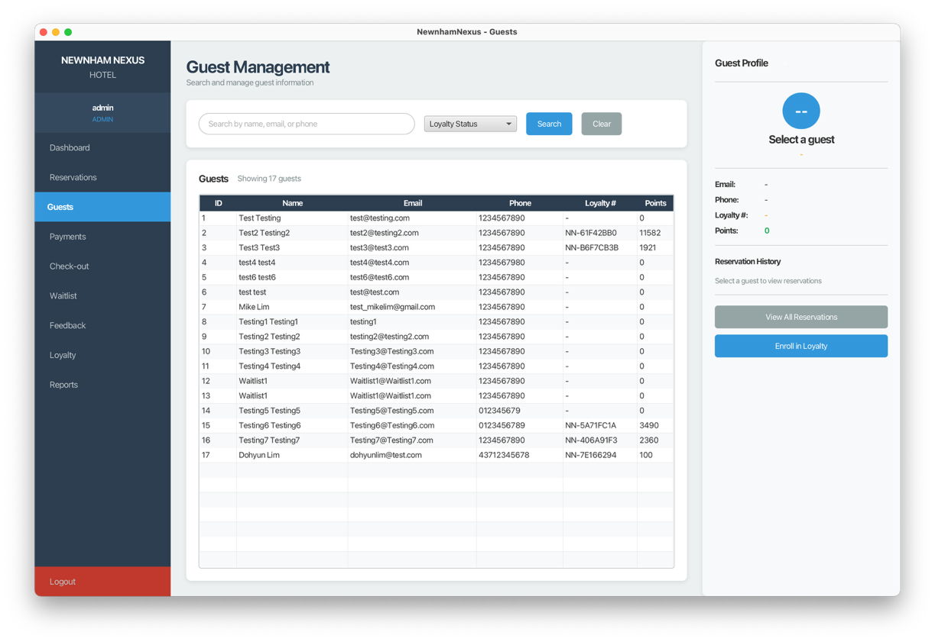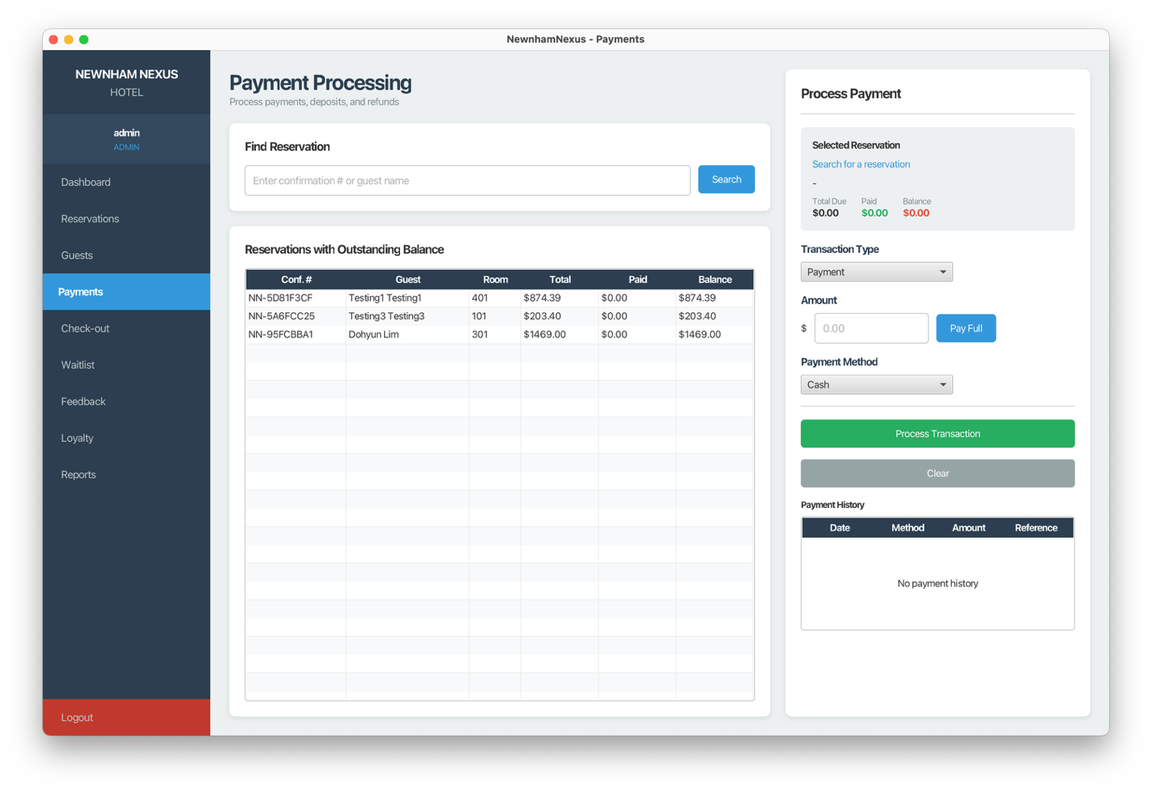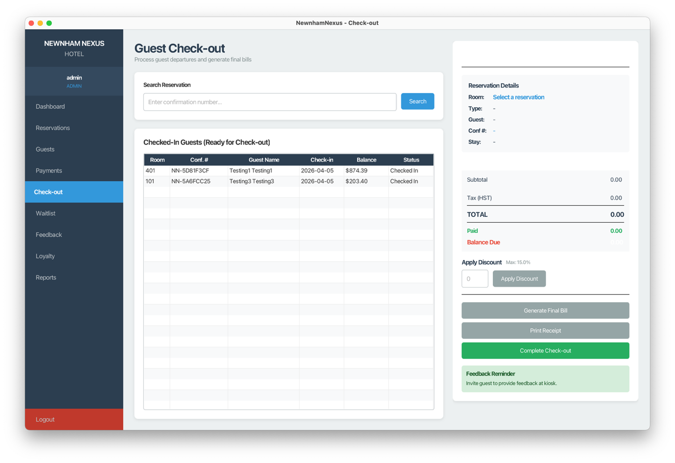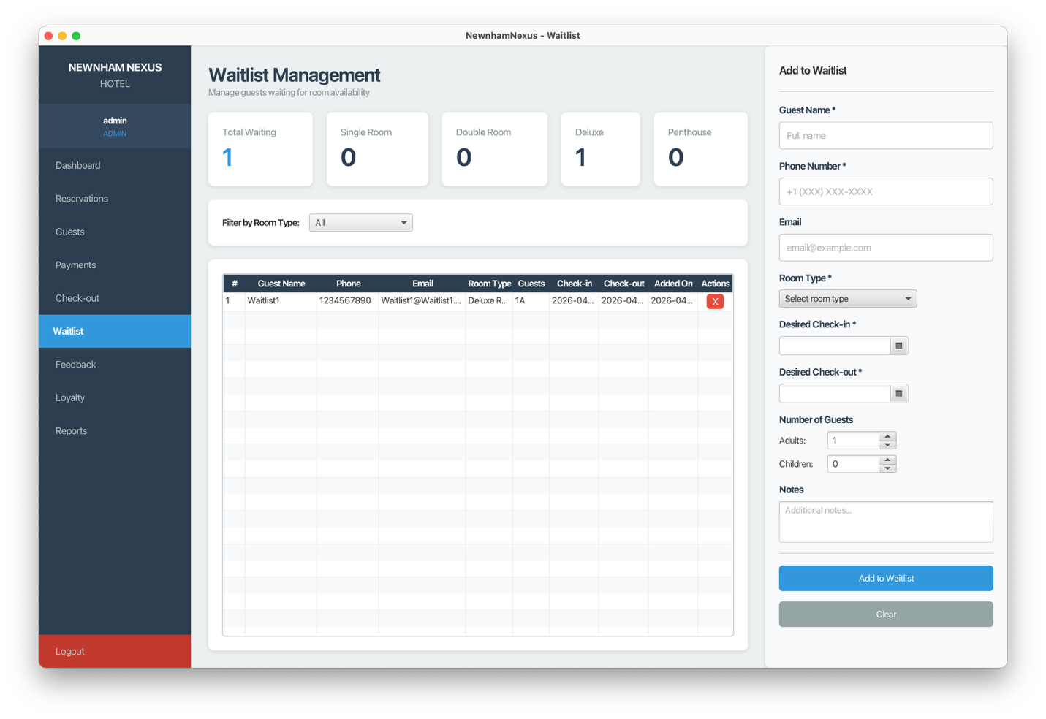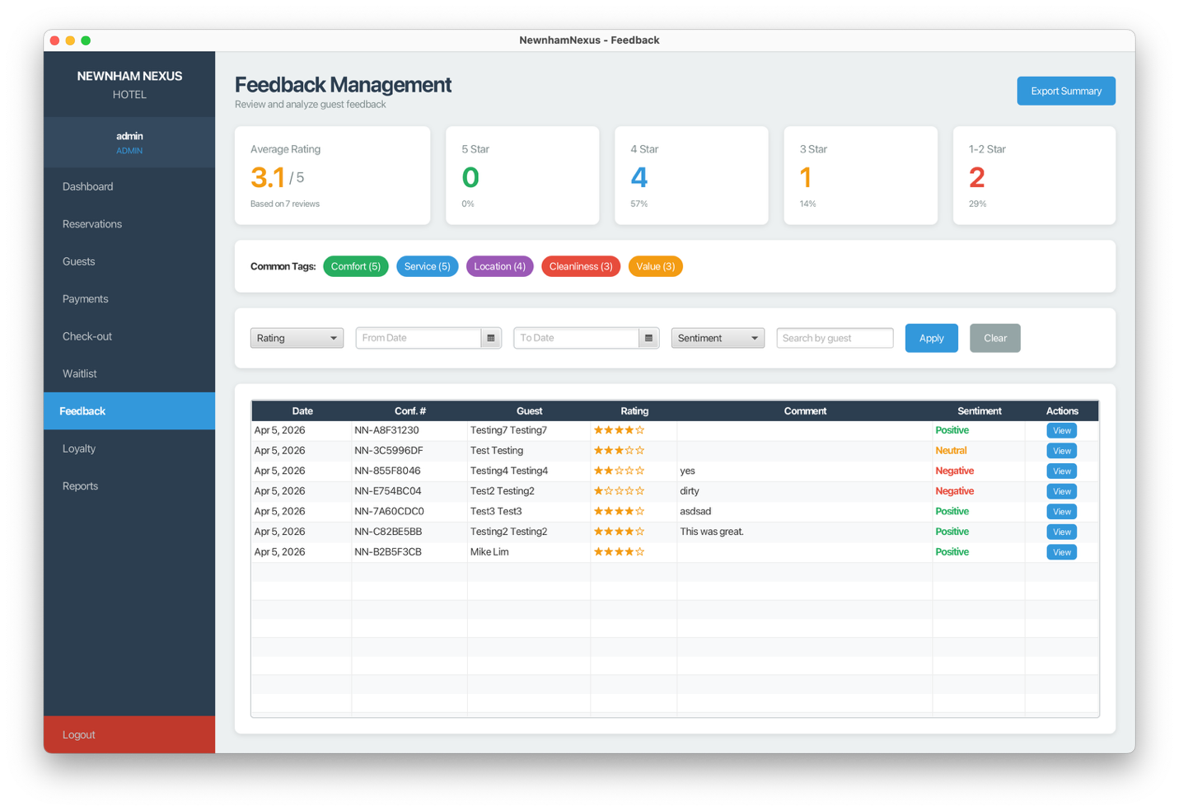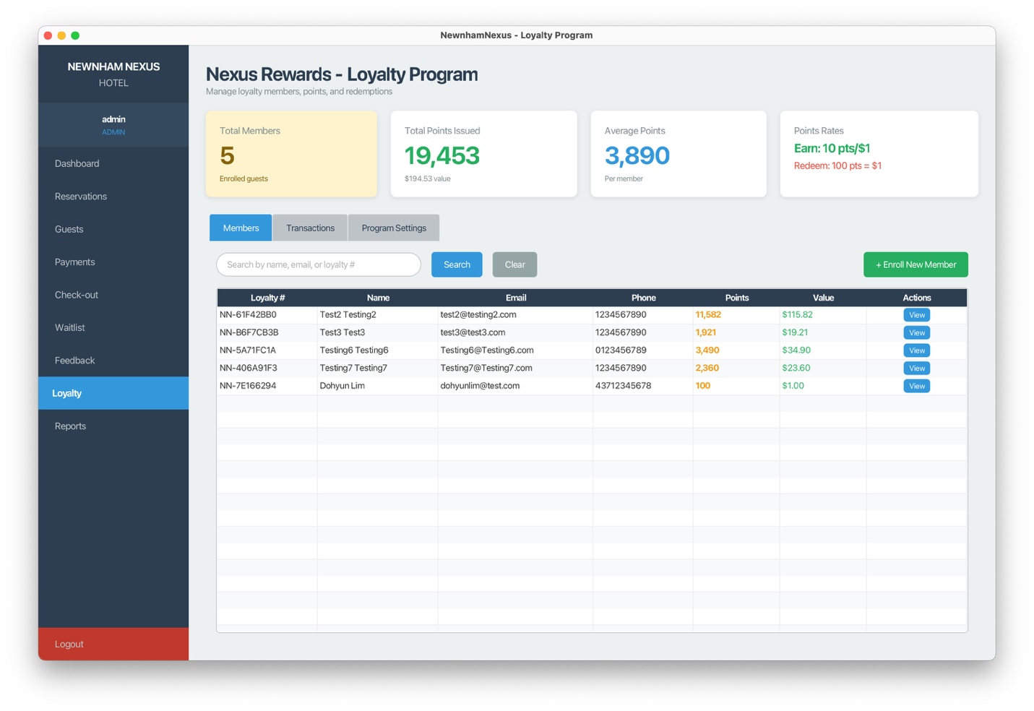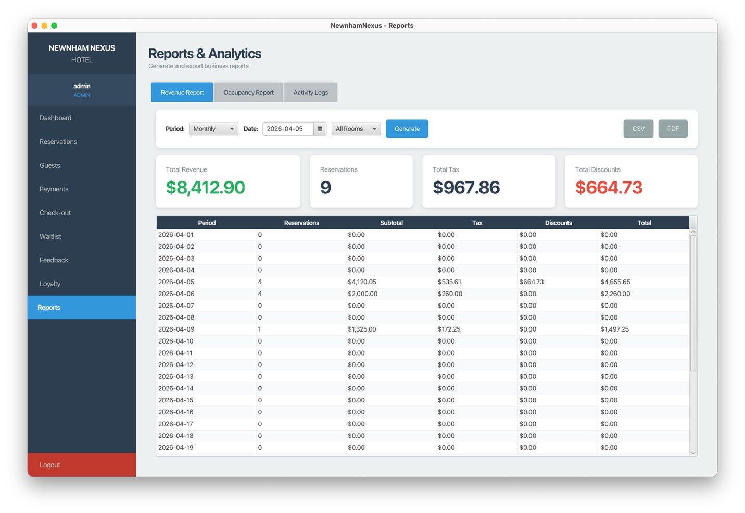
- Feedback Screens – Find Reservation, Details, Confirmation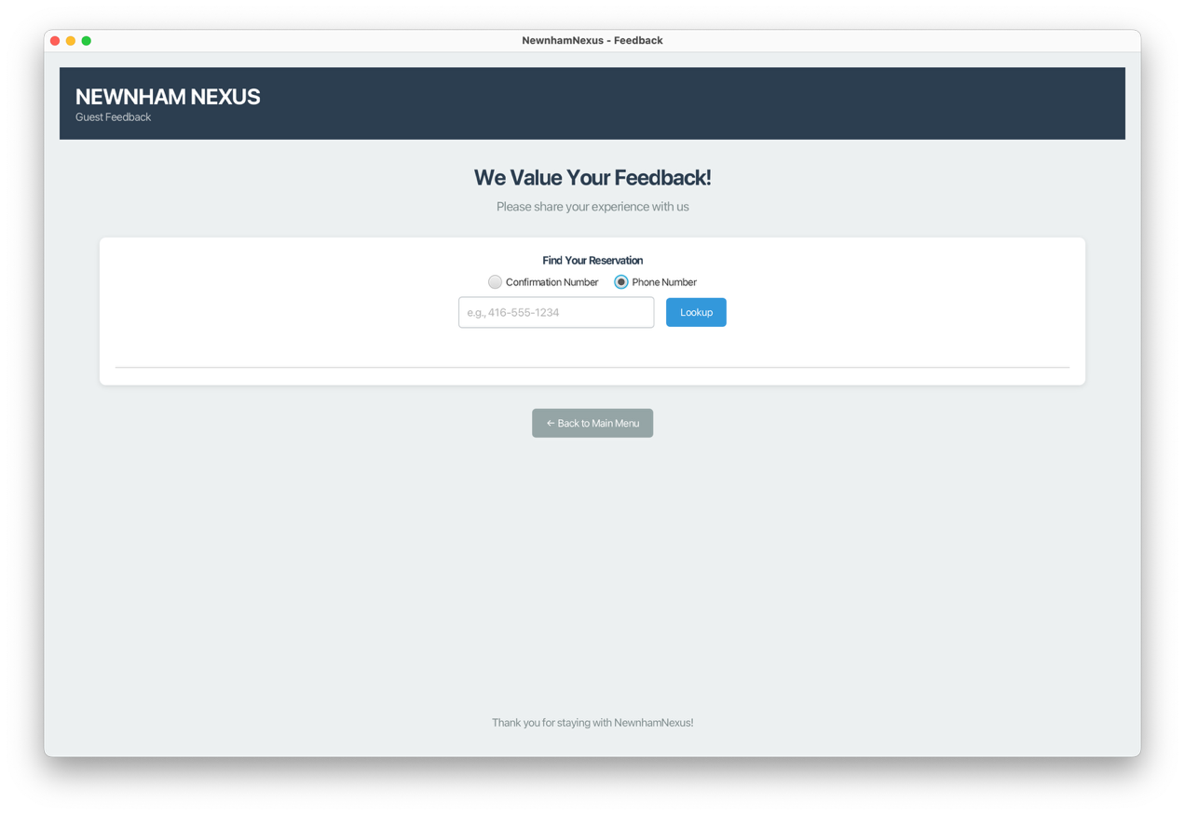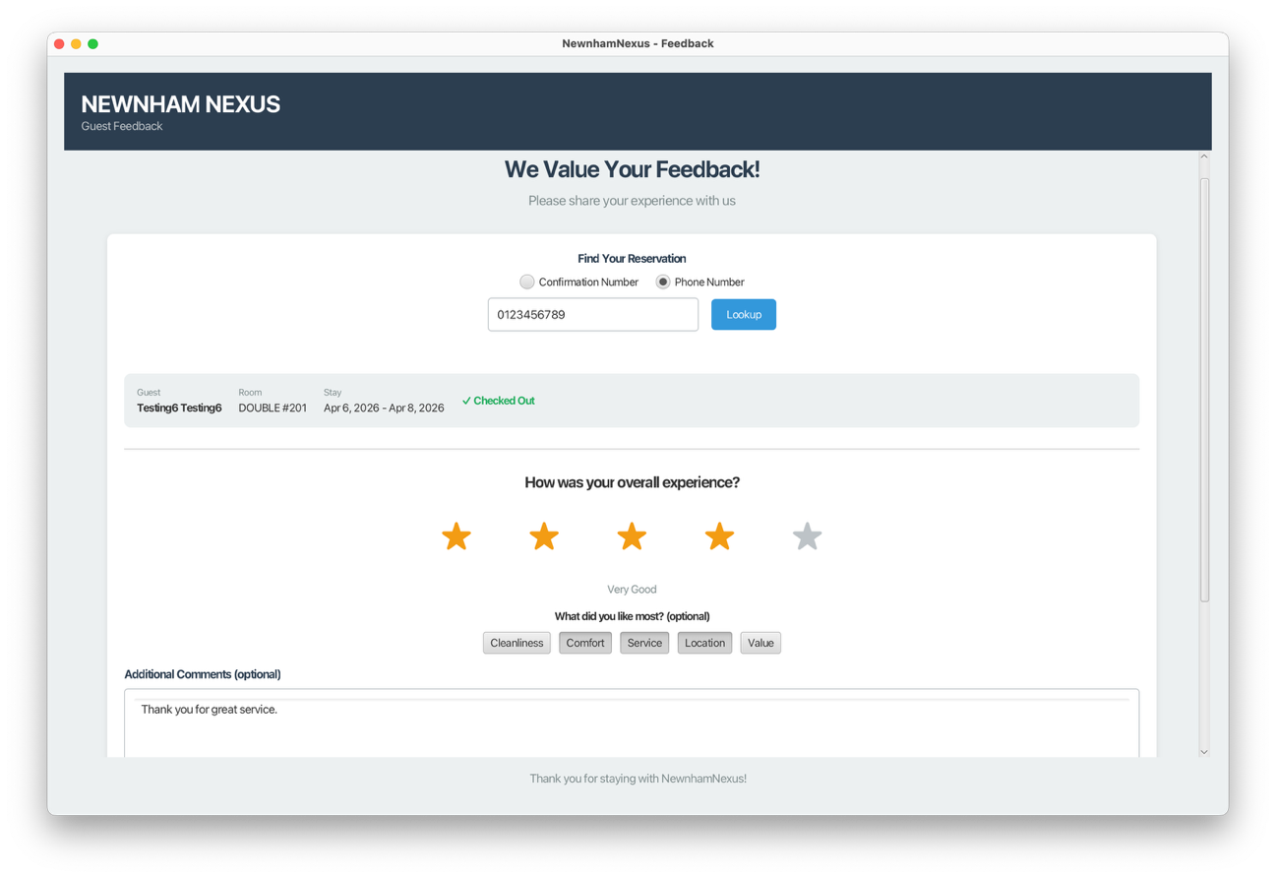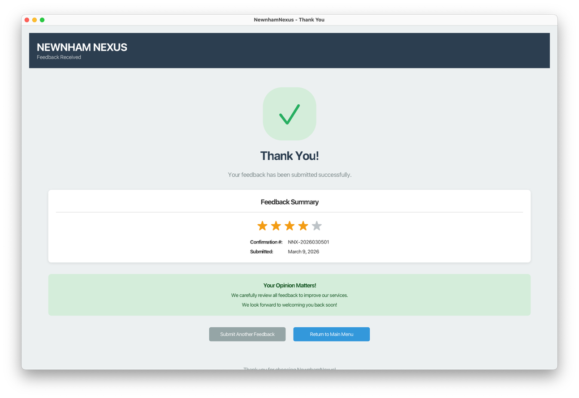

4. Entity and Relationship Mapping

4.1 Entities (9 Tables + 2 Join Tables)
Entity | Table Name | Primary Key | Description
Guest | guests | id | Hotel guests/customers
Room | rooms | id | Hotel rooms
Reservation | reservations | id | Booking records
Payment | payments | id | Payment transactions
Addon | addons | id | Add-on services
User | users | id | Admin/Manager accounts
Feedback | feedbacks | id | Guest reviews
Waitlist | waitlist | id | Waitlist entries
AuditLog | audit_logs | id | Activity logs
- | reservation_rooms | - | Join table (Reservation-Room)
- | reservation_addons | - | Join table (Reservation-Addon)

4.2 Relationships

One-to-Many (1:N)
Parent | Child | Description
Guest | Reservation | One guest can have many reservations
Guest | Feedback | One guest can leave many feedbacks
Guest | Waitlist | One guest can have many waitlist entries
Reservation | Payment | One reservation can have many payments

Many-to-Many (M:N)
Entity 1 | Entity 2 | Join Table | Description
Reservation | Room | reservation_rooms | Reservation can have multiple rooms
Reservation | Addon | reservation_addons | Reservation can have multiple add-ons

4.3 Key JPA Annotations Used
// Entity and Table
@Entity
@Table(name = "guests")
public class Guest {
// Primary Key with Auto-Increment
@Id
@GeneratedValue(strategy = GenerationType.IDENTITY)
private Long id;
// Required Field
@Column(nullable = false)
private String firstName;
// Unique Constraint
@Column(unique = true)
private String loyaltyNumber;
// Enum Stored as String
@Enumerated(EnumType.STRING)
private RoomType type;
}
// Many-to-One Relationship
@Entity
public class Reservation {
@ManyToOne(fetch = FetchType.EAGER)
@JoinColumn(name = "guest_id")
private Guest guest;
}
// Many-to-Many with Join Table
@Entity
public class Reservation {
@ManyToMany(fetch = FetchType.EAGER)
@JoinTable(
name = "reservation_rooms",
joinColumns = @JoinColumn(name = "reservation_id"),
inverseJoinColumns = @JoinColumn(name = "room_id")
)
private List<Room> rooms;
}

4.4 Cascade and Fetch Strategy Notes
Relationship | Fetch Type | Cascade | Reason
Reservation → Guest | EAGER | None | Always need guest info with reservation
Reservation → Rooms | EAGER | None | Always need room info with reservation
Reservation → Addons | EAGER | None | Always need addon info with reservation
Reservation → Payments | LAZY | PERSIST | Load payments only when needed
Guest → Waitlist | EAGER | None | Quick access for notifications

5. Pattern Usage

5.1 Singleton Pattern
Purpose: Ensure single instance management for shared resources.
Implementations:
- EntityManagerFactoryProvider - Single database connection factory
public class EntityManagerFactoryProvider {
private static EntityManagerFactory emf;
public static synchronized EntityManagerFactory getEntityManagerFactory() {
if (emf == null) {
emf = Persistence.createEntityManagerFactory("HotelPU");
}
return emf;
}
}
- LoyaltyService - Single instance for loyalty point management
- AuditService - Single instance for activity logging
- BookingSession - Single instance for kiosk booking state

5.2 Factory Pattern
Purpose: Create room instances without exposing creation logic.
Implementation: RoomFactory and RoomPlanFactory
public class RoomFactory {
public static Room createRoom(String roomNumber, RoomType type, int floor) {
Room room = new Room();
room.setRoomNumber(roomNumber);
room.setType(type);
room.setFloor(floor);
room.setStatus(RoomStatus.AVAILABLE);
room.setBasePrice(getBasePriceForType(type));
room.setMaxOccupancy(getMaxOccupancyForType(type));
return room;
}
private static double getBasePriceForType(RoomType type) {
return switch (type) {
case SINGLE -> 100.0;
case DOUBLE -> 150.0;
case DELUXE -> 200.0;
case PENTHOUSE -> 350.0;
};
}
}
Usage: In DatabaseInitializer to create all initial room instances.

5.3 Strategy Pattern
Purpose: Dynamic pricing calculation based on day type.
Implementation:
// Strategy Interface
public interface PricingStrategy {
double calculatePrice(double basePrice);
String getStrategyName();
}
// Standard Pricing (Weekdays)
public class StandardPricingStrategy implements PricingStrategy {
@Override
public double calculatePrice(double basePrice) {
return basePrice * 1.0; // No markup
}
}
// Weekend Pricing (Friday/Saturday)
public class WeekendPricingStrategy implements PricingStrategy {
@Override
public double calculatePrice(double basePrice) {
return basePrice * 1.25; // 25% markup
}
}
// Context: PricingService
public class PricingService {
public PricingStrategy getStrategyForDate(LocalDate date) {
DayOfWeek day = date.getDayOfWeek();
if (day == DayOfWeek.FRIDAY || day == DayOfWeek.SATURDAY) {
return new WeekendPricingStrategy();
}
return new StandardPricingStrategy();
}
}

5.4 Observer Pattern
Purpose: Notify admins when rooms become available after checkout.
Implementation:
// Event Data
public class RoomAvailabilityEvent {
private final Room room;
private final LocalDate availableFrom;
private final LocalDate availableTo;
// getters...
}
// Observer Interface
public interface RoomAvailabilityObserver {
void onRoomAvailable(RoomAvailabilityEvent event);
}
// Notifier (Subject)
public class RoomAvailabilityNotifier {
private final List<RoomAvailabilityObserver> observers = new ArrayList<>();
public void subscribe(RoomAvailabilityObserver observer) {
observers.add(observer);
}
public void notifyRoomAvailable(RoomAvailabilityEvent event) {
for (RoomAvailabilityObserver observer : observers) {
observer.onRoomAvailable(event);
}
}
}
Usage: When checkout completes in AdminController, it publishes a RoomAvailabilityEvent. The waitlist observer checks for matching entries and notifies guests.

5.5 Decorator Pattern
Purpose: Dynamically add services to booking pricing.
Implementation:
// Base Interface
public interface BookingComponent {
double getPrice();
String getDescription();
}
// Concrete Component
public class BaseBooking implements BookingComponent {
private final double basePrice;
public double getPrice() { return basePrice; }
}
// Abstract Decorator
public abstract class BookingDecorator implements BookingComponent {
protected BookingComponent wrapped;
public BookingDecorator(BookingComponent wrapped) {
this.wrapped = wrapped;
}
}
// Concrete Decorator
public class ServiceDecorator extends BookingDecorator {
private final Addon addon;
private final int nights;
@Override
public double getPrice() {
double addonPrice = addon.getPricingModel() == PricingModel.PER_NIGHT
? addon.getPrice() * nights
: addon.getPrice();
return wrapped.getPrice() + addonPrice;
}
}
Usage: In PricingService.calculateTotalWithAddons() to build up the final price with all selected add-ons.

6. Business Rules

6.1 Room Occupancy Rules
Room Type | Max Occupancy | Notes
Single | 2 guests | Adults + Children combined
Double | 4 guests | Adults + Children combined
Deluxe | 4 guests | Adults + Children combined
Penthouse | 6 guests | Adults + Children combined

6.2 Pricing Rules
Rule | Description
Base Pricing | Single: $100, Double: $150, Deluxe: $200, Penthouse: $350
Weekend Multiplier | Friday/Saturday nights: 1.25x base price
Tax Rate | 13% HST applied to subtotal
Add-on Pricing | PER_NIGHT or PER_RESERVATION based on addon type

6.3 Discount Rules
Role | Maximum Discount | Notes
ADMIN | 15% | Applied at checkout
MANAGER | 30% | Applied at checkout

6.4 Loyalty Program Rules (Nexus Rewards)
Rule | Value
Points Earned | 10 points per $1 spent
Points Redemption | 100 points = $1 discount
Welcome Bonus | 100 points on enrollment
Minimum Redemption | 100 points

6.5 Feedback Rules
Rule | Description
Rating Range | 1-5 stars
One Per Reservation | Only one feedback per reservation allowed
Requires Confirmation # | Guest must provide valid confirmation number
Sentiment Tags | Excellent, Good, Average, Poor, Terrible (auto-assigned)

6.6 Reservation Status Flow
PENDING → CONFIRMED → CHECKED_IN → CHECKED_OUT
↓ ↓
CANCELLED NO_SHOW

7. Security and Logging

7.1 Authentication
Password Hashing: BCrypt with default work factor
// Hashing (during user creation)
String hash = BCrypt.hashpw(plainPassword, BCrypt.gensalt());
// Verification (during login)
boolean valid = BCrypt.checkpw(plainPassword, storedHash);

7.2 Role-Based Access Control
Feature | ADMIN | MANAGER
View Reservations | ✓ | ✓
Create Reservations | ✓ | ✓
Process Payments | ✓ | ✓
Apply Discount (15%) | ✓ | ✓
Apply Discount (30%) | ✗ | ✓
View Reports | ✓ | ✓
Export Reports | ✓ | ✓

7.3 Logging Configuration
File Logging: - Location: ./logs/hotel.log - Rotation: 1MB per file, 10 files maximum - Format: [TIMESTAMP] [LEVEL] [CLASS] - MESSAGE
Database Logging (AuditLog): - Actor: Username who performed action - Action: CREATE, UPDATE, DELETE, LOGIN, LOGOUT, PAYMENT - Entity Type: What was affected - Message: Human-readable description

7.4 Exception Handling
All exceptions are caught and displayed to users via JavaFX Alert dialogs:
try {
// Operation
} catch (Exception e) {
Alert alert = new Alert(Alert.AlertType.ERROR);
alert.setTitle("Error");
alert.setHeaderText("Operation Failed");
alert.setContentText(e.getMessage());
alert.showAndWait();
// Log the error
logger.error("Operation failed: " + e.getMessage(), e);
}

8. Export and Reporting

8.1 Report Types
Report | Description | Filters
Revenue Report | Total revenue by period | Date range (day/week/month)
Occupancy Report | Room utilization statistics | Date range, room type
Feedback Summary | Rating averages and comments | Date range, rating, sentiment
Activity Logs | System activity audit trail | Date range, actor, action

8.2 Export Formats
Format | Implementation | Use Case
CSV | Built-in Java file writing | Data analysis in Excel
PDF | Apache PDFBox library | Printable reports
TXT | Built-in Java file writing | Activity logs

8.3 Sample Report Structure
Revenue Report (CSV):
Period,Room Revenue,Addon Revenue,Total Revenue,Reservations
2026-03-01,1500.00,250.00,1750.00,5
2026-03-02,2100.00,180.00,2280.00,7
Occupancy Report (PDF):
NEWNHAM NEXUS - Occupancy Report
Period: March 1-31, 2026
Room Type | Available | Occupied | Occupancy Rate
-------------|-----------|----------|---------------
Single | 155 | 120 | 77.4%
Double | 155 | 145 | 93.5%
Deluxe | 93 | 85 | 91.4%
Penthouse | 62 | 58 | 93.5%

8.4 PDF Export Implementation
public class PdfExportUtil {
public static void exportDocument(String title, List<String> content, String filePath)
throws IOException {
try (PDDocument document = new PDDocument()) {
PDPage page = new PDPage();
document.addPage(page);
try (PDPageContentStream stream = new PDPageContentStream(document, page)) {
stream.setFont(PDType1Font.HELVETICA_BOLD, 18);
stream.beginText();
stream.newLineAtOffset(50, 750);
stream.showText(title);
stream.endText();
// Write content lines...
}
document.save(filePath);
}
}
}

9. Challenges and Learnings

9.1 Team Challenges

Challenge 1: Code Merging and Version Control
Problem: Multiple team members working on different features simultaneously resulted in numerous merge conflicts (20+ conflicting files at one point).
Solution: Established a “primary version” approach where one member’s UI/UX was the base, and architectural components were carefully merged. Improved communication about file ownership and used feature branches consistently.

Challenge 2: Integrating JavaFX Frontend with Hibernate/JPA Backend
Problem: Entity objects weren’t persisting correctly, lazy loading caused exceptions, and EntityManager lifecycle management was challenging.
Solution: Created service classes as intermediaries between controllers and repositories. Switched to EAGER fetch for critical relationships and ensured repository.update() was called when modifying entities.

Challenge 3: Implementing Design Patterns Correctly
Problem: Initially had pattern classes implemented but they weren’t actually being used in the code.
Solution: Went through each pattern systematically: - Factory: Used in DatabaseInitializer - Strategy: Wired into PricingService - Observer: Connected to checkout flow - Decorator: Integrated into addon pricing

Challenge 4: UI/UX Consistency
Problem: Different screens had inconsistent styling, sidebar layouts, and color schemes.
Solution: Created shared styles.css and established conventions for common components. Did a final pass to ensure all admin screens had consistent navigation and styling.

Challenge 5: Database Schema Evolution
Problem: Adding new fields to entities caused issues with existing H2 database data.
Solution: Used Hibernate’s “update” schema generation and handled null values carefully with wrapper types and null-safe getters.

9.2 Individual Reflections
See: reflect.txt for detailed individual reflections from each team member.
Summary of Key Learnings:
- Design Patterns - Implementing patterns isn’t just about creating classes; they must be meaningfully integrated into the codebase.
- JPA/Hibernate - Understanding entity lifecycle (transient, managed, detached) is crucial for proper persistence.
- Git Workflow - Merge conflicts can be minimized with good communication and branch management.
- Separation of Concerns - Service classes make code more testable and maintainable.
- Security - BCrypt for password hashing, proper salting, and work factors are essential.
- Database Design - Early decisions have long-lasting effects; changing relationships later requires updating multiple files.
- Team Collaboration - Writing clean, readable code with comments and naming conventions helps when others need to work with the code.

9.3 Suggestions for Future Improvements
- Multi-tenant Support - Allow multiple hotel properties
- Email Notifications - Send actual confirmation emails
- Mobile App - Develop companion mobile application
- Online Payments - Integrate Stripe/PayPal
- Room Images - Add photo gallery for rooms
- Multi-language - Support for multiple languages
- API Layer - RESTful API for third-party integrations

Appendices

A. File Structure
/Project
├── pom.xml
├── README.md
├── DATABASE_DESIGN.md
├── ProjectDocumentation.md
├── reflect.txt
├── UML-deployment-diagram.png
├── package-diagram.png
├── data/
│ └── hoteldb.mv.db
├── logs/
│ └── hotel.log
└── src/main/
├── java/com/hotel/
│ ├── app/
│ ├── controller/
│ ├── events/
│ ├── model/
│ ├── repository/
│ ├── service/
│ └── util/
└── resources/
├── META-INF/persistence.xml
├── css/styles.css
└── view/
├── Launcher.fxml
├── kiosk/
├── admin/
└── feedback/

B. How to Run
- Prerequisites: Java 17+, Maven 3.6+
- Build: mvn clean install
- Run: mvn javafx:run
- Default Accounts:
  - Admin: admin / admin123
  - Manager: manager / manager123

C. References
- JavaFX Documentation: https://openjfx.io/
- Hibernate ORM: https://hibernate.org/orm/
- H2 Database: https://h2database.com/
- Apache PDFBox: https://pdfbox.apache.org/
- BCrypt: https://github.com/jeremyh/jBCrypt

Group 18 - APD545 Winter 2026 Dohyun Lim, Phuong Bac Nguyen, Eunki Kim

