Coconut Surveillance is a system that combines phone based notifications from health facilities, a team of surveillance officers using tablets for household followups, and a management team that responds to the data.

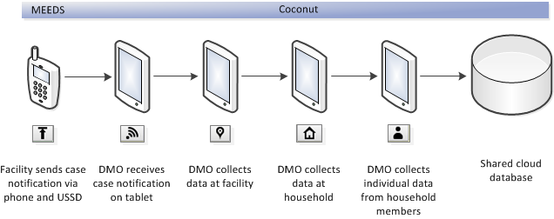

In Coconut Surveillance, there are four kinds of interactions that lead to data being captured. As the DMSO progresses through the different interactions, Coconut Surveillance, will create records corresponding to the data that needs to be collected. It will also copy over any existing and relevant information between the forms, to minimize typing and ensure consistency. The following sections describe the process in detail.

# Case Notification

The health facility sends a notification that a new malaria case has been detected via their mobile phone. When this notification is received, a SMS is sent to the DMSO for that health facility. This SMS tells the DMSO that they have a new case to followup. They must then get their tablet online (via mobile network or wifi) and press the "Get Data" button. This will download all new case data within that DMSO's district of responsibility and save it as a Case Notification record. The data is as follows:

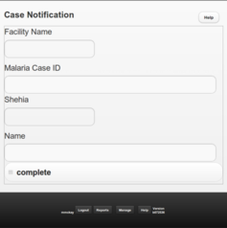

# Facility

The DMSO goes to the facility that reported the case. They will then look through the appropriate documents and registers to capture the required data.

If a DMSO finds a case that they should have received a notification for, but have not, then they should help the health facility to report the notification immediately. Since the DMSO may not have internet access, and therefore are unable to download the just created notification, they can write down the case details on paper, and then add it to their tablet once it gets online and downloads the data. This will save them from having to visit the facility again.

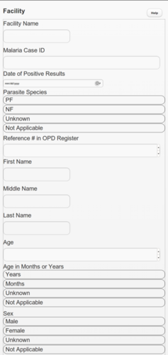 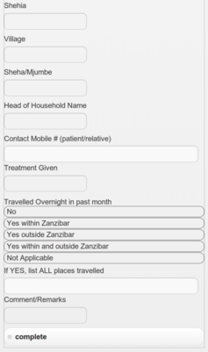

# Household

After data is collected from the reporting facility, the DMSO will use the information to find the household where the patient lives. This usually involves calling the patient or going to the house of the Sheha to find the correct household.

A household may be visited for one of the following reasons:

1. A health facility found that a resident of the household was positive (index case)
2. A nearby house has had a positive malaria result
3. The house is located in a mass screening zone

The household location is captured using GPS technology. For this to work, the DMSO does not need an internet connection, but they do need an unobstructed path to the sky. The location should be captured standing outside in a clear area (not inside a house, or standing under tree cover).

Mosquito nets (LLINs) or coupons for mosquito nets may be provided based on the answers to the questions (if they have more sleeping places and residents than they have nets).

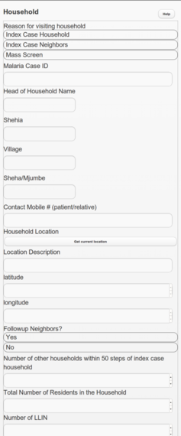 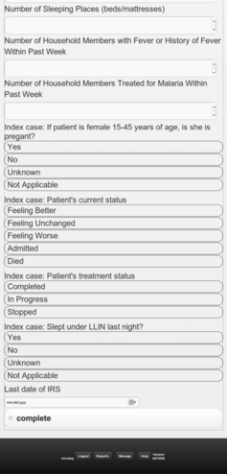

# Household Member

Based on the number of household members answered in the Household form, the same number of Household Member records will be created that need to be filled in.

Taking the temperature can be a sensitive procedure for some, so it may require that someone from the same gender assists.

If the patient is found to be positive then they should be treated. If the patient is positive and pregnant then they should be referred to a health facility. They should also be referred to a health facility if the patient has a very high fever or is visibly suffering (Need Issa to describe these rules in detail).

