Hi Hung,

I have finished all the tasks given, here is my list:

1. *Come up with a test plan to cover the application.*

*“AgeRangerTestPlan.docx” attached*

1. *Provide feedback on possible issues with the application.*

*Two issues found and one improvement filed:*

* *Issue one: Overlap appears when First Name or Last Name is longer than 80 characters and no space within the name.*

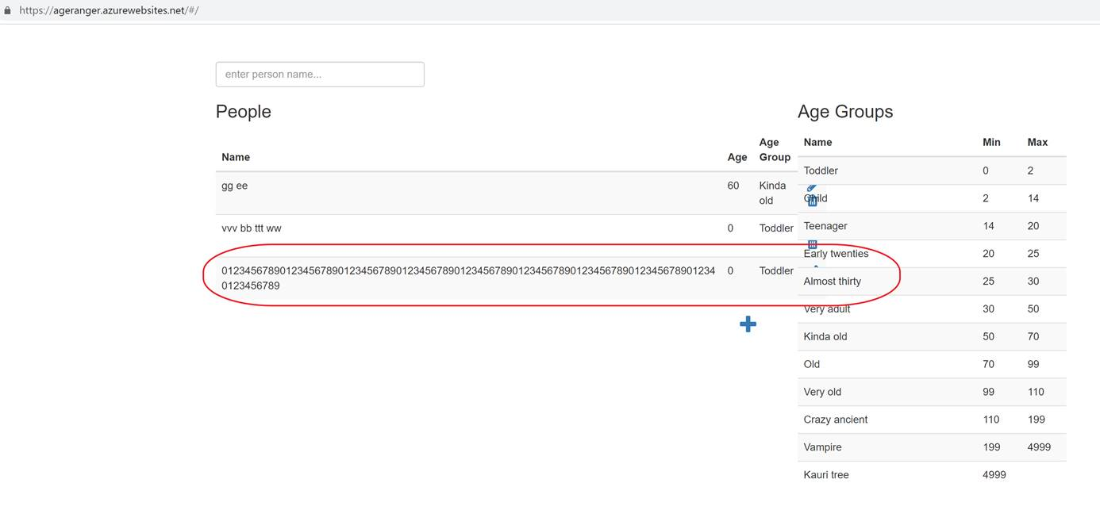

* *Issue two: Can’t get the warning message when age is a float number*

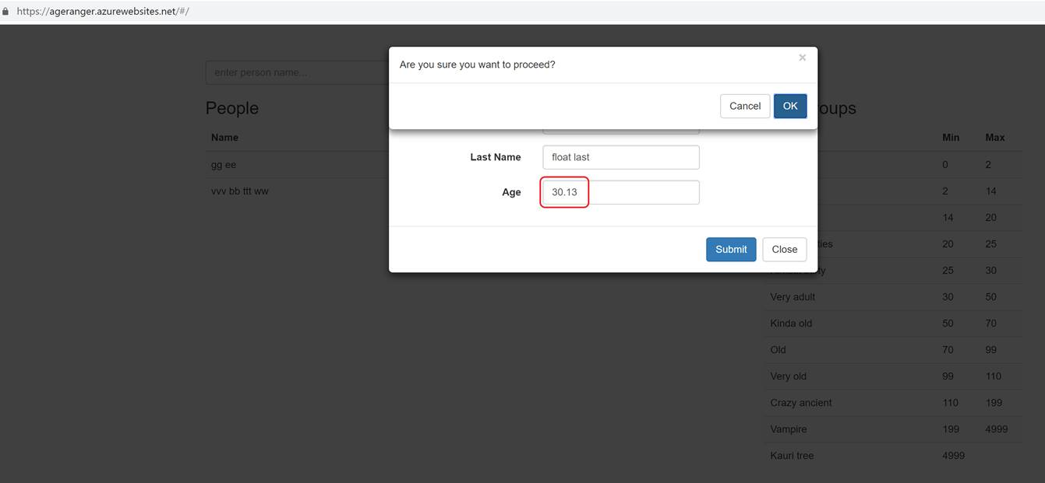

* *Improvement: When people list is larger than 22, user needs to drag scroll bar to click the add person button, a better solution is to split the people list into pages, every page contains items less than 22.*

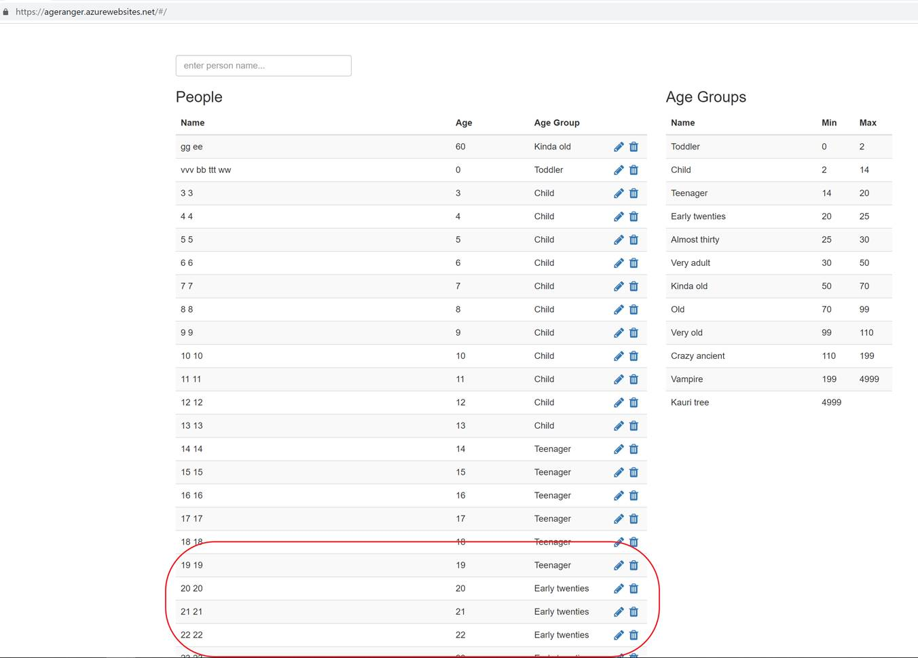

For automation framework, I have attached my updated version.

1. *Find and fix if there are any issues with the current automated solution.*
   1. *Utilities/Hooks.cs:* 
      1. *Delete Driver initiation within BeforeScenario() function, which will create excess driver.*
      2. *Add Quit() into AfterScenario() function and Dispose() into AfterTestRun to close browser in the end of test running.*
   2. *Utilities/CommonConstants.cs:* 
      1. *Change BaseUrl from* [*http://agerange.azurewebsits.nett*](http://agerange.azurewebsits.nett) *to* [*http://agerange.azurewebsites*](http://agerange.azurewebsites)
      2. *Change DefaultWaitTime from 3000 to 30*
      3. *Change FirefoxBrowser to “Firefox”*
      4. *Change ChromeBrowser to “Chrome”.*
   3. *Steps/BaseClass.cs:* 
      1. *Add ElementIsPresent() function to wait for the present of element, reduce waiting time.*
   4. *Steps/AgeRangerUITestSteps.cs:* 
      1. *Change Sleep(2000) to Sleep(5) or ElementIsPesent() function to reduce waiting time and make sure element is present.*
      2. *Add Clear() operation within EnterNewPersonDetail() function to avoid Inconsistency when editing person.*
      3. *Parameter sequence of DeletePerson() is wrong, switch “lastName” and “age”.*
      4. *Add DeleteUpdatedPerson() function, else DeletePerson() will probably delete the wrong item.*
      5. *Add SubmitForm() within CreateNewPerson() function, else no item will be added.*
      6. *Replace By.TagName(“td”) to By.TagName(“tr”) and locate table item from tagname to xpath.*
      7. *Missing one “,” before function UserExistVerification().*
      8. *Replace hardcode “20”&”Very Old” with “oldAge”&”ageGroup.ToString()” within function UserExistVerification().*
      9. *Correct Assert statements*
   5. *PageFactoryObjects/AgeRangerMainPage.cs:*
      1. *Correct locators(typo and wrong Ids or Names)*
   6. *Features/AgeRangerUITests.feature:*
      1. *Add 5 test cases*
      2. *Modify “And I delete created person <FirstName>, <LastName> and <Age>” to “And I delete updated person <FirstName>, <LastName>, <Age>, <NewFirstName>, <NewLastName> and <NewAge>”*
      3. *Modify “Then I should not see <FirstName>, <LastName> and <Age> anymore” to “Then I should not see <FirstName>, <LastName> and <Age> record anymore”*
2. *Check the scenarios to see if they are all relevant and provided some feedback.*
   1. *Delete Person scenario is similar with Add New Person scenario.*
3. *Create new scenarios as you see fit.*
   1. *Add five input test cases using high-ascii and non-ascii names.*
4. *Come up with any possible enhancement to the current solution.*
   1. *Run test cases via nunit3-console and convert test result to html format.*
   2. *Get mailsend source from* <https://github.com/muquit/mailsend/> *then* *compile source file to get mailsend.exe*
   3. *Create batch file(AgeRanger.bat) to send html test report via mailsend.exe(mailreceiver.list as the receiver list)*

BTW: I will send a test report to you a few minutes later via the updated automation framework, the report will be like AgeRangerReport-2018-12-28_******

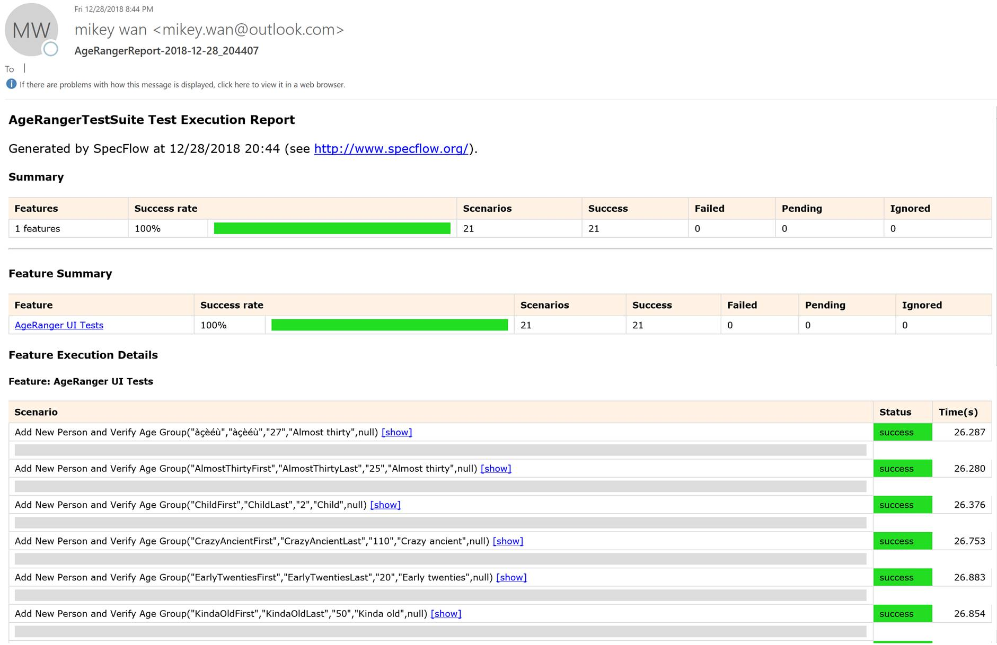

Thanks,

Mikey