Use case diagram, Sequence diagram, and class diagram

DP EX01

Exercise No...........: 1

First Student Details.: 321031940 - Michael Goldenberg

Second Student Details: 206125262 - Adam Kovrigaro

USE CASE

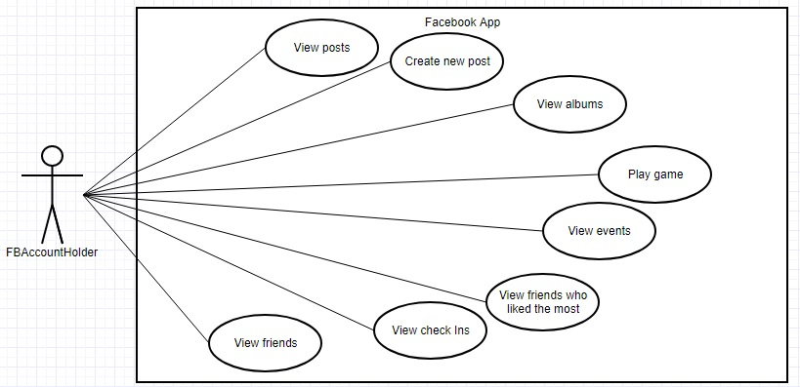

Sequence diagram (1)

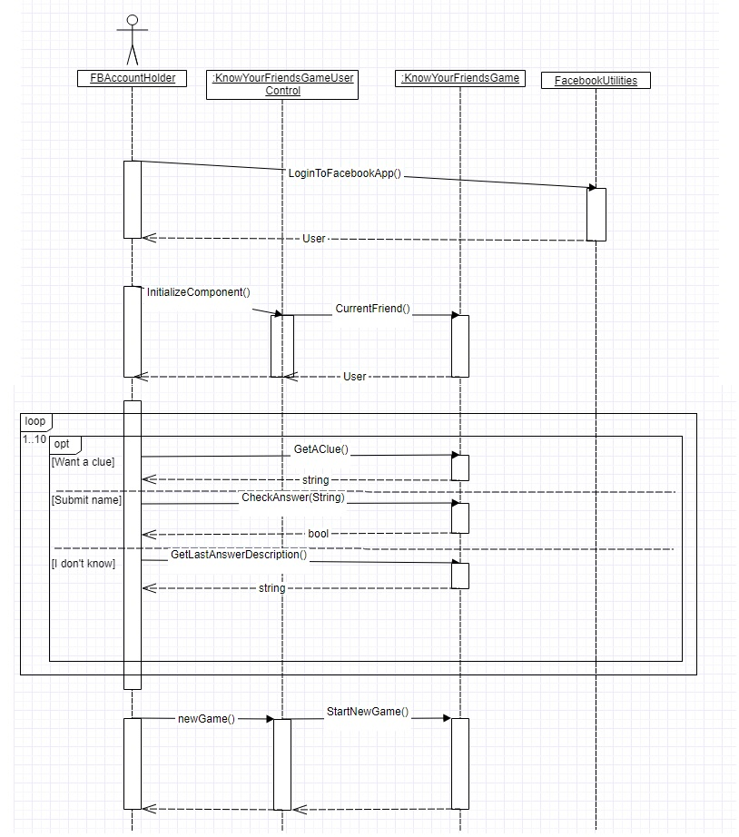

Sequence diagram (2)

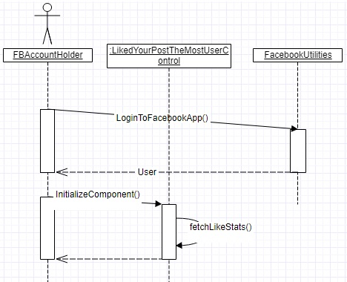

**Class Diagram**

