Core Platform & Admin
Phase II: Analysis, Design, Test Plan and Initial Prototype

Team Members
Mykhailo Naumenko
Yaroslav Kalinichenko
Vladyslav Konrad

SDT-213 Fall 2026

1. Project Overview

1.1 Project Purpose
Core Platform & Admin is the shared foundation of a modular university management platform. The platform, requested by the customer, combines a modern learning management system (LMS) with the core campus systems: student registration and records (SIS), academic scheduling, and admissions. Each of these modules is developed by a separate team, and all of them depend on the Core Platform.
Our module provides the services that every other module uses: one sign-in and role-based access for all users, a user directory with profiles, a notification and messaging service, system configuration, cross-module dashboards and reports, audit logs, and the API gateway that connects the modules. It also includes the Admin Console, a web application where university administrators manage users, roles and settings and monitor the whole platform. In addition, our team defines the shared data models, API contracts and architecture guidelines that the other teams follow.

1.2 Target Users
The Core Platform is used by everyone who works with the university platform, because every module relies on it for sign-in, user data and notifications. Following the customer's requirements, the platform supports five user roles:
- Student - enrolled students who sign in once to reach their courses, registration and timetable, manage their profile and receive notifications.
- Faculty - instructors who reach their courses and schedules, find students and colleagues in the directory and send messages to their classes.
- Staff - university employees (for example, the registrar office, the admissions office or the IT help desk) who work in the modules of their office and may get limited access to the Admin Console.
- Applicant - prospective students who create their own account to apply through the Admissions module and receive updates about their application.
- Administrator - platform administrators who manage users, roles, settings, notifications and monitoring through the Admin Console.
Inside the Admin Console, access is divided into three levels: Administrator (full access), Operator (day-to-day account support, usually given to IT help desk staff) and Viewer (read-only access to dashboards and reports, for example for university management). Students, faculty members and applicants have no access to the Admin Console.

1.3 Main Features
- Unified sign-in and sign-out for all university users (single sign-on with JWT)
- Password reset and applicant self-registration
- Role-based access for students, faculty, staff, applicants and administrators
- Operational dashboard
- User directory with search and filtering
- User creation, editing and account activation/deactivation
- User profiles with self-service editing
- Roles and permissions management
- Notification service (in-app and email) and direct messaging
- Announcements to all users or selected groups
- Cross-module dashboards and reports
- System configuration
- System service monitoring
- Administrative activity log
- CSV export of activity records and reports
- API gateway and shared REST APIs for the other modules

1.4 Functional Requirements
ID | Requirement
FR1 | Allow all users (students, faculty, staff, applicants and administrators) to sign in and sign out through one shared sign-in page.
FR2 | Give access to all connected modules (LMS Core, SIS, Academic Scheduling, Admissions) after one sign-in (single sign-on with JWT tokens).
FR3 | Allow users to reset a forgotten password through a link sent by email.
FR4 | Allow signed-in users to change their own password.
FR5 | Lock an account for 15 minutes after five failed sign-in attempts in a row.
FR6 | Allow applicants to create their own account and confirm it through an email link.
FR7 | Show each user only the modules, pages and actions allowed by their role.
FR8 | Display an administrative dashboard with user statistics, recent activity and platform health.
FR9 | Display a list of platform users.
FR10 | Search users by name or email and filter them by role, status and department.
FR11 | Create new users and send them an invitation email to set a password.
FR12 | Display and edit user details.
FR13 | Activate and deactivate user accounts.
FR14 | Allow administrators and operators to send a password reset link to a user.
FR15 | Create student accounts automatically when SIS creates a new student record.
FR16 | Change an applicant's role to Student automatically when the applicant is enrolled.
FR17 | Allow every user to view their profile and edit their own contact details, preferred name and photo.
FR18 | Allow faculty and staff to search permitted directory contacts; allow students to find faculty and staff only. Show basic contact details (name, department and university email) according to the user's role.
FR19 | Display roles and permissions.
FR20 | Assign and change the role of a user.
FR21 | Edit the permissions included in each role.
FR22 | Provide a notification service that other modules use to send in-app and email notifications to users.
FR23 | Display a notification center with the number of unread notifications and allow users to mark them as read.
FR24 | Allow users to choose which notification types they also receive by email.
FR25 | Allow administrators and authorized staff to send announcements to permitted audiences (role, department or course). Authorized faculty may announce to their own course groups only.
FR26 | Allow users to send and receive direct messages.
FR27 | Display cross-module reports (for example, enrolled students, active courses, new applications and room usage) using data from the other modules.
FR28 | Export reports as CSV.
FR29 | Allow administrators to manage system settings: university information, academic term dates, password rules, session timeout and email settings.
FR30 | Allow administrators to turn connected modules on or off.
FR31 | Display the current status of platform services and connected modules.
FR32 | Notify administrators when a service becomes slow or unavailable.
FR33 | Record all administrative and security actions (sign-ins, failed sign-ins, account, role and settings changes) in the activity log.
FR34 | Display activity records and filter them by date, actor and action.
FR35 | Export activity records as CSV.
FR36 | Provide an API gateway that routes requests to the module services and checks the user's token and permissions.
FR37 | Provide shared REST APIs for user data, roles and notifications that the other modules use.

1.5 Non-Functional Requirements
ID | Requirement
NFR1 | The interface should be simple and consistent, with the same layout and navigation on every page.
NFR2 | The system should support desktop and mobile layouts (screens from 360 px wide) in current versions of Chrome, Firefox, Safari and Edge.
NFR3 | Administrative functionality should be available only to authorized users. Permissions should be checked on the server for every request, not only hidden in the interface.
NFR4 | Administrative actions should be traceable through the activity log. Audit records should not be editable or deletable by any user and should be kept for at least one year.
NFR5 | The main interface should respond quickly to normal user actions: pages should load in under 2 seconds and normal API requests should complete in under 500 ms.
NFR6 | Passwords should be stored only as secure hashes (BCrypt), and all traffic should use HTTPS.
NFR7 | Sessions use JWT tokens with a server-enforced 30-minute inactivity timeout; the backend tracks last activity and rejects expired or revoked sessions.
NFR8 | The system should support at least 10,000 user accounts and 1,000 users working at the same time, for example during registration week.
NFR9 | The platform should be available at least 99.5% of the time during the semester. Planned maintenance should happen outside of class hours.
NFR10 | The database should be backed up daily, and the system should be restorable from a backup within 4 hours.
NFR11 | Personal data should be visible only to users who need it for their role (for example, students cannot see other students' profiles).
NFR12 | All modules should communicate through REST APIs with JSON. API contracts should be documented (OpenAPI/Swagger) and versioned so that changes do not break other modules.
NFR13 | The system should use the stack required by the customer: JavaScript, React and HTML5 for the frontend, Java with Spring Boot for the backend, Spring Security with JWT for authentication and MySQL for the database.
NFR14 | The code should be easy to maintain: stored in the public GitHub repository, organized in layers (controller, service, repository) and reviewed through pull requests.
NFR15 | The interface should follow basic accessibility rules (WCAG 2.1 AA): enough color contrast, labels for all form fields and keyboard navigation.

1.6 Project Scope
Phase I focused on the requirements, the user interface and the project plan. Phase II adds the analysis and design of the system (use cases, objects, CRC cards and classes), the functional test plan and an initial working prototype. The screens in Section 2 are taken from this prototype.
The Core Platform covers identity and access, user data, notifications, configuration, reporting, audit and integration. Course content and grades (LMS Core), enrollment and transcripts (SIS), timetables and rooms (Academic Scheduling) and applications (Admissions) are developed by the other teams. The Core Platform only provides the shared services that these modules use. Our team is also responsible for the shared data models (for example, User, Role and Notification), the REST API contracts and the architecture guidelines for the whole platform.

2. User Guide / Proposed UI Prototype
This section describes the Core Platform workflows. The screenshots show the planned interface for every role. The parts that already work in the code are described in Section 9. Sections 2.1-2.8 cover the Admin Console, 2.9 covers common tasks and 2.10-2.13 cover the other roles.

2.1 Login
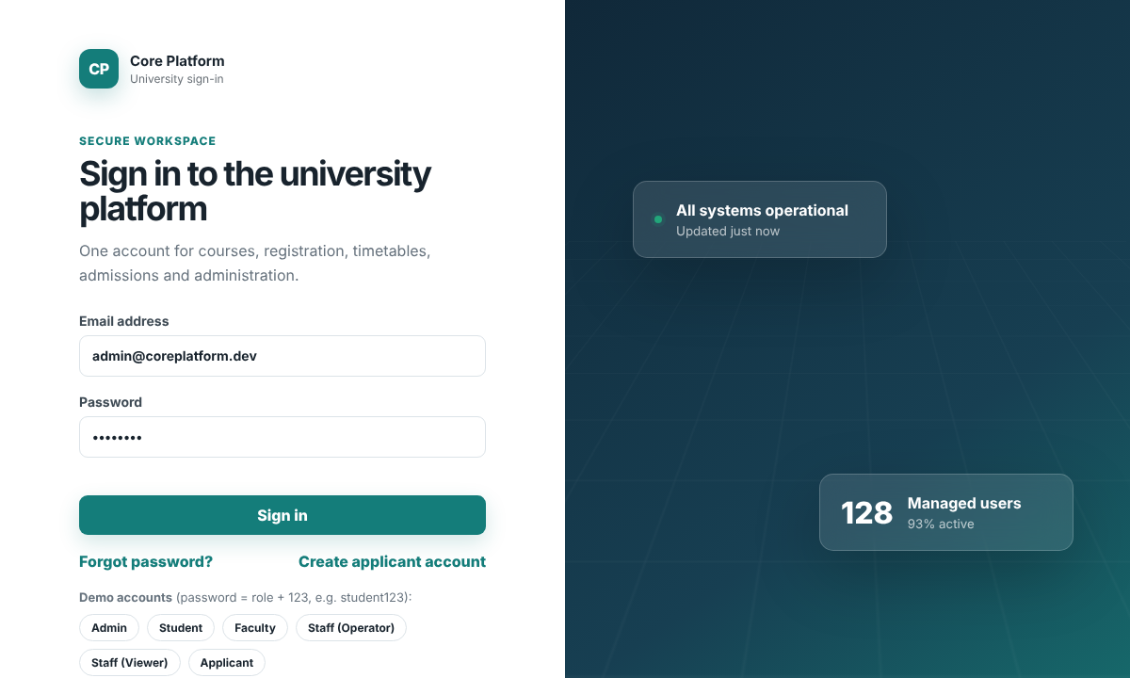
The Login page is the entry point to the Admin Console. The administrator enters an email and password and selects Sign in. If the credentials are correct, the system creates a JWT session and opens the dashboard. Invalid credentials display an error and are recorded in the activity log. After five consecutive failures, the account is locked for 15 minutes.
The right side of the page shows a short summary of the platform state: the overall service status and the number of managed users. Under the form there are links to reset a forgotten password (Section 2.9) and to create an applicant account (Section 2.13), and buttons that fill in the demo accounts for each role. Students, faculty, staff and applicants use the same sign-in page, but after sign-in they are taken to their own home page instead of the Admin Console.
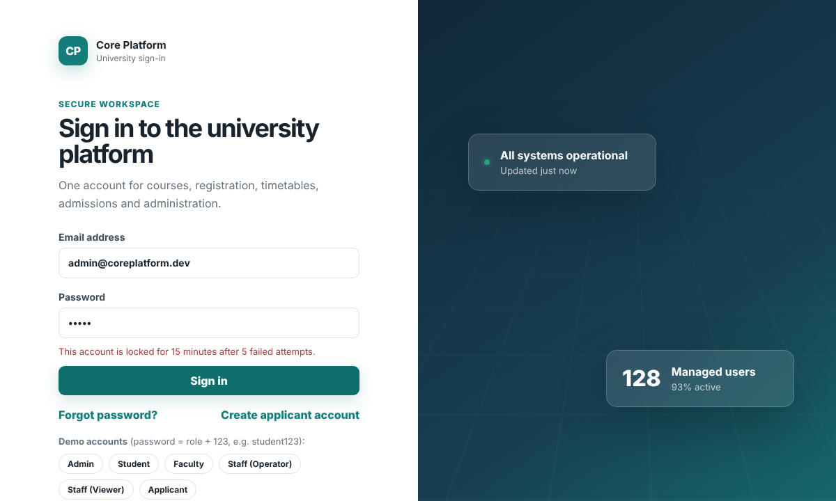
After five wrong passwords in a row, the account is locked for 15 minutes and the form shows the message above. The failed attempts are visible in the Activity Log.

2.2 Dashboard
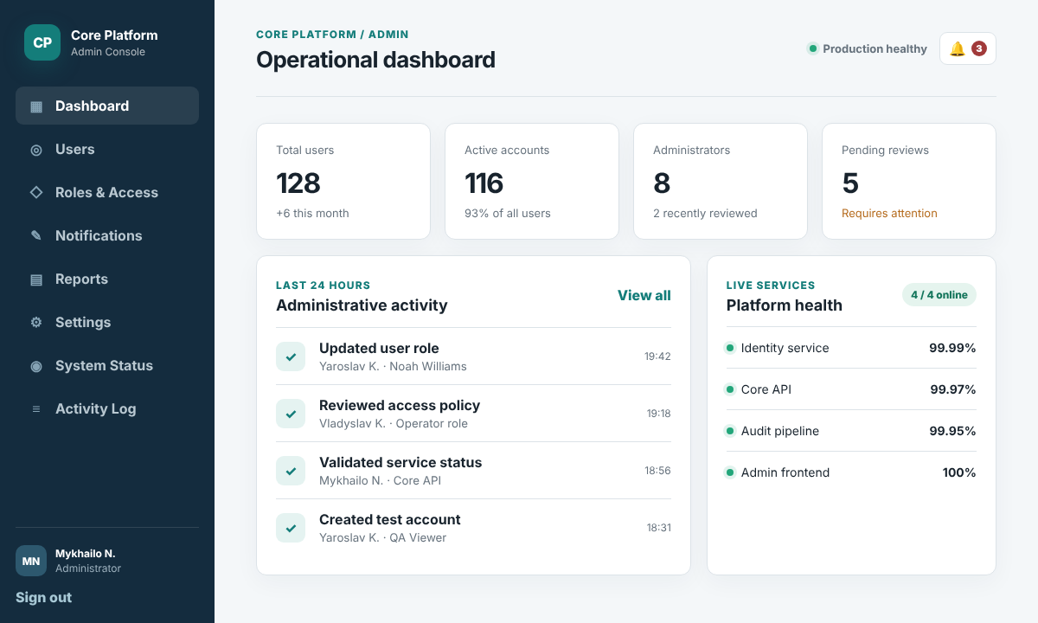
After sign-in, the administrator sees the Operational dashboard. The left sidebar is the main navigation and is the same on every page: Dashboard, Users, Roles & Access, System Status and Activity Log.
The four cards at the top show the key numbers: total users (with growth this month), active accounts, the number of administrators, and pending reviews that need attention, for example new accounts waiting for activation. The Administrative activity panel lists the latest actions from the last 24 hours, and the Platform health panel shows the availability of the main services. If something looks wrong, the administrator opens the related page from the sidebar.

2.3 User Management
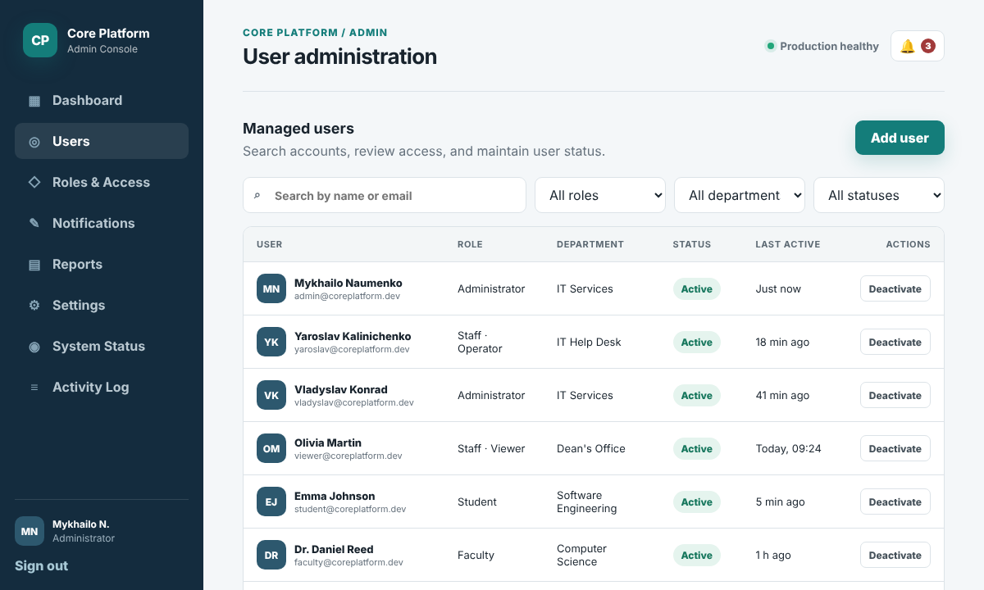
The Users page is the user directory of the platform. The table shows each account with its name, email, role, department, status and last activity time. To find a user, the administrator types a name or email in the search field, or narrows the list with the role, department and status filters. The role column shows the university role and, for staff, the console access level (for example, Staff · Operator).
The status badge shows whether the account is Active, Pending (the invitation was sent, but the user has not signed in yet) or Inactive. The Deactivate button in the Actions column blocks the account immediately: the user can no longer sign in, but the data is kept and the account can be activated again later. Selecting a user's name opens the user details, where the administrator can edit the profile, change the role or send a password reset link (see Section 2.8). New accounts are created with the Add user button.

2.4 Add User
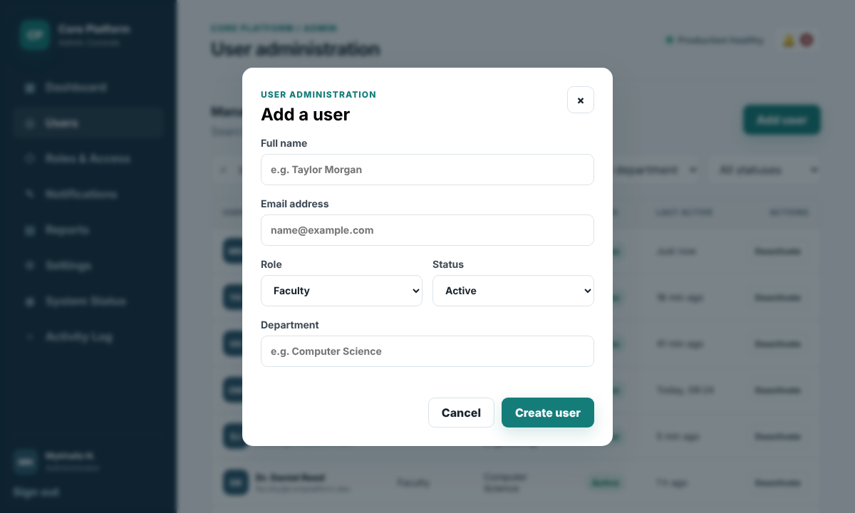
Selecting Add user opens the Add a user form. The administrator enters the full name and email address, selects a role, chooses the initial status (Active or Pending) and enters the department. Name and email are required, and the email must be unique. If the email is already used, the form shows an error and the user is not created.
After selecting Create user, the account appears in the user list, the system sends an invitation email so the new user can set a password, and the action is recorded in the Activity Log. Cancel closes the form without saving. Student accounts are normally created automatically from SIS, and applicants register themselves, so this form is mainly used for faculty, staff and administrators.

2.5 Roles & Access
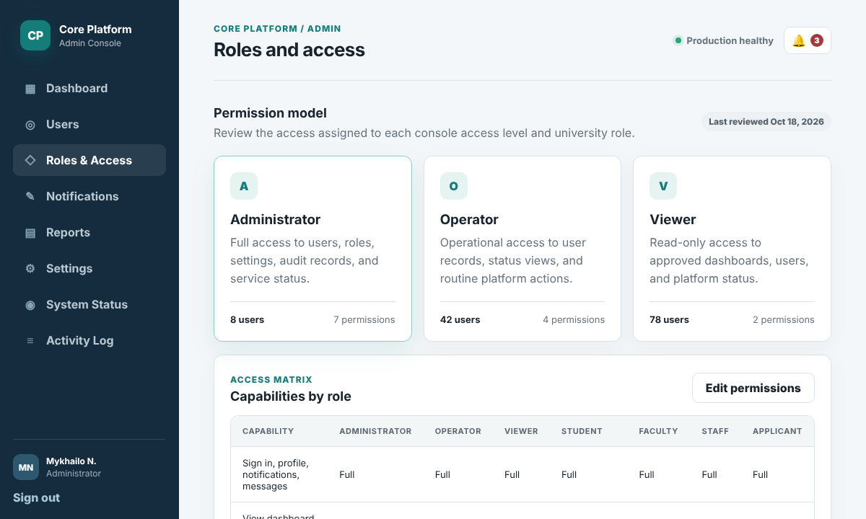
The Roles & Access page shows the permission model of the Admin Console. Each card represents one access level and shows a short description, the number of users who have it and the number of permissions it includes. Administrator has full access to users, roles, settings, audit records and service status. Operator can work with user records and status views but cannot change roles or settings. Viewer has read-only access to dashboards, users and platform status.
The Capabilities by role table compares the three levels for each main action, so the administrator can check who is allowed to do what before assigning a role. Administrators can also edit the permissions of a role from this page, and every change is saved to the Activity Log. The university roles (Student, Faculty, Staff and Applicant) are managed on the same page.

2.6 System Status
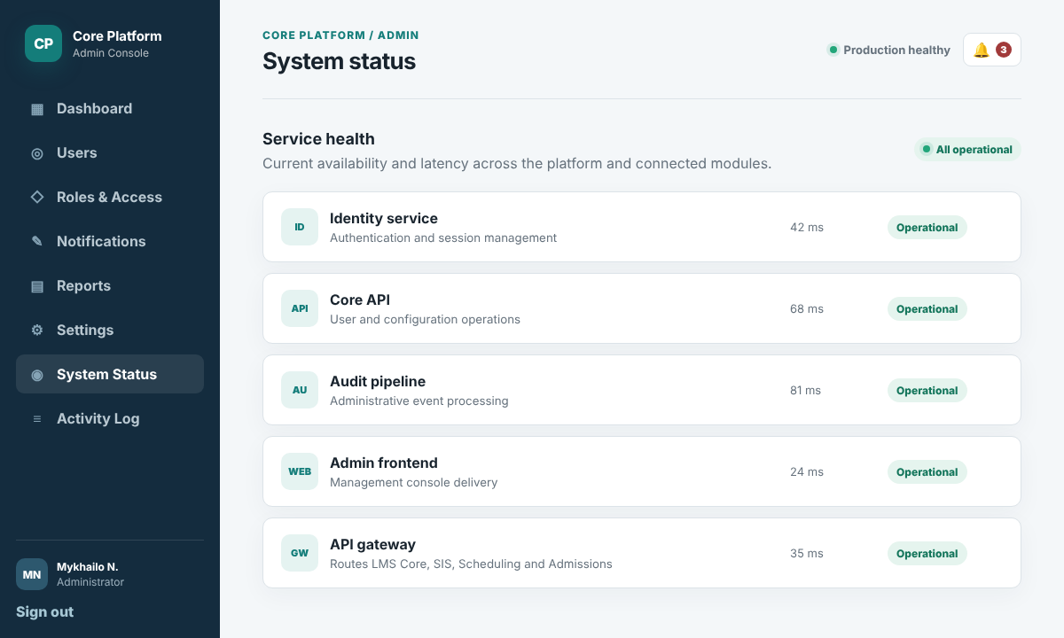
The System Status page shows the health of the platform services. For each service, the page shows its name, a short description, the current response time in milliseconds and a status badge. The Identity service handles sign-in and sessions, the Core API handles user and configuration operations, the Audit pipeline processes activity records, and the Admin frontend delivers the console itself.
A service can be Operational, Degraded (slow or partly working) or Down. If a service becomes Degraded or Down, administrators receive a notification. The last row shows the API gateway, which connects the LMS Core, SIS, Academic Scheduling and Admissions modules to the Core Platform.

2.7 Activity Log
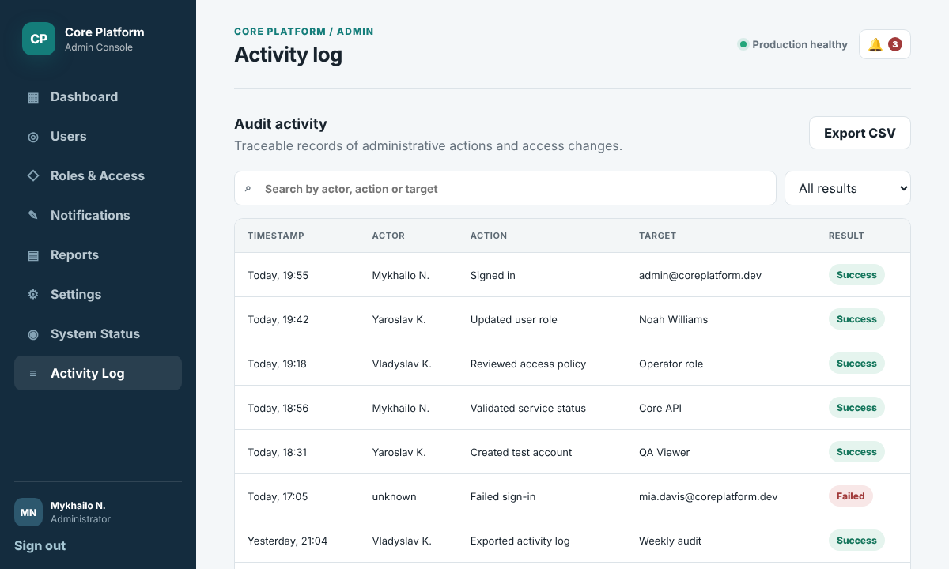
The Activity Log is the audit trail of the platform. Every administrative and security action is saved as a record with the time it happened, the person who did it (actor), what was done (action), which object it affected (target) and the result (Success or Failed). The newest records are shown at the top.
The administrator uses Activity Log to review role changes, account management and failed sign-ins. Search and result filters narrow the records; Export CSV downloads a report. Audit records are stored in the database and cannot be changed or deleted through the API.

2.8 Other Administrator Tasks
The following tasks complete the administrator workflow. Each change is recorded in the Activity Log.
Edit a user or change a role. On the Users page, select the user's name to open the User details window. Change the needed fields (for example, department or phone) or choose a new role and console access level, then select Save. The new role is applied at the user's next sign-in. From the same window, Send password reset emails the user a link that is valid for 24 hours. Administrators never see or set user passwords directly.
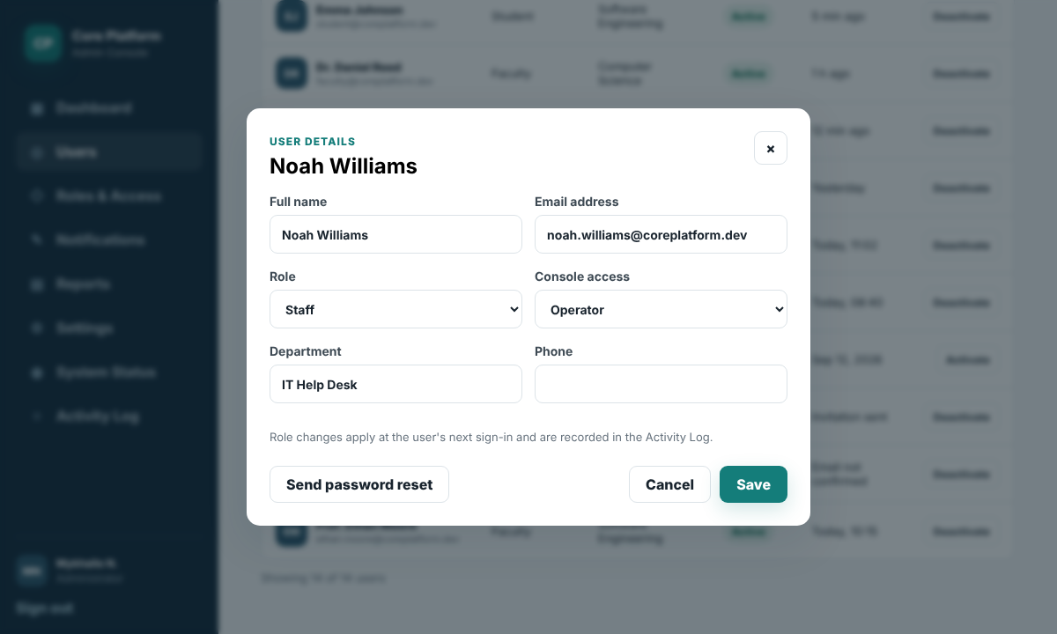
Send an announcement. Select Notifications in the sidebar. Choose the audience (all users, a role or a department) and the channel (in-app, email or both), enter a title and the message and select Send. The announcement appears in every recipient's notification center and in the Sent announcements history on the right.
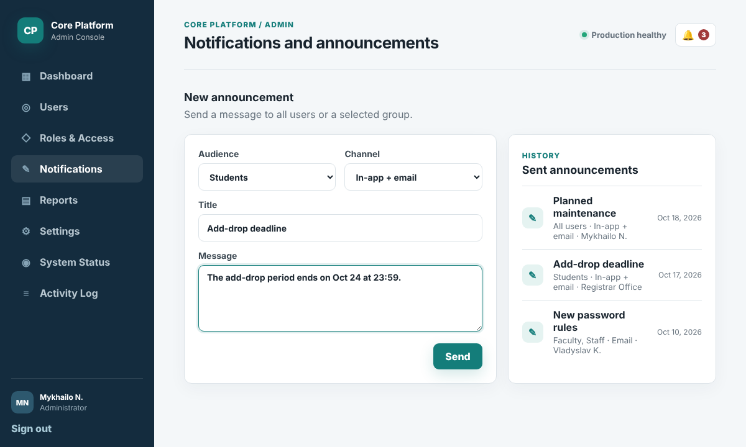
Change system settings. Select Settings in the sidebar. Here the administrator sets the university name, the current term dates, the email sender address, the password rules, the session timeout and the number of failed attempts before an account is locked. On the right, the connected modules can be turned on or off. Select Save changes to apply them.
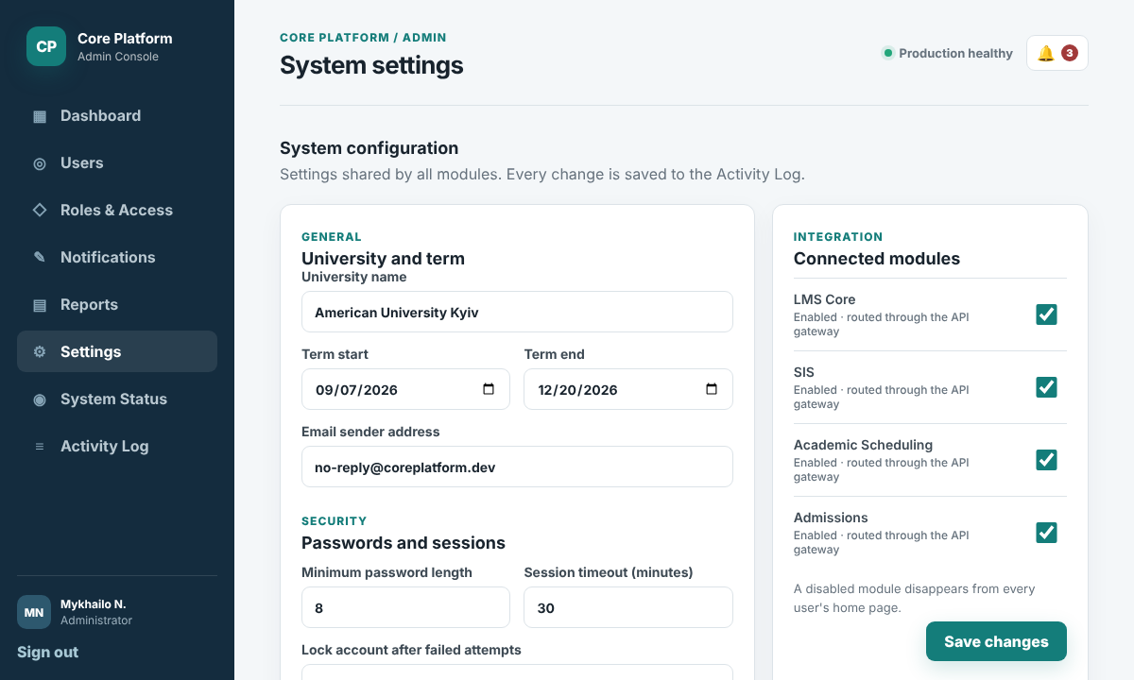
View cross-module reports. Select Reports in the sidebar to see data collected from all modules: enrolled students (SIS), active courses (LMS Core), new applications (Admissions) and room usage (Academic Scheduling), plus a table by department. Choose the period in the list at the top and select Export CSV to download the report.
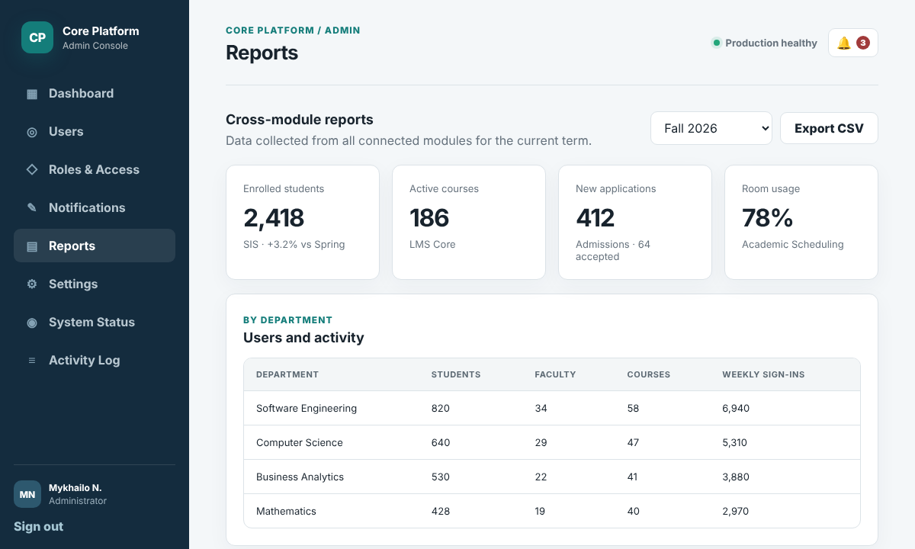

2.9 Common Tasks for All Users
Students, faculty, staff and applicants do not use the Admin Console. They work in the University Portal: the same sign-in page, a home page with the modules they can open, notifications, messages and their profile. These parts look the same for every role; only the menu items and modules depend on the role.
Sign in and sign out. Open the platform address, enter the university email and password and select Sign in (Section 2.1). The home page shows tiles for the modules the user can open. Thanks to single sign-on, the user does not need to sign in again when moving between modules. To sign out, select Sign out at the bottom of the sidebar. For security, the session also ends after 30 minutes of inactivity.
Reset a forgotten password. On the sign-in page, select Forgot password?, enter the university email and select Send link. The page confirms that a link was sent. Open the email, follow the link and enter the new password twice. The password must have at least 8 characters, including a letter and a number.
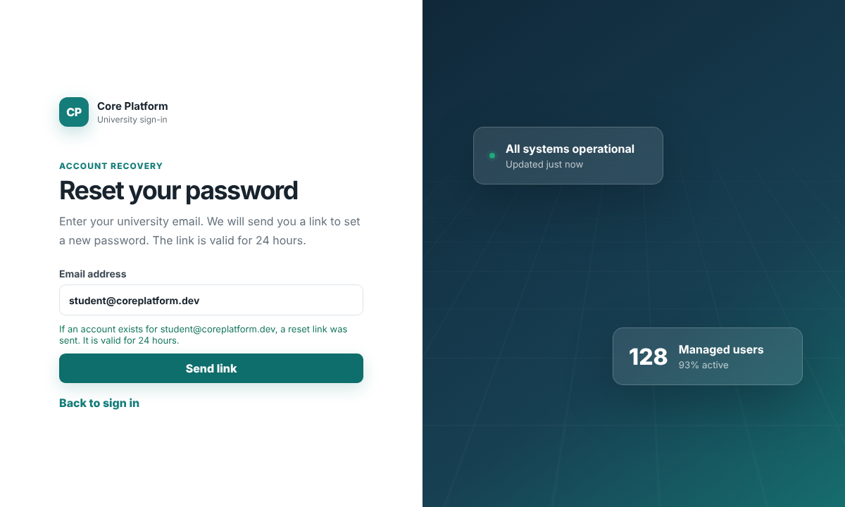
View and edit the profile. Select My Profile in the sidebar. On the left, the user can change the preferred name, contact phone, personal email and photo and select Save. On the right, the official data (full name, university email, role and student ID or department) is shown read-only, because only an administrator or the registrar office can change it. Below it, the user can change the password by entering the current password and the new one twice.
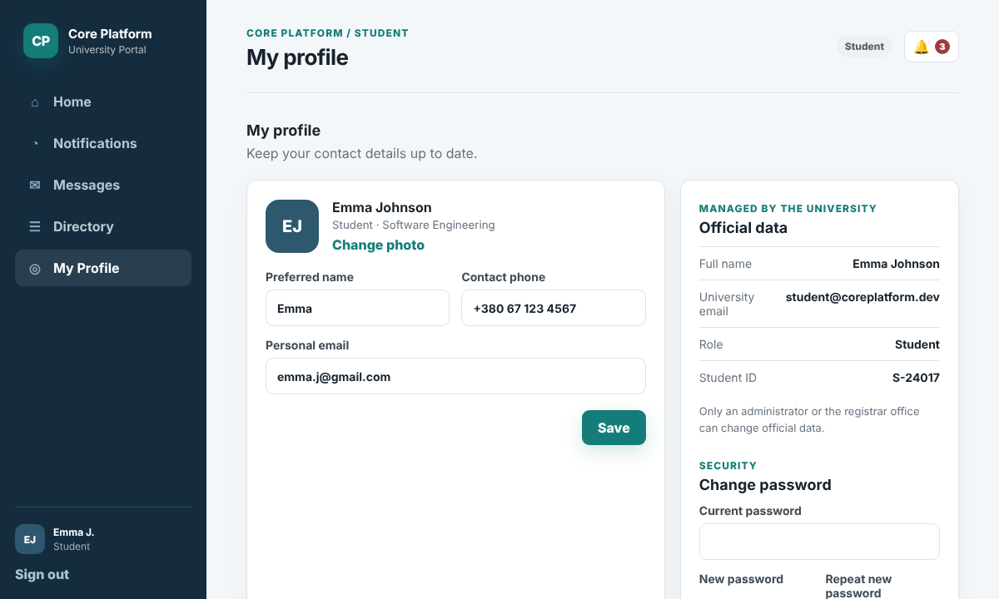
Read notifications. The bell icon in the top bar shows the number of unread notifications. Select it, or Notifications in the sidebar, to open the notification center. It collects messages from all modules, for example a new grade from LMS Core, a room change from Scheduling or a deadline from SIS. Unread notifications are highlighted; selecting one opens the related module and marks it as read, and Mark all as read clears all of them. On the right, under Also send by email, the user chooses which types of notifications are also sent by email.
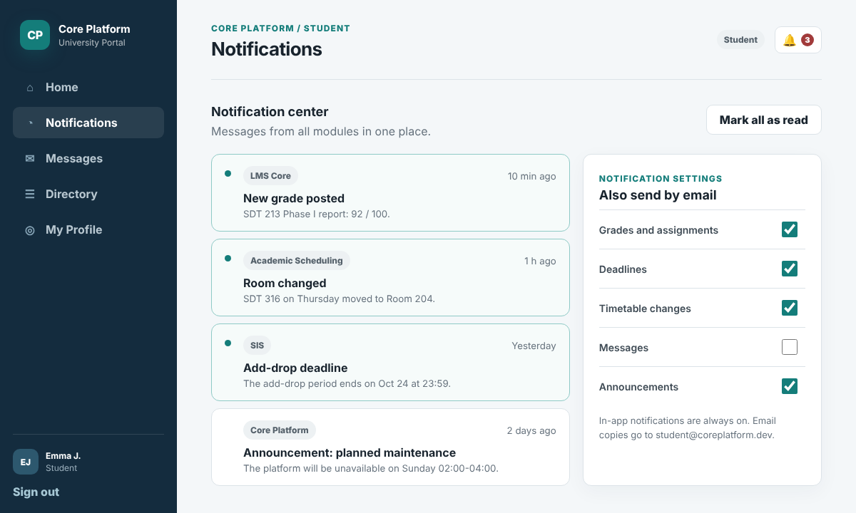
Send messages. Select Messages to see the conversations on the left and the selected conversation on the right. To reply, type in the field at the bottom and select Send. To start a new conversation, select New message, choose the recipient from the list and write the text. The list only contains people the user is allowed to contact; for example, students can write to faculty, staff and university offices.
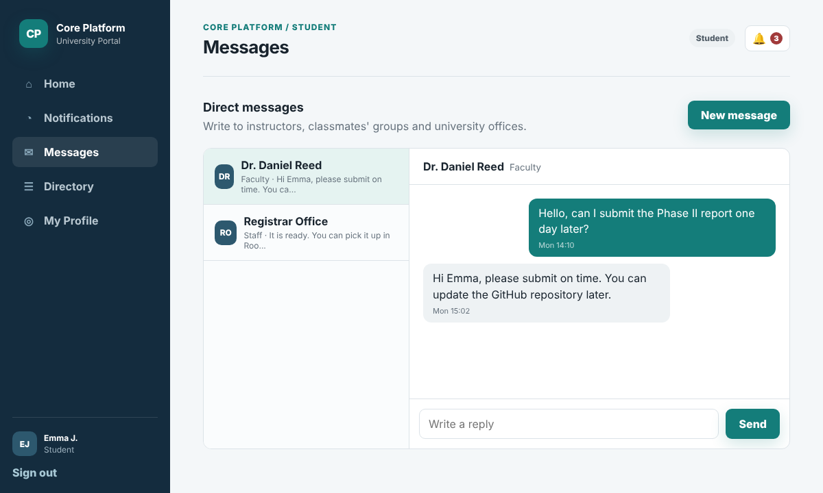

2.10 Student Guide
Students get their account automatically when they are enrolled in SIS and receive an invitation email to set a password. A student uses the Core Platform mainly as the entry point to the other modules. Demo account: student@coreplatform.dev / student123.
Home page. After sign-in, the student sees a greeting with the study program and three tiles: My Courses (LMS Core), Registration & Records (SIS) and My Timetable (Academic Scheduling). Each tile shows a short status, for example the next class. Selecting a tile opens the module without signing in again. Below the tiles, the student sees the latest university announcements and notifications.
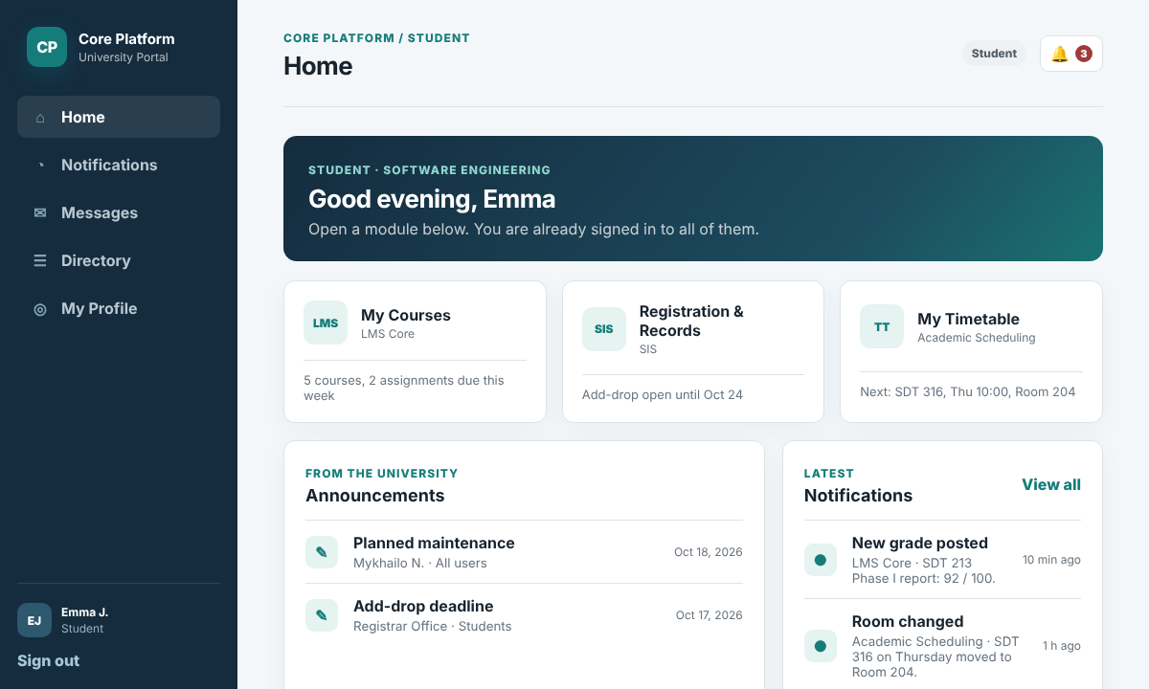
Find an instructor. Select Directory and type a name or department. Students see only faculty and staff members, with their role, department and university email. Select Message to write to the person directly.
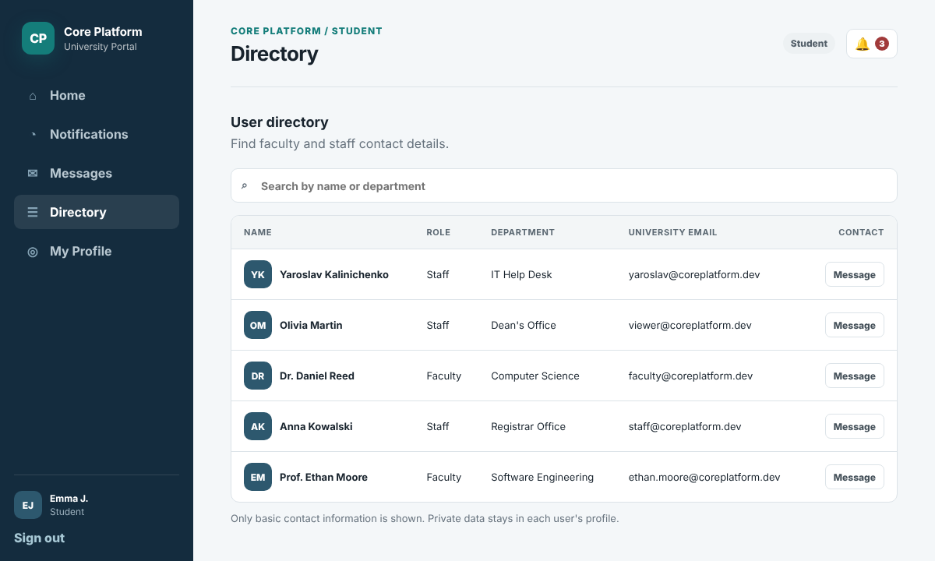
Other tasks. Notifications, messages and the profile work as described in Section 2.9. Students cannot open the Admin Console, see other students' profiles or view platform reports.

2.11 Faculty Guide
Faculty accounts are created by an administrator (Section 2.4) with the Faculty role. Demo account: faculty@coreplatform.dev / faculty123.
Home page. The faculty home page shows tiles for Teaching (courses in LMS Core), My Schedule (Academic Scheduling) and Class Lists (SIS), together with announcements and the latest notifications, such as new submissions or a changed lecture room.
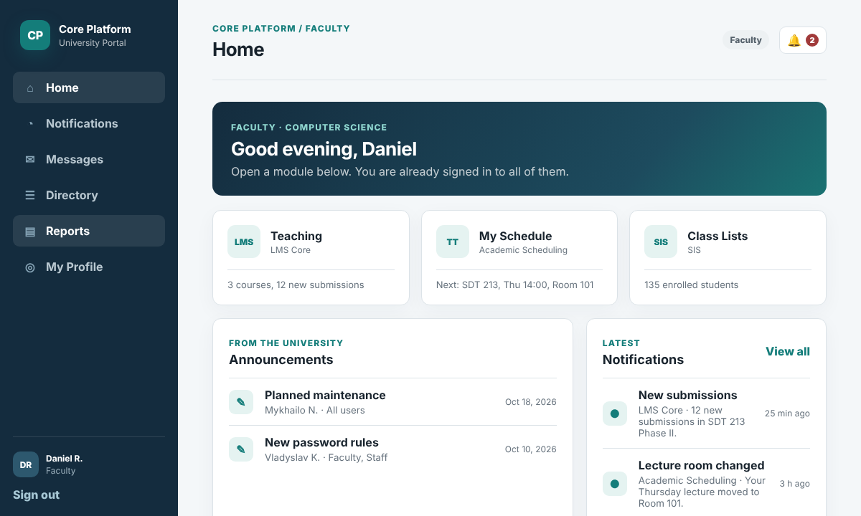
Message a whole class. Select Messages and then New message. In the To list, choose a course group, for example SDT 213 - all students, write the text and select Send. Every student in the course receives the message in the notification center and, if enabled, by email.
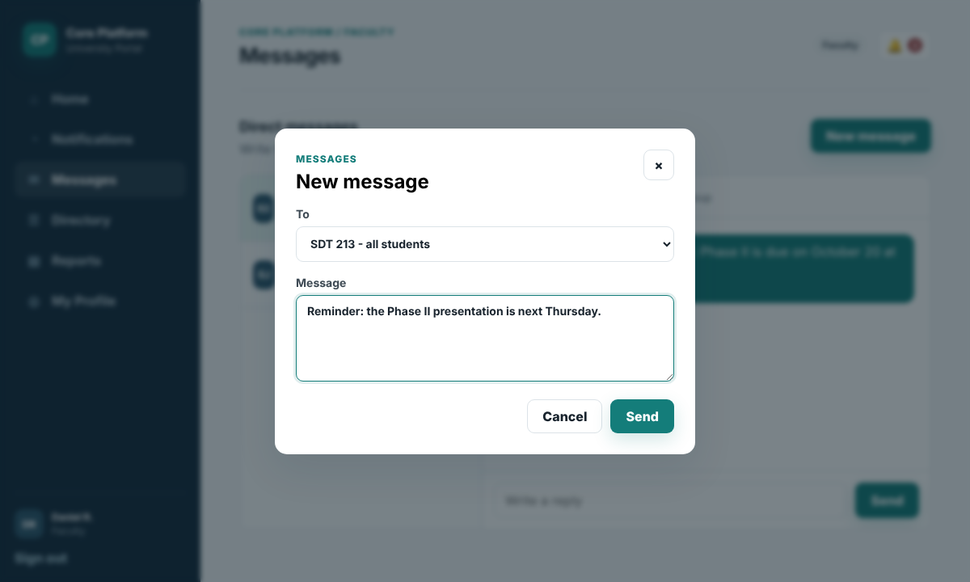
Find students and colleagues. Select Directory and search by name or department. Faculty members see colleagues and students with their department and university email, and can message them from the list.
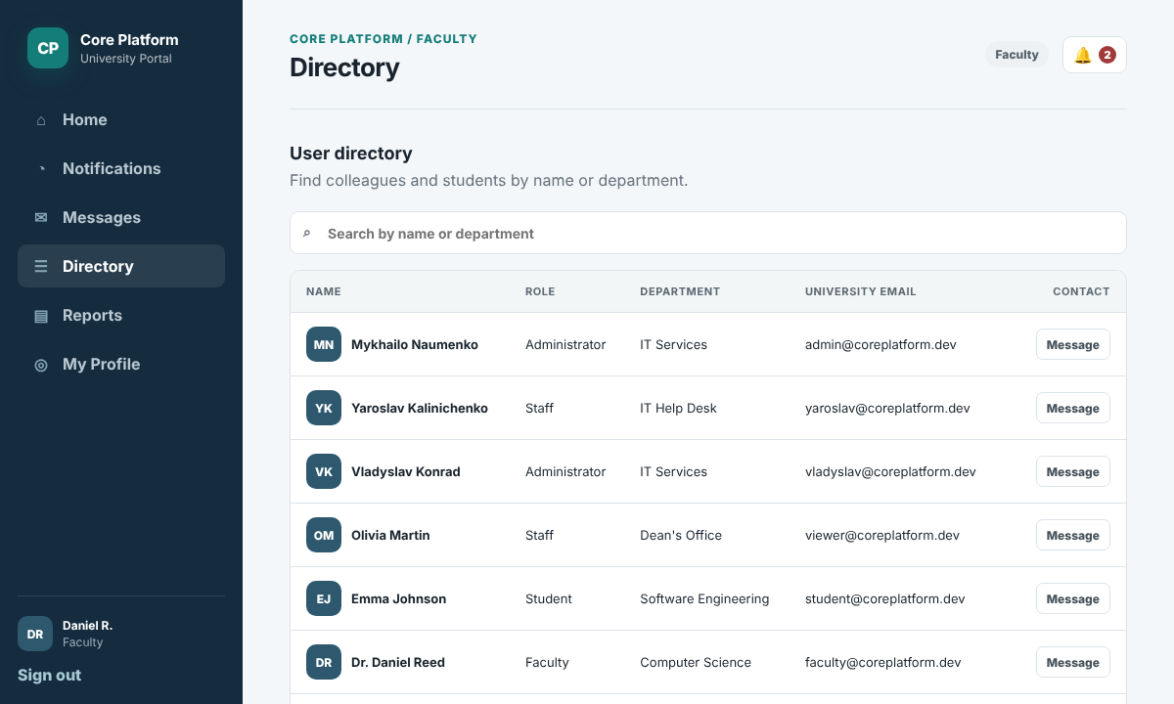
View course reports. Select Reports to see the courses the faculty member teaches, with the number of students from SIS, the average progress from LMS Core and the number of missing submissions. Select Export CSV to download the table.
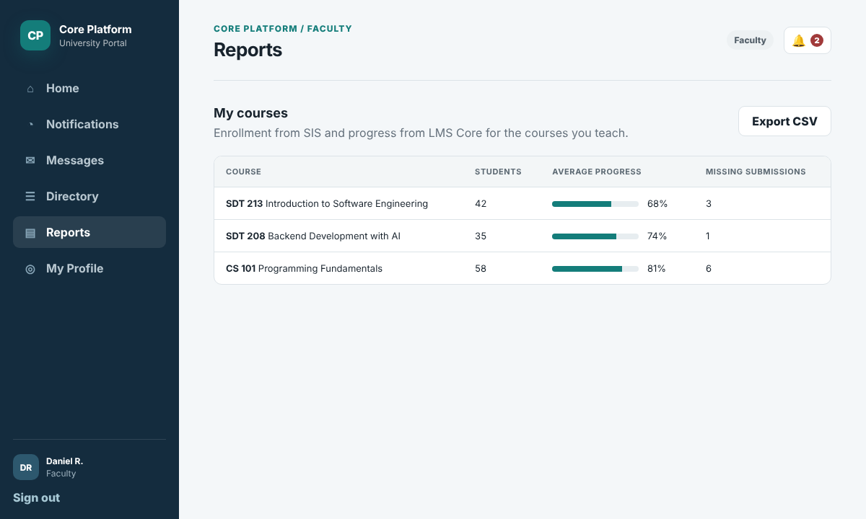
Help students with access. Faculty members cannot reset student passwords. If a student cannot sign in, the faculty member directs the student to the Forgot password? link or to the IT help desk.

2.12 Staff Guide
Staff members are university employees, for example in the registrar office, the admissions office or the IT help desk. Their accounts are created by an administrator. Depending on their duties, a staff member can also get Operator or Viewer access to the Admin Console. Demo accounts: staff@coreplatform.dev / staff123 (Operator) and viewer@coreplatform.dev / viewer123 (Viewer).
Home page. The staff home page shows the modules of the office, for example Student Records (SIS), Room Booking (Academic Scheduling) and Admissions Desk. If the staff member has console access, an extra Admin Console tile appears, and the sidebar shows an Admin Console section with the pages allowed for that access level.
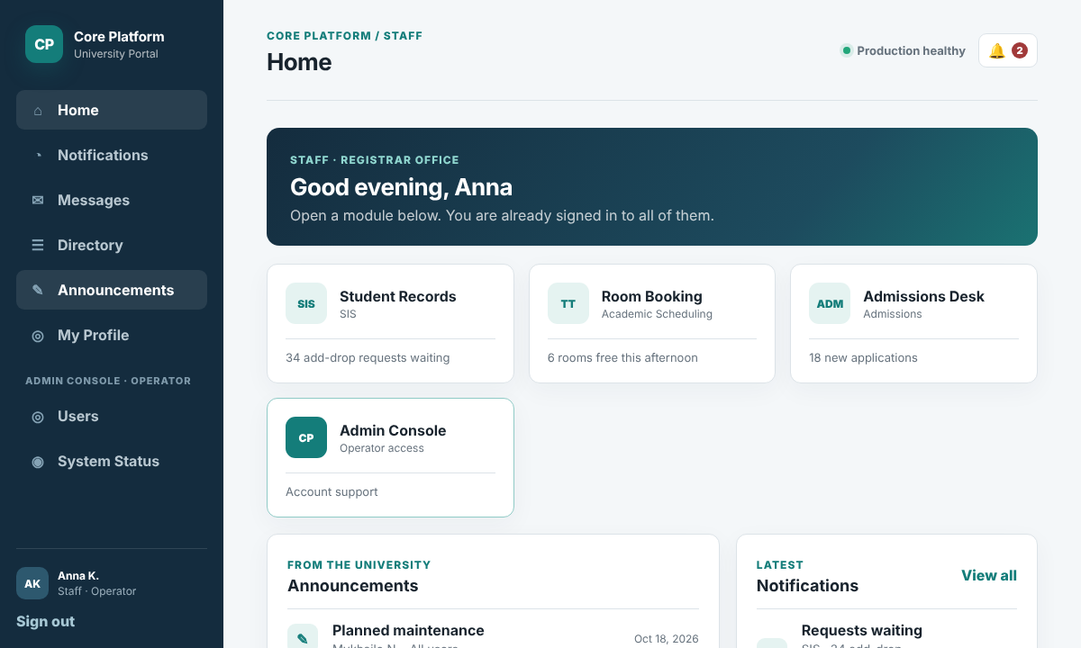
Send announcements. Authorized staff can send announcements to the groups their office is responsible for. Select Announcements, choose the audience and channel, enter a title and message and select Send. For example, the registrar office notifies all students about the add-drop deadline.
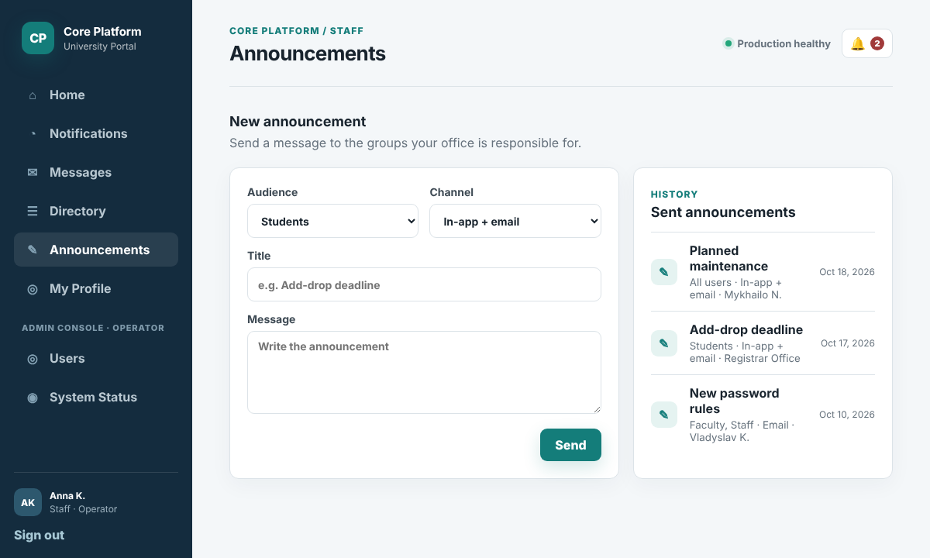
Work as an Operator. A staff member with Operator access (for example, the IT help desk) opens Users under Admin Console, finds the account and opens the user details. The operator can edit contact data, activate or deactivate the account and select Send password reset. The role and console access fields are greyed out, because operators cannot change roles, permissions or system settings.
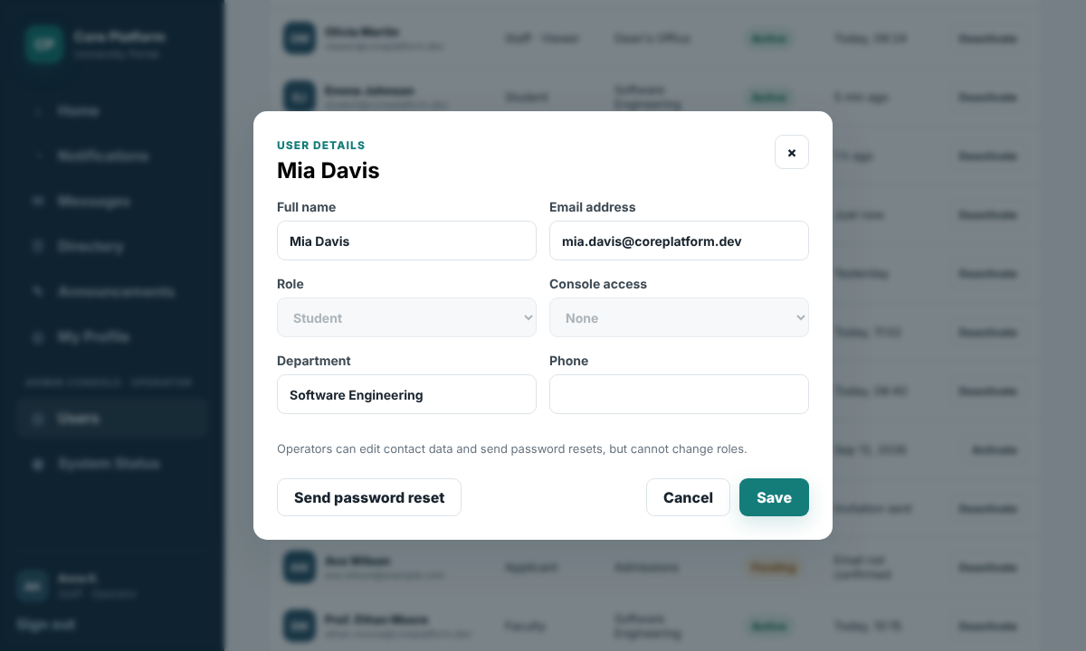
Work as a Viewer. A staff member with Viewer access (for example, a manager in the dean's office) can open the Dashboard, Users, System Status and Reports pages, but only to read them. In the Users table, the action buttons are replaced with Read only, and the Add user button is hidden.
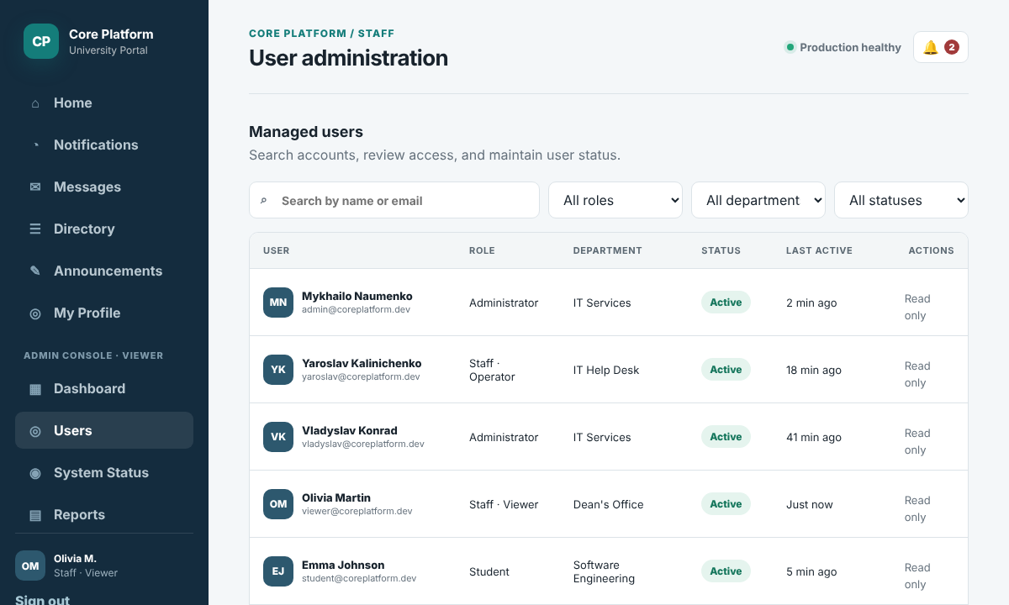

2.13 Applicant Guide
Applicants are prospective students who apply to the university. They are the only users who create their own accounts. Demo account: applicant@coreplatform.dev / applicant123.
Create an account. On the sign-in page, select Create applicant account. Enter the full name, email and password (twice), accept the privacy notice and select Register. If the email is already used or the passwords do not match, the form shows an error.
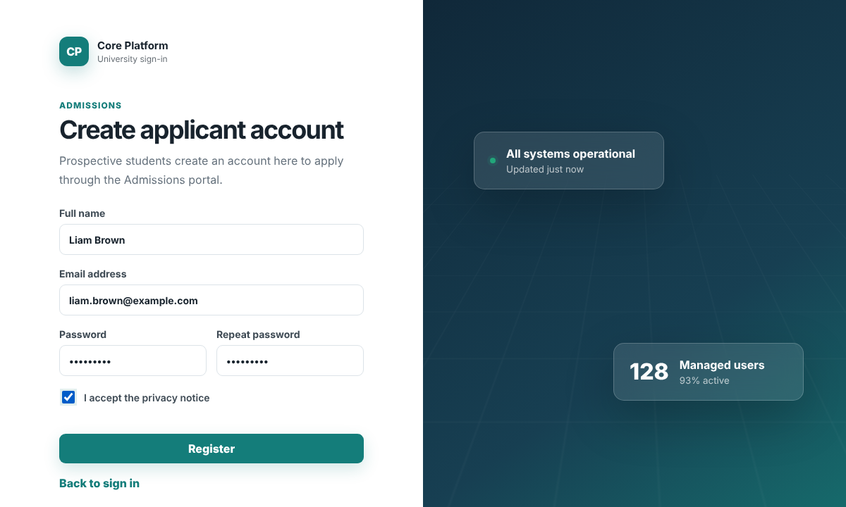
Confirm the email. After registration, the page asks the applicant to check the email. Selecting the confirmation link in the email activates the account and signs the applicant in. In the prototype, the button Open confirmation link (demo) simulates the email link.
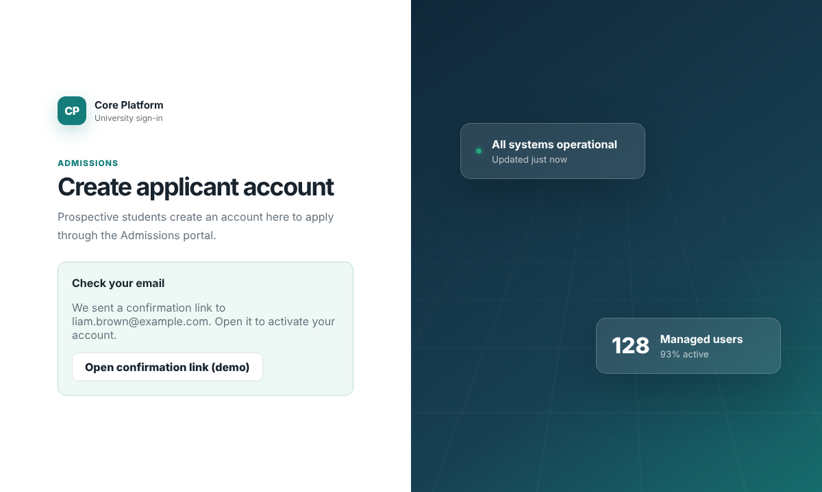
Follow the application. The applicant home page shows the Admissions Portal tile and the Application status panel with four steps: Submitted, Documents received, Interview and Decision. Completed steps are green and the current step is orange. The application forms and documents themselves are handled by the Admissions module; the Core Platform provides the account, sign-in, profile and notifications.
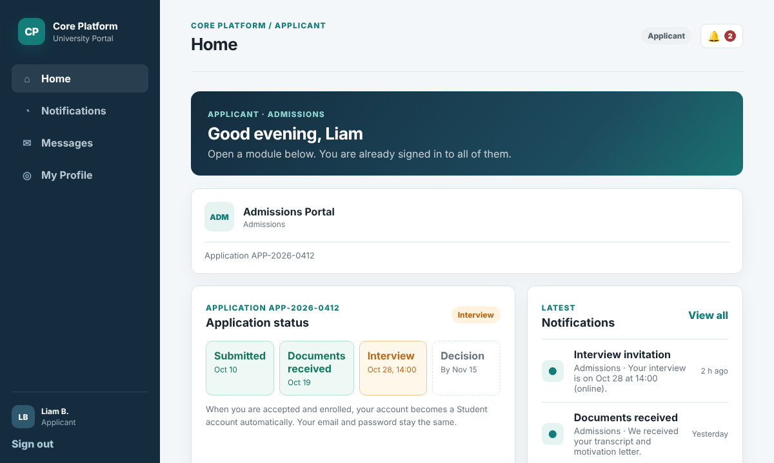
Get updates. Every change in the application (for example, documents received or an interview invitation) arrives as a notification and, if enabled, by email. When the applicant is accepted and enrolled, SIS creates a student record and the Core Platform changes the account role from Applicant to Student automatically. The email and password stay the same, and the student home page appears at the next sign-in.
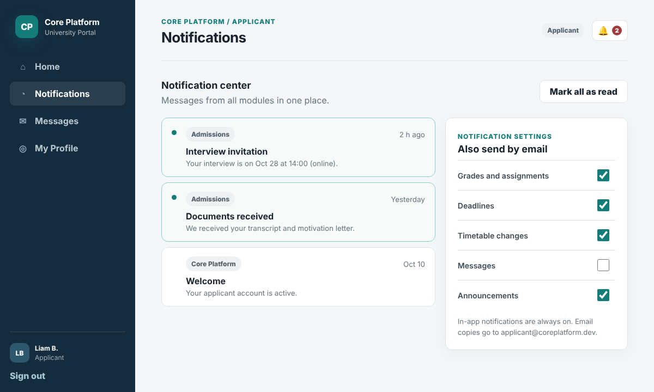

3. Project Schedule
The project schedule is managed in Jira (project KAN). It follows the four course phases and their deadlines and is split into 10 epics and 88 tasks. Every task has an owner, a start date, a due date and a status, and the work is divided equally between the team members: Mykhailo 29 tasks, Yaroslav 30 tasks and Vladyslav 29 tasks. Each team member tests the features he did not build (see the test plan in Section 8.5).
The table below lists the epics. The individual tasks of each epic can be seen in Jira. Status is shown as of October 20, 2026. The official Phase II Canvas submission deadline is October 20; KAN-27's October 21 date reflects the internal presentation/wrap-up milestone and should not be used as the Canvas submission date.
# | Epic | Jira | Owner | Start | Due | Status
1 | Phase I - Requirements, User Guide and Schedule | KAN-25 | Mykhailo | Sep 14 | Sep 30 | Done
2 | Phase II - Use Cases, CRC Cards and Class Diagram | KAN-26 | Yaroslav | Oct 1 | Oct 16 | Done
3 | Phase II - Test Plan, Initial Prototype and Submission | KAN-27 | Mykhailo | Oct 1 | Oct 21 | In Progress
4 | Phase III - Backend Foundation and Authentication | KAN-28 | Mykhailo | Oct 22 | Oct 29 | To Do
5 | Phase III - Users, Roles, Profiles and Directory | KAN-29 | Vladyslav | Oct 26 | Nov 4 | To Do
6 | Phase III - Notifications, Announcements and Messages | KAN-30 | Yaroslav | Oct 28 | Nov 6 | To Do
7 | Phase III - Admin Hub: Dashboard, Reports, Settings, Status and Audit Log | KAN-31 | Vladyslav | Oct 28 | Nov 8 | To Do
8 | Phase III - API Gateway, Integration and Submission | KAN-32 | Mykhailo | Oct 28 | Nov 11 | To Do
9 | Phase IV - Testing, Final Report and Presentation | KAN-66 | Vladyslav | Nov 12 | Dec 2 | To Do
10 | Weekly Team Updates - Journal, Time Logs, Recordings, Peer Evaluation | KAN-33 | Yaroslav | Sep 14 | Dec 6 | In Progress

Phase deadlines and presentations:
Phase | Main deliverables | Due (11:59 pm) | Presentation
Phase I | Requirements, User's Guide, project schedule | Sep 29 | Sep 30
Phase II | Use cases, CRC cards, class diagram, test plan, initial prototype | Oct 20 | Oct 21
Phase III | Implementation and demo, GitHub commits and Jira screenshots | Nov 10 | Nov 11
Phase IV | Final implementation, final class diagram, Testing Report, Conclusions | Nov 30 | Dec 2

Jira Timeline
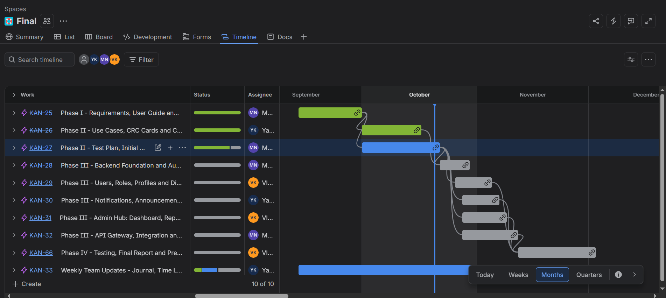
Planned dependency flow: Phase I (requirements, user guide, schedule) > Phase II analysis and design (use cases, CRC cards, class diagram) and Phase II test plan, prototype and submission > Phase III implementation (backend and authentication, users, roles and profiles, notifications and messages, admin hub, API gateway and integration) > Phase IV testing, final report and presentation. Weekly team updates (journal, time logs, recordings, peer evaluation) run through the whole project.

4. GitHub Repository
Public repository:
https://github.com/mikhail2574/sdt-213-final
The repository contains the up-to-date report, the runnable prototype (folder Core_Platform_Admin_App), the draw.io source files of the use case and class diagrams, the team journal, the individual time logs, the peer evaluations and the link to the weekly meeting recordings.

5. Use Case Diagram and Use Case Scenarios

5.1 Use Case Diagram
The use case diagram below shows all actors of the Core Platform and the 21 use cases they perform. It was created in draw.io. The source file (use_case_diagram.drawio) is in the GitHub repository.
Actors on the left are the university users. Student, Faculty, Staff and Applicant are specializations of the general User actor, so they inherit the common use cases (sign in, password, profile, notifications and messages). Actors on the right use the Admin Console: Administrator, and the two console access levels Operator and Viewer. Actors outside the boundary at the top and bottom are other systems: SIS, Admissions and the general Platform Module (LMS Core, SIS, Academic Scheduling and Admissions). The “include” relations show steps that are reused: every important action records an audit event (UC20), announcements, messages and status alerts deliver notifications (UC12), and module notifications go through the API gateway (UC21).
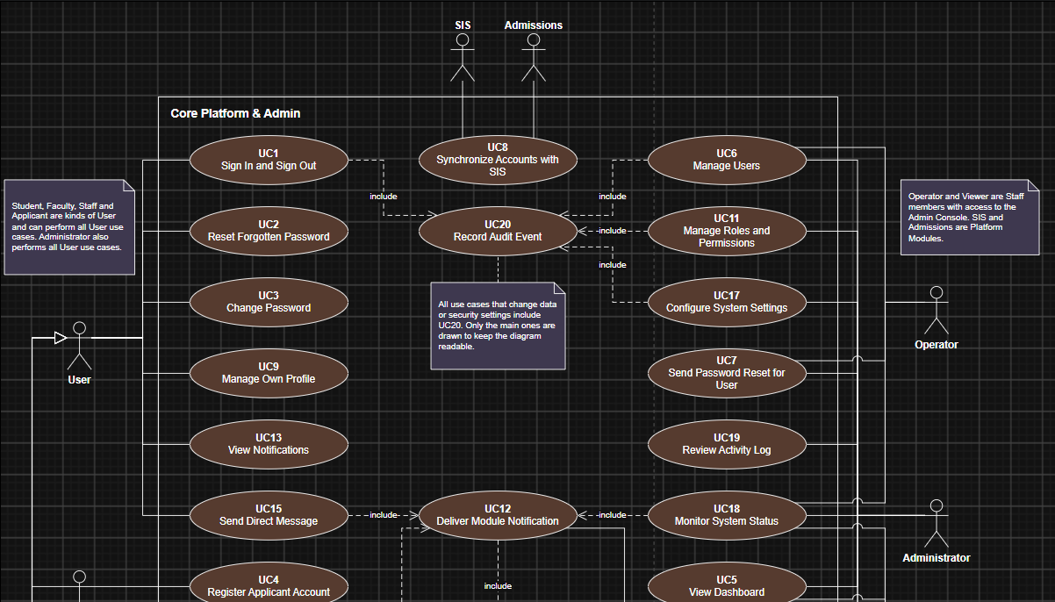
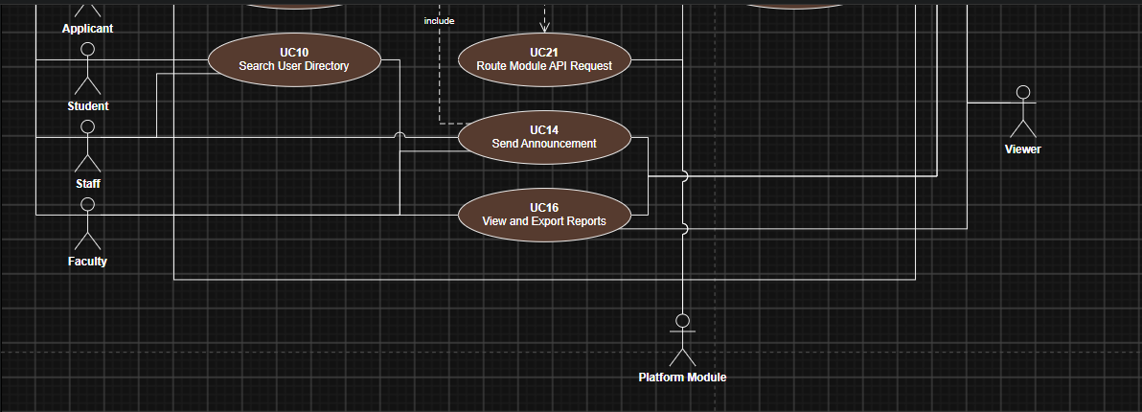

5.2 Mapping of Use Cases to Functional Requirements
Every functional requirement from Section 1.4 is covered by at least one use case. The table below shows the mapping, and each scenario lists the requirements it covers.
Use Case | Name | Functional Requirements
UC1 | Sign In and Sign Out | FR1, FR2, FR5, FR7
UC2 | Reset Forgotten Password | FR3
UC3 | Change Password | FR4
UC4 | Register Applicant Account | FR6
UC5 | View Dashboard | FR8
UC6 | Manage Users | FR9, FR10, FR11, FR12, FR13
UC7 | Send Password Reset for User | FR14
UC8 | Synchronize Accounts with SIS | FR15, FR16
UC9 | Manage Own Profile | FR17
UC10 | Search User Directory | FR18
UC11 | Manage Roles and Permissions | FR19, FR20, FR21
UC12 | Deliver Module Notification | FR22
UC13 | View Notifications | FR23, FR24
UC14 | Send Announcement | FR25
UC15 | Send Direct Message | FR26
UC16 | View and Export Reports | FR27, FR28
UC17 | Configure System Settings | FR29, FR30
UC18 | Monitor System Status | FR31, FR32
UC19 | Review Activity Log | FR34, FR35
UC20 | Record Audit Event | FR33
UC21 | Route Module API Request | FR36, FR37

5.3 Use Case Scenarios
Each use case is documented with the scenario template from the lectures (use case name, description, primary actor and basic flow). We added three rows: other actors, related functional requirements and alternative flows, because they are needed for the test plan in Section 8.
Use case name | UC1 Sign In and Sign Out
Description | Lets any university user enter the platform with one account and leave it safely. After sign-in the user can open every connected module without signing in again.
Primary Actor | User (any role)
Related FR | FR1, FR2, FR5, FR7
Basic Flow | 1. The user opens the sign-in page.  2. The user enters the university email and password and selects Sign in.  3. The system checks the email and password.  4. The system creates a session (JWT token) and records the sign-in in the Activity Log.  5. The system shows the start page for the user's role: the Admin Console dashboard for administrators, the portal home page for other users.  6. The system shows only the menu items and modules allowed for the role.  7. To leave, the user selects Sign out and the system ends the session.
Alternative Flow | 3a. Wrong email or password: the system shows an error, records a failed sign-in and shows how many attempts are left.  3b. Fifth failed attempt in a row: the system locks the account for 15 minutes.  3c. The account is inactive or not confirmed: the system shows a message and does not sign the user in.

Use case name | UC2 Reset Forgotten Password
Description | Lets a user who forgot the password set a new one through a link sent by email.
Primary Actor | User (any role)
Related FR | FR3
Basic Flow | 1. The user selects Forgot password on the sign-in page.  2. The user enters the university email and selects Send link.  3. The system creates a reset token valid for 24 hours and sends the link by email.  4. The system shows a neutral message that a link was sent if the account exists.  5. The user opens the link and enters the new password twice.  6. The system checks the password rules, saves the new password and records the action.
Alternative Flow | 5a. The link is expired or already used: the system asks the user to request a new link.  6a. The password does not follow the rules: the system shows the rules and asks again.

Use case name | UC3 Change Password
Description | Lets a signed-in user change their own password from the profile page.
Primary Actor | User (any role)
Related FR | FR4
Basic Flow | 1. The user opens My Profile.  2. The user enters the current password and the new password twice.  3. The user selects Update password.  4. The system checks the current password and the password rules.  5. The system saves the new password and records the change in the Activity Log.
Alternative Flow | 4a. The current password is wrong or the new passwords do not match: the system shows an error and nothing is changed.

Use case name | UC4 Register Applicant Account
Description | Lets a prospective student create an account to apply through the Admissions module.
Primary Actor | Applicant
Related FR | FR6
Basic Flow | 1. The applicant selects Create applicant account on the sign-in page.  2. The applicant enters full name, email and password and accepts the privacy notice.  3. The applicant selects Register.  4. The system checks that the email is not used and the password follows the rules.  5. The system creates the account with the Applicant role and Pending status and sends a confirmation email.  6. The applicant opens the confirmation link.  7. The system activates the account and signs the applicant in.
Alternative Flow | 4a. The email is already used: the system shows an error.  6a. The link is not opened within 7 days: the pending account is deleted.

Use case name | UC5 View Dashboard
Description | Shows administrators and viewers the key numbers, recent activity and service health in one place.
Primary Actor | Administrator
Other Actors | Viewer
Related FR | FR8
Basic Flow | 1. The administrator signs in or selects Dashboard in the sidebar.  2. The system loads user statistics (total, active, administrators, pending reviews).  3. The system loads the latest administrative actions from the Activity Log.  4. The system loads the health of the main services.  5. The system shows the dashboard. The administrator can open a related page from it.
Alternative Flow | 3a. A service does not answer: the system marks it as Down in the health panel.

Use case name | UC6 Manage Users
Description | Lets administrators and operators find accounts, create new users, edit user details and activate or deactivate accounts.
Primary Actor | Administrator
Other Actors | Operator
Related FR | FR9, FR10, FR11, FR12, FR13
Basic Flow | 1. The administrator opens Users.  2. The system shows the user list with name, role, department, status and last activity.  3. The administrator searches by name or email or filters by role, department and status.  4. To create a user, the administrator selects Add user, fills in name, email, role, status and department and selects Create user.  5. The system checks the data, creates the account, sends an invitation email and records the action.  6. To edit a user, the administrator selects the user's name, changes the details and selects Save.  7. To block or unblock an account, the administrator selects Deactivate or Activate.  8. The system saves every change and records it in the Activity Log.
Alternative Flow | 5a. The email is already used: the system shows an error and does not create the user.  6a. An Operator opens the details: the role fields are read-only.

Use case name | UC7 Send Password Reset for User
Description | Lets help desk staff help a user who cannot sign in, without seeing the user's password.
Primary Actor | Operator
Other Actors | Administrator
Related FR | FR14
Basic Flow | 1. The operator opens Users and finds the account.  2. The operator opens the user details.  3. The operator selects Send password reset.  4. The system creates a reset token and emails the link to the user.  5. The system records the action in the Activity Log and shows a confirmation.
Alternative Flow | 1a. The account is inactive: the operator first activates it (UC6).

Use case name | UC8 Synchronize Accounts with SIS
Description | Keeps accounts in line with student records: creates accounts for new students and turns enrolled applicants into students.
Primary Actor | SIS
Other Actors | Admissions
Related FR | FR15, FR16
Basic Flow | 1. SIS sends a new or changed student record to the Core Platform API.  2. The system checks whether an account with this email exists.  3. If no account exists, the system creates one with the Student role and sends an invitation email.  4. If the account belongs to an applicant, the system changes the role from Applicant to Student and keeps the email and password.  5. The system notifies the user and records the change in the Activity Log.
Alternative Flow | 2a. The record is incomplete: the system rejects it and returns an error to SIS.

Use case name | UC9 Manage Own Profile
Description | Lets every user see the own data and update contact details, preferred name and photo.
Primary Actor | User (any role)
Related FR | FR17
Basic Flow | 1. The user opens My Profile.  2. The system shows editable fields and official data (name, university email, role, student ID or department).  3. The user changes the preferred name, phone, personal email or photo.  4. The user selects Save.  5. The system checks the data, saves it and confirms.
Alternative Flow | 3a. The user wants to change official data: the system shows that only an administrator or the registrar office can do it.

Use case name | UC10 Search User Directory
Description | Lets users find contact information of colleagues, instructors and students.
Primary Actor | Faculty
Other Actors | Student, Staff
Related FR | FR18
Basic Flow | 1. The user opens Directory.  2. The user types a name or department.  3. The system shows matching users with name, role, department and university email only.  4. The user can select Message to write to the person (UC15).
Alternative Flow | 3a. The user is a student: the system shows only faculty and staff members.

Use case name | UC11 Manage Roles and Permissions
Description | Lets administrators review the permission model, change a user's role and edit the permissions of a role.
Primary Actor | Administrator
Related FR | FR19, FR20, FR21
Basic Flow | 1. The administrator opens Roles & Access.  2. The system shows each role with its description, number of users and permissions, and the capabilities table.  3. To change a user's role, the administrator opens the user details, selects a new role or console access level and selects Save.  4. To change a role, the administrator selects Edit permissions, turns permissions on or off and saves.  5. The system saves the change, applies it at the user's next sign-in and records it in the Activity Log.
Alternative Flow | 3a. The administrator tries to remove the last Administrator: the system blocks the change.

Use case name | UC12 Deliver Module Notification
Description | Lets other modules (LMS Core, SIS, Scheduling, Admissions) send notifications to users through one shared service.
Primary Actor | Platform Module
Related FR | FR22
Basic Flow | 1. A module calls the notification API with the receiver, title, text and category.  2. The system checks the module's token.  3. The system saves the notification and shows it in the user's notification center.  4. The system checks the user's notification settings.  5. If email is on for this category, the system sends an email copy.
Alternative Flow | 2a. The token is invalid: the system rejects the request.  5a. Email sending fails: the system retries later, the in-app notification stays.

Use case name | UC13 View Notifications
Description | Lets users read notifications from all modules and choose which ones also come by email.
Primary Actor | User (any role)
Related FR | FR23, FR24
Basic Flow | 1. The user selects the bell icon or Notifications.  2. The system shows notifications from all modules, newest first, with unread ones marked.  3. The user selects a notification, the system opens the related page and marks it as read.  4. The user can select Mark all as read.  5. In Notification settings, the user turns email copies on or off for each category, the system saves the choice.
Alternative Flow | 2a. There are no notifications: the system shows an empty state.

Use case name | UC14 Send Announcement
Description | Lets administrators and authorized staff or faculty send a message to all users or to a group.
Primary Actor | Administrator
Other Actors | Staff, Faculty
Related FR | FR25
Basic Flow | 1. The sender opens Notifications (administrator) or Announcements (staff).  2. The sender chooses the audience (all users, a role, a department or a course) and the channel (in-app, email or both).  3. The sender enters a title and the message and selects Send.  4. The system creates a notification for every user in the audience (UC12).  5. The system records the announcement and shows it in the history.
Alternative Flow | 2a. The sender has no permission for the audience: the audience is not offered in the list.

Use case name | UC15 Send Direct Message
Description | Lets users write to each other, for example a student to an instructor or a faculty member to a whole course.
Primary Actor | User (any role)
Related FR | FR26
Basic Flow | 1. The user opens Messages and selects New message.  2. The user chooses a recipient allowed for the role (a person, an office or a course group).  3. The user writes the text and selects Send.  4. The system saves the message in the conversation and notifies the recipient (UC12).
Alternative Flow | 2a. The recipient is not allowed for the role (for example, a student writing to another student's private contact): the recipient is not offered.

Use case name | UC16 View and Export Reports
Description | Shows reports built from the data of all modules and lets users download them.
Primary Actor | Administrator
Other Actors | Viewer, Faculty
Related FR | FR27, FR28
Basic Flow | 1. The user opens Reports.  2. The user chooses the period.  3. The system requests data from SIS, LMS Core, Admissions and Scheduling through the API gateway.  4. The system shows the report (administrators and viewers: cross-module report; faculty: only their courses).  5. The user selects Export CSV and the system downloads the file and records the export.
Alternative Flow | 3a. A module is not available: the system shows the report without its data and marks it as missing.

Use case name | UC17 Configure System Settings
Description | Lets administrators change platform-wide settings and turn connected modules on or off.
Primary Actor | Administrator
Related FR | FR29, FR30
Basic Flow | 1. The administrator opens Settings.  2. The system shows general, security and integration settings.  3. The administrator changes values (for example, term dates, session timeout or a module switch).  4. The administrator selects Save changes and confirms.  5. The system checks the values, saves them and records the change in the Activity Log.
Alternative Flow | 5a. A value is not allowed (for example, password length below 8): the system shows an error and keeps the old value.

Use case name | UC18 Monitor System Status
Description | Shows the health of platform services and connected modules and warns administrators about problems.
Primary Actor | Administrator
Other Actors | Operator, Viewer
Related FR | FR31, FR32
Basic Flow | 1. The user opens System Status.  2. The system shows each service with description, response time and status.  3. When a service becomes Degraded or Down, the system sends a notification to administrators (UC12).
Alternative Flow | 2a. The monitoring service itself does not answer: the page shows the last known status and the time it was checked.

Use case name | UC19 Review Activity Log
Description | Lets administrators check who did what and when, and download the records.
Primary Actor | Administrator
Related FR | FR34, FR35
Basic Flow | 1. The administrator opens Activity Log.  2. The system shows records with time, actor, action, target and result, newest first.  3. The administrator searches by actor, action or target and filters by result.  4. The administrator selects Export CSV; the system downloads the filtered records and records the export.
Alternative Flow | 3a. Nothing matches the filter: the system shows an empty table.

Use case name | UC20 Record Audit Event
Description | Saves every administrative and security action. It is included in other use cases, such as sign-in, user management, role changes and settings.
Primary Actor | System
Related FR | FR33
Basic Flow | 1. An included use case finishes an action (for example, sign-in or role change).  2. The system creates an audit record with time, actor, action, target and result.  3. The system saves the record; it can no longer be edited or deleted.
Alternative Flow | 2a. The audit pipeline is slow: the record is queued and saved later in the same order.

Use case name | UC21 Route Module API Request
Description | All modules talk to each other and to the Core Platform through one API gateway that checks access.
Primary Actor | Platform Module
Related FR | FR36, FR37
Basic Flow | 1. A module or the web client sends a REST request to the API gateway with a JWT token.  2. The gateway checks the token and the caller's permissions.  3. The gateway forwards the request to the right service (for example, the user, role or notification API).  4. The service returns the result, and the gateway sends it back to the caller.
Alternative Flow | 2a. The token is missing, expired or has no permission: the gateway returns an error (401 or 403).  3a. The target module is disabled in Settings: the gateway returns 503.

6. Object Identification and CRC Cards

6.1 Object Identification
To identify the objects, we read each use case scenario and marked the nouns that the system must know about or work with (for example, user, session, role, notification, report). Nouns that only describe a value (such as email or title) became attributes, not objects. We then added the objects inside the software that do the work in the scenario: services that hold the business rules (for example, AuthService and UserService), the API gateway and the email service. Actors are listed first in each row to show who starts the scenario.
The table shows the objects involved in each scenario. In total, 26 objects (classes) were identified. Each of them has one CRC card in Section 6.2 and a full description in Section 7.2.
Use Case Scenario | Objects Involved
UC1 Sign In and Sign Out | User (actor); User, Session, Role, Permission, AuthService, SystemSettings, ApiGateway, AuditService, AuditLogEntry
UC2 Reset Forgotten Password | User (actor); User, AuthService, PasswordResetToken, EmailService, SystemSettings, AuditService
UC3 Change Password | User (actor); User, AuthService, SystemSettings, AuditService
UC4 Register Applicant Account | Applicant (actor); User, Role, AuthService, EmailService, AuditService
UC5 View Dashboard | Administrator, Viewer (actors); UserService, ReportService, MonitoringService, ServiceStatus, AuditService, AuditLogEntry
UC6 Manage Users | Administrator, Operator (actors); User, Role, Department, UserService, EmailService, AuditService, AuditLogEntry
UC7 Send Password Reset for User | Operator, Administrator (actors); User, UserService, AuthService, PasswordResetToken, EmailService, AuditService
UC8 Synchronize Accounts with SIS | SIS, Admissions (actors); ApiGateway, UserService, User, Role, NotificationService, AuditService
UC9 Manage Own Profile | User (actor); User, UserService
UC10 Search User Directory | Faculty, Student, Staff (actors); User, Department, UserService
UC11 Manage Roles and Permissions | Administrator (actor); Role, Permission, User, RoleService, AuditService
UC12 Deliver Module Notification | Platform Module (actor); ApiGateway, NotificationService, Notification, NotificationPreference, User, EmailService
UC13 View Notifications | User (actor); Notification, NotificationPreference, NotificationService
UC14 Send Announcement | Administrator, Staff, Faculty (actors); Announcement, Department, User, NotificationService
UC15 Send Direct Message | User (actor); Conversation, Message, User, MessageService, NotificationService
UC16 View and Export Reports | Administrator, Viewer, Faculty (actors); ReportService, Report, ApiGateway, ConnectedModule, Department, AuditService
UC17 Configure System Settings | Administrator (actor); SystemSettings, ConnectedModule, AuditService
UC18 Monitor System Status | Administrator, Operator, Viewer (actors); MonitoringService, ServiceStatus, ConnectedModule, NotificationService
UC19 Review Activity Log | Administrator (actor); AuditService, AuditLogEntry, User
UC20 Record Audit Event | AuditService, AuditLogEntry, User
UC21 Route Module API Request | Platform Module (actor); ApiGateway, Session, Permission, ConnectedModule

6.2 CRC Cards
The table below summarizes the responsibilities and collaborators of all 26 classes identified in Section 6.1. Each row represents one CRC (Class–Responsibility–Collaborator) card.

Class | Responsibilities | Collaborators
User | Maintain account and profile; update status and password; track failed sign-ins; check permissions. | Role, Department, Session, Notification, AuditLogEntry
Role | Group permissions; add/remove permissions; count assigned users. | Permission, User, RoleService
Permission | Represent an allowed action; expose its permission code. | Role, ApiGateway
Department | Group users; support directory filters and targeted reports/announcements. | User, Announcement, ReportService
Session | Track login token and expiry; validate, refresh, or invalidate sessions. | User, AuthService, ApiGateway
PasswordResetToken | Represent a single-use reset token; validate expiry and mark as used. | User, AuthService
AuthService | Authenticate users; manage sessions and lockouts; register applicants; handle password resets. | User, Session, PasswordResetToken, EmailService, AuditService, SystemSettings
UserService | Search, create, edit, and activate accounts; request resets; synchronize SIS records. | User, Role, AuthService, EmailService, AuditService, NotificationService
RoleService | List and assign roles; update permission sets. | Role, Permission, User, AuditService
Notification | Store notification details and read state; mark as read. | User, NotificationService
NotificationPreference | Store per-category email delivery preferences; toggle an option. | User, NotificationService
NotificationService | Deliver and retrieve notifications; update read state/preferences; send announcements. | Notification, NotificationPreference, Announcement, User, EmailService
Announcement | Store message, audience, and channel; determine recipients. | User, Department, NotificationService
Conversation | Manage a message thread; add and retrieve messages. | Message, User, MessageService
Message | Store message content and timestamp; identify its sender. | User, Conversation
MessageService | Send messages; list threads and permitted recipients; trigger notifications. | User, Conversation, Message, NotificationService
ReportService | Build cross-module and course reports; export report data as CSV. | Report, ApiGateway, Department, AuditService
Report | Hold report data; convert report contents to CSV. | ReportService
SystemSettings | Store shared configuration; update and validate settings. | ConnectedModule, AuthService, AuditService
ConnectedModule | Track integration settings; enable or disable a module. | SystemSettings, ApiGateway, ServiceStatus
ServiceStatus | Store service health and latency; assess whether a service is healthy. | MonitoringService, ConnectedModule
MonitoringService | Check service availability; report status; alert administrators to failures. | ServiceStatus, ConnectedModule, NotificationService
AuditLogEntry | Capture actor, action, target, result, and time; format a CSV row. | User, AuditService
AuditService | Record security/admin events; search and export activity logs. | AuditLogEntry, User
EmailService | Send transactional and notification emails. | AuthService, UserService, NotificationService
ApiGateway | Authorize requests using tokens/permissions; route calls to connected modules. | Session, Permission, ConnectedModule, ReportService

7. Class Diagram and Class Descriptions

7.1 Class Diagram
The class diagram shows all 26 classes of the Core Platform with their attributes and operations and the relationships between them. It was created in draw.io. The source file (class_diagram.drawio) is in the GitHub repository and can be zoomed there.
Light blue classes are entity classes that hold data and will be stored in the MySQL database. Green classes are service classes that hold the business logic and will become Spring Boot services. Solid lines are associations (with multiplicity), a filled diamond is composition (the part cannot exist without the whole, for example a Session without its User), an empty diamond is aggregation (a Role includes Permissions), and dashed arrows are dependencies (a service uses or creates another class). Every class is connected to at least one other class.
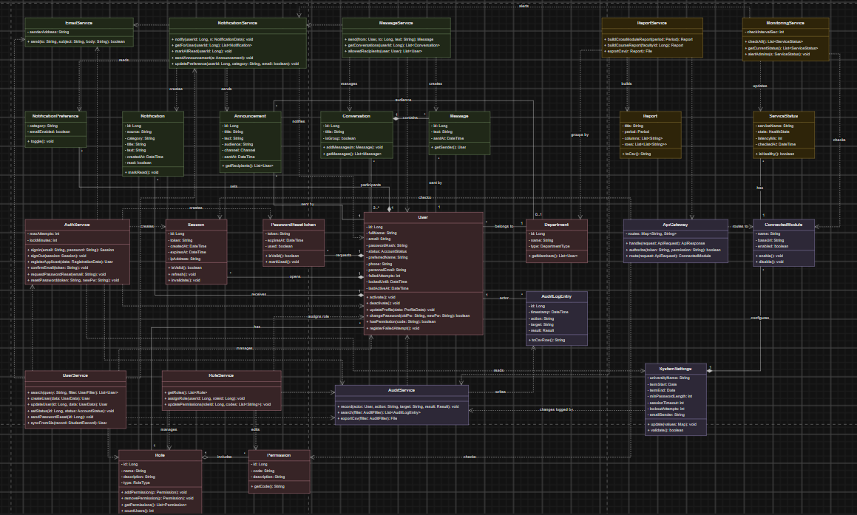

7.2 Class Descriptions
Each class below has a short description of its role in the system and its UML representation with name, attributes and operations.

7.2.1 User
Represents one person who uses the platform: a student, faculty member, staff member, applicant or administrator. It stores the account data that every module needs and is the center of the system, because almost every other class is linked to a user.
User
- id: Long
- fullName: String
- email: String
- passwordHash: String
- status: AccountStatus
- preferredName: String
- phone: String
- personalEmail: String
- failedAttempts: int
- lockedUntil: DateTime
- lastActiveAt: DateTime
+ activate(): void
+ deactivate(): void
+ updateProfile(data: ProfileData): void
+ changePassword(oldPw: String, newPw: String): boolean
+ hasPermission(code: String): boolean
+ registerFailedAttempt(): void

7.2.2 Role
Describes what a group of users may do. The platform has university roles (Student, Faculty, Staff, Applicant, Administrator) and console access levels (Operator, Viewer). A role is a set of permissions, so access can be changed without changing code.
Role
- id: Long
- name: String
- description: String
- type: RoleType
+ addPermission(p: Permission): void
+ removePermission(p: Permission): void
+ getPermissions(): List<Permission>
+ countUsers(): int

7.2.3 Permission
One allowed action, for example 'users.edit' or 'reports.view'. Permissions are grouped into roles and are checked on the server for every request.
Permission
- id: Long
- code: String
- description: String
+ getCode(): String

7.2.4 Department
A faculty, office or study program, such as Computer Science or Registrar Office. It is used for filtering users, choosing announcement audiences and building reports.
Department
- id: Long
- name: String
- type: DepartmentType
+ getMembers(): List<User>

7.2.5 Session
A signed-in period associated with a JWT. The backend tracks last activity, enforces inactivity timeout, and supports server-side revocation.
Session
- id: Long
- token: String
- createdAt: DateTime
- expiresAt: DateTime
- ipAddress: String
+ isValid(): boolean
+ refresh(): void
+ invalidate(): void

7.2.6 PasswordResetToken
A one-time link token for setting a new password. It is valid for 24 hours and can be used only once.
PasswordResetToken
- token: String
- expiresAt: DateTime
- used: boolean
+ isValid(): boolean
+ markUsed(): void

7.2.7 AuthService
Handles authentication, secure password changes, session lifecycle, lockouts, applicant registration, and password resets. User owns account state; AuthService coordinates secure password updates.
AuthService
- maxAttempts: int
- lockMinutes: int
+ signIn(email: String, password: String): Session
+ signOut(session: Session): void
+ registerApplicant(data: RegistrationData): User
+ confirmEmail(token: String): void
+ requestPasswordReset(email: String): void
+ resetPassword(token: String, newPw: String): void

7.2.8 UserService
Contains the business rules for managing accounts: search and filtering, creating and editing users, activation, and synchronization with SIS (new students and applicant-to-student changes).
UserService
(no attributes; the service is stateless)
+ search(query: String, filter: UserFilter): List<User>
+ createUser(data: UserData): User
+ updateUser(id: Long, data: UserData): User
+ setStatus(id: Long, status: AccountStatus): void
+ sendPasswordReset(id: Long): void
+ syncFromSis(record: StudentRecord): User

7.2.9 RoleService
Manages the permission model: assigns roles to users and changes the permissions of a role. It also prevents unsafe changes, such as removing the last administrator.
RoleService
(no attributes; the service is stateless)
+ getRoles(): List<Role>
+ assignRole(userId: Long, roleId: Long): void
+ updatePermissions(roleId: Long, codes: List<String>): void

7.2.10 Notification
One message in a user's notification center, sent by a module or the Core Platform, for example a new grade or a room change.
Notification
- id: Long
- source: String
- category: String
- title: String
- text: String
- createdAt: DateTime
- read: boolean
+ markRead(): void

7.2.11 NotificationPreference
A user's choice whether a notification category is also sent by email.
NotificationPreference
- category: String
- emailEnabled: boolean
+ toggle(): void

7.2.12 NotificationService
The shared notification service used by all modules. It saves notifications, checks user preferences, sends email copies and sends announcements to groups.
NotificationService
(no attributes; the service is stateless)
+ notify(userId: Long, n: NotificationData): void
+ getForUser(userId: Long): List<Notification>
+ markAllRead(userId: Long): void
+ sendAnnouncement(a: Announcement): void
+ updatePreference(userId: Long, category: String, email: boolean): void

7.2.13 Announcement
A message sent to many users at once, for example to all students of a department. It keeps the audience, channel and sender for the history.
Announcement
- id: Long
- title: String
- text: String
- audience: String
- channel: Channel
- sentAt: DateTime
+ getRecipients(): List<User>

7.2.14 Conversation
A message thread between two users or between a user and a group, such as all students of a course.
Conversation
- id: Long
- title: String
- isGroup: boolean
+ addMessage(m: Message): void
+ getMessages(): List<Message>

7.2.15 Message
One direct message inside a conversation.
Message
- id: Long
- text: String
- sentAt: DateTime
+ getSender(): User

7.2.16 MessageService
Sends individual or course-group messages, checks recipient permissions, and triggers recipient notifications.
MessageService
(no attributes; the service is stateless)
+ send(from: User, to: Long, text: String): Message
+ getConversations(userId: Long): List<Conversation>
+ allowedRecipients(user: User): List<User>

7.2.17 ReportService
Builds reports with data from all modules through the API gateway: enrollment from SIS, courses from LMS Core, applications from Admissions and room usage from Scheduling.
ReportService
(no attributes; the service is stateless)
+ buildCrossModuleReport(period: Period): Report
+ buildCourseReport(facultyId: Long): Report
+ exportCsv(r: Report): File

7.2.18 Report
The result of a report request: a title, period, column names and rows that can be shown in a table or exported.
Report
- title: String
- period: Period
- columns: List<String>
- rows: List<List<String>>
+ toCsv(): String

7.2.19 SystemSettings
Platform-wide configuration: university name, term dates, password rules, session timeout, lockout limit and email sender.
SystemSettings
- universityName: String
- termStart: Date
- termEnd: Date
- minPasswordLength: int
- sessionTimeout: int
- lockoutAttempts: int
- emailSender: String
+ update(values: Map): void
+ validate(): boolean

7.2.20 ConnectedModule
One of the other platform modules (LMS Core, SIS, Academic Scheduling, Admissions) with its address and an on/off switch.
ConnectedModule
- name: String
- baseUrl: String
- enabled: boolean
+ enable(): void
+ disable(): void

7.2.21 ServiceStatus
The latest health check of a service or module: status, response time and check time.
ServiceStatus
- serviceName: String
- state: HealthState
- latencyMs: int
- checkedAt: DateTime
+ isHealthy(): boolean

7.2.22 MonitoringService
Checks all services and modules regularly and warns administrators when one becomes slow or unavailable.
MonitoringService
- checkIntervalSec: int
+ checkAll(): List<ServiceStatus>
+ getCurrentStatus(): List<ServiceStatus>
+ alertAdmins(s: ServiceStatus): void

7.2.23 AuditLogEntry
One immutable audit record showing actor (or supplied identity for unknown users), action, target, timestamp and result.
AuditLogEntry
- id: Long
- timestamp: DateTime
- action: String
- target: String
- result: Result
+ toCsvRow(): String

7.2.24 AuditService
Records security and administrative actions, including failed sign-ins by unknown identities, and supports authorized search and export.
AuditService
(no attributes; the service is stateless)
+ record(actor: User, action: String, target: String, result: Result): void
+ search(filter: AuditFilter): List<AuditLogEntry>
+ exportCsv(filter: AuditFilter): File

7.2.25 EmailService
Sends emails: invitations, confirmation and reset links, notification copies and announcements.
EmailService
- senderAddress: String
+ send(to: String, subject: String, body: String): boolean

7.2.26 ApiGateway
The single entry point for REST requests from the web client and other modules. It checks the JWT token and permissions and forwards the request to the right service or module.
ApiGateway
- routes: Map<String, String>
+ handle(request: ApiRequest): ApiResponse
+ authorize(token: String, permission: String): boolean
+ route(request: ApiRequest): ConnectedModule

8. Test Plan for Functional Testing

8.1 Purpose and Scope
The purpose of this plan is to check that the Core Platform does what the functional requirements (Section 1.4) and the use case scenarios (Section 5) describe. The plan covers functional testing of all 21 use cases through the user interface and the REST API. Non-functional requirements (performance, security scanning, accessibility) will be checked separately in Phase IV and are not part of this plan.

8.2 Approach
We use use-case-based black-box testing. The plan covers the basic flows of all 21 use cases, with additional negative tests for security-critical or validation-sensitive workflows. Further alternative-flow tests will be added during implementation and regression testing. Testers compare actual and expected UI/API behavior without inspecting code.
Each test case is linked to its use case and functional requirements, so we can see that every requirement is tested. Tests for role-based access are run with every demo account (Administrator, Student, Faculty, Staff Operator, Staff Viewer and Applicant) to make sure each role sees only what it is allowed to.
Test types: (1) functional UI tests for every screen; (2) access tests for each role; (3) API tests with Postman for the gateway, notification and user APIs once the Spring Boot backend exists; (4) regression tests: after each sprint, all passed test cases are run again.

8.3 Test Environment
Phase II: the React frontend, the Spring Boot backend and a local MySQL database started with Docker Compose (Section 9), tested in current versions of Chrome, Firefox, Safari and Edge on desktop and on a phone screen. The database is reset with the six demo accounts before each test run. Backend tests run with mvn test on an H2 test database.
Implementation (Phases III-IV): React frontend, Spring Boot backend and a separate MySQL test database with the same demo users. Emails are captured by a test mail server instead of being sent to real addresses.

8.4 Entry and Exit Criteria
Entry criteria: the feature is merged into the main branch, the build starts without errors and the test data is loaded.
Exit criteria: all test cases have been run; all high-priority test cases (sign-in, access control, user management, audit log) pass; no open defect blocks a use case; every failed test has a defect record in Jira with steps to reproduce.

8.5 Responsibilities and Schedule
Testing is distributed across the team: Mykhailo checks the user guide and portal screens; Yaroslav checks users, roles and audit; Vladyslav checks sign-in, notifications, reports and settings. If a tester helped build a feature, another teammate independently peer-reviews it. All members peer-review the Phase II deliverables; test results will be recorded in Phase IV.
Testing follows the Jira schedule: smoke tests of the prototype in Phase II, full functional testing of each feature during implementation (Phase III), and a full regression run during Testing, Bug Fixing and Final Preparation (Nov 16 - Nov 29).

8.6 Test Cases
The table lists the planned functional test cases. The Actual Result and Pass/Fail columns will be added in the Testing Report in Phase IV.
ID | Use Case / FR | Test Steps | Input Data | Expected Result
TC1 | UC1 / FR1, FR7 | Sign in as administrator: open the sign-in page, enter credentials, select Sign in. | admin@coreplatform.dev / admin123 | Admin Console dashboard opens; sidebar shows all admin pages; sign-in recorded in Activity Log.
TC2 | UC1 / FR1, FR2, FR7 | Sign in as student and open a module tile. | student@coreplatform.dev / student123 | Student home opens with LMS, SIS and Timetable tiles; no admin pages; module opens without a second sign-in.
TC3 | UC1 / FR1 | Sign in with a wrong password. | admin@coreplatform.dev / wrong | Error message with attempts left; Failed sign-in record in Activity Log; user stays on sign-in page.
TC4 | UC1 / FR5 | Enter a wrong password five times in a row. | Any account, 5 wrong passwords | Message that the account is locked for 15 minutes; even the correct password is refused.
TC5 | UC1 / FR1 | Sign in with a deactivated account. | Account with status Inactive | Message that the account is deactivated; no session is created.
TC6 | UC1 / FR1 | Select Sign out. | Signed-in user | Sign-in page is shown; pages cannot be opened without signing in again.
TC7 | UC2 / FR3 | Select Forgot password?, enter email, select Send link. | student@coreplatform.dev | Neutral confirmation message; reset email with a link valid for 24 hours.
TC8 | UC2 / FR3 | Open a reset link after 24 hours. | Expired link | Message that the link expired; password is not changed.
TC9 | UC3 / FR4 | On My Profile, change the password with matching new passwords. | Current pw, new pw 'newpass123' twice | Message Password updated; change recorded in Activity Log.
TC10 | UC3 / FR4 | Change the password with different new passwords. | 'newpass123' / 'newpass124' | Error The new passwords do not match; nothing changes.
TC11 | UC4 / FR6 | Create applicant account and open the confirmation link. | Liam Brown, liam.brown@example.com, secret123 twice | Account created with Applicant role and Pending status; after confirmation it is Active and the applicant home opens.
TC12 | UC4 / FR6 | Register with an email that already exists. | student@coreplatform.dev | Error An account with this email already exists; no account is created.
TC13 | UC5 / FR8 | Open the Dashboard as administrator. | Admin account | Four metric cards, latest administrative activity and platform health are shown.
TC14 | UC6 / FR9, FR10 | On Users, search by name and filter by role, department and status. | Search 'Emma'; Role = Student | Only matching users are listed; the counter shows the number of results.
TC15 | UC6 / FR11 | Select Add user, fill in the form, select Create user. | Taylor Morgan, taylor@coreplatform.dev, Faculty, Active | User appears at the top of the list; invitation email sent; Created user record in Activity Log.
TC16 | UC6 / FR11 | Add a user with an email that already exists. | admin@coreplatform.dev | Error This email is already used; user is not created.
TC17 | UC6 / FR12 | Open user details, change department, select Save. | Department = IT Services | New department is shown in the list; Edited user record in Activity Log.
TC18 | UC6 / FR13 | Select Deactivate for an active user, then Activate. | Mia Davis | Status changes to Inactive, then back to Active; both actions logged; inactive user cannot sign in.
TC19 | UC7 / FR14 | As Operator, open user details and select Send password reset. | staff@coreplatform.dev, user Mia Davis | Confirmation that the link was sent; action logged; role fields are read-only for the Operator.
TC20 | UC8 / FR15, FR16 | Send a new student record and an enrolled applicant record from SIS to the API. | New student; applicant Liam Brown | New Student account with invitation; applicant role changes to Student, same email and password.
TC21 | UC9 / FR17 | On My Profile, change preferred name and phone, select Save. | Emma / +380 67 000 0000 | Message Profile saved; official data stays read-only.
TC22 | UC10 / FR18 | As student, search the Directory. | Search 'Reed' | Only faculty and staff are listed, with name, role, department and university email.
TC23 | UC11 / FR19, FR20 | As administrator, change a user's role and console access, then sign in as that user. | Noah Williams: Staff, Operator -> Viewer | Role is saved and logged; at next sign-in the user sees Viewer pages only.
TC24 | UC11 / FR20 | As Operator or Viewer, try to change a role. | staff@ / viewer@ accounts | Role fields are disabled (Operator) or the page is read-only (Viewer).
TC25 | UC12 / FR22 | Send a notification through the notification API with a valid and with an invalid token. | Module token | Valid: notification appears in the user's center (and email if enabled). Invalid: 401 error, nothing saved.
TC26 | UC13 / FR23, FR24 | Open notifications, select one, then Mark all as read; turn off email for Messages. | Student account | Unread count in the bell decreases to 0; preference is saved.
TC27 | UC14 / FR25 | As administrator, send an announcement to Students. | Title 'Add-drop deadline', In-app + email | Announcement appears in history; students see it in notifications and on the home page.
TC28 | UC15 / FR26 | As faculty, send a message to a course group; as student, reply to the instructor. | SDT 213 - all students | Message appears in the conversation; recipients get a notification; students cannot choose other students' private contacts.
TC29 | UC16 / FR27, FR28 | Open Reports as administrator and as faculty, select Export CSV. | Period Fall 2026 | Admin sees the cross-module report; faculty sees only own courses; CSV file downloads; export logged.
TC30 | UC17 / FR29, FR30 | Change session timeout and turn a module off, select Save changes. | Timeout 20; Admissions off | Settings saved and logged; Admissions tile disappears from home pages; gateway returns 503 for it.
TC31 | UC17 / FR29 | Enter a password length below the minimum. | Minimum length 4 | Error; old value is kept.
TC32 | UC18 / FR31, FR32 | Open System Status; stop one service in the test environment. | Audit pipeline stopped | Service shows Down; administrators receive a notification.
TC33 | UC19, UC20 / FR33, FR34, FR35 | Do several admin actions, then open Activity Log, search and filter by Failed, select Export CSV. | Search 'role'; Result = Failed | Every action has a record; filters work; CSV with the shown records downloads; records cannot be edited.
TC34 | UC21 / FR36, FR37 | Call the user API through the gateway without a token, with an expired token, with a valid token lacking users.view, and with a valid token containing users.view. | GET /api/users; no JWT, expired JWT, valid JWT without/with users.view | 401 without or with expired token; 403 without permission; 200 with valid token and permission.
TC35 | UC11 / FR21 | As Administrator, open Roles & Access, add or remove a permission from a role, save, and sign in with an affected account. | Operator role; toggle users.edit permission | Updated permissions are saved and logged; authorized actions match the revised role after the next sign-in; unauthorized users cannot edit role permissions.

9. Initial Prototype Code
For Phase II we built the first working version of the Core Platform. It already has a real frontend, backend and database, and it implements the most important functions of the system. The rest of the features from Section 1.4 will be added in the next phases. The User Guide in Section 2 shows the full planned interface, and this section describes what already works in the code.
The frontend is written in React 19 with Vite. The backend is written in Java with Spring Boot and Spring Security and stores its data in a MySQL 8.4 database. Passwords are stored as BCrypt hashes, and after sign-in the user gets a JWT token that is valid for 30 minutes. Every request is checked on the server, so a user cannot open an admin function just by changing the page. The REST API uses the path /api/v1, and its documentation is generated automatically with Swagger at http://127.0.0.1:8000/docs.
At the moment a user can sign in with one of the six demo accounts and sign out. After five wrong passwords the account is locked for 15 minutes. Each role sees only the menu items it is allowed to use. The administrator can open the dashboard with the main user counters and the latest audit entries, search the user list and filter it by role and status, add a new user, edit a user and change the role and console access. The administrator can also see the roles overview and the last 100 entries of the audit log, which records failed sign-ins and changes to users. A health check shows the status of the Core API. The backend also has automated tests for sign-in, lockout, permissions and user editing.
Some functions are not built yet and are planned for the next phases. These are password reset, applicant registration, sending emails, notifications, messages, announcements, reports, system settings and the connection to the LMS, SIS, Scheduling and Admissions modules.
To run the project you need Java 17, Maven, Node.js 20 and Docker.
Step 1. Start the database and the backend:
cd Core_Platform_Admin_App/backend
docker compose up -d --wait
mvn spring-boot:run
Step 2. In a second terminal, start the frontend:
cd Core_Platform_Admin_App/frontend
npm install
npm run dev
Step 3. Open http://127.0.0.1:5173 in a browser.
Demo accounts: admin@coreplatform.dev, student@coreplatform.dev, faculty@coreplatform.dev, staff@coreplatform.dev, viewer@coreplatform.dev and applicant@coreplatform.dev. The password is the role name followed by 123, for example student123.
The code is in the public GitHub repository at https://github.com/mikhail2574/sdt-213-final in the folder Core_Platform_Admin_App.

