Table of contents

1. Table of contents
1. Table of contents 1
2. Organizational_Chart__Sports_Arena 1
2.1. Model graphic: 1
2.2. Objects 1
2.2.1. Advertising Sales Manager 1
2.2.2. Box Office Manager 1
2.2.3. Brand & PR Manager 1
2.2.4. Chief Financial Officer 1
2.2.5. Chief Operating Officer 1
2.2.6. Chief Operating Officer 1
2.2.7. Chief Revenue Officer 1
2.2.8. Chief Technology Officer 1
2.2.9. Controller 1
2.2.10. Customer Support Manager 1
2.2.11. Cybersecurity Lead 1
2.2.12. Database Administrator (DBA) 1
2.2.13. Digital Marketing Manager 1
2.2.14. Director of Corporate Sales & Partnerships 1
2.2.15. Director of Corporate Sales & Partnerships 1
2.2.16. Director of Event Operations & Facilities 1
2.2.17. Director of Event Operations & Facilities 1
2.2.18. Director of Guest Services 1
2.2.19. Director of Guest Services 1
2.2.20. Director of Marketing 1
2.2.21. Director of Marketing 1
2.2.22. Director of Security & Safety 1
2.2.23. Director of Ticket Sales 1
2.2.24. Director of Ticket Sales 1
2.2.25. Event Day Staff 1
2.2.26. Event Managers 1
2.2.27. Executive Management 1
2.2.28. Executive Management 1
2.2.29. Executive Management 1
2.2.30. Executive Management 1
2.2.31. Executive Management 1
2.2.32. Executive Management 1
2.2.33. Executive Managment 1
2.2.34. Executive Managment 1
2.2.35. Executive Managment 1
2.2.36. Executive Managment 1
2.2.37. Executive Managment 1
2.2.38. Facilities Maintenance Manager 1
2.2.39. HR 1
2.2.40. IT Infrastructure Manager 1
2.2.41. Legal Counsel 1
2.2.42. Logistics & Warehousing Manager 1
2.2.43. Market Analyst 1
2.2.44. Partnership Integration Specialist 1
2.2.45. Premium Seating & Suites Sales Manager 1
2.2.46. Pricing & Inventory Specialist 1
2.2.47. Season Ticket Relations Specialist 1
2.2.48. Sponsorship Sales Manager 1
2.2.49. Systems Development & Integration Lead 1
2.2.50. Ticket Sales Managers 1
2.2.51. Treasury Manager 1

2. Organizational_Chart__Sports_Arena

Model graphic:

2.1. Model graphic:
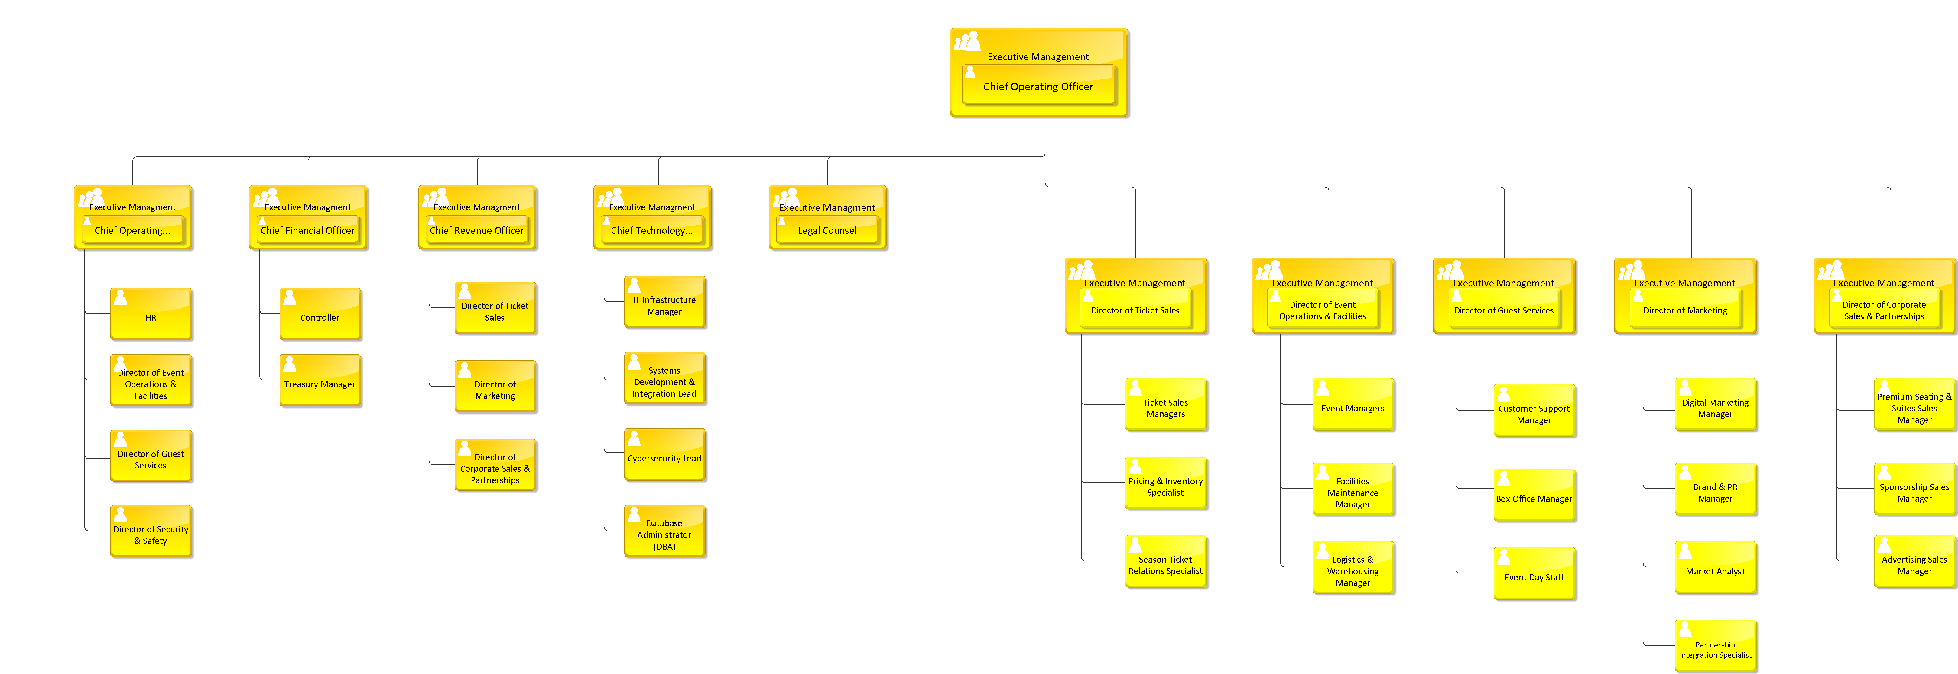

2.2. Objects

Objects

2.2.1. Advertising Sales Manager
 | Advertising Sales Manager

2.2.2. Box Office Manager
Box Office Manager

2.2.3. Brand & PR Manager
Brand & PR Manager

2.2.4. Chief Financial Officer
Chief Financial Officer

2.2.5. Chief Operating Officer
Chief Operating Officer

2.2.6. Chief Operating Officer
Chief Operating Officer

2.2.7. Chief Revenue Officer
Chief Revenue Officer

2.2.8. Chief Technology Officer
Chief Technology Officer

2.2.9. Controller
Controller

2.2.10. Customer Support Manager
Customer Support Manager

2.2.11. Cybersecurity Lead
Cybersecurity Lead

2.2.12. Database Administrator (DBA)
Database Administrator (DBA)

2.2.13. Digital Marketing Manager
Digital Marketing Manager

2.2.14. Director of Corporate Sales & Partnerships
Director of Corporate Sales & Partnerships

2.2.15. Director of Corporate Sales & Partnerships
Director of Corporate Sales & Partnerships

2.2.16. Director of Event Operations & Facilities
Director of Event Operations & Facilities

2.2.17. Director of Event Operations & Facilities
Director of Event Operations & Facilities

2.2.18. Director of Guest Services
Director of Guest Services

2.2.19. Director of Guest Services
Director of Guest Services

2.2.20. Director of Marketing
Director of Marketing

2.2.21. Director of Marketing
Director of Marketing

2.2.22. Director of Security & Safety
Director of Security & Safety

2.2.23. Director of Ticket Sales
Director of Ticket Sales

2.2.24. Director of Ticket Sales
Director of Ticket Sales

2.2.25. Event Day Staff
Event Day Staff

2.2.26. Event Managers
Event Managers

2.2.27. Executive Management
 | Executive Management

2.2.28. Executive Management
Executive Management

2.2.29. Executive Management
Executive Management

2.2.30. Executive Management
Executive Management

2.2.31. Executive Management
Executive Management

2.2.32. Executive Management
Executive Management

2.2.33. Executive Managment
Executive Managment

2.2.34. Executive Managment
Executive Managment

2.2.35. Executive Managment
Executive Managment

2.2.36. Executive Managment
Executive Managment

2.2.37. Executive Managment
Executive Managment

2.2.38. Facilities Maintenance Manager
Facilities Maintenance Manager

2.2.39. HR
HR

2.2.40. IT Infrastructure Manager
IT Infrastructure Manager

2.2.41. Legal Counsel
Legal Counsel

2.2.42. Logistics & Warehousing Manager
Logistics & Warehousing Manager

2.2.43. Market Analyst
Market Analyst

2.2.44. Partnership Integration Specialist
Partnership Integration Specialist

2.2.45. Premium Seating & Suites Sales Manager
Premium Seating & Suites Sales Manager

2.2.46. Pricing & Inventory Specialist
Pricing & Inventory Specialist

2.2.47. Season Ticket Relations Specialist
Season Ticket Relations Specialist

2.2.48. Sponsorship Sales Manager
Sponsorship Sales Manager

2.2.49. Systems Development & Integration Lead
Systems Development & Integration Lead

2.2.50. Ticket Sales Managers
Ticket Sales Managers

2.2.51. Treasury Manager
Treasury Manager

