**Members**: Zachary Cosenza, Oliver Mikhail Gaerlan, Lahiru Chamain Hewa Gamage

**Problem Statement**: Image/text recognition requires a lot of data to training, so dimensionality reduction techniques (such as PCA or SVD) may be incorporated into preprocessing techniques before traditional learners such as K-nearest neighbors (KNN) or support vector machines (SVM) are used. Additionally, how these dimensionality reduction techniques interface with data transform techniques such as discrete cosine transform (DCT) or discrete wavelet transform (DWT) and their combined effect on test error of image classification is unknown. We wish to explore these techniques in combination. Furthermore we would like to find out if less deep/complex convolutional/dense neural networks (NN) are sufficient for dimensionality reduced data to achieve a good classification accuracy compared to complex models like ResNet/AlexNet. This way we can investigate how dimensionality reduction affects image compression.

**Dataset Description and Location**: CIFAR-10 is a set of 60,000 32x32 RBG images with ten classes (0-9) which will be used for image classification training and testing. The dataset is divided into a 50,000 training and 10,000 test set.

**samples of CIFAR-10**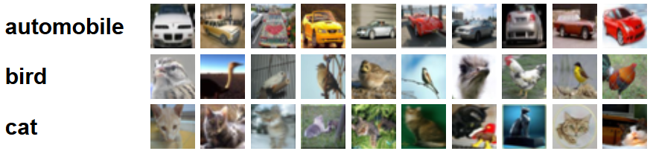

**Method Plan**: The goal of our project is to test the accuracy, speed and the complexity of various classification methods along with image compression algorithms and preprocessing methods. To this end, we will compare the RBG domain with DCT and DWT. After preprocessing, we will tune image compression with PCA. Then we will apply our classification algorithms on the dimension-reduced data set which include KNN, SVM and NN. Then we will experiment with CNNs to see if we can use a simplified network to obtain similar results with the dimension-reduced.

**Evaluation Plan**: The results we wish to compare include the accuracy of each combination of methods along with complexity, image bandwidth, training and inference time.

**References**:

Abouelnaga, Yehya, et al. "Cifar-10: Knn-based ensemble of classifiers." *2016 International Conference on Computational Science and Computational Intelligence (CSCI)*. IEEE, 2016.

Dan Fu, Gabriel Guimarães, et al.“Using Compression to Speed Up Image Classification in Artificial Neural Networks”