The Aeskulap Project
original website: http://aeskulap.nongnu.org
fork of the project: https://github.com/jenslody/aeskulap

Tutorials

Table of contents

Table of contents 2
Introduction 3
Reordering series 4
Default layout behaviour 4
Setting a custom layout 4
Reordering 5
“Single Series” mode 6
Toggling the “Single Series” mode 6
Directly switching to a series 6
Using the mouse 7
Window Center / Width 7
Zooming 7
Panning 7
Scrolling 7

Introduction
This document is currently a compilation of different tutorials and guidelines how to get things done with Aeskulap. Over time it will hopefully evolve into a usable user guide. In it's current state it's far from being complete (or even usable).
As Aeskulap is an open source project everyone is invited in helping to improve this document. The more people contributing, the better the documentation will get in time. If you're interested in improving this tutorial please email the edited version to me. Please give also a short description on your changes. All contributors will be listed in “Contributors” section.

Thanks for your help, enjoy using Aeskulap.
Alexander Pipelka <xxxx@xxx.xx>
The original author Alexander Pipelka does no longer work on Aeskulap, due to lack of time.
I forked the project on github, to repackage it for Fedora, to fix bugs, update the build-system and probably start to enhance the project.
Jens Lody <fedora@jenslody.de>

You can download the source-code from https://github.com/jenslody/aeskulap .

Contributors
Name | Task

Reordering series

Default layout behaviour
Open a study of your choice. Aeskulap will automatically choose a layout which displays all series of the study. This example study contains 6 MR series.
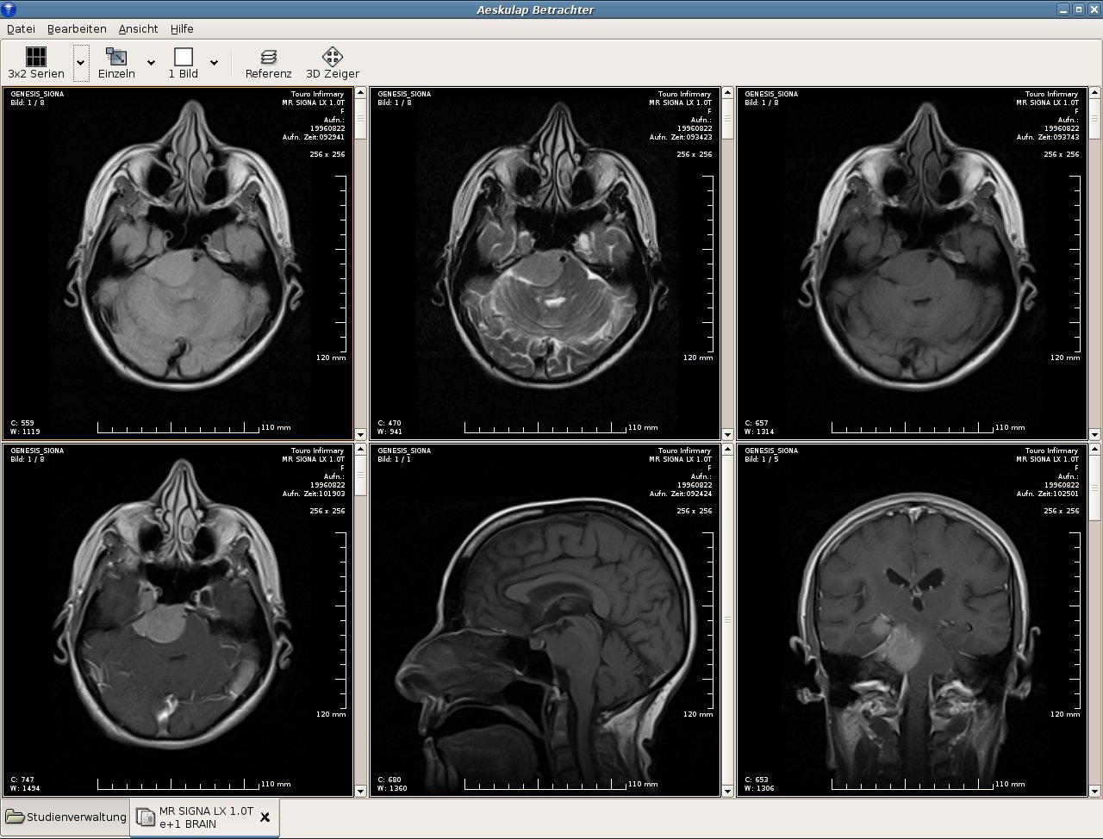

Setting a custom layout
On the left side of the upper toolbar you will find a “Menutoolbutton” for switching the current layout of the study. By pressing the button the layout of the study will cycle though all available settings.
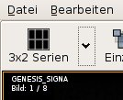
If you press the “arrow” right of the button a pop-up menu with all available layouts will show up.
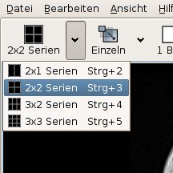
Now select e.g. the “2x2 Series” layout.
The study-view will change it's layout:

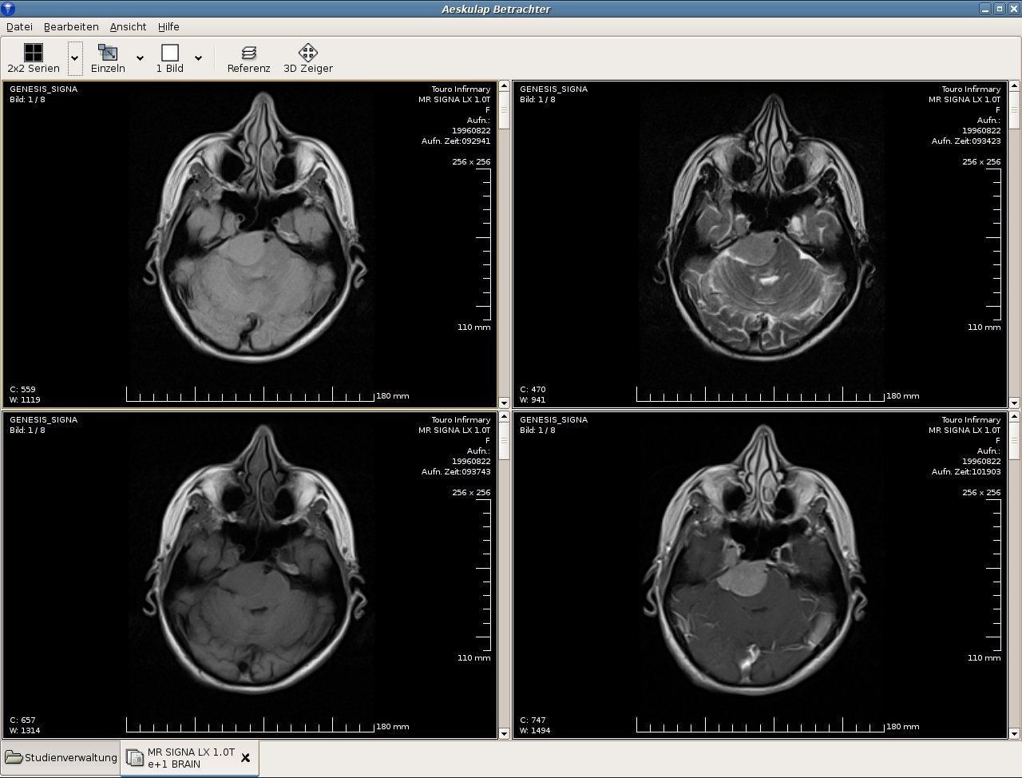

Reordering
Now we would like to reorder the series of the study.
Select a series you would like to change (just click into it with the left mouse button).
Now hold the <CTRL> key and press the right mouse button inside the series view.
A menu with thumbnails of all series (not only the visible ones) will pop up.

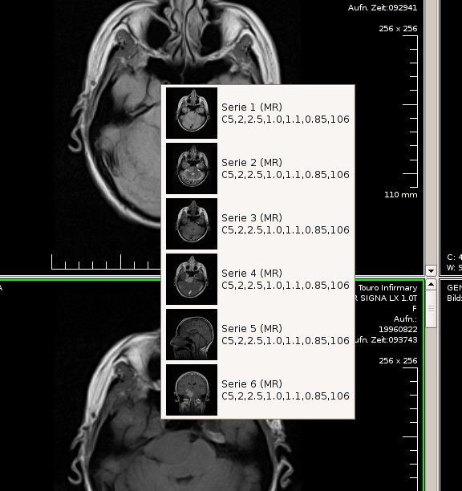
Select the new series from the menu.
The current and the selected series will be exchanged.

“Single Series” mode
Your layout usually contains 2 or more series. If you would like to view only 1 series of the cur rent
study you need to switch to the “Single Series” mode.

Toggling the “Single Series” mode
Select a series of a currently opened study by clicking into its view with the left mouse button.
In the upper Toolbar you will find a “Toggle-Button” enabling / disabling the “Single Series” mode.
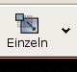

Directly switching to a series
It's possible to switch directly to a series by selecting the series from a menu. Right of the “Single Series” button you will find an “arrow”. If you press this button a menu with all available series will pop up.
Select the desired series from the menu. The selected series will be displayed in the “Single Series”
mode.
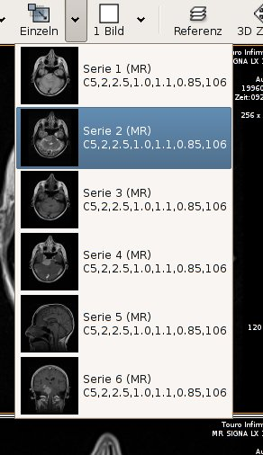

Using the mouse
It might sound strange that there's a tutorial about using the mouse but within Aeskulap the mouse and its buttons do a lot of tasks. For all functions you will need a 3-button mouse with scroll-wheel.

Window Center / Width
That's a fairly simple one:
Move the mouse to any display. Press the left mouse button and move it while holding the button down.
Movement will change Center / Width values:
- left – right: change the window center
- up – down: change the window width

The current window values will be displayed at the bottom left of the display.
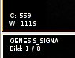

Zooming
Press the middle mouse button, on a scroll-wheel mouse you have to press (not rotate) the wheel, hold the button and move the mouse up and down.
Movement will change the zoom level:
- up: zoom in
- down: zoom out

Panning
Press the right mouse button, hold the button and move the mouse. Movement will pan the image in the corresponding direction. You need to zoom into the image first to be able to pan.

Scrolling
Use the mouse-wheel to navigate through all the images of a series. Alternatively you may use the scrollbar right of the display.

