Task #1
Write the functional test cases that belong to the smoke test to cover the outlined section in the picture https://parabank.parasoft.com/parabank/index.htm
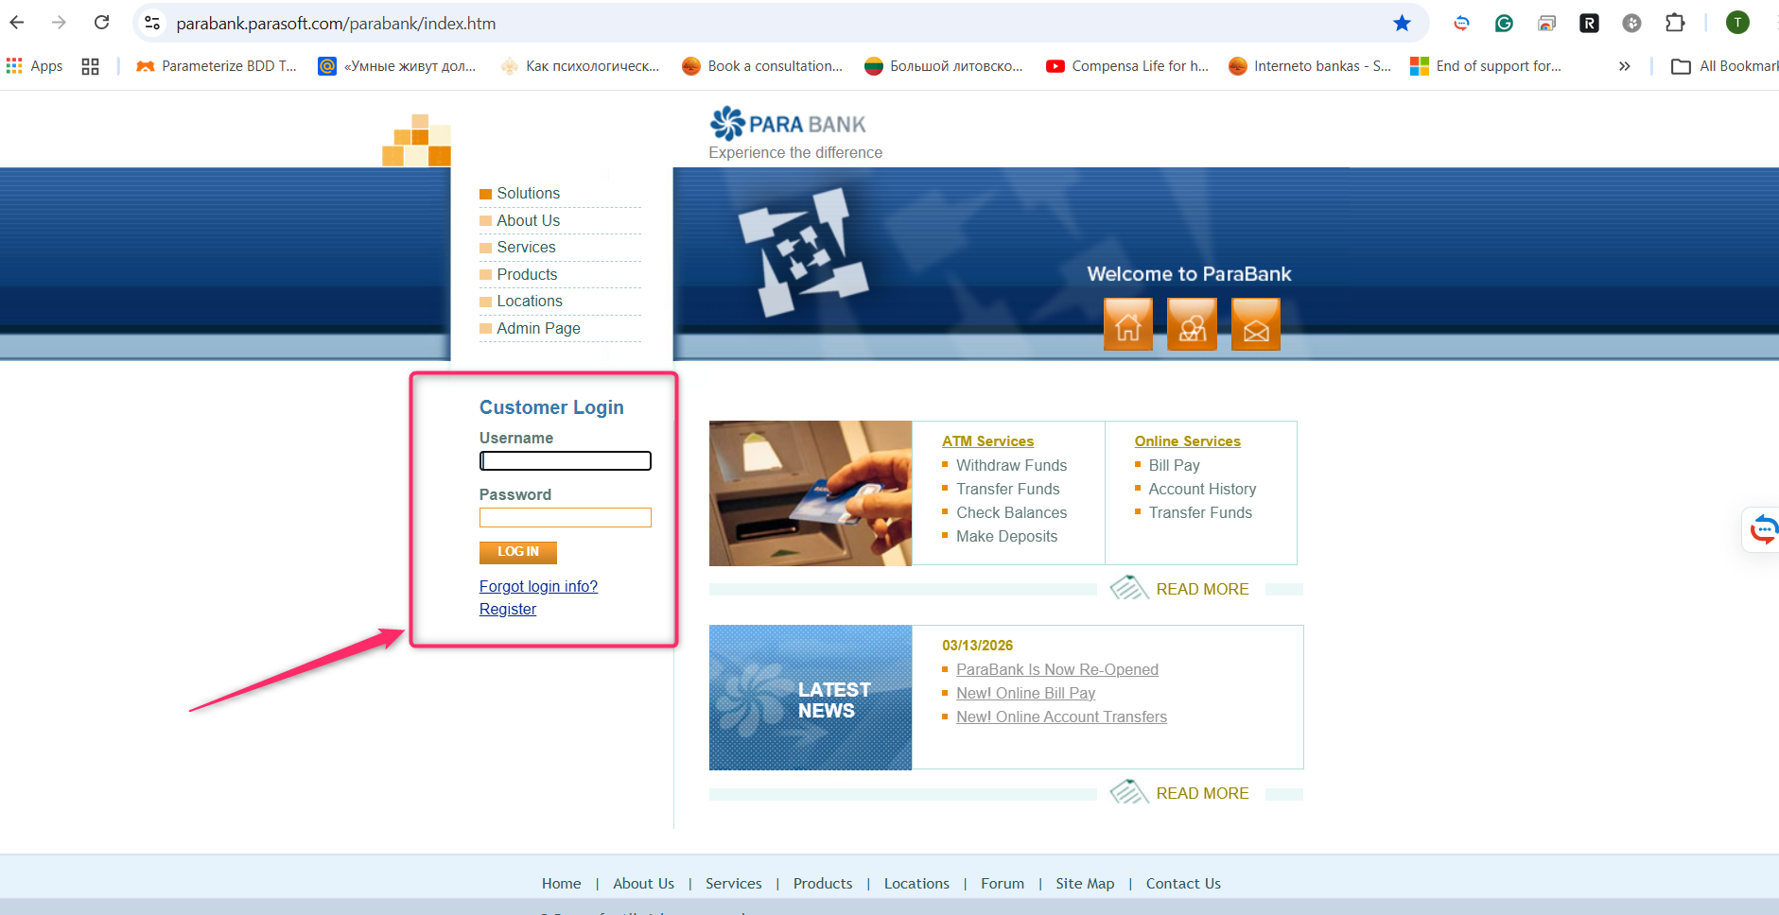

Deadline is 2026.03.31
Dear students, you can attach your text file with written test cases directly in the opened assignment body or put your file into your GIT repository and provide the reference to it.

