**Report**

Assignment 2

*Mikhail Ostanin, Stanislav Mikhel*

**Virtual Joint Model**

For each leg of the given robot VJM model has the following structure (figure 1). Here we assume that base and platform are rigid. In order to build VJM model we introduce 1 degree of freedom (DOF) spring for active joint and two 6 DOF springs for links.

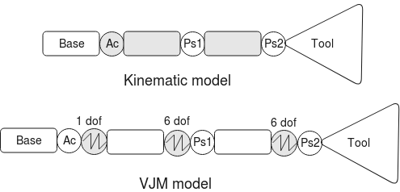Figure 1. VJM model structure structure.

Matrix transformation model can be found as:

where - angle of active joint, - passive angles, - length of the links, - virtual joints, - 6 DOF virtual joint transformation.

**Stiffness calculation**

In order to find stiffness matrix in Cartesian space we have to know Jacobians for virtual and passive joints, and also stiffness in joint space. Both Jacobians was calculated with the help of numerical derivatives. Matrix has size 6x13 and implemented in function *J_theta*() using zero-value matrix derivative. Size of matrix is 6x2, it can be calculated by the function *J_passive*(). Stiffness matrix in joint space for one link was calculated in assumption that the cross section has form of quill cylinder. Its implementation can be found in *K_theta*().

The result Cartesian stiffness matrix is calculated using analytical solution:

,

where , . Details can be found in function *Kc_leg()*.

Aggregated stiffness matrix can be found as

where - inverted differential relation between the coordinates of the I-th virtual spring and the end-point frame, - connection vector. Result can be found in function *Kc_full()*.

**Deflection map**

**Analysis of obtained results**

From comparison of obtained results with singularity map can be found that system dramatically lose its stiffness in case of singularity. In other cases stiffness is changed slightly, near the limits of work space it is low, while in central positions it is typically high. The reason is that in boundary positions one or two legs are close to straight line and power shoulder become higher, while in center distance (and torque) lower.

**Summary**

Stiffness model for 3RRR planar robot has been created. Here we assumed, that platform and base are rigid and legs has form of quill cylinder. In order to obtain the model VJM technique has been used. Jacobians for virtual and passive joints were calculated with the help of numerical approach. Cartesian stiffness matrix for each leg was calculated analytically and then found the aggregated matrix for the whole platform.