CMPT 276 D100, Group 3, Sprint 2

**Use Case Document for Mathematics Game**

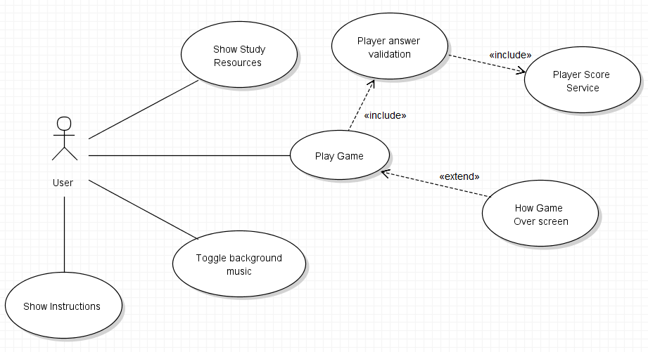Use Case Diagram

Use Case Descriptions

|  |  |
| --- | --- |
| Use Case Name: | Show Study Resources |
| Use Case Description: | This Use Case describes the process by which users can access resources to help in their learning of the topics covered in the game. |
| Actors: | User |
| Priority: | High |
| Status: | Completed |
| Pre-Conditions: | N/A |
| Post-Conditions: | Shows user a list of links of where they can learn about the topics covered in the application. Links are organized based on the topic covered and specific types of questions. |
| Extension Points: | N/A |
| “Used” Use Cases | N/A |
| Flow of Events | 1. The Use Case starts when the user selects the “Study” button in the main menu. 2. The system will display a list of available resources organized by general topics and specific topics. 3. The user selects a link.    1. If user selects a YouTube link, based on local device settings, Android will ask user to open link in built-in YouTube app or in a web browser, or will automatically open in default app set to handle YouTube links.    2. If user selects a regular webpage link, Android will ask user to select web browser to launch in (if more than one installed on local machine) or launch in default web browser. 4. The Use Case ends. |

|  |  |
| --- | --- |
| Use Case Name: | Play Game |
| Use Case Description: | The Use Case describes the process of which a user starts the game activity. It also makes calls to validate user answers and calls to display game over screen when player looses. |
| Actors: | User |
| Priority: | High |
| Status: | Completed |
| Pre-Conditions: | N/A |
| Post-Conditions: | Gives user questions to answer. Questions are based on topics covered in first year computing science courses including calculus, and discrete mathematics. |
| Extension Points: | Game over screen |
| “Used” Use Cases | Player answer validation |
| Flow of Events: | 1. The Use Case starts when the user selects the “Game” button in the main menu. 2. The system will display a short story of which the plot of the game is based on. 3. While the user does not run out of questions, run out of lives, or selects back on activity. 4. The system will display a question for the user to answer. 5. The user types in their answer with the keypad restricted input. 6. The system will validate the answer given.    1. If the answer is wrong, the console will display the correct answer. The user will lose an in-game life point.    2. If the answer is correct, the console will notify the answer is correct.    3. If no answer was given, the console will notify the user that no answer was given. The system will not proceed until an answer is given.    4. If the answer given is “0451”, cheat code is activated and the user skips to the end of the game.    5. If the answer given is “0000”, cheat code is activated and the current question will be skipped.    6. If the answer given is “0099”, cheat code is activated and number of lives is set to 99.    7. If the given answer is “1337”, cheat code is activated and system will print answer to current question onto the console.   end if   * 1. The user has run out of lives.   end loop   * 1. The user has answered all of the questions.   end loop   1. The system will display Game Over screen, listing the player statistics. 2. The Use Case ends. |

|  |  |
| --- | --- |
| Use Case Name: | Toggle Background Music |
| Use Case Description: | This Use Case describes the process of which the user can toggle the application background music on or off. |
| Actors: | User |
| Priority: | Low |
| Status: | Completed |
| Pre-Conditions: | Music was playing or stopped. |
| Post-Conditions: | Allows the user to toggle the background on and off. |
| Extension Points: | N/A |
| “Used” Use Cases | N/A |
| Flow of Events: | 1. The Use Case starts when the user selects the “Settings” button in the main menu. 2. The system will display a button to “Toggle Music”. 3. The User presses the button.    1. The background music will stop if music was initially playing.    2. The background music will play if music was initially stopped 4. The Use Case ends. |

|  |  |
| --- | --- |
| Use Case Name: | Show Instructions |
| Use Case Description: | This Use Case describes the process of which the user can view the underlying story of the game and instructions of how to play the game. |
| Actors: | User |
| Priority: | Low |
| Status: | Completed |
| Pre-Conditions: | N/A |
| Post-Conditions: | Gives the user a brief description of the underlying story of which the game is based. Also |
| Extension Points: | N/A |
| “Used” Use Cases | N/A |
| Flow of Events: | 1. The Use Case starts when the user selects the “Instructions” button in the main menu. 2. The system will display a brief description of the underlying story of the game. The system will also display an example of how answers should be answered in the game. 3. The Use Case ends. |

|  |  |
| --- | --- |
| Use Case Name: | Player Answer Validation |
| Use Case Description: | This Use Case interacts with the Player Score Service to apply changes to the player score |
| Actors: | Playing Game process |
| Priority: | Low |
| Status: | Completed |
| Pre-Conditions: | Answer from player is handed from Play Game. |
| Post-Conditions: | Answer is validated and deduction of score is applied if necessary. |
| Extension Points: | N/A |
| “Used” Use Cases | N/A |
| Flow of Events: | 1. The Use Case starts when the user submits an answer in the game. 2. The system will compare the user’s answer if the answer game built in the game. 3. The system will send a request to the Player Score Service for a deduction in player life-points if answer is wrong. 4. The Use Case ends. |

|  |  |
| --- | --- |
| Use Case Name: | Player Score Service |
| Use Case Description: | This Use Case responds to requests made by the Player Answer Validation. |
| Actors: | Player Score Service |
| Priority: | Low |
| Status: | Completed |
| Pre-Conditions: | Request for player life-point deduction is made |
| Post-Conditions: | Player life-point and score updated. |
| Extension Points: | N/A |
| “Used” Use Cases | N/A |
| Flow of Events: | 1. The Use Case starts when the Player Answer validation sends a request. 2. The system will deduct a life-point if that request was made 3. The Use Case ends. |

|  |  |
| --- | --- |
| Use Case Name: | Show Game Over screen |
| Use Case Description: | This Use Case responds to game over request from Play Game. |
| Actors: | Play Game |
| Priority: | Low |
| Status: | Completed |
| Pre-Conditions: | Player has run out of lives or completes all questions |
| Post-Conditions: | Game Over screen is displayed. Gives option to play again. |
| Extension Points: | N/A |
| “Used” Use Cases | N/A |
| Flow of Events: | 1. The Use Case starts when the player has run out of lives or questions and the Play Game service calls Game Over screen. 2. The system will show the user a Game Over screen. 3. Option to play again is given.    1. New game starts if player chooses to play again.    2. Brings user back to main menu if chooses not to play again. 4. The Use Case ends. |

Resource

<http://www.ibm.com/developerworks/rational/library/content/legacy/parttwo/1000/0670/0670_Schneider_Ch07.pdf>