Playtest Rules
Skirmish test, 2 players only. 2018-04-22

Create Warband
Pick 40 points worth of figures. Point cost of figures are inside shield icons. Representation of armor:

Visual | Armor Type | Armor Value
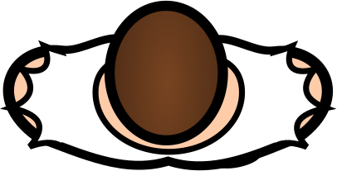 | No armor | 0d
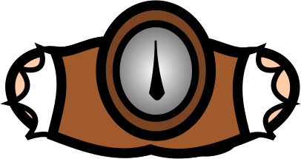 | Light armor | 1d
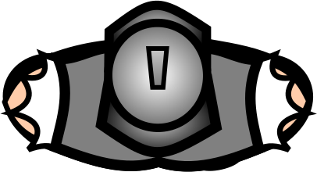 | Heavy armor | 2d

Other equipment:
Hand Weapon: Melee, 2d
Spear: Melee, 2d, Reach
Two Handed Weapon: Melee, 3d
Polearm: Melee, 3d, Reach
Shield: Special
Bow, Crossbow: Ranged, 3d, Base Range 6
Shortbow, Light Crossbow: Ranged, 3d, Base Range 4

Setup Scenario
For now, use "Bridge Crossing" scenario. Randomly determine which player is Attacker (highest roll). Attacker deploys first, Defender deploys second. Defender starts with Initiative.

Bridge Crossing

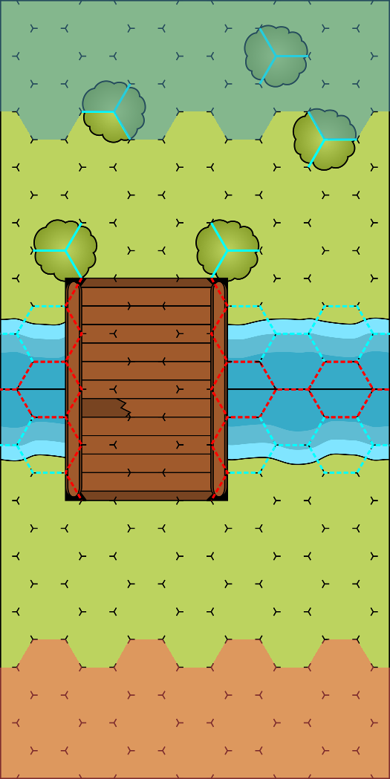
Scenario Setup: Defenders deployment zone is at the stop. Attacker deployment zone is at the bottom. Attacker deploys first. Defender has initiative.
Scenario Objectives: Attacker, move at least one of your figures out of the map through Defenders deployment zone. Defender, you win at the end of 6th round.
Scenario Rules: Attacker figures may move off the map through top map edge.

Encounter (Playing the Game)

Rolling Dice
Two important concepts, Base Dice and Die Step. Whenever you see modifier with "d" suffix it affects Base Dice, if you see modifier without "d" it affects Die Step. Notation for rolls is "Bd +/- S", where B is Base Dice and S is Die Step. Base Dice represents range of results while Die Step represents difficulty of obtaining result.
If Die Step is positive, add that number of dice to your roll and then chose and remove that many dice from your roll (you are left with Base Dice number of dice). If Die Step is negative, add that number of dice to your roll and then your opponent will chose and remove that many dice from your roll.
If not noted differently, after it is decided which dice to keep, sum all hits rolled and subtract all skulls rolled, this is the result of your roll.
Note: Melee weapons adds 1 additional hit for every Advance rolled after counting hits.

Game Round
Encounter is played out in rounds. Before starting a round all players should do a Tactics Test in order of Initiative (player with initiative first). At the start of round, all figures are Readied, so they can be Activated during current round. Players take turns Activating one Ready figure at a time, starting with player with Initiative. Once figure is Activated it is not considered Ready anymore. After all figures have Activated, round is over. At the end of a round, player with Initiative Loses Initiative. If you have no figures on map at the end of game round, you lose.

Tactics Test
Depending on number of figures you still have on map, you will roll nd – 1 where n is:
- at least 2 figures: 1d
- at least 5 figures: 2d
- at least 10 figures: 3d

Example: If you have 4 figures, you would roll 1d – 1.

If you roll -1 hit, you lose the initiative. For every Hit rolled, you may spend 1 of these Hits during figure activation for that figure to gain 1 Attack. For every Advance rolled, you may spend 1 of these Advances during figure activation for that figure to gain 2 Movement Points.

Losing Initiative
Only player with Initiative can lose initiative. When you lose initiative next player gains Initiative. Initiative Order is order in which players activate figures. When you lose initiative you move to last place in initative order.

Activation
When you (figure) activate, you gain 2 Actions and 1 Free Interact. During your activation you may spend these actions as concrete actions that will give Movement Points, Attacks and Interacts. You may use the same action for as long as you have actions to spend.
Concrete actions are:
- Movement Action: gain 4 Movement Points
- Attack Action: gain 1 Attack for one of your weapons
- Interact Action: gain 1 Interact
Movement Points can be used during your activation to move.
Attacks can be used during your activation for attacking with equiped weapon.
Interact can be used during your activation for interacting with special equipment or map elements.
Free Interact is not the same as Interact and can't be used in place of Interact. Interact can be used as Free Interact.

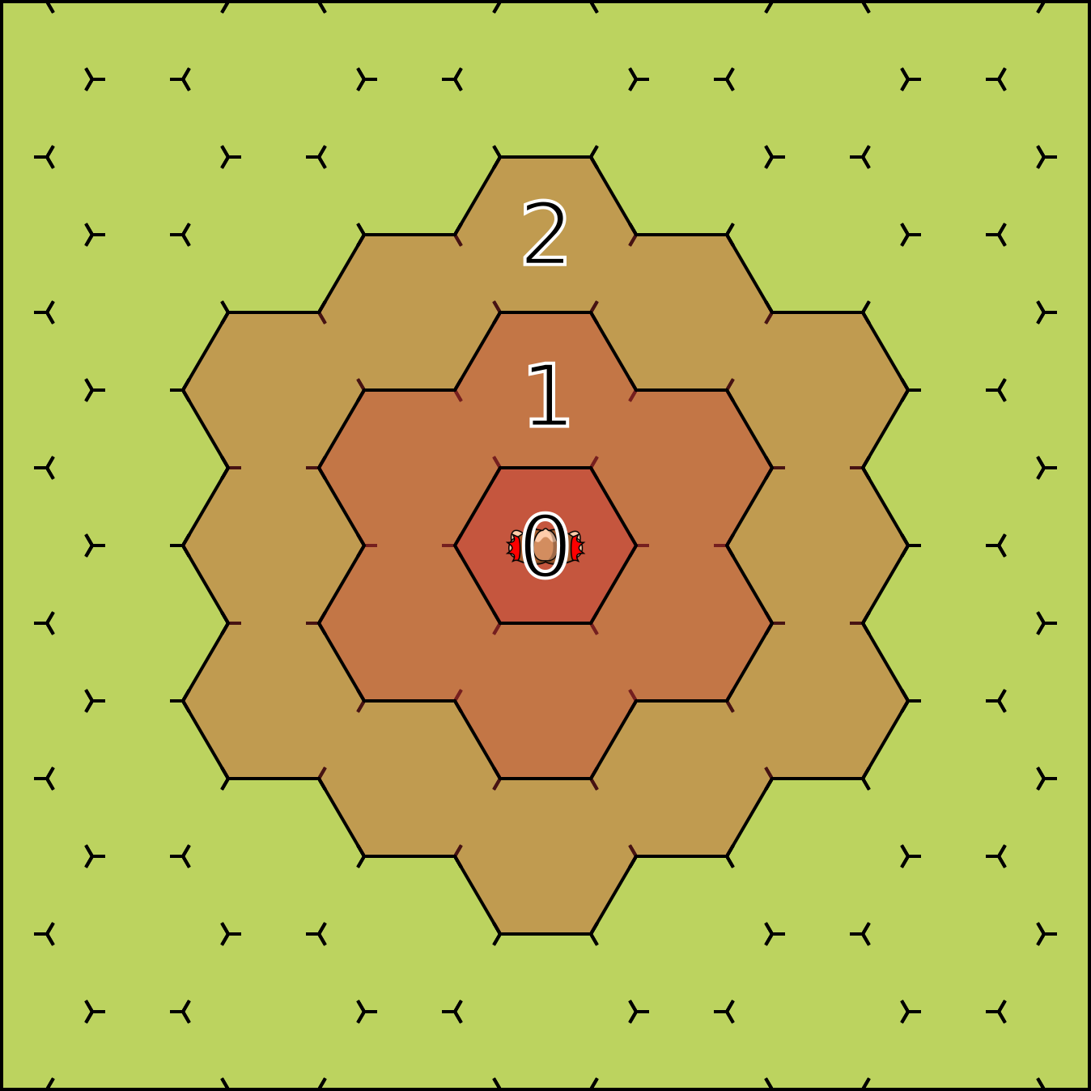
Engagement Zone
Figures equiped with melee weapons have Engagement Zone of 1. Spaces adjacent to you up to Engagement Zone value are inside your Engagement Zone. If you have weapon with Reach, spaces adjacent up to 2 are inside your Engagement Zone. Reach doubles Engagement Zone. Moving out of space inside opponents Engagement Zone costs more Movement Points. If you are in enemies engagement zone you are Engaged by that enemy.

Movement
Movement is done by spending Movement Points. You move through edges into adjacent space. Spaces are adjacent if they share non blocking edges. Moving to adjacent space costs 1 Movement Point but may be modified by circumstances. Edges can be Free, Blocking, Impeding or Obscuring.
- Free edges have no special rules and have no representation
- Blocking edges. You may not move through blocking edge. They are represented by red lines
- Impeding edges. Moving through impeding edge costs 1 additional Movement Point. They are represented by light blue lines
- Obscuring edges. Block line of sight, corner where 2 or more obscuring edges intersect is considered obscuring. They are represented by solid line.
If line is dashed it is not obscuring. Edge can be be Free, Blocking or Impeding, never a combination of the 3. Edge can be Obscuring in addition to being Blocking or Impeding.
You may not move to space containing enemy figure.
Moving to space containing friendly figure costs 1 additional Movement Point.
You may not Attack, Interact or end your Activation while sharing space with other figure.
While moving, you lose your Engagement Zone.
For every enemy you are engaged with that is not engaged by ally, add 1 to Movement Point cost (to leave current space).
Check image below for example of movement costs when moving away from engaged opponents.
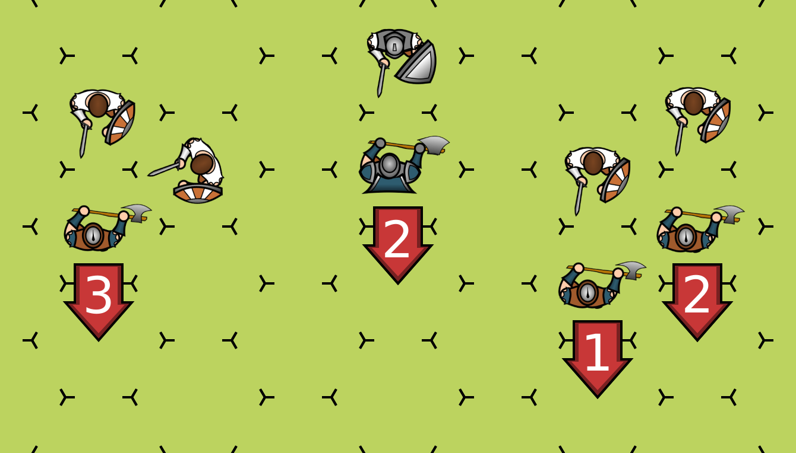

Line of Sight (LoS)
Line of Sight is mostly used for ranged attacks. Edges of spaces that contain figures other than attacker and defender are considered obscuring for the purposes of LoS. This means that figure that is targeted can't block LoS to itself and attacker can't block LoS by itself.
Chose one corner of your space and draw imagionary lines toward all corners of target space. Count lines that are not going through obscuring edge or corner and for overlaping line pairs count only 1 of them.
Depending on number of non obscured lines:
- 1 or less lines: You have no LoS to target space
- 2 lines: You have LoS but target has Heavy Cover
- 3 lines: You have LoS but target has Light Cover
- 4 or more lines: You have full LoS to target space

Ajacency
Space is considered adjacent to other space if they share non blocking edge. Space is "adjacent up to x" if there is a path of adjacent spaces with length of up to x between them. "Adjacent up to 1" and "andjacent" means the same thing.
Note: Adjacency and Movement Point cost are not connected.

Attacking
You(as figure) attack by spending attacks. There are 2 types of attacks, melee and ranged attacks. Melee attacks require adjacency of up to your Engagement Zone value, ranged attacks require line of sight. You may check adjacency or line of sight before spending attack. When you spend attack, chose a valid target. Your weapon will provide you with how many dice you need to roll. Most of the time it's 2d for hand weapons and 3d for two handed weapons.

Melee Attack
Target for melee attack must be adjacent up to Engagement Zone value from you.
If your target has shield, apply -1 step to your attack (parry bonus).
Make attack roll. For every Advance rolled on chosen dice, add additional Hit (Melee weapon ability).

Ranged Attack
Target for ranged attack must be in your line of sight.
If your target has shield, apply -1 step to your attack (deflect bonus).
Apply range and cover penalties.
Range penalty: count number of spaces between you and your target, not including your space and counting target space. For every Base Range started after the first, apply -1 step penalty.
Example: For Base Range of 6 and target 13 spaces away you would apply -2 steps. If target was 12 spaces away, you would apply only -1 step.
Cover penalty: after checking LoS you will see if your target has No cover, Light Cover of Heavy Cover. Light Cover provides -1 step to your attack, Heavy Cover provides -2 steps to your attack.
Total all penalties and make attack roll.

Armor Roll
If your attack roll had at least 1 Hit, convert all of your hits to Damage at 1 for 1 basis. If target has at least 1d of Armor (Light Armor), target rolls Armor and for every Hit rolled remove 1 Damage from attack. Rolling negative on Armor roll does not increase damage.

Injury Roll
If there is still damage after armor roll, target needs to make Injury roll. First, if damage is over 3, for every point of damage above 3 apply -1 step to Injury Roll, then, if damage is over 3, it becomes 3. Now, target (defender) rolls 1d -1 for Injury roll (don't forget to apply penalties for damage over 3). Every Hit negates 1 point of damage, but Skull increases damage by 1. After rolling, check the following table:
- 0 dmg: no effect
- 1 dmg: target gains Stunned Condition
- 2 dmg: target gains Wounded Condition
- 3 dmg: target is Incapacitated and removed from map
- 4 dmg: target is Mortaly Wounded, removed from map and, in campaign, rolls for Mortal Wound.

Attack example: You have 2 handed axe and attack defender with shield. You roll 3d – 1. You roll 3 Hits and 1 Advance. Advance adds 1 Hit, bringing your attack roll to 4 Hits. Now your opponent rolls armor of 1d, he rolls Skull. Since negative Hits do not increase damage, your damage is still 4. Now target does Injury roll. First, your damage is downgraded to 3, but it will apply extra -1 step do roll. Your target now rolls 1d – 2 and rolls Blank. Your target is Incapacitated and removed from map.

Conditions
- Stunned Condition: during your activation you must spend 1 Action to remove this condition.
- Wounded Condition: during your activation you must spend 2 Actions to remove this condition.

Tabletopia notes

You can flip figure tokens to mark them as activated. Use star marker for Stunned Condition. Use blood drop marker for Wounded Condition.

