FutorkhniastbmlyFutorkhniastbmly


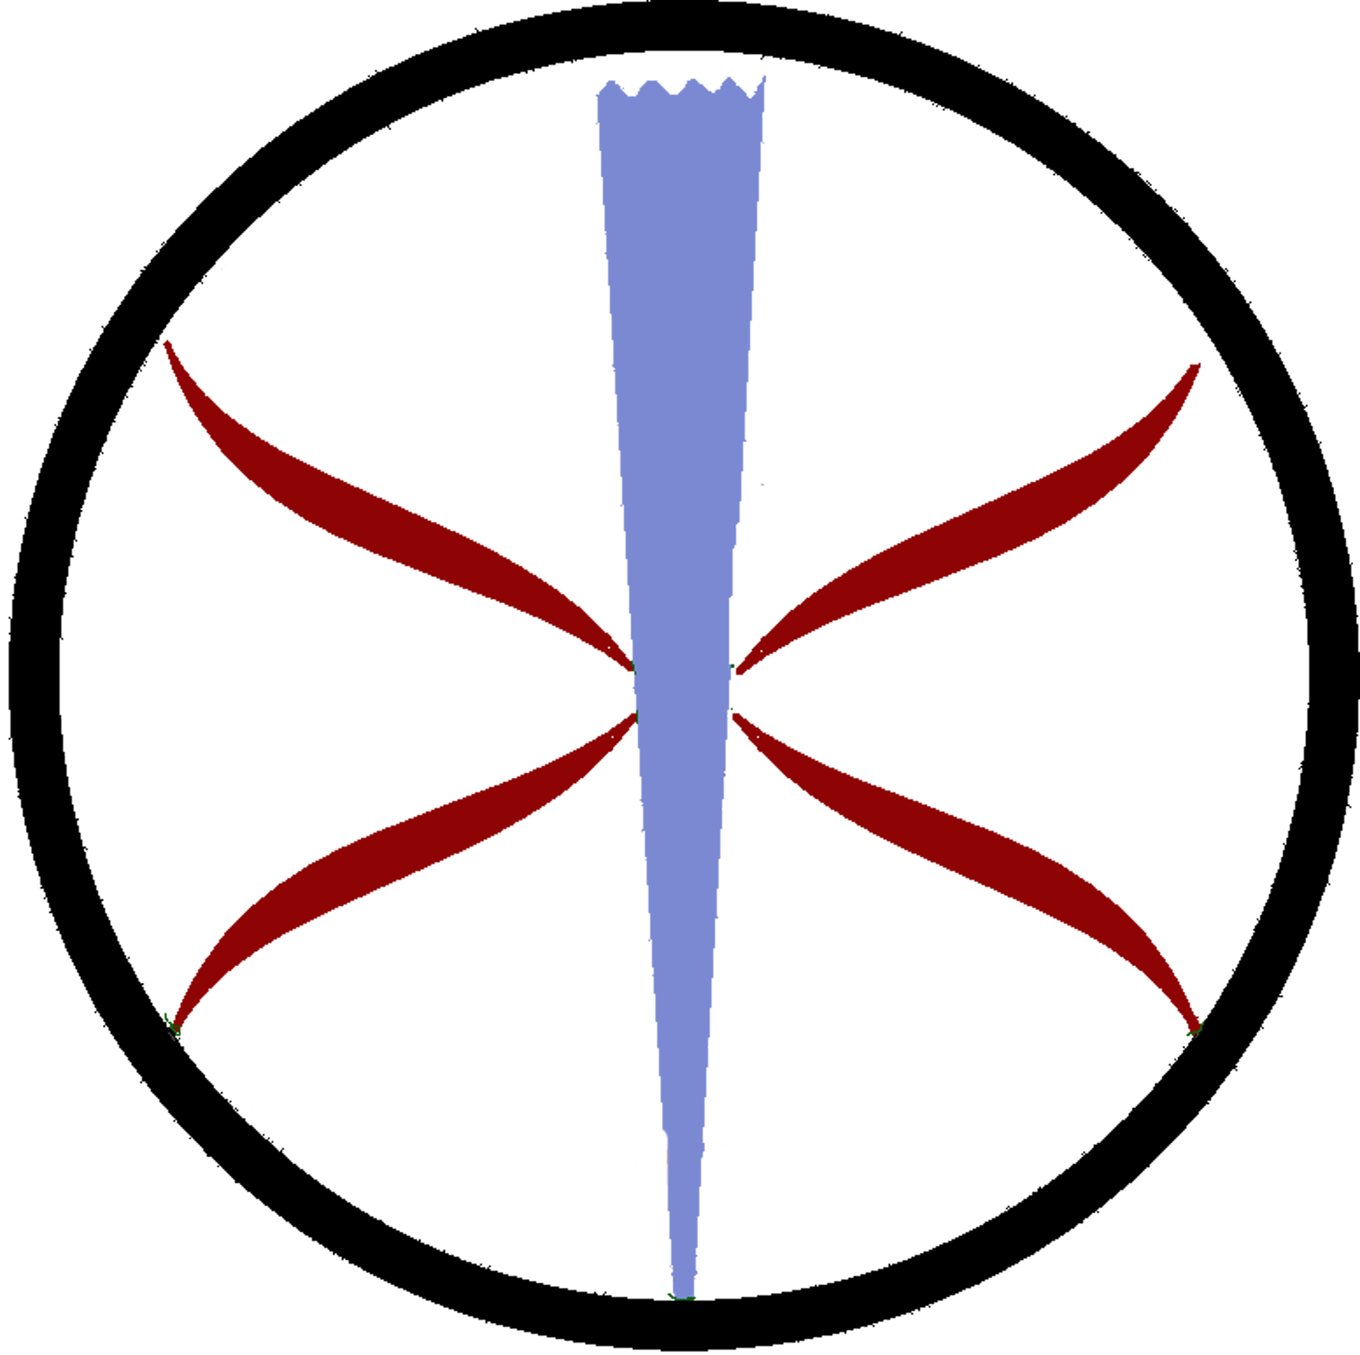
Asheville Stáv Club
Asheville, NC
instr. Josh Calhoun
josh@iceandfire.us

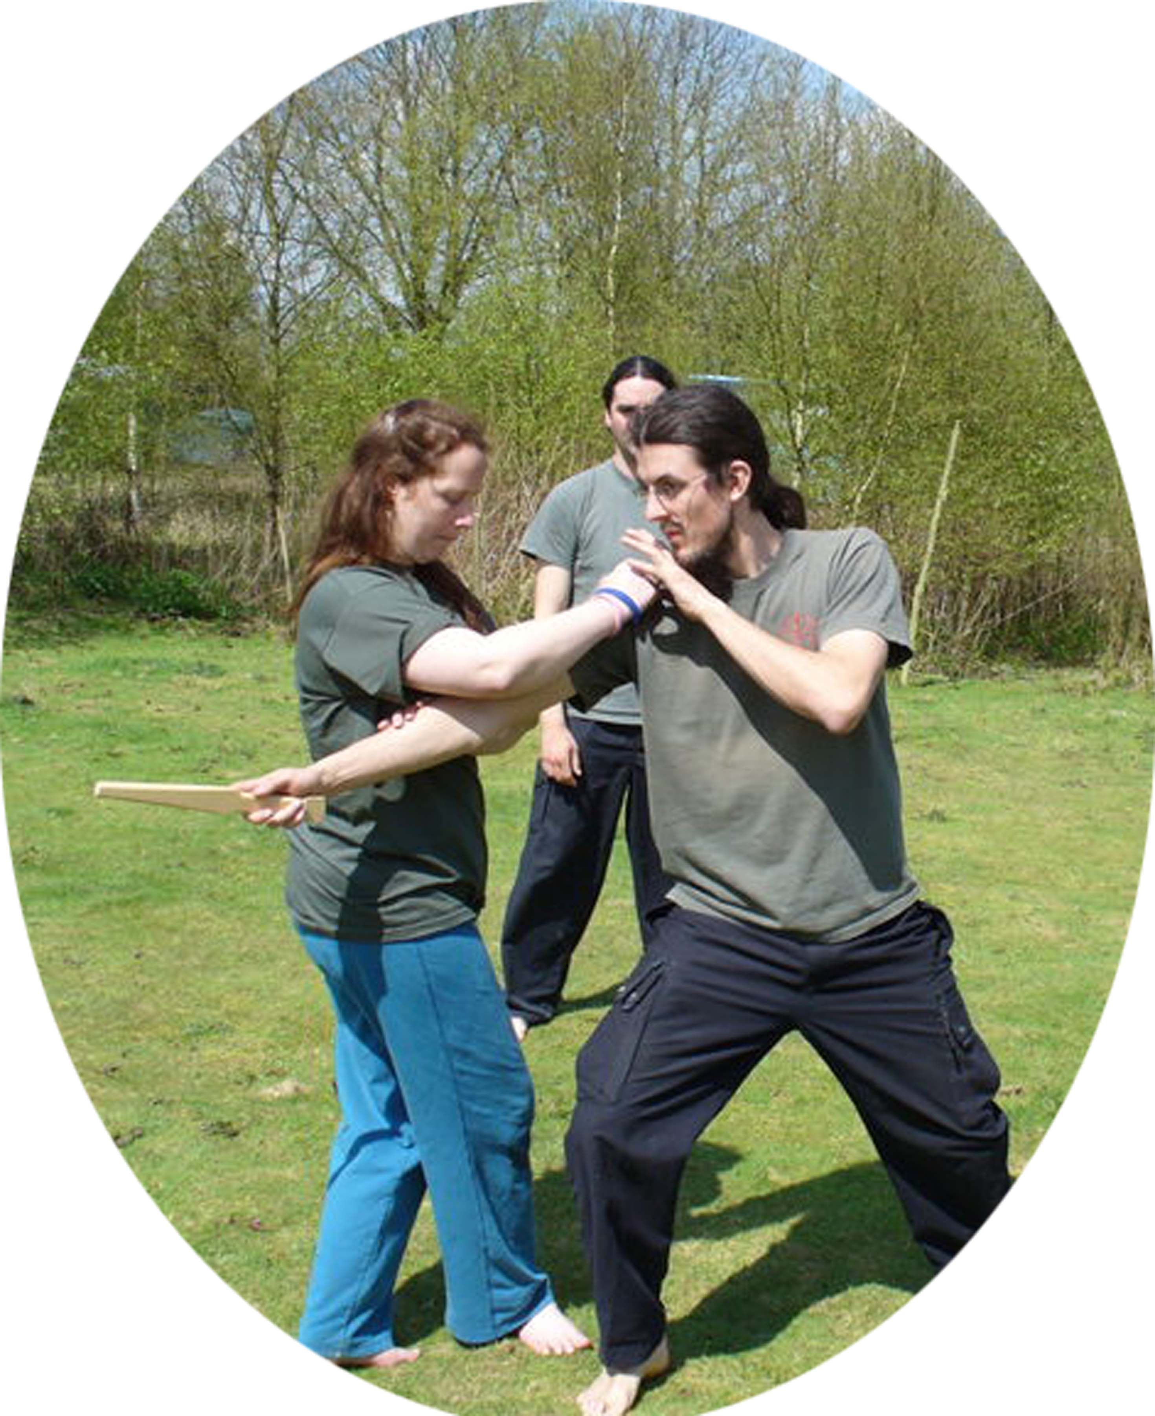
What is it?
Stáv is probably the only authentic European body, mind and spirit training and martial art to have been passed down complete to modern times. Stáv literally means: 'Knowledge of the rune staves.' The Martial application of Stáv may be the only “European” Martial Art to survive to the current day.

What Does it Cost?
Stáv Martial Practice is currently free to all. It will remain so throughout the year. Rate changes are announced yearly in January.

What Do we Learn?
Stáv Martial Practice gives participants a basic understanding of the Exercises, Principles and practice with the many applications of Stáv as a martial art. For those with some background, it serves as an excellent time to practice what you’ve already learned.

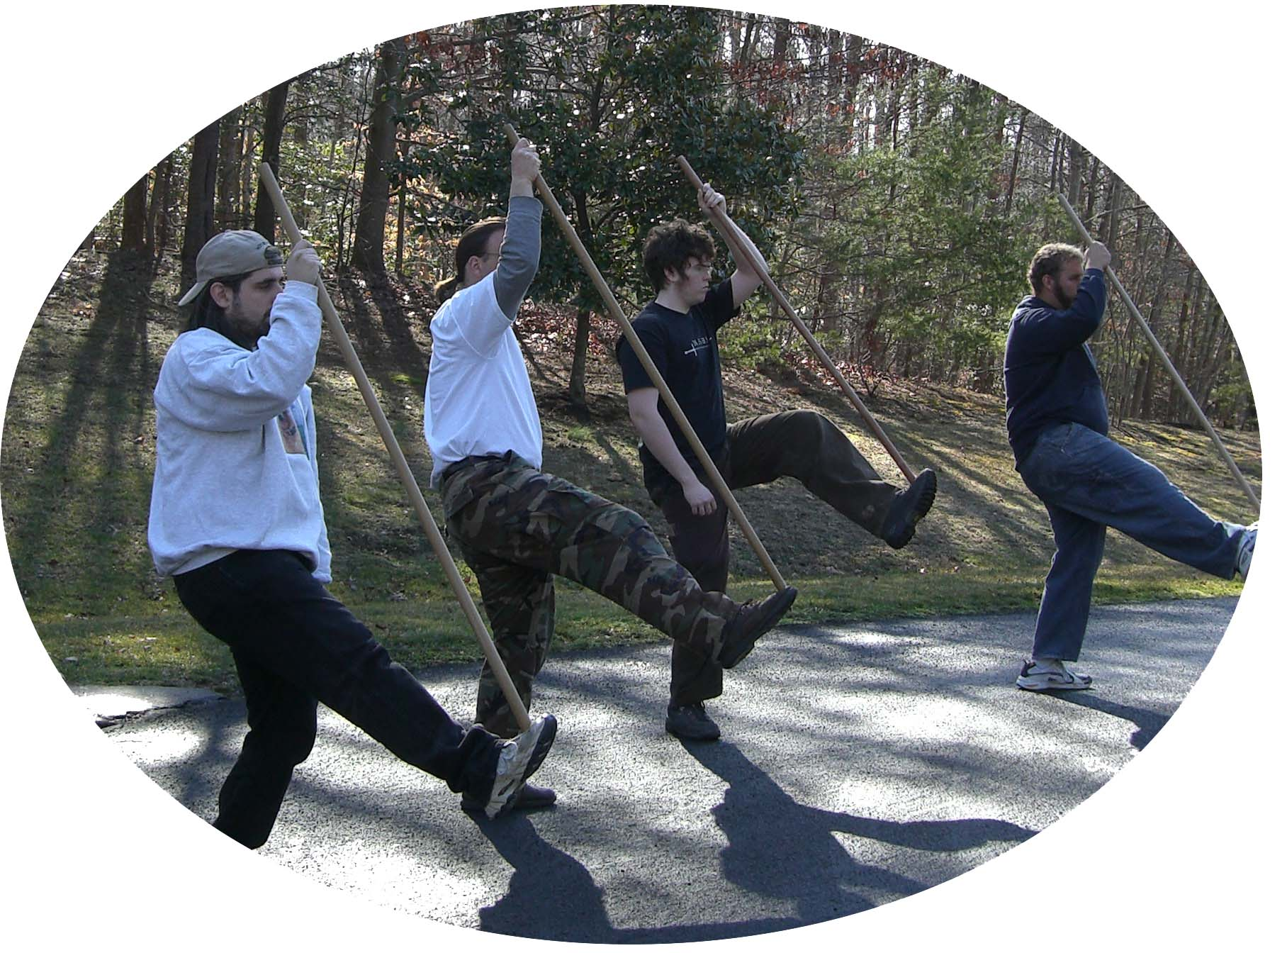
The Leaders:
Josh Calhoun is a Certified Practicioner and Instructor of the Butcher Line of Hafskjold Stáv. He has practiced Stáv since 2006 and was recently featured on public access cable.

Vital Information
Level: Beginner and Advanced Beginner
How Much: Free!
Where: By Arrangement (twice a week)
When: By arrangement
What to Bring?: Loose comfortable clothing suitable for gentle physical training, a staff if you have one (loaners are available ).
Contact Information: Josh Calhoun; josh@iceandfire.us; 865-776-7718
More Information: http://www.iceandfire.us

FutorkhniastbmlyFutorkhniastbmly

