FujorkhniastbmlyFujorkhniastbmly



Stáv Training Weekend
October 9-10 2010
With Graham Butcher
Chief Instructor of Ice and Fire UK
Asheville, NC

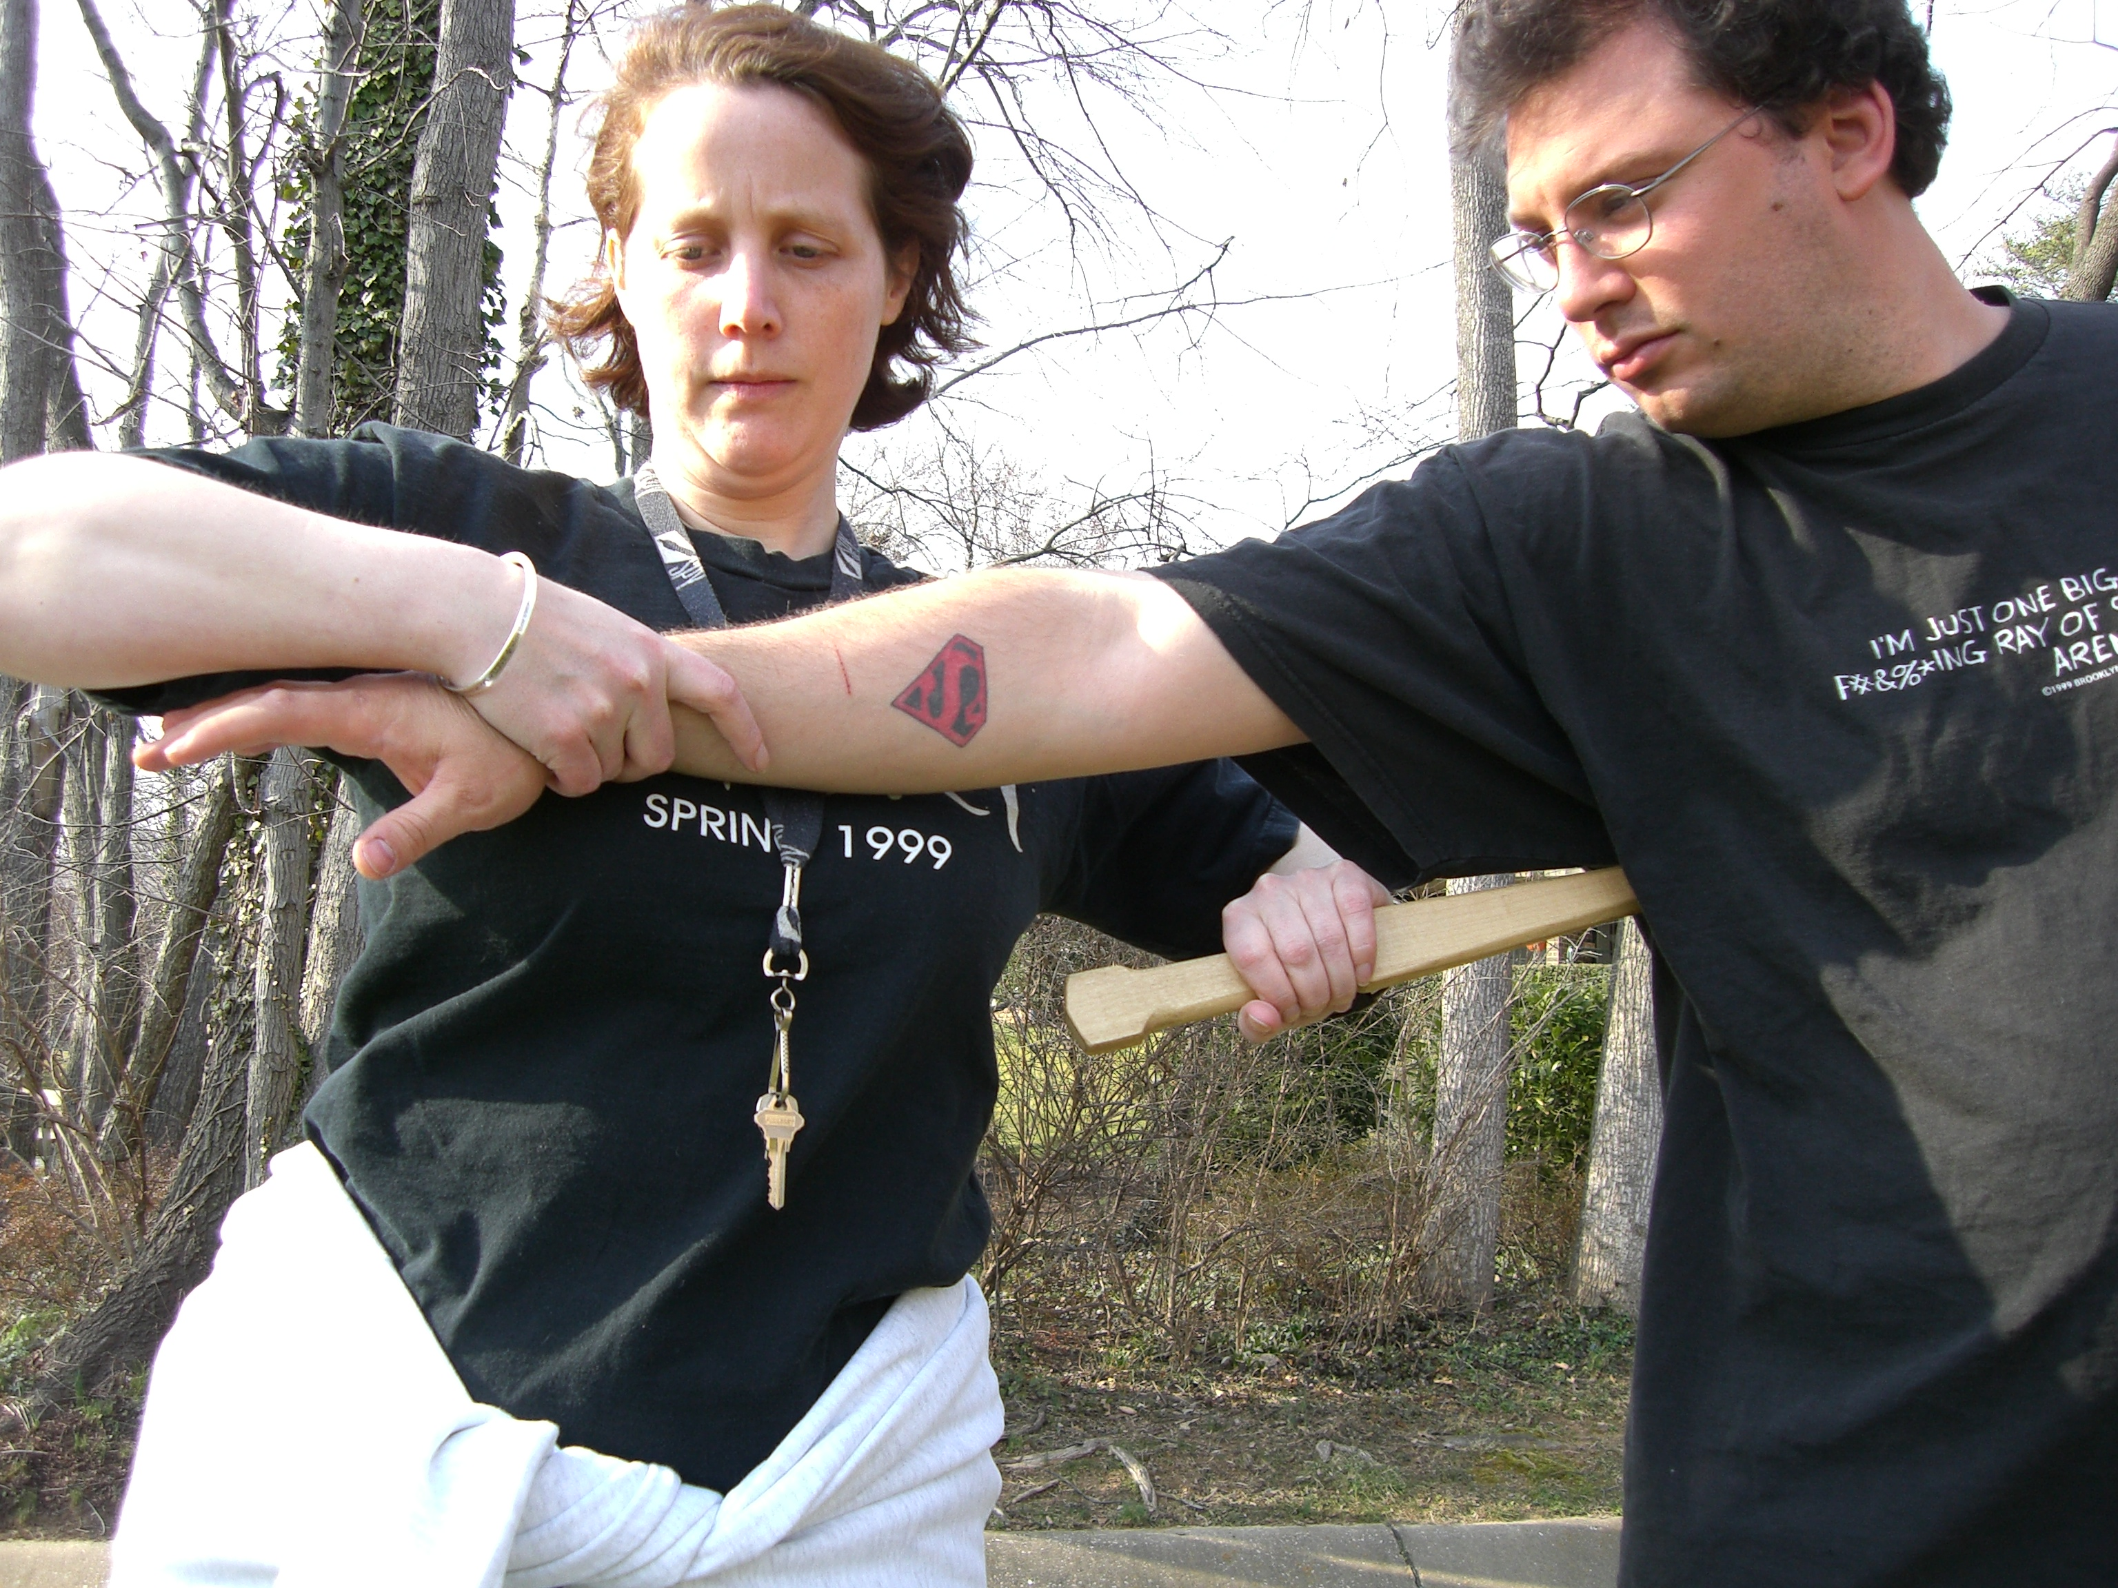
What is it?
Stáv is believed to be a 1500yr old Northern European martial art and mind/body/spirit which survived obliteration in a small isolated family in Norway. Stáv literally means: 'Knowledge of the rune staves.' The martial art of Stáv is gentle and suitable for most persons. This weekend of Stáv training will provide an excellent introduction to Stáv for beginners and an opportunity for continuation training for those with some experience.
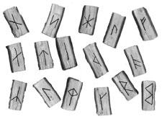
What will it cover?
The sixteen runic stances, basic rune lore, staff training, and movement. Also covered may be martial practice, staff weapon training, hand to hand training, healing skills, rune counseling, Fylgae and bindrunes.

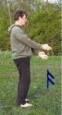
The Instructor:
Graham Butcher has been a master student of Ivar Hafskjold since 1992. He has been teaching Stáv since 1996 and created Ice and Fire in 2003 to promote and teach all aspects of Stav

Vital Information
Level: Beginner and Advanced Beginner
Meals provided: Saturday Lunch, Sunday Lunch
How Much?: Members $125 for the weekend; Non-Members $175. Day rate (any day of the weekend, $65 members, $90 non-members) Payment info on reverse. Limited overnight accommodation offered on a first paid first served basis.
What to bring?: Loose comfortable clothing suitable for gentle physical training, a staff if you have one (loaners are available ), a notebook and pen, an open mind.
Where? Carrier Park. Asheville NC.
Contact Information: Miki Tracey: tel 703 447-7311, or Email miki@iceandfire.us
Signup Online: at http://products.iceandfire.us. To pay by mail, see other side.
Plane, Train, Bus and Metro pickup available by ADVANCE request.

FujorkhniastbmlyFujorkhniastbmly
F u j o r k h n i a s t b m l y F u j o r k h n i a s t b m l y
Terms and Conditions Please read these carefully before booking on any course.
● Stav training is a gentle physical exercise, however please consult your physician to determine if you are physically capable of the exercise.
● Ice and Fire reserves the right to refuse any booking and return payment without giving a reason.
● In the event that you need to cancel a booking we will normally only make a refund if we can fill your place.
● In the event of Ice and Fire canceling a course all monies will be refunded.

Booking Form
Please book me on the on the Stav Semi-Annual Training to be held at Annapolis MD on the 9 and 10 October, 2010
Name: ____________________________________________
Address 1: _________________________________________
Address 2: __________________________________________
City: _______________ State: ______________
Zip Code: ______________ Country: __________________
Telephone: ________________ Cell: ____________________
Email: ______________________
Please note that we will send acknowledgment of booking and
joining instructions by email unless specified otherwise. If you particularly wish to receive these on paper we would appreciate it if you could enclose a stamped and addressed envelope.
I am a member of Ice and Fire USA and I am enclosing a check or money order for $125 ($65 day rate)
I am not a member of Ice and Fire and I am enclosing a check or money order for $175 ($90 day rate)
I would like to join Ice and Fire USA at $40 for the year and have the members discount price for
this course. So I am enclosing a check or money order for a total of $165 (or $105 day rate)
Please make checks made payable to Ice and Fire USA and send to Ice and Fire USA; 9703 Kings Crown Ct. Suite 102; Fairfax, VA 22031 USA
If you would like to pay by credit card “send money” to our Paypal account: admin@iceandfire.us
Please send a Paypal invoice to my email address: ____________________
Until you have paid (your check has cleared) you will not be considered for overnight accommodation, public transportation pickup, or loaners. Please keep this in mind if using the Paypal Option

