**In-Class Lab**

1. Create a Python Project with the name Lab4
2. Create a Python file called lab4.py
3. In file lab4.py Create function main in the format:

def main():

pass

if __name__ = “__main__”:

main()

1. Create a Python file with the name login.py

In file login.py create the following functions:

* Function generate_login(), the function takes three parameters (first name, last name and BCIT ID), and returns the default login password.
  + First and last name should be properly formatted i.e. the first character is upper case and the rest of the name is lowercase.

The password is generated as follows:

* + Get the first three letters from a properly formatted first name, if the first name length is less than three characters then the entire name will be used.
  + Get the first three characters from a properly formatted last name, if the last name length is less than three characters then the entire last name will be used.
  + Get the last three characters of the BCIT ID, if BCIT ID length is less than three characters then the entire ID will be used.
  + Concatenate the characters generated from the above instructions as follows:

(Characters from the first name + characters from the last name+ characters from BCIT ID)

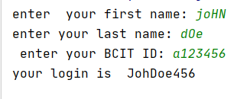

* Function change_password(),. The function will prompt the user to enter a new password, if the password meets the specifications, the loop terminates and the password will be returned otherwise a message including the password specifications and a request to enter another password” will be displayed and the user will be prompted to enter another password.

The password specifications are as follows:

* + The password must be at least seven characters long, it must contain at least one uppercase and one lowercase character.
  + The password must contain at least one numeric digit.
* In lab3.py:
  + Import module loging.py
  + In the main() function prompt the user to enter the first name, last name and BCIT ID
  + Create the default password by passing those values to function generate_login() and display the result.
  + Call function change_password() to prompt the user to change the default password.
  + Display the password generated by function change_password.

**HINT**: Consider breaking down the validation of the password into separate functions such as has_upper(),has_lower() and so on. Use these functions in change_password().

Sample output:

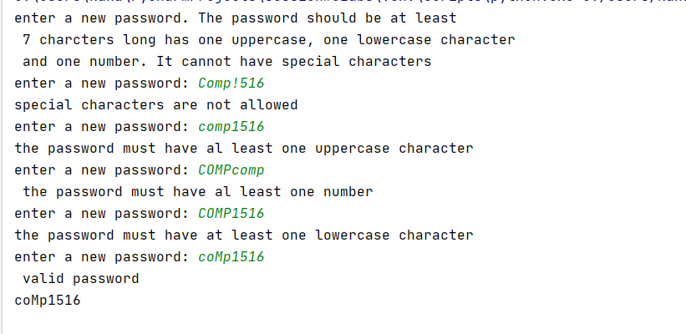

**Take-Home lab:**

Create a file with the name data_format.py

Add the following functions to file data_format:

* function get_book_info(), the function askes the user to enter the following information:
  + - book title
    - book ISBN
    - book author last name
    - book publisher
    - year published
    - book price

The function will eliminate leading and trailing spaces from title, ISBN, author name and publisher (use function strip ()).

The function will return a string from the given information in the same order specified above, separated by forward slash (/)

Note: price should be formatted to have two digits after the decimal point

* Function to_csv_format(), the function takes one parameter which is the string generated by get_book_info(), parse it and return a string of the provided information in a csv format.
* Function to_JSON_format(), the function takes a CSV formatted string and returns the corresponding JSON format string. Use String Methods find() ,string slicing and string concatenation to implement the required functionality.
* Create a main method as shown in the in-class lab section. Add function calls to get the book information, produce and display the csv format and the json format of the given information as shown.

Example of the expected input and output: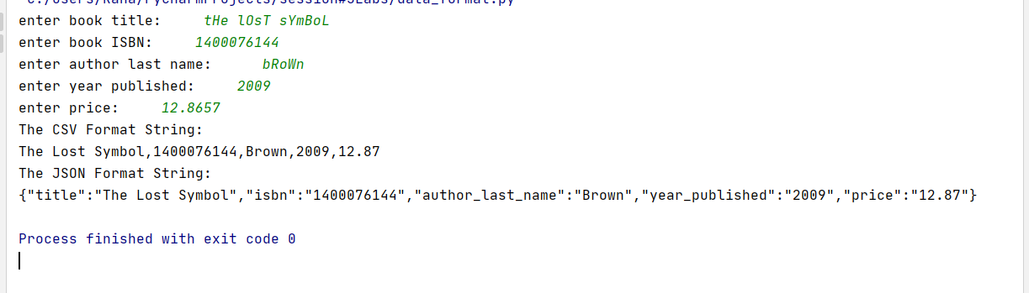

Best Practices

* Variable names are descriptive and should be lower_snake_case
* function names should be lower_snake_case
* All functions include Doc-String comments

Submission

Submit zipped folder containing project Lab4 to the dropbox before the deadline.