Wing Theatre Controller
User Manual
Show-control software for the Behringer Wing digital mixer, built for theatre and live production.

Contents
1. What This Software Does
2. Installation
3. Connecting to the Wing
4. The Cue List
5. Recall Scope — Choosing What Each Cue Changes
6. Fades
7. Auto Update
8. Groups
9. OSC Settings
10. Bitfocus Companion Integration
11. Show Files
12. About / Version
13. Troubleshooting
14. Credits

1. What This Software Does
Wing Theatre Controller connects to a Behringer Wing over the network and lets you:
- Capture snapshots of the console's current state
- Build a cue list and fire snapshots in sequence with a single GO
- Choose exactly which parameters each snapshot recalls (Recall Scope) — so a cue can change only the vocal mics, only the band, only FX, etc.
- Fade faders and send levels smoothly instead of jumping
- Keep snapshots automatically up to date while you mix, using Auto Update
- Trigger cues remotely via OSC or from Bitfocus Companion (with two-way status feedback)
It runs alongside the Wing, not instead of it — you still mix on the console or in Wing Editor as normal. Wing Theatre Controller listens to everything you do and remembers it in snapshots.
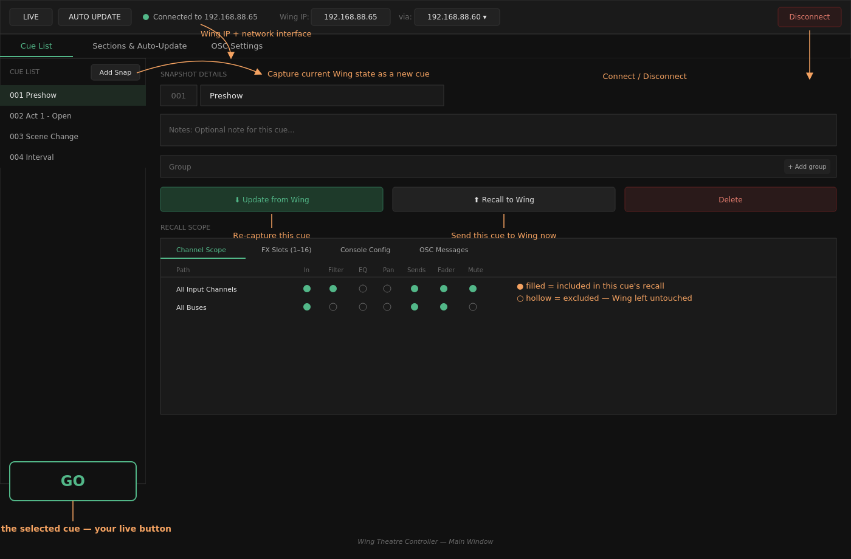
Main window overview — diagrams in this manual are illustrative layouts matching the app's real colour scheme; exact spacing may differ slightly from your installed version.

2. Installation

macOS
- Download WingTheatreController-macos.dmg from the release page.
- Open the DMG and drag Wing Theatre Controller into Applications.
- First launch: right-click the app → Open (unsigned app — one-time step).

Windows
- Download WingTheatreController-windows.zip.
- Extract it anywhere (e.g. C:\WingTheatre\).
- Run Wing Theatre Controller.exe.
- If Windows Firewall prompts you the first time you enable the Companion TCP server, click Allow access (needed so Companion on other machines can reach you).
No separate installation of Wing drivers or software is required — Wing Theatre Controller talks to the console directly over the network.

3. Connecting to the Wing
At the top of the window:
Field | Purpose
Wing IP | The Wing console's IP address on your network
via | Which network interface on your computer to send traffic through — important if your machine has more than one active network connection (Wi-Fi + Ethernet, VPN, etc.)
Connect / Disconnect | Opens or closes the connection

Click Connect. The status dot turns green and shows Connected to [IP] once the console handshake and initial parameter sync complete (a few seconds — the app is reading the Wing's full current state).

If it won't connect
- Confirm the Wing IP is correct and reachable (ping it)
- Check you selected the right network interface in via
- Make sure nothing else has an exclusive lock on the console connection

4. The Cue List
The left-hand panel is your show's running order.
- Add Snap — captures the Wing's current state as a new cue at the end of the list
- Click a cue to select it and see its Snapshot Details on the right
- Drag to reorder cues
- Each cue has a number, an editable name, and optional Notes

Snapshot Details panel
- Update from Wing — re-captures this cue from the Wing's current state (overwrites what was previously stored)
- Recall to Wing — sends this cue to the console immediately (same as selecting it and pressing GO)
- Delete — removes the cue
- Group — optionally assign the cue to a named group (see §8, Groups)

GO
The big GO button (bottom-left) recalls the currently selected cue to the Wing. This is the button you'll use live. It respects that cue's Recall Scope and any fade times configured for it.

5. Recall Scope — Choosing What Each Cue Changes
This is the heart of the software. Every cue has its own Recall Scope: a per-parameter map of what gets sent to the Wing and what's left untouched.
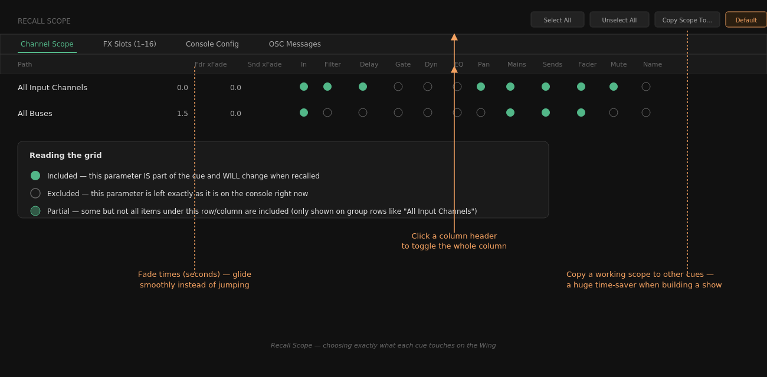
The Recall Scope grid
Four tabs under Recall Scope:
Tab | Covers
Channel Scope | Channels, buses, matrix outputs, main outputs, DCA groups — broken down by function (In, Filter, Delay, Gate, Dyn, EQ, Pan, Mains, Sends, Fader, Mute, Name, Tags, etc.)
FX Slots (1–16) | The 16 internal FX processors
Console Config | Global console settings
OSC Messages | Custom OSC messages sent to external gear when this cue recalls

Each cell is a toggle:
- ● Included (solid green) — this parameter is part of the cue and will be recalled
- ○ Excluded (hollow) — this parameter is ignored; the console stays as it is
- ◐ Partial — some but not all items in that row/column are included
Click a column header (e.g. "EQ") to toggle that entire column at once. Click the small expand arrow next to a row (e.g. "All Input Channels") to expand it to individual channels.

Toolbar buttons
- Select All / Unselect All — set every cell in the current tab
- Copy Scope To… — copy this cue's scope to other cues (huge time-saver for building a show)
- Default — left-click resets this cue's scope to a 1-to-1 copy of the app's current default scope

Setting your own default scope
Right-click the Default button to open "Edit Default Recall Scope." This is a full scope editor — the same grid as on a normal cue — where you set what the default should be, including per-group differences (e.g. Sends off for buses only) and default fade times. FX Slots and Console Config have their own defaults too; OSC Messages are never part of the default.
This matters beyond just the Default button: every new cue — including ones created with Add Snap — starts out with whatever the current default scope is. Set it once to match how you like to work, and every cue you create from then on already has the right scope, instead of you configuring it by hand every time.
Changes made in this dialog only take effect on cues where you explicitly press Default (or on new cues going forward) — existing cues you've already configured are never changed automatically.

Why this matters
A cue with only Mute and Fader included on "All Input Channels" will only move faders and mutes when recalled — EQ, dynamics, pan, everything else on the console is left completely alone. This lets you build cues that touch just what a scene actually needs.

6. Fades
Two fade-time columns appear per row in Channel Scope:
- Fdr xFade — fade time (seconds) for that channel/bus's fader level
- Snd xFade — fade time (seconds) for its send levels
Set a fade time greater than 0.0 and that parameter will glide smoothly to its target value over that many seconds when the cue recalls, instead of jumping instantly. Fades interpolate linearly in dB, so they sound and look natural.

Fade + Mute coordination
If a cue simultaneously fades a fader and changes its mute state, the software times the mute intelligently:
- Fading down into a mute: the mute is applied right at the end of the fade — so you hear the level drop away before the channel goes silent, not an abrupt cut mid-fade.
- Fading up out of a mute: the channel is unmuted immediately, so the fade-in is actually audible from the start rather than silent while the fader ramps.
Pressing GO on a new cue automatically cancels any fades still in progress from the previous cue.

7. Auto Update
Found under the Sections & Auto-Update tab.
Auto Update keeps your already-recalled cues in sync with live changes you make on the console — so if you rode a fader during a scene, the next time that cue is recalled it remembers where you left it, rather than snapping back to the originally-saved value.
- Toggle AUTO UPDATE on/off from the top toolbar or remotely via OSC/TCP

Sections are required
Auto Update will not write anything at all until at least one Section exists in the show. With no sections defined, the status bar shows "create a section first to enable per-cue writing" and every live change is ignored. Create a Section under the Sections & Auto-Update tab to turn writing on.

What a Section controls
Each Section sets, per parameter type (fader, mute, sends, EQ, dynamics, etc.), how far a live change is written:
- Snap — only the currently active (last GO'd) cue is updated
- Group — every cue sharing the same Group as the active cue is updated (see §8, Groups)
- All — every cue in the entire show is updated
By default, Fader, Mute, Sends and FX Rack are set to Snap, and everything else defaults to All — a sensible starting point where level rides stay local to the current cue, while broader setup changes propagate everywhere. Adjust this per Section to match how a scene actually behaves. A Section can also be restricted to specific channels only.

A cue must be active
Auto Update only ever writes to cues once GO has been pressed at least once — moving a fader before any cue is active does nothing. If you see "press GO on a cue first to enable writing" in the status bar, that's why.

8. Groups
Cues can be assigned to a named Group (set in the Snapshot Details panel). Groups are primarily an organisational tool — useful for filtering, batch scope operations, and visually grouping related cues (e.g. all cues belonging to one song or scene) in a large show.

9. OSC Settings
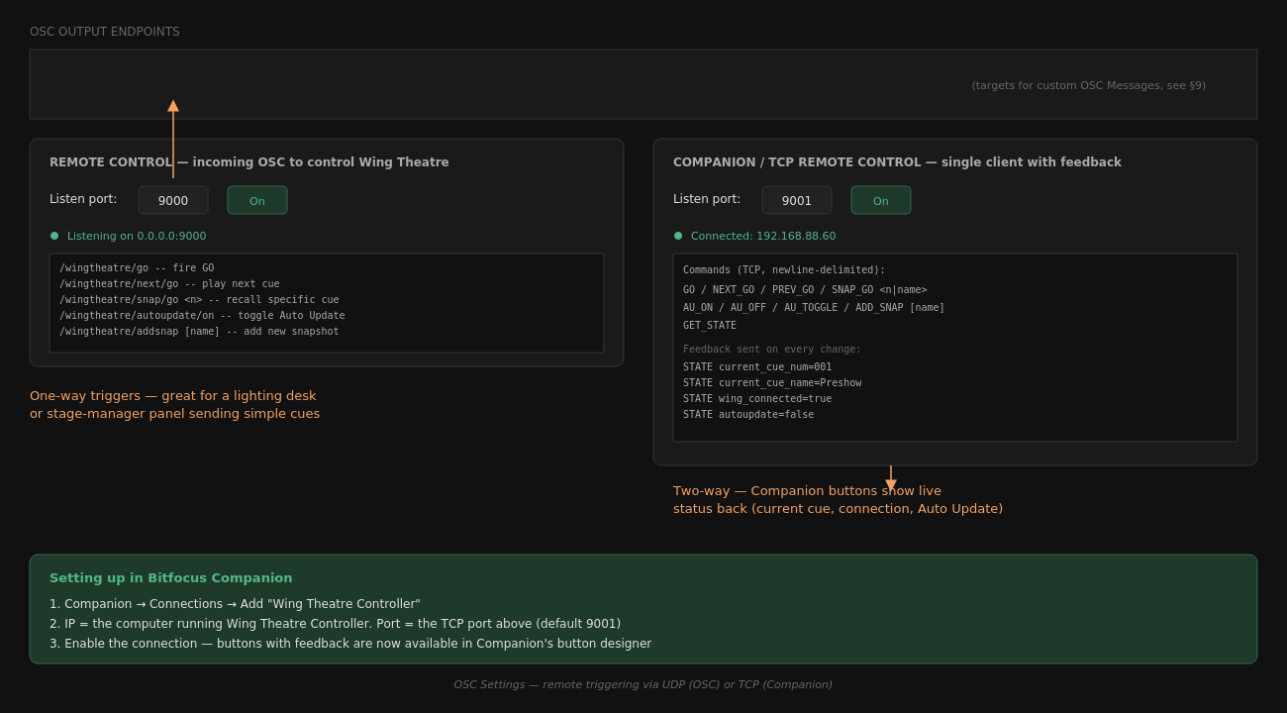
OSC and TCP remote control settings

OSC Output Endpoints
External OSC targets (other consoles, media servers, lighting desks) that receive messages when a cue recalls, if that cue has custom messages defined in its OSC Messages scope tab.
- + Add Endpoint — add a target (Name, IP Address, Port, Via interface)
- Toggle Enabled per endpoint
- Remove Selected to delete

Remote Control (UDP) — incoming OSC
Lets an external device (lighting console, stage manager panel, etc.) drive Wing Theatre Controller over OSC.
- Listen port — UDP port to listen on (default 9000)
- Toggle On/Off

OSC Address | Action
/wingtheatre/go | Fire GO (play current/selected cue)
/wingtheatre/previous/go | Play the cue before the last-fired one
/wingtheatre/next/go | Play the cue after the last-fired one
/wingtheatre/previous | Move selection up (no recall)
/wingtheatre/next | Move selection down (no recall)
/wingtheatre/snap/go <n|name> | Recall a specific cue by number or name
/wingtheatre/store | Store current Wing state as a new snapshot
/wingtheatre/autoupdate/on|off | Toggle Auto Update
/wingtheatre/addsnap [name] | Add a new snapshot (optional name)

Companion / TCP Remote Control — incoming TCP
A dedicated TCP protocol used by the Bitfocus Companion module, offering two-way state feedback (not just one-way triggering like OSC).
- Listen port — TCP port to listen on (default 9001)
- Toggle On/Off

Command | Action
GO | Fire the currently selected cue
NEXT_GO | Fire the next cue
PREV_GO | Fire the previous cue
SNAP_GO <n|name> | Fire a specific cue
NEXT | Move selection down (no recall)
PREV | Move selection up (no recall)
AU_ON / AU_OFF / AU_TOGGLE | Control Auto Update
ADD_SNAP [name] | Add a snapshot
GET_STATE | Request a full state refresh

Feedback sent automatically on every change: current_cue_num, current_cue_name, next_cue_num, next_cue_name, selected_cue_num, selected_cue_name, autoupdate, wing_connected, cue_count, fading

10. Bitfocus Companion Integration
A dedicated Companion module (v5+) ships alongside the app, giving you buttons with live feedback — the button text/colour updates automatically to reflect the current cue, connection state, and Auto Update status.

Setup
- In Companion → Connections, add Wing Theatre Controller
- Set the IP address to the computer running Wing Theatre Controller, and the port to the TCP port set in OSC Settings (default 9001)
- Enable the connection

Available Actions
GO, Next GO, Previous GO, Snap GO, Auto Update ON/OFF/Toggle, Next cue (no GO), Previous cue (no GO), Add Snap, Get State

Available Variables
$(wingtheatre:current_cue_num), current_cue_name, next_cue_num, next_cue_name, selected_cue_num, selected_cue_name, autoupdate, wing_connected, cue_count, fading

Available Feedbacks
autoupdate, wing_connected, fading, current_cue_num, current_cue_name — use these to colour-code buttons (e.g. red when Wing is disconnected, green when Auto Update is on).
Note: Companion talks to Wing Theatre Controller, not directly to the Wing console — Wing Theatre Controller is always the single source of truth in the middle.

11. Show Files
- New Show — start a blank cue list
- Open / Save / Save As — standard show-file management (.wts files)
- Autosave — set an interval (minutes) for automatic background saves; 0 min disables it
Show files store the full cue list, every cue's snapshot data, its recall scope, fade times, groups, sections, and OSC message configuration.

12. About / Version
Click the ? button in the toolbar to see the installed version number and build date, plus credits and a link to the project's GitHub page. Useful when reporting an issue — always include this version string.

13. Troubleshooting
Symptom | Likely cause / fix
Won't connect to Wing | Wrong IP, wrong network interface selected in via, or Wing unreachable on the network
GO does nothing | Check the connection status dot is green; check the cue's Recall Scope isn't fully excluded
Companion shows no connection | Confirm the TCP port matches on both ends; check firewall allowed the app through
A parameter recalls to the wrong value | Confirm it's actually included in that cue's Recall Scope — an excluded parameter is always left as-is
App disconnects after a few minutes of no activity | Should not happen on current versions — if it does, please report with the version number from the About dialog
EQ/Dynamics values look wrong after recall | Confirmed fixed as of the current build — please report if still seen, along with the exact parameter and version

14. Credits
- Wing Theatre Controller — Mikkel Peter Larsen & Claude (Anthropic)
- wingmon (Wing protocol bridge) — Mikkel Peter Larsen & Claude, built on libwing by dannyfiresnake
- Protocol documentation — Patrick-Gilles Maillot
- python-osc — attwad
- PyQt6 — Riverbank Computing

Source and releases: github.com/mikk3722/wing-theatre-controller

