Project 5: Vehicle Detection

Rubric points

**Write-up / README**

**1. Provide a Write-up / README that includes all the rubric points and how you addressed each one. You can submit your write-up as markdown or pdf.**[**Here**](https://github.com/udacity/CarND-Vehicle-Detection/blob/master/writeup_template.md)**is a template write-up for this project you can use as a guide and a starting point.**

You're reading it!

**Histogram of Oriented Gradients (HOG)**

**1. Explain how (and identify where in your code) you extracted HOG features from the training images.**

iPython note book, Cells #3 - 6

Before extracting the HOG features, I decided to have a look at different color spaces representation of car and non car images.

Conclusion RGB line space shows no clustering of colors. However the S (Saturation component in the HLS and HSV) and Cr (in the YCrCb) showed clustering of color components in their dimensions. Therefore can be used to train the classifier to identify car and non cars.

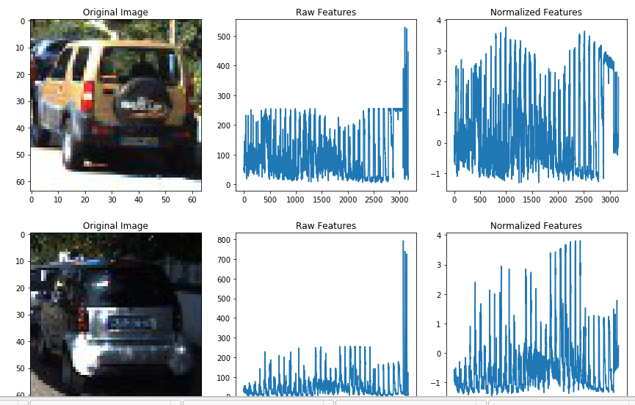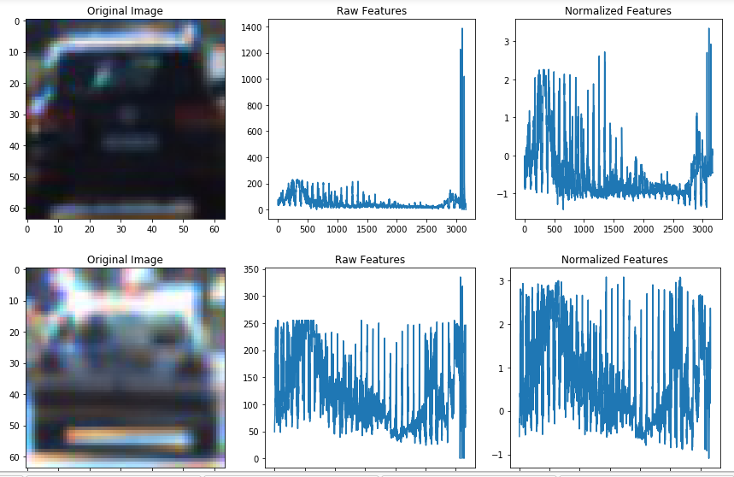

**2. Explain how you settled on your final choice of HOG parameters.**

**3. Describe how (and identify where in your code) you trained a classifier using your selected HOG features (and color features if you used them).**

**Sliding Window Search**

**1. Describe how (and identify where in your code) you implemented a sliding window search. How did you decide what scales to search and how much to overlap windows?**

**2. Show some examples of test images to demonstrate how your pipeline is working. What did you do to optimize the performance of your classifier?**

**Video Implementation**

**1. Provide a link to your final video output. Your pipeline should perform reasonably well on the entire project video (somewhat wobbly or unstable bounding boxes are ok as long as you are identifying the vehicles most of the time with minimal false positives.)**

Here's a [link to my video result](https://github.com/udacity/CarND-Vehicle-Detection/blob/master/project_video.mp4)

**filter for false positives and some method for combining overlapping bounding boxes.**

**Discussion**

**1. Briefly discuss any problems / issues you faced in your implementation of this project. Where will your pipeline likely fail? What could you do to make it more robust?**