Research Article  
Published in *Open Quantitative Sociology & Political Science (OQSPS)* 10, 02, 2018  
Submitted 10, 02, 2018

# Red-Green Correlations in Danish Party Ideologies

### Mikkel Freltoft Krogsholm

#### Abstract

By using data collected from candidates from the danish municipal election in 2017 and creating two indices - one for the traditional “socialist-capitalist” scale and one for a new “green” scale - I show that the two follow each other very closely and are almost interchangeable. The “reddest” parties are indeed also the “greenest”.

**Key words**: socialist-capitalist scale, left-right scale, socialism, capitalism, liberalism, green movement

#### Introduction

This paper looks into the relationship between the “red” and the “green” political ideologies. By creating indices that measure the two I look at how closely they are related in a danish context.

Because, where does the green movement belong? Is the green movement a separate independent movement or does it actually belong as a subset to the older “socialist-capitalist” ideologies that traditionally have been mostly concerned with questions of redistribution of wealth?

In Denmark we often associate the green movement with the socialist leaning parties and the most socialist party in the Danish parliament “The Red-Green Alliance” even bears the word “green” it in its name. But now and again we also hear about how green the danish conservatives are (Pedersen 2014), even though the conservatives are firmly planted on the capitalist side of the traditional socialist-capitalist political spectrum.

The socialist parties see the green movement as a natural part of the socialist movement because it addresses issues and problems created by capitalism. As “The Red-Green Alliance” writes on their website: “The fact that the capitalist society is based on private property and market economy has serious consequences not only for society and for individuals but also for nature and the environment.” (translated from Danish, (“Delprogram: Miljøkampen,” n.d.)).

Danish conservative thinkers on the other hand see the care for the environment as part of a contract with future generations: “A healthy and sustainable environment is the prerequisite of life not only for the generations that were before us, not just for us living, but also for the future generations that come after us.” (translated from Danish, (Pedersen 2014)).

So where does the green movement belong? As an independent movement that unites both conservatives and socialists or is it in fact just a sub-movement of the larger socialist-capitalist ideological spectrum?

#### Method

The survey data used in this article comes from the danish political news site [Altinget](https://www.altinget.dk/kandidater/kv17/). Every election they create so called *candidate tests* that try to match voters with likely candidates. Altinget has done this for several of the previous municipal, regional and national elections.

The way it works is this: The candidates all get a micro-site on Altinget that they can fill out with information about themselves, their political views, etc.

##### Figure 1: Example of a candidate micro site

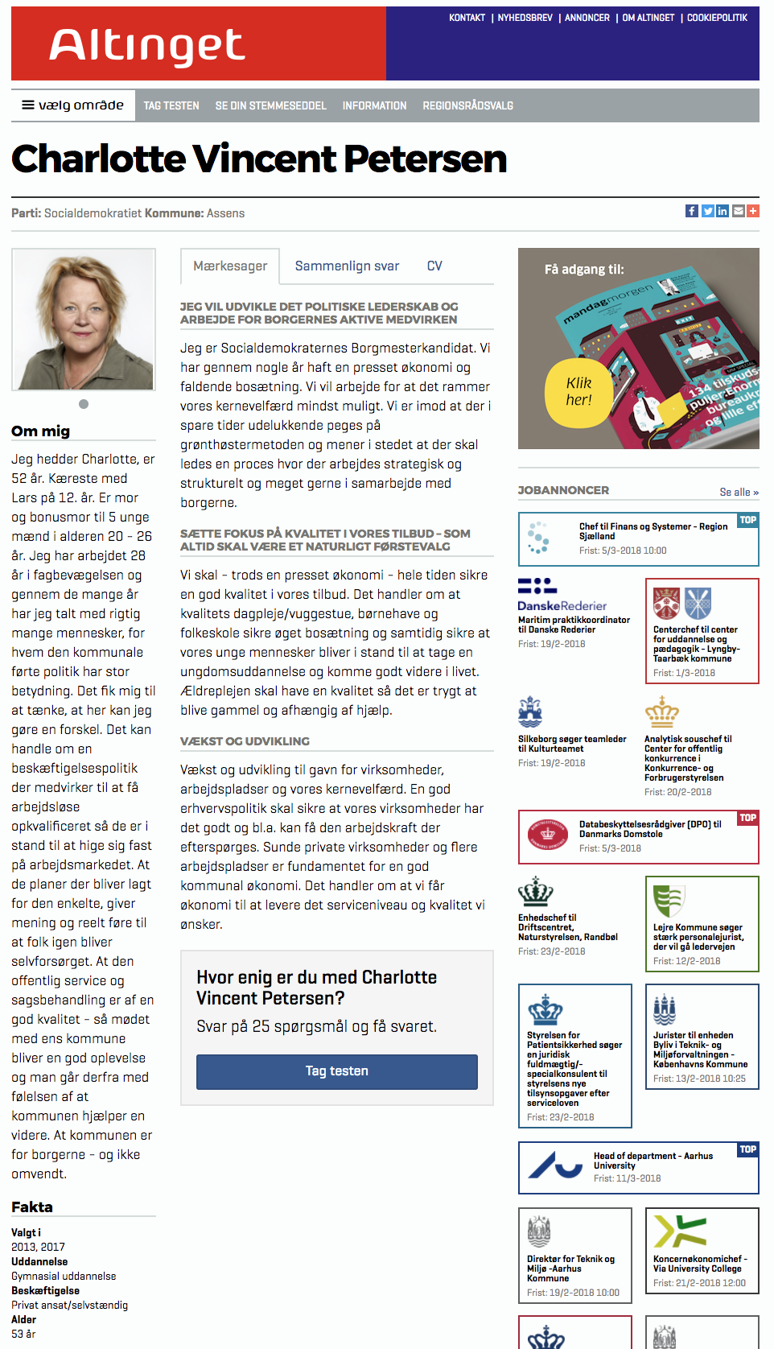

The candidates also fill in the above mentioned candidate test. This test has questions regarding different political issues and can usually be answered on a 5 point scale. The results of the test can then be used by the voters to discover candidates they agree or disagree with. Both candidates and voters fill out the same survey and the results are then compared with each other to find the best match in political convictions.

In the figure below is an example of a match between a voter and candidates in a Copenhagen Municipality. The math behind the matching done by Altinget is not made publicly available.

##### Figure 1: Example of a candidate micro site

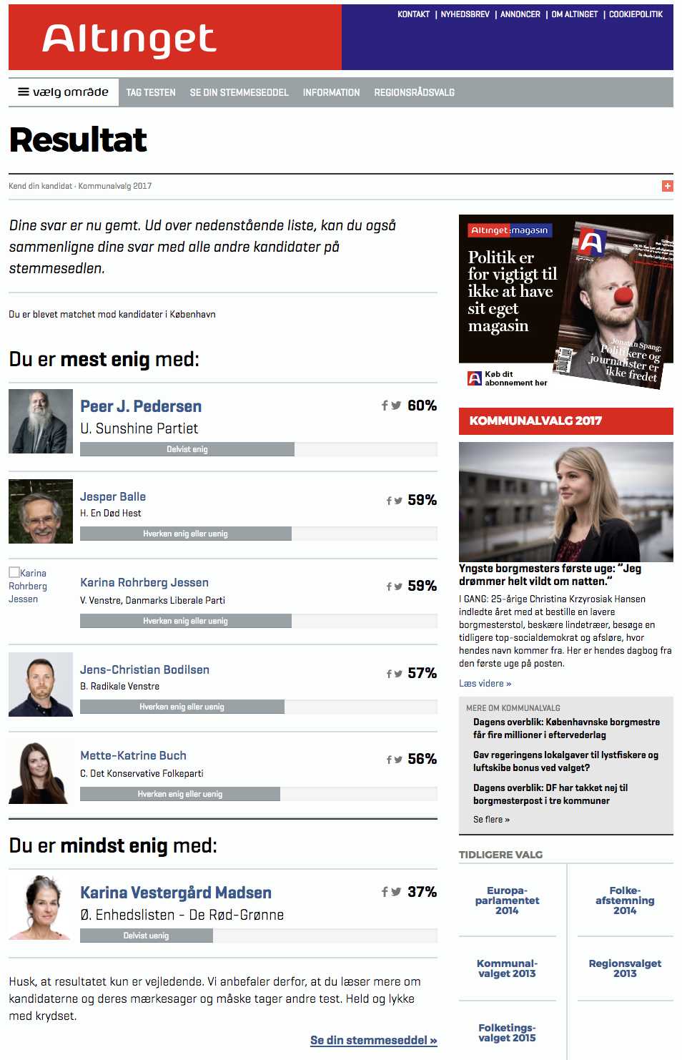

This data used in this article is from the answers to the candidate test for the nationwide municipal election in Denmark in November of 2017.

There are 9,557 candidates listed on the Altinget website. In Denmark it is usual to see quite a lot of local candidates running on local lists in municipal elections. This article though will only focus on candidates from the ten major parties that are either already elected to Folketinget (Danish Parliament) or stand a very good chance of it in the national polls. These ten parties are:

##### Table 1: Overview of Danish parties

|  |  |  |
| --- | --- | --- |
| Party letter | Party name (Danish) | Party name (English) |
| A | Socialdemokratiet | The Danish Social Democrats |
| B | Radikale Venstre | The Danish Social-Liberal Party |
| C | Det Konservative Folkeparti | Conservative People’s Party |
| D | Nye Borgerlige | The New Right |
| F | SF - Socialistisk Folkeparti | Socialist People’s Party |
| I | Liberal Alliance | Liberal Alliance |
| O | Dansk Folkeparti | Danish People’s Party |
| V | Venstre, Danmarks Liberale Parti | Venstre, Liberal Party of Denmark |
| Ø | Enhedslisten - De Rød-Grønne | The Red-Green Alliance |
| Å | Alternativet | The Alternative |
|  |  |  |

The data set is narrowed from 9.557 candidates by removing candidates not belonging to the ten parties listed above and candidates that have not filled out the survey. This brings the data set to a total of 5.883 candidates. They are distributed among the parties as follows:

##### Table 2: Distribution of candidates by party

|  |  |  |
| --- | --- | --- |
| Party letter | Party name | N |
| A | The Danish Social Democrats | 1,247 |
| V | Venstre, Liberal Party of Denmark | 1,223 |
| C | Conservative People’s Party | 712 |
| F | Socialist People’s Party | 563 |
| B | The Danish Social-Liberal Party | 507 |
| Ø | The Red-Green Alliance | 493 |
| O | Danish People’s Party | 423 |
| I | Liberal Alliance | 319 |
| Å | The Alternative | 265 |
| D | The New Right | 131 |

The candidates answered 25 different questions. These questions are:

##### Table 3: Overview of questions

|  |  |  |
| --- | --- | --- |
| ID | Danish wording | English translation |
| q_01 | Private virksomheder bør stå for en større del af hjemmehjælpen til ældre | Private companies should account for a greater part of the care for the elderly |
| q_02 | Kommunen skal inddrage frivilligt arbejde på plejehjem ​for at aflaste personalet | The municipality must involve voluntary work in nursing homes to relieve the staff |
| q_03 | Kommuneskatten skal sænkes | Municipal tax should be lowered |
| q_04 | Virksomheder skal betale færre afgifter til kommunen | Companies must pay less taxes to the municipality |
| q_05 | Det er muligt at spare penge i kommunen uden at det går ud over velfærden | It is possible to save money in the municipality without compromising welfare |
| q_06 | Kommunen skal sikre, at folkeskoleklasserne er bredt socialt sammensatte | The municipality must ensure that the primary school classes are broadly socially composed |
| q_07 | Der skal være en fast grænse for, hvor mange børn der må være pr pædagog i børnehaver og vuggestuer | There must be a fixed limit for how many children there are per childcare worker in kindergartens |
| q_08 | Kommunen skal bruge flere penge på forbedring af veje | The municipality should spend more on road improvement |
| q_09 | Kommunen skal bruge flere penge på cykelstier | The municipality should spend more on cycle paths |
| q_10 | Kommunen kan modtage flere flygtninge | The municipality can receive more refugees |
| q_11 | Kommunale institutioner tager for mange hensyn til religiøse minoriteter | Municipal institutions have too many considerations for religious minorities |
| q_12 | Der anvendes for mange penge på biblioteker og kulturhuse | Too much money is spent on libraries and cultural centers |
| q_13 | Kommunen skal betale for børns idrætsaktiviteter​, hvis forældrene ikke har råd​ | The municipality has to pay for children’s sports activities if parents can not afford it |
| q_14 | Ældre der har råd, skal kunne tilvælge og betale for ekstra service på de kommunale plejehjem | Older people who can afford it, should be able to opt and pay for extra services at the municipal nursing homes |
| q_15 | Kommunen skal sikre mere sortering og genanvendelse af borgernes affald | The municipality must ensure more sorting and recycling of municipal waste |
| q_16 | Kommunen skal gøre mere for at skabe sammenhængende ​naturområder | The municipality must do more to create cohesive natural areas |
| q_17 | Kommunen skal hjælpe borgere til at stoppe med at ryge | The municipality must help citizens to stop smoking |
| q_18 | Salg af alkohol i idrætshaller skal være forbudt | The sale of alcohol in sports venues must be prohibited |
| q_19 | Kommunen skal prioritere at købe strøm fra vindmøller | The municipality must give priority to purchasing wind power |
| q_20 | Det er en fordel at indkøbsmuligheder samles i storcentre​ | It is a good thing that shops are concentrated in malls |
| q_21 | Kommunen skal stille større krav til arbejdsløse | The municipality must demand more of the unemployed |
| q_22 | Børn går for mange timer i skole | Children have too many hours of school |
| q_23 | Der bør kun serveres økologisk mad i offentlige madordninger | Food made by the public institutions should always be organic |
| q_24 | Kommunens biler skal køre på el | The municipality’s cars should run on electricity |
| q_25 | Der bør ansættes flere i hjemmeplejen | More people should be hired to care for the elderly |

They answer all the questions on a five-point scale from “strongly agree”, “agree”, “don’t know”, “disagree”, “strongly disagree”.

##### Indices

From these questions I will create two indices to measure two underlying political orientations:

1. the traditional “socialist-capitalist” orientation with regard to taxation and redistribution of wealth.
2. a “green” axis regarding the orientation towards ecology, recycling and sustainability.

The socialist-capitalist axis is build with the candidates answers to the following questions:

##### Table 4: Questions used for socialist-capitalist index

|  |  |  |
| --- | --- | --- |
| ID | Danish wording | English translation |
| q_01 | Private virksomheder bør stå for en større del af hjemmehjælpen til ældre | Private companies should account for a greater part of the care for the elderly |
| q_03 | Kommuneskatten skal sænkes | Municipal tax should be lowered |
| q_04 | Virksomheder skal betale færre afgifter til kommunen | Companies must pay less taxes to the municipality |
| q_05 | Det er muligt at spare penge i kommunen uden at det går ud over velfærden | It is possible to save money in the municipality without compromising welfare |

And the green axis is build with the candidates answers to the following questions:

##### Table 5: Questions used for green index

|  |  |  |
| --- | --- | --- |
| ID | Danish wording | English translation |
| q_15 | Kommunen skal sikre mere sortering og genanvendelse af borgernes affald | The municipality must ensure more sorting and recycling of municipal waste |
| q_16 | Kommunen skal gøre mere for at skabe sammenhængende ​naturområder | The municipality must do more to create cohesive natural areas |
| q_19 | Kommunen skal prioritere at købe strøm fra vindmøller | The municipality must give priority to purchasing wind power |
| q_23 | Der bør kun serveres økologisk mad i offentlige madordninger | Food made by the public institutions should always be organic |
| q_24 | Kommunens biler skal køre på el | The municipality’s cars should run on electricity |

I will asses the reliability of the indices by using Cronbach’s Alpha (Cronbach 1951, Revelle (2017)). “Cronbach’s alpha will generally increase as the intercorrelations among test items increase, and is thus known as an internal consistency estimate of reliability of test scores.” (“Cronbach’s Alpha.” n.d.). In plain English it measures if the items in the index pull in the same direction and can be considered indicators of the same underlying trend.

The standardized alpha for the “socialist-capitalist” index is **0.87** and the alpha will not increase if I drop any of the variables in the index:

##### Table 6: Cronbachs alpha values for the socialist-capitalist index

|  |  |  |  |  |  |
| --- | --- | --- | --- | --- | --- |
| if_dropped | raw_alpha | std.alpha | G6(smc) | average_r | S/N |
|  | 0.8723299 | 0.8730138 | 0.8417336 | 0.6321795 | 6.874869 |
| q_01 | 0.8251913 | 0.8254658 | 0.7660104 | 0.6118783 | 4.729535 |
| q_03 | 0.8164324 | 0.8177003 | 0.7544757 | 0.5992237 | 4.485472 |
| q_04 | 0.8344033 | 0.8354229 | 0.7789080 | 0.6285371 | 5.076178 |
| q_05 | 0.8685825 | 0.8692596 | 0.8166553 | 0.6890787 | 6.648744 |

The standardized alpha for the “green” index is **0.83** and the alpha will not increase if I drop any of the variables in the index:

##### Table 7: Cronbachs alpha values for the green index

|  |  |  |  |  |  |
| --- | --- | --- | --- | --- | --- |
| if_dropped | raw_alpha | std.alpha | G6(smc) | average_r | S/N |
|  | 0.8295129 | 0.8316985 | 0.8068739 | 0.4970689 | 4.941719 |
| q_15 | 0.8129881 | 0.8142066 | 0.7754692 | 0.5228053 | 4.382323 |
| q_16 | 0.8164640 | 0.8192587 | 0.7796016 | 0.5312190 | 4.532768 |
| q_19 | 0.7752110 | 0.7814803 | 0.7379577 | 0.4720340 | 3.576246 |
| q_23 | 0.7853480 | 0.7858474 | 0.7443828 | 0.4784582 | 3.669568 |
| q_24 | 0.7807451 | 0.7874408 | 0.7423670 | 0.4808277 | 3.704572 |

Based on the alpha values for our two indices (both above .8) I can conclude that they have good reliability and are good indices (Yockey 2016).

I then reverse code the “green” questions so that if a candidate wanted more or less of taxation and sustainability then she would answer in the same direction.

In order to create the the final index for each party I calculate the scores for each candidate on the two indices and summarize the median scores for each of the parties on the two indices.

I am choosing the median as the method to summarize the party scores. The median is the number that separates the upper and the lower half of a population from each other. The median is the observation in the middle and by that definition whatever side the median candidate choose will have the majority.

‘There is no more transparent nor easily communicated explanation of political outcomes in a democracy than that all political outcomes reflect median voter preferences.’ (Congleton 2004). And by extension I am assuming that the political preferences of a party reflects the median candidates preferences.

#### Results

The results show a very strong connection between wanting more taxation and wanting more green.

Lets first see how all the voters distribute themselves on a plot with the traditional “socialist-capitalist” index and the new “green” index.

The plot shows the median candidates position on the two indices (marked by the party letter). The area surrounding the party letters is the area where 50 per cent of each party’s candidates that are closest to the median candidate reside. This is calculated by calculating the Cartesian minimum distance between two geometries (the median candidate and every other candidate) in the units of the current projection, i.e. the coordinate system comprised of the two indices (R. Bivand and Rundel 2017; R. S. Bivand, Pebesma, and Gomez-Rubio 2013).

I do this because all parties have outlier candidates - noise basically - so by focusing on the candidates closest to the median candidate we see a more fair representation of the party’s position on the issue.

##### Figure 3: Candidates placement on the two indices

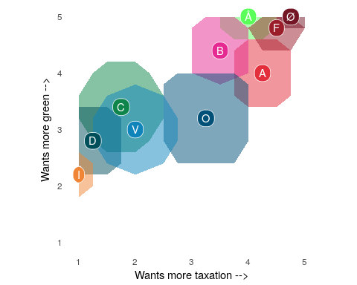

There are overlaps between the areas of each party but also a very clear linear trend; the more a party and its candidates favors a policy proposing higher taxation the more they will also favor a green environmentalist policy.

When we look at the summary tables, then each party has the following score on the indices:

##### Table 8: Overview of party values on the indices

|  |  |  |
| --- | --- | --- |
| Party | socialist-capitalist | Green |
| I | 1.00 | 2.2 |
| D | 1.25 | 2.8 |
| C | 1.75 | 3.4 |
| V | 2.00 | 3.0 |
| O | 3.25 | 3.2 |
| B | 3.50 | 4.4 |
| Å | 4.00 | 5.0 |
| A | 4.25 | 4.0 |
| F | 4.50 | 4.8 |
| Ø | 4.75 | 5.0 |

As you can see the two indices follow each other very closely and they have a correlation of **0.91**, which is quite high.

If I plot the two indices against each other then the pattern shows very clearly:

##### Figure 4: Party placement on the two indices

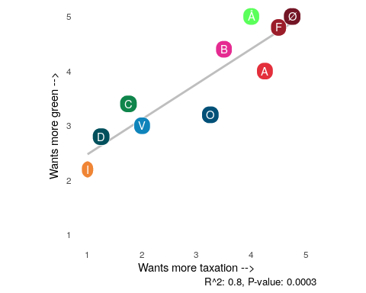

The fitted linear model (R Core Team 2017) on the plot has an R2 of 0.8 and a P-value of 0.0003. All in all I can conclude that there is indeed a very strong connection between wanting more taxation and wanting more green.

##### Table 9: Model summary

|  |  |  |  |  |  |  |  |  |  |  |
| --- | --- | --- | --- | --- | --- | --- | --- | --- | --- | --- |
| r.squared | adj.r.squared | sigma | statistic | p.value | df | logLik | AIC | BIC | deviance | df.residual |
| 0.8191591 | 0.796554 | 0.4509496 | 36.23779 | 0.0003163 | 2 | -5.109671 | 16.21934 | 17.1271 | 1.626845 | 8 |

#### Discussion

I began the paper by introducing the question of whether the green movement was a sub-movement of the traditional socialist-capitalist ideology or a movement in its own right.

I introduced the discrepancy of both socialist and conservative views on the green movement and them both taking ownership of it. But even though the Danish conservatives might see themselves as green, they are not anyway near the level of the socialist parties in Denmark - even though they are the most green of the capitalist parties. Figure 1 and 2 clearly shows that.

So it seems that the green environmentalist movement is not a movement in its own right, but rather a subset of the socialist-capitalist ideology. This then begs the question: what can make two so apparently different policy areas such as taxation and the environment follow each other so closely?

The answer might lie in the *moral foundations theory* proposed by Jonathan Haidt and his colleagues and elaborated upon in his book *The Rightous Mind* (Haidt 2012).

The moral foundations that Haidt and his colleagues have uncovered are:

1. Care/harm: This foundation is related to humans ability to feel (and dislike) the pain of others. It underlies virtues of kindness, gentleness, and nurturance.
2. Fairness/cheating: This foundation is related to the evolutionary process of reciprocal altruism. It generates ideas of justice, rights, and autonomy.
3. Loyalty/betrayal: This foundation is related to patriotism and self-sacrifice for the group. It is active anytime people feel that it’s “one for all, and all for one.”
4. Authority/subversion: This foundation is related to leadership and followership, including deference to legitimate authority and respect for traditions.
5. Sanctity/degradation: This foundation was shaped by the psychology of disgust and contamination. It underlies the widespread idea that the body is a temple which can be desecrated by immoral activities and contaminants.

Haidt and his colleagues later expanded the foundations (Iyer et al. 2012) to include a 6th one:

1. Liberty/oppression: This foundation is about the feelings of reactance and resentment people feel toward those who dominate them and restrict their liberty.

The points above are paraphrased from moralfoundations.org (“Moralfoundations.org,” n.d.).

And it is this foundation that might shed some light on why socialism and environmentalism follow each other so closely.

Part of the socialist agenda is controlling agenda. Controlling the means of production, controlling certain behaviors and controlling people as we witnessed in socialist countries up through the 20th century. It is an agenda focused on the collective before the individual. Socialism’s opposite, liberalism, on the other hand is focused on limiting control and government. It is an agenda focused on the individual before the collective.

The green agenda is also a “limiting” or “controlling” agenda. It is an agenda focused on changing peoples behavior or habits so the people behave in a certain way - i.e.. eats only organic, recycles or drive electric vehicles.

It therefore makes sense that the “red” and the “green” movement share a common ground: the approximately same place on Haidt’s Liberty/oppression foundation.

Perhaps it is this common ground that we are actually measuring with the two indices. That would explain why they follow each other so closely. Maybe it is the underlying theme of the collective vs the individual - liberty vs oppression - that our two indices are measuring. If this is true, then the green movement is not a separate movement but actually a sub-movement of the socialist and thereby collectivist movement.

#### Conclusion

By creating an index to measure the position of danish parties on the traditional “socialist-capitalist” scale and a new index to measure the parties position on a “green” scale we see that these follow each other very closely. In a Danish context there does not seem to be a difference between red and green parties. They are in fact the same.

#### Acknowledgements

Special acknowledgement should go to Altinget who collected the data from all the candidates.

#### Source material

OSF: <https://osf.io/zfm4k/>

#### References

Bivand, Roger S., Edzer Pebesma, and Virgilio Gomez-Rubio. 2013. *Applied Spatial Data Analysis with R, Second Edition*. Springer, NY. <http://www.asdar-book.org/>.

Bivand, Roger, and Colin Rundel. 2017. *Rgeos: Interface to Geometry Engine - Open Source (’Geos’)*. <https://CRAN.R-project.org/package=rgeos>.

Congleton, Roger D. 2004. “The Median Voter Model.” In *The Encyclopedia of Public Choice*, 707–12. Springer.

Cronbach, Lee J. 1951. “Coefficient Alpha and the Internal Structure of Tests.” *Psychometrika* 16 (3). Springer: 297–334.

“Cronbach’s Alpha.” n.d. <https://en.wikipedia.org/wiki/Cronbach%27s_alpha>.

“Delprogram: Miljøkampen.” n.d. <https://enhedslisten.dk/programmer/delprogram-miljoekampen>.

Haidt, Jonathan. 2012. *The Righteous Mind: Why Good People Are Divided by Politics and Religion*. Vintage.

Iyer, Ravi, Spassena Koleva, Jesse Graham, Peter Ditto, and Jonathan Haidt. 2012. “Understanding Libertarian Morality: The Psychological Dispositions of Self-Identified Libertarians.” *PloS One* 7 (8). Public Library of Science: e42366.

“Moralfoundations.org.” n.d. <http://www.moralfoundations.org/>.

Pedersen, Søren Hviid. 2014. “De Konservative Og Miljøet.” *Berlingske Tidende*, February. <https://www.b.dk/kommentarer/de-konservative-og-miljoeet>.

R Core Team. 2017. *R: A Language and Environment for Statistical Computing*. Vienna, Austria: R Foundation for Statistical Computing. <https://www.R-project.org/>.

Revelle, William. 2017. *Psych: Procedures for Psychological, Psychometric, and Personality Research*. Evanston, Illinois: Northwestern University. <https://CRAN.R-project.org/package=psych>.

Yockey, Ronald D. 2016. *SPSS Demystified: A Simple Guide and Reference*. Routledge.