QUIET membrane CMPC gas sensors
Summary of the simulations behind the Fig. 1–3 artifacts: models, data, results, realism and next steps
Repository mikkojhuttunen/misc-applets, branch quiet-v32-realistic, folder QUIET_sims_v32/ (plus quiet_sims/ for the older step 10–11 data). State of 6 November 2026 (commit 45990e3 and this report). Proposal: RCF2027_CMPC_gas_sensors_multibeam_v32. All results are simulations; nothing here has been measured.
Artifacts: Fig. 1 https://claude.ai/artifact/VFiq7T1cwXerfD6nQ8L54p · Fig. 2 https://claude.ai/artifact/BiVxtNey99hyrtPLYcvhm8 · Fig. 3 https://claude.ai/artifact/9sezcN5zEXTv9Som5LCpBr (private to the owner).
For a future session: §2 says which model and data file each figure panel uses; §3 gives the formulas; §6 ranks how realistic each ingredient is; §8 maps every result file and its JSON keys. The detailed per-task tables are in QUIET_sims_v32/REPORT.md (854 lines); the 100 ms breath study is in QUIET_sims_v32/reports/breath_100ms_technical_report.md.

1. Summary
The project simulates the static stray-light fringe (the noise floor of multipass absorption) and the gas detection limits of membrane multipass cells: a 24-facet circular CMPC (chaotic multipass cell, with weak index inclusions) and an integrated Herriott cell, both on a free-standing SiNₓ membrane with trench-DBR facets. The fringe is suppressed by dithering the wavelength and the input state (angle, position) and by averaging.
- Two generations of model. (i) A single-ray 2D engine (Fig. 2 a–f, Fig. 3 data sets B03/B05/S10/A, robustness panels). (ii) A wave-consistent Gaussian-beamlet model (Tasks 9–12; Fig. 2 j–k, Fig. 3 data sets G5–G20, Task 12). Task 5b showed that the single-ray engine is optimistic for the angle dither by 6–170× because a ray resolves sub-diffraction tilts; the beamlet model removes this.
- Realistic set B (500 nm SiNₓ at 1.53 µm, 1000 nm at 3.3 µm, constant R 95–99.5 %, 0.3–0.5 dB/cm, ε = 1e-6, NEP 14 pW/√Hz) moves most proposal targets from PASS to marginal or FAIL for the 4 mm cell; the grating-coupler design in 10–20 mm cells (Task 11) recovers them.
- Current best design (Task 11): free-space beam on a large-area input grating coupler (75 µm waist, ±60 mrad angle and ±100 µm position dither, N ≈ 400 input states), 8 inclusions r 25 µm |Δn| 0.01, output on facet 11, ±35 pm (1.53 µm) / ±81 pm (3.3 µm) wavelength dither, 10 mW, two grating couplers (8 dB).

quantity (median of 30 layouts) | 4 mm cell, old launch | 10 mm design | 15 mm design | 20 mm design
NH₃ 1.53 µm, 30 s, R 97 / 99.5 % | 353 / 176 ppb | 61 / 46 ppb | 35 / 24 ppb | 32 / 19 ppb
CH₄ 3.31 µm, 30 s, R 97 / 99.5 % | 13.5 / 7.7 ppb | 1.6 / 1.4 ppb | 0.91 / 0.86 ppb | 1.1 / 0.81 ppb
C₂H₆ 3.34 µm, 30 s, R 97 / 99.5 % | 17 / 9.7 ppb | 2.0 / 1.8 ppb | 1.2 / 1.1 ppb | 1.4 / 1.0 ppb
Cell transmission T, R 97 % | 0.111 | 0.027 | 0.018 | 0.010
Γ⟨L⟩ (cm) | 3.8 | 10.5 | 15.5 | 20.7
CH₄ / C₂H₆ at 0.1 s, R 99.5 %, breath-referenced | – | 1.35 / 1.71 ppb | 1.35 / 1.71 ppb | 1.39 / 1.77 ppb
These assume fringe drift 0.1 rad/s (averaging the static fringe at T ≳ 10 s), ε = 1e-6, NEP 14 pW/√Hz also in the mid-IR (TE-cooled detector), 8 dB coupler loss and the 2D beamlet model. With an uncooled mid-IR detector (1 nW/√Hz) CH₄ at 30 s is ≈ 6–7 ppb.
Realism in one sentence: the relative trends (N^−½ input-dither law, cell-size lever, facet choice, sparse weak scatterers) are robust within the model; absolute limits hinge on four unmeasured inputs: the stray fraction ε, the fringe drift rate, the real coupler and membrane losses, and out-of-plane scattering at inclusions and trenches (none in the 2D model).

2. The figures and where their numbers come from

2.1 Fig. 1: schematics (no simulation data except the ray traces)
Built by scripts/build_fig1_gc.py from artifacts/fig1_src_live.html → artifacts/fig1_v32.html. Three input designs selectable with the “Input design” buttons; the default is the reader + cartridge layout.
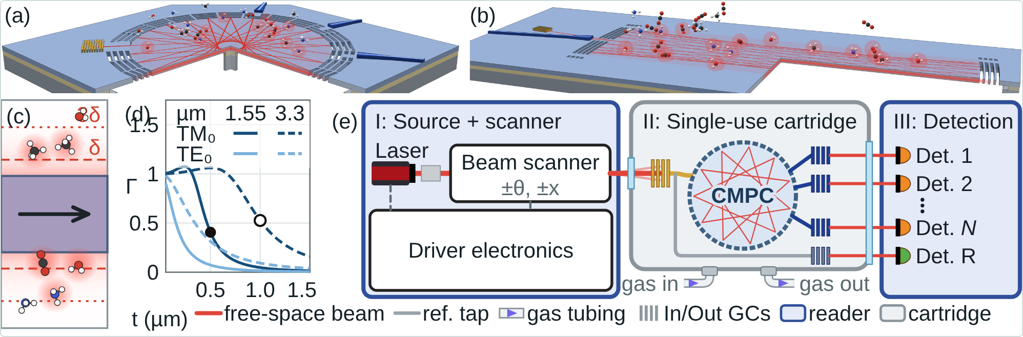
Fig. 1, input design “Reader + cartridge” (default). (a) CMPC chip and (b) integrated Herriott cell, 3D renders with the grating input port (gold), no free-space beam drawn, bottom 20 % cropped; (c) evanescent field; (d) Γ against SiNₓ thickness at 1.55 / 3.3 µm (TM₀/TE₀; dots: 500 nm and 1000 nm designs); (e) system: I source + beam scanner and III detection (reusable reader), II single-use cartridge with windows, gas tubing, grating port, CMPC, output grating couplers and an on-chip reference tap.
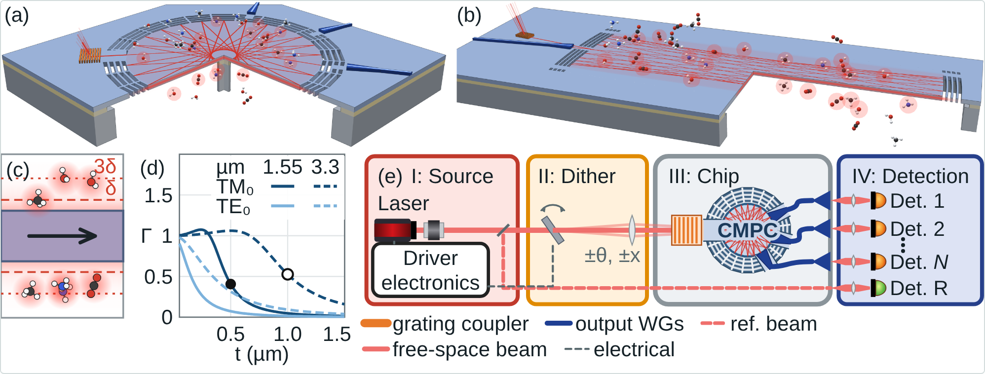
Fig. 1, input design “Grating coupler + free-space dither”: (e) with separate blocks I source, II dither (scanning mirror and scan lens), III chip (ray trace of the Task 11 design: 8 inclusions r 25 µm, centre ray and a +45 mrad / +100 µm edge state), IV detection.
Data inside Fig. 1: (a) the 3D CMPC orbit is a live engine trace (memOrbit, 8 × 25 µm inclusions in the new designs, 16 × 50 µm in the waveguide design); (b) the Herriott trace is an exact 2D circular-mirror trace with the trench-DBR reflectance per hit (TM₀, lossless 1D model); (d) Γ from the in-page slab solver (gammaOf, Si₃N₄ Sellmeier); (e) ray trace from DitherLab (G.marchRay). The Herriott DBRs carry mechanical bridges at |y| = 1.2 A (outside the spot pattern; drawn only).

2.2 Fig. 2: ray tracing, residual fringe, robustness, design scaling
Built by scripts/build_fig23_v32.py (functions build2, build2_design) from artifacts/fig2_src_live.html → artifacts/fig2_v32.html; the source also carries the other session's labels-in-schematics patch. A “Data set” selector switches B03 (default) / B05 / S10 / A.
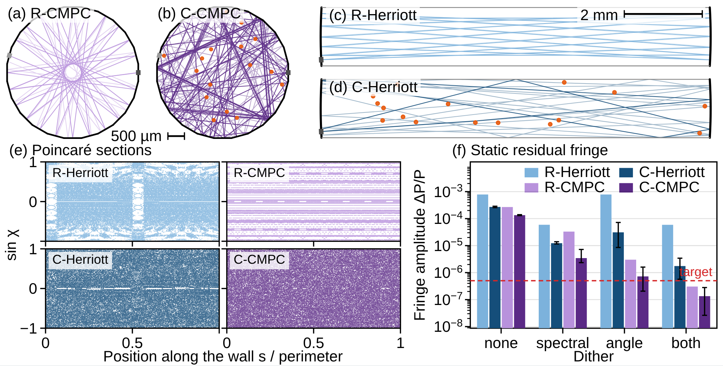
Fig. 2 main sheet, data set B03 (set B, 500 nm SiNₓ, 1.53 µm, 0.3 dB/cm). (a)–(d) live engine ray traces of regular and chaotic CMPC and Herriott cells; (e) Poincaré sections; (f) static residual fringe ΔP/P per dither mode (none, spectral ±20 pm, angle ±2 mrad, both), medians and quartiles over 30 layouts, target 5×10⁻⁷. Source: `results/t2/*_nir_*` (single-ray engine). The angle and both bars are optimistic by the Task 5b factor (wave-bounded both-dither value ≈ 3.4e-6 at R 97 %).
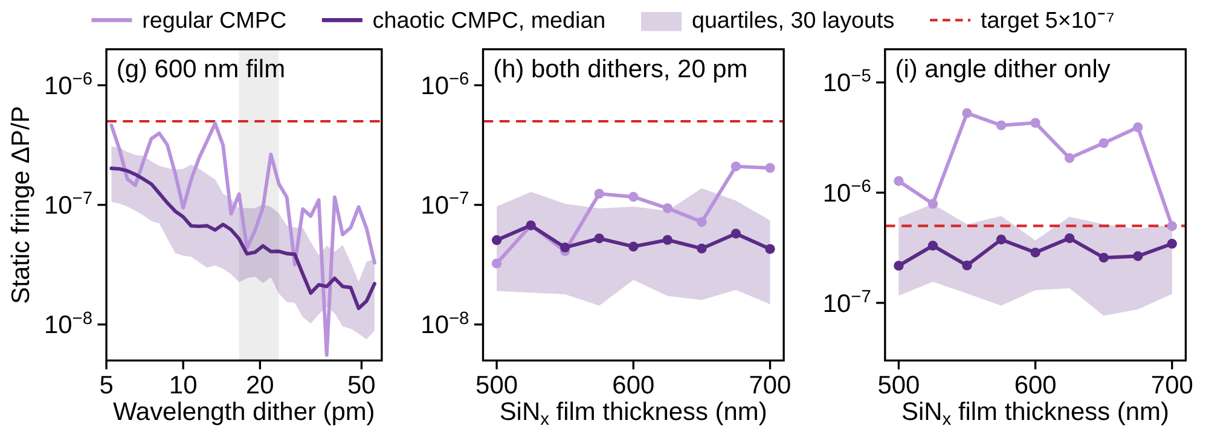
Fig. 2 robustness panels (g)–(i): static fringe against wavelength-dither depth and SiNₓ thickness 500–700 nm, regular vs chaotic CMPC. Source: older QUIET step 11 (`quiet_sims/results/step11_artifact_data.json`; 1.55 µm, designed R(χ) tables, 0.1 dB/cm, ±2 mrad angle dither, single-ray engine). Not updated to set B or the beamlet model; the angle-dither parts are optimistic (Task 5b).
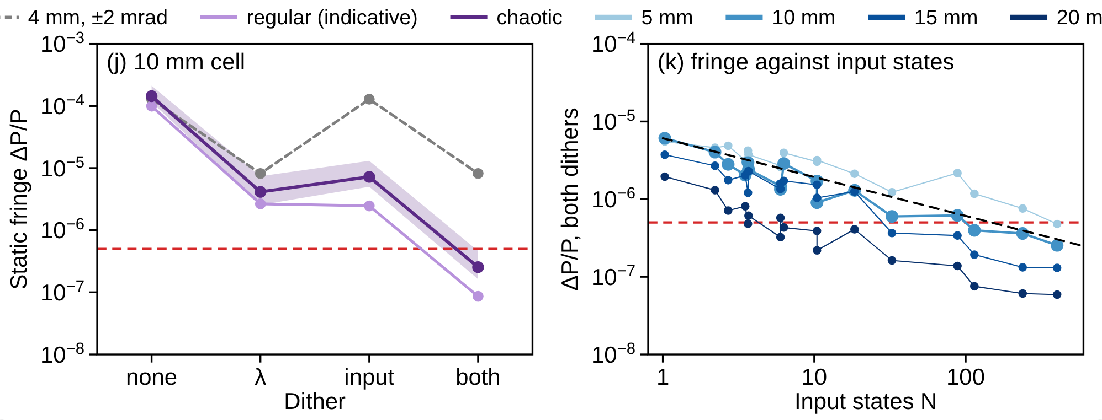
Fig. 2 design add-on (Task 11, beamlet model). (j) static fringe per dither mode for the selected cell size (buttons 5 / 10 / 15 / 20 mm), chaotic median and min–max band, regular (indicative only), dashed: the old 4 mm cell with ±2 mrad, 40 µm launch; (k) both-dither fringe against the number of input states N for 17 input-dither designs and four sizes, dashed N^−½. Source: `results/t11/artifact_data.json` (from `final_nir_R0.97.json` etc.). A table under the panel gives limits at 0.1, 1, 15, 30 s.

2.3 Fig. 3: spectra and noise floor
Built by build3, build3_more, build3_species, build3_gc, then apply_external (re-applies artifacts/fig3_external_edits.patch: edits made on the published artifact by another session: CH₄ default line, 0.1 s default, NH₃ strip optional, axis tweaks) and build3_fast (Task 12 options) → artifacts/fig3_v32.html.
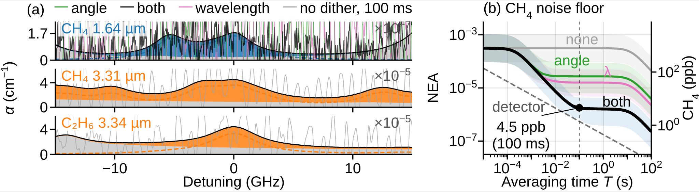
Fig. 3 main sheet (as published, data set G10: grating-coupler design, 10 mm). (a) HITRAN absorption strips at breath conditions (35 °C, 1 atm, 5.5 % H₂O, 4.5 % CO₂) with noise realisations from the exit paths of a representative layout; (b) noise-equivalent absorbance (NEA) against averaging time for none / λ / angle / both dithers, the detector term and the ppb axis; marker at the analysis time (here 0.1 s: 4.5 ppb CH₄, R 97 %, not referenced). Options: data sets G5–G20 and B03/B05/S10/A, noise model, drift toggle, breath referencing every 3 s, C₂H₆/CH₄ ratio readout (line hopping at 2990 cm⁻¹ or two lines in turn).
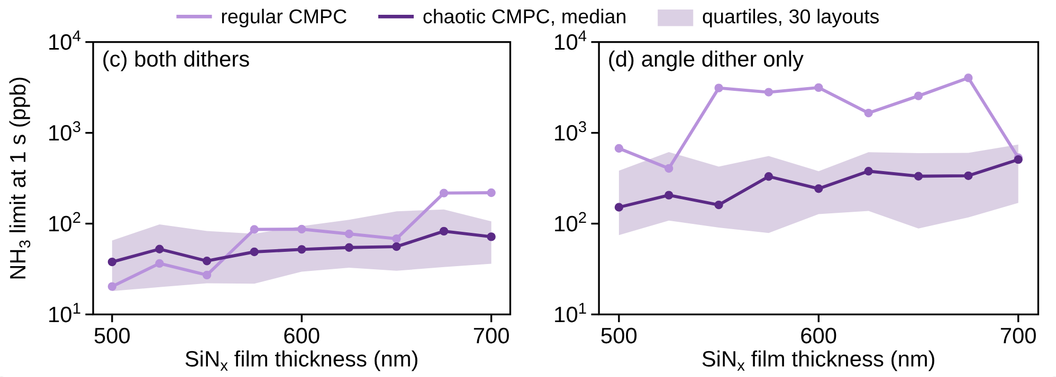
Fig. 3 robustness panels (c)–(d): NH₃ limit at 1 s against film thickness, both dithers and angle only. Source: step 11 (as Fig. 2 g–i), older noise model of the step 10–11 figures, single-ray engine: optimistic (compare v32 set B: 270–480 ppb at 1 s for the 4 mm cell with the T1.3 detector budget).

3. Models and formulas

3.1 Single-ray engine (Tasks 1–8; Fig. 2 a–f, i; Fig. 3 B03/B05/S10/A)
engine/quiet_engine.js = PlanarEngine / GasEngine / DitherLab of the Fig. 2 artifact, with membrane loss and optional R(|sin χ|) tables. 2D in-plane rays, TM₀ slab mode with phase index n_eff, specular DBR facets with constant power reflectance R per bounce (set B), membrane loss exp(−α_m L) with α_m = dB/cm·100/4.343 m⁻¹. Cells: 24-facet circle, 4 mm, launch 7.5° from the wall normal, output port at 0.458 of the perimeter, 150 µm ports; Herriott 10 × 1.5 mm, N = 14, M = 3. Chaotic = 16 index discs r 50 µm, Δn_eff ±0.01, layouts = mulberry32 seeds 1–30.
ΔP/P_m = 2 √ε · V_m / √M, V_none = 1, V_m = |time average of the fringe phasor over dither m|
M = speckle grains (engine phase-space count). Dithers: sine angle ±2 mrad at 1 kHz, triangle wavelength ±20 pm at 1.297 kHz. Each dither angle is one centre ray: this is what makes the angle dither optimistic (§6).

3.2 Gaussian-beamlet model (Tasks 9–12; Fig. 2 j–k; Fig. 3 G5–G20)
scripts/t9_input_states.js, t10_design.js, t11_sizes.js. The input field exp(−(x−X)²/w²)·exp(i k n Θ (x−X)) is expanded on a Gabor lattice of beamlets (σ = 10 µm, oversampling 4, Δx = √π σ, Δφ = √π/(2κσ)); each beamlet is traced as one engine ray to the output port:
g_j = R^((h−1)/2) · exp(−α L/2) · exp(i k₀ OPL_j), c_j = √(π/A) · exp(B²/(4A) − C) (closed-form overlap)
static fringe phasor = Σ c̄_j ḡ_j, ḡ_j = g_j · sinc(k₀ OPL_j Δλ/λ) (triangle wavelength dither)
c̄_j is the time average over the input dither (sine angle and sine position at incommensurate rates; samples max(48, ⌈2π A κ w⌉) and max(48, ⌈4π X_a/w⌉) per period). V = |static| / rms(undithered); residual 2√ε V/√M. Number of input states N = |E|²/|⟨E⟩_t|²; the input-dither factor follows N^−½ up to N ≈ 400. M per geometry: M = 4π/λ_M · √det cov(y, u), within-port covariance pooled, calibrated to the engine's grains (c_cal = 1.41 / 1.36 at 1.53 µm, R 97 / 99.5 %; 1.38 / 1.29 at 3.3 µm). Validity: beamlets of one diffraction cell are treated as independent rays, which needs a fully mixing cell (chaotic; FTLE checked with D.chaosMap); regular-cell numbers are indicative only. σ = 7 / 10 / 14 µm agree within ±30 %.

3.3 Averaging, drift and referencing
r(T) = √( S_both² H_d(T)² + (S_none² − S_both²) H_ac(T)² )
H_d(T) = 1/√(1 + 2 (w T/2)²) (w = fringe-phase drift; 0.1 rad/s → 0.69 at 15 s, 0.43 at 30 s), H_ac(T) = 1/√(1 + 2 (π·1000·T)²)
breath referencing every τ: r → r · 2 sin(w τ/2) (0.30 at w = 0.1 rad/s, τ = 3 s; 0.06 at 0.02 rad/s)

3.4 Detection
NEA(T) = √( r(T)² + δ_det(T)² ), δ_det = √(NEP² + 2hνP_d) / (P_d √(2T)), P_d = P · T_cell · 10^(−0.8)
c_min = NEA / (α_peak,1ppm · s_line · Γ⟨L⟩)
Older data sets use IL = 14 / 20 / 25 dB instead of T_cell·8 dB, or shot noise only √(q/(P T_cell T)) (published Fig. 3, set A). s_line = line peak kept under the wavelength dither (uniform average): NH₃ 0.896 / 0.804 / 0.518 / 0.434 at ±20 / 35 / 81 / 160 pm; CH₄ 3.31 µm 0.993 / 0.979 / 0.921 / 0.785; C₂H₆ 0.986 / 0.959 / 0.824 / 0.609. Line data: HAPI on cached HITRAN tables (../HITRAN/hitran_data), Voigt, air broadening, 35 °C, 1 atm, 5.5 % H₂O, 4.5 % CO₂: NH₃ 6528.77 cm⁻¹ 2.28e-7 /(ppm cm); CH₄ 3016.49 cm⁻¹ 3.79e-5; C₂H₆ Q 2996.85 cm⁻¹ 3.34e-5 (results/t7/lines.json). Detection is peak absorbance only: no line-shape fit, no WMS demodulation, no background subtraction (except the Task 12 window fits).

3.5 Gas exchange (Task 12)
Flush time V/Q of a channel of height h above the membrane and diffusion time h²/(2D) (D ≈ 0.22 / 0.15 / 0.24 cm²/s for CH₄ / C₂H₆ / NH₃).

4. Parameter sets
set | film / λ | n_eff, Γ | mirrors, loss | dithers | used in
A (published) | – / 1.6537 µm | 2.0, 0.2 | R 99.5 %, no loss | ±2 mrad, ±20 pm | Task 1 regression; Fig. 2/3 data set A
step 10 (S10) | 600 nm / 1.55 µm | 1.66, ≈0.31 | R(|sin χ|) tables ideal/target/min. | ±2 mrad, ±20 pm | Fig. 2/3 data set S10
step 11 | 500–700 nm / 1.55 µm | 1.53–1.74, 0.46–0.22 | designed R(χ), 0.1 dB/cm | ±2 mrad, 5–60 pm | robustness panels Fig. 2 g–i, Fig. 3 c–d
B (v32 realistic) | 500 nm / 1.5317 µm; 1000 nm / 3.3151 µm | 1.5391, 0.4532; 1.4253, 0.5526 | R 95 / 97 / 99.5 %, 0.3 / 0.5 dB/cm | ±2 mrad, ±20 pm | Tasks 2–8; data sets B03 / B05
Task 11 design | set B films | as B | R 97 / 99.5 %, 0.3 dB/cm | 75 µm, ±60 mrad, ±100 µm; ±35 / ±81 pm | Fig. 2 j–k, Fig. 3 G5–G20, Task 12
Common: ε = 1e-6 (placeholder), 30 inclusion layouts (seeds 1–30; Task 8: 100), 24-facet circle, ports 150 µm (4 mm cell). Γ is the E-field fraction Γ_E; the n_g-weighted Γ_abs of Fig. 1d is ≈ 0.39 at 500 nm.

5. Simulation campaign (Tasks 1–12)
task | question | model | main result | files
1 | reproduce published Fig. 2f/3 | engine | bit-for-bit; Herriott gain median 55× (not 80×); NH₃ 56 ppb shot-noise | results/t1, tests/
2 | realistic Fig. 2f | engine | near-IR C-CMPC 0.8–2.1e-7 (PASS); mid-IR 1.1–1.6e-6 (FAIL); chaotic gain ≈ 2× | results/t2, figs/fig2f_*
3 | ε sweep | engine | ΔP/P ∝ √ε exactly; set-B ε thresholds 25–30× tighter | results/t3
4 | path, N_λ for 2 cm | engine | N_λ ≈ 1.2–1.5 at ±0.55 GHz; n_g would give 1.5× more | results/t4
5 | angle-dither validity | engine | K_eff ≈ 1.9 for ±2 mrad (≪ M ≈ 300) | results/t5
5b | wave-optics bound | analytic | V_wave ≥ 0.98 at ±2 mrad, 40 µm waist: engine angle dither optimistic 6–11× (both dithers) | results/t5/wave_bound.json
6 | inclusion strength | engine | Δn ≥ 0.005 needed; small discs (25 µm) best | results/t6
7 | detection limits set B | engine | NH₃ 270–480 ppb at 1 s; CH₄/C₂H₆ fringe-limited 7–22 ppb | results/t7, figs/fig3_setB
8 | layout spread (100) | engine | fringe spans 3 decades; n_pass ≥ 36 picks the better half | results/t8
9 / 9b | input states, wide sweeps | beamlet | factor N^−½ to N ≈ 400; near-IR best 6e-7 (±35 pm); 3.3 µm best 5e-6 | results/t9, t9b, figs/input_states, dither_raytrace
10 | design levers | beamlet | cell size is the lever (3–30×); extra/random ports do not help; sparse weak scatterers | results/t10, figs/t10_cell_size
11 | 5–20 mm design, facet, drift | beamlet | facet 11 best (holdout); limits in §1; N^−½ scaling per size | results/t11
12 | 100 ms breath | beamlet + analytic | 0.1 s CH₄ 1.35, C₂H₆ 1.71 ppb (ref.); line hopping 2990 cm⁻¹ | results/t12, reports/breath_100ms_*

5.1 Selected numbers
Task 9b, 4 mm circle, R 97 %, static both-dither fringe, median (share of layouts < 5e-7):
input dither | N | factor (N^−½) | ±20 pm | ±35 pm | ±81 pm | 3.3 µm ±81 pm, CH₄ static
40 µm, ±2 mrad | 1.0 | 0.98 (0.98) | 2.3e-5 | 8.6e-6 (0 %) | 4.7e-6 | 4.3e-5, 317 ppb
150 µm, ±60 mrad | 18.5 | 0.24 (0.23) | 6.6e-6 | 2.4e-6 (3 %) | 1.4e-6 | 1.8e-5, 132 ppb
75 µm, ±60 mrad, ±100 µm | 401.9 | 0.06 (0.05) | 1.3e-6 | 6.0e-7 (33 %) | 3.4e-7 | 5.0e-6, 37 ppb
Task 12 (10 mm, R 99.5 %, 10 mW), 1σ ppb at 0.1 s:
gas | raw (w 0.1) | referenced 3 s | ref., w 0.02 | ref., 20 mW | uncooled 1 nW/√Hz | 1 s ×10 breaths
CH₄ | 3.5 | 1.35 | 0.75 | 1.1 | 49 | 0.32
C₂H₆ | 4.5 | 1.71 | 0.95 | 1.4 | 62 | 0.41
NH₃ | 316 | 230 | 219 | 133 | – | 25
One-laser CH₄ + C₂H₆ (2990 cm⁻¹ window: C₂H₆ 2990.06, CH₄ 2988.93/2989.02 cm⁻¹): line hopping 80/20 gives 5.2 / 1.9 ppb at 0.1 s; a full-window least-squares fit (C₂H₆, CH₄, H₂O, linear baseline) costs 6.6× (C₂H₆) and 14× (CH₄). Gas exchange of a 10 × 10 × 0.3 mm channel: 30 µL, 30 ms at 1 mL/s; diffusion 2–3 ms.
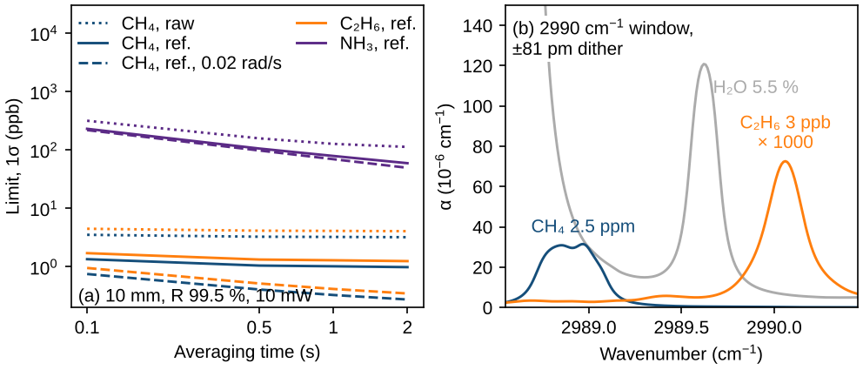
figs/t12_fast.pdf: (a) limits against averaging time (10 mm, R 99.5 %, 10 mW): raw, breath-referenced, referenced at 0.02 rad/s drift; (b) the 2990 cm⁻¹ window at breath conditions (absorption coefficients, ±81 pm dither).

6. How realistic are the calculations?
Direction: “optimistic” means real limits are likely worse. Impact: rough factor on the limits where it can be estimated.
ingredient | status / evidence | direction | impact on limits | affected outputs
Angle dither as single ray per angle (engine) | Task 5b: wave bound V ≥ 0.98 at ±2 mrad, 40 µm; beamlet model confirms | optimistic | 6–170× on angle / both fringe | Fig. 2 f (angle, both), Fig. 2 g–i, Fig. 3 B03/B05/S10/A and c–d, Tasks 2–8
Beamlet independence (one ray per beamlet) | needs full mixing; FTLE 0.15–0.6 per hit, ≥ 92 % chaotic rays; σ-convergence ±30 % | uncertain | ±30 %; regular cells not valid | Tasks 9–12 (G sets, Fig. 2 j–k)
2D in-plane model | no out-of-plane scattering at inclusion steps, trenches, DBR; no vertical radiation; no polarisation coupling | optimistic | loss and extra stray light unknown; ε may rise | all
Stray fraction ε = 1e-6 | placeholder of the proposal; fringe ∝ √ε exactly | unknown | ×√(ε/1e-6) | all fringe numbers
Stray path model | stray copy follows the wavelength, not the input state; OPD = exit path | possibly optimistic | if stray light passes part of the cell, the λ dither is weaker | all
Fringe drift 0.1 rad/s | assumed (engine default); helps at T ≳ 10 s | unknown | fringe part ×1.45 (15 s) to ×2.3 (30 s) higher with no drift | Fig. 3 (b) curves, Task 11/12
Constant R per bounce (set B) | the designed trench DBR reflects totally above ≈ 40°; ignored | pessimistic | higher effective R | set B, Tasks 2–12
Phase index n_eff for λ → phase | group index n_g = 2.28 / 2.15 would decorrelate 1.5× faster | pessimistic | λ-dither fringe somewhat lower | all
Membrane loss 0.3 dB/cm in 10–20 mm films | assumed; large suspended films untested | possibly optimistic | Γ⟨L⟩ and T fall | Tasks 10–12
Coupler loss 8 dB (two grating couplers) | assumed | unknown | detector term ∝ loss (NH₃ 15–20 mm is detector-limited) | Tasks 11–12
NEP 14 pW/√Hz in the mid-IR | plausible for TE-cooled InAsSb/HgCdTe; uncooled 1 nW/√Hz gives 5–70× worse | optimistic for uncooled | CH₄ 30 s 1.6 → ≈ 6 ppb (10 mm) | 3.3 µm limits
Peak-only detection | no line fit / WMS; Task 12 adds fits only for the 2990 cm⁻¹ window | mixed | fits gain from line shape; WMS adds demodulation constraints | all limits
Input-dither amplitude modulation | transmission changes with input state not modelled | optimistic | adds AM at dither frequency | Tasks 9–12
Line hopping / referencing | white-noise assumption; fringe correlated over ≈ 0.05–0.1 cm⁻¹; breaths independent | optimistic | unknown until a measured zero-air spectrum | Task 12, Fig. 3 ratio readout
Facet / inclusion choice | holdout-validated (layouts 1–15 vs 16–30) | robust | – | Task 11
Regression | bit-for-bit rerun of published ensembles (5 tests pass) | validated | – | Task 1
Overall: within the 2D beamlet model the Task 11/12 numbers are internally consistent (model limitations flagged, no tuning after seeing results, failing cases kept). The likely real-world shortfall comes from ε, out-of-plane scattering and coupler/membrane losses; a fair expectation is that first devices land 3–10× above the Task 11 limits until ε and the drift are measured and controlled.

7. How to improve: models and experiments

7.1 Model improvements (in order of value)
- Validate the beamlet model with a full-wave or beam-propagation calculation on a small chaotic cell (2–4 mm, a few inclusions): compare V(N) and M against Tasks 9–11. Other branches of the repository have a full-wave CMPC study (claude/cmpc-ray-propagation-engine-*, E24) and a Tidy3D setup export (ccr-a94be260-*) to build on.
- Model the stray light explicitly: where ε comes from (facet back-reflection, coupler second order, scattering at inclusion steps), its OPD relative to the exit paths and its dependence on the input state; replace the single ε = 1e-6 by a distribution.
- 3D / out-of-plane loss at inclusion steps and trench DBRs (FDTD or eigenmode expansion): gives a per-hit scattering loss and a stray contribution; feed both into the ray model as R and ε per event.
- Angle-dependent DBR reflectance including total internal reflection for set B (the step-1 R(χ) tables exist for 600 nm films; regenerate for 500 / 1000 nm).
- Group index for the wavelength → phase conversion (n_g instead of n_eff in the beamlet phases).
- Detection chain: line-shape fitting and WMS demodulation in the noise model; correlated (spectral) fringe instead of white per-point noise; amplitude modulation from the input dither; the 8 dB coupler loss from a coupler simulation.
- Intracavity modulation (local heaters over a few inclusions): the only untested route to N ≫ 400 independent realisations.
- Layout screening: use n_pass (Task 8: Spearman −0.47 with the fringe) or a direct beamlet run to pick fabricated layouts.

7.2 First measurements that would calibrate the model
- Zero-air fringe spectrum and its time drift on a mounted, heated chip (sets ε, the drift rate w and the fringe correlation length).
- Cell transmission and Γ⟨L⟩ (cut-back or ring-down) against R and membrane loss for 10 mm cells.
- Grating-coupler efficiency and its dependence on the input angle/position dither (AM).
- Scattering loss and back-reflection of single inclusion steps (test structures).
- Fringe against the number of input states N with a MEMS scanner (checks the N^−½ law of Task 9b).

8. Data and code map
path (QUIET_sims_v32/ unless noted) | content | key structure
engine/quiet_engine.js | single-ray engine (PlanarEngine, GasEngine, DitherLab) | –
qv/ (analysis.py, gas.py, slabmodes, style.py) | analysis helpers, HAPI wrapper, TM₀ solver, figure style (Liberation Sans 10 pt, 16.8 cm) | gas.alpha(table, x, ν_min, ν_max)
configs/setA.json, setB.json | parameter sets | –
results/t1 … t8/ | engine ensembles and summaries (Tasks 1–8) | per case JSON; table.md
results/t9, t9b/ | beamlet input-state sweeps | table.md; summary.json
results/t10/ | design levers | variants[name].chaotic[i]: fringe[dl][mode], T, GL_cm, M
results/t11/final_{nir,mir}_R{0.97,0.995}.json | Task 11 runs, 5 cells × 30 layouts × 17 dithers | cells[c].chaotic[i].d[design]: T, GL_cm, M, fringe[20pm|35pm|81pm][none|input|spectral|both], paths
results/t11/summary.json | limits per band/R/cell | "nir_R0.97_d10": T, GL_cm, M, static, limits["NH3_15s_NEP14pW"] = [Q1, med, Q3] (T = 0.1, 1, 15, 30, 60 s)
results/t11/artifact_data.json | data embedded in Fig. 2 j–k and Fig. 3 G sets | cells[...].cur/reg: env (vs T grid), floor, lay.fr[T] per layout
results/t12/fast.json | 100 ms limits, windows, hopping, exchange, NO | limits["mir|R0.995|d10|CH4|NEP14pW|P10mW|w0.1|ref|T0.1"] = {total: [Q1, med, Q3], fringe, det}
results/t7/lines.json | HITRAN line peaks at breath conditions | alpha_peak_per_ppm_cm, nu0_cm, bg_at_peak_per_cm
../quiet_sims/results/step10, step11_* | older 600 nm / R(χ) data (S10, robustness panels) | step11_artifact_data.json
../HITRAN/hitran_data/ | cached line lists (CH₄, C₂H₆, NH₃, NO, H₂O, CO₂) | HAPI tables
artifacts/fig{1,2,3}_src_live.html → fig{1,2,3}_v32.html | artifact sources and built pages | build_fig1_gc.py, build_fig23_v32.py
artifacts/fig3_external_edits.patch | edits made on the published Fig. 3 by another session, re-applied on build | unified diff
REPORT.md, reports/breath_100ms_technical_report.md | full per-task report; 100 ms technical report | –

8.1 Reproduction
cd QUIET_sims_v32
python run_all.py (all ensembles, ≈ 2 h on 4 cores)
python run_all.py --analysis (analyses, figures, tests from stored results)
sh scripts/run_t11.sh (Task 11 runs)
python scripts/t11_analysis.py && python scripts/t12_fast.py
python scripts/build_fig23_v32.py && python scripts/build_fig1_gc.py
python -m pytest -q tests
Rules kept throughout (from the project brief): proposal .tex untouched; no tuning after seeing results; failing cases kept; bugs documented in REPORT.md (Task 9b sampling, Task 10 multi-input normalisation and port placement, t11 smear lookup, Fig. 3 mode naming).

