# INTRODUCTION

It’s pleasantly warm outside. The average temperature is pretty nice, but there are some colder or warmer areas around, so the world is divided in four habitats based on the average temperature and precipitation in each area.

The savannah is occupied by different species, perfectly adapted to their habitat. Life is easy.

But every now and then the climate changes. When the temperature increases the savannah expands; when it drops it shrinks and the ice grows. In order to survive, species need to adapt quickly and become new ones, or they will get extinct.

Do you have what is needed to survive? Which species will you be in around 10 million years, at the end of the game?

# CONTENT

* 5 boards showing how the habitats are distributed with different temperature, numbered from 1 (coldest) to 5 (warmest).
* 5 species figurines
* 20 tokens (5 for each habitat)
* 41 mutation cards (5 “+1” and 5 “-1” for each gene, 10 neutral mutations, 1 deleterious)
* 5 Genomes tables
* 15 markers to mark the adaptation on the genome board.
* 1 dice

For 2 or 3 players use 33 mutation cards (4 “+1” and 4 “-1” for each gene, 8 neutral mutations, 1 deleterious mutation)

For 4 or 5 players use all cards.

# BOARDS

There are 4 type of habitat:

* **Savannah (yellow)**: warm and seasonally humid, not many trees
* **Tropical forest (light green)**: warm and humid, tropical trees
* **Temperate forest (dark green)**: cold and humid, temperate trees
* **Tundra (white)**: cold and dry, few vegetation, no trees

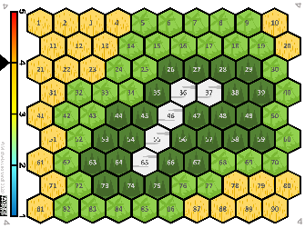 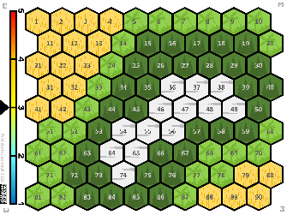 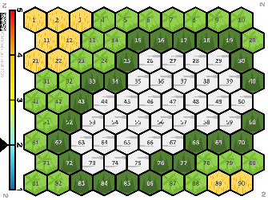 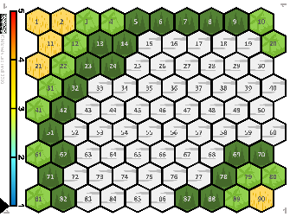

*Boards*

There are 5 levels of temperature (bar on the left) each one associated to a specific combination of the 4 habitats. Their proportions on the board are based on the overall level of temperature. Every now and then the climate changes, and the species may find themselves in a new habitat.

# GENOME BOARD AND MUTATION CARDS

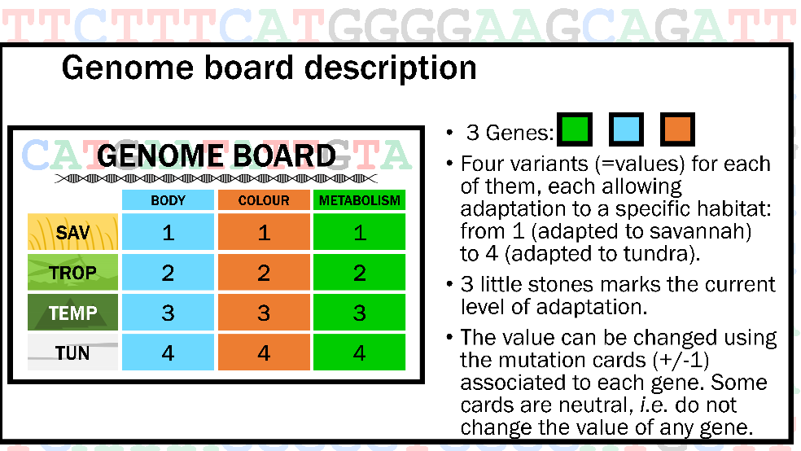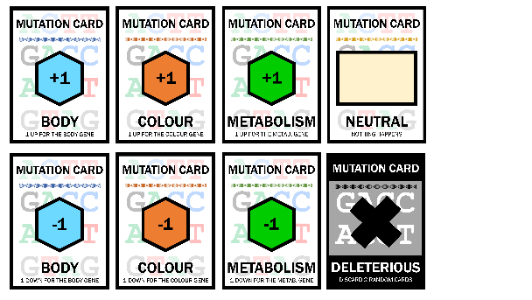

*Genome board and mutation cards*

Can species live everywhere? No!

Their DNA (genome board) contains three genes, coding for three characters: fur colour and type, metabolism, and shape/size of the body. Each of them has four variants (=values) each allowing adaptation to a specific habitat: from 1 (adapted to savannah) to 4 (adapted to tundra). The level of adaptation is indicated using the markers.

At the beginning, while the species lives in the savannah each gene is present in the variant that allows them to be adapted to such habitat.

Luckily, during the game each species collect mutations (mutation cards) that, when needed, may allow to change the gene value (+/-1) in order to adapt to other habitats and survive in them. Some cards are neutral, *i.e.* do not change the value of any gene. There is also a deleterious mutation,

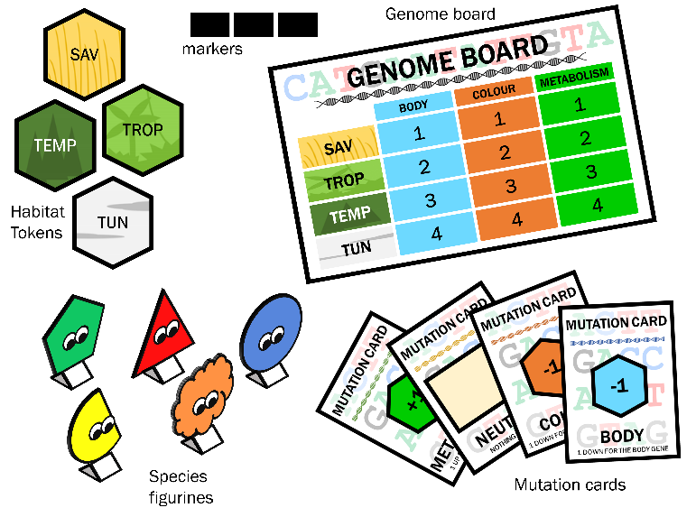In order to survive in any given environment the species must possess at least two of the gene variants associated to the habitat itself.

# PREPARATION

Each player gets:

* a species figurine,
* a savannah token,
* 2 mutation cards,
* a genome table
* three markers

# START

The deck of mutation cards is shuffled and placed face down on the table. The deleterious mutation card is put at random in the deck facing up. Some space must be left for a pile of discarded cards.

The game starts from board 3, each player puts its figurine in a cell of choice within the Savannah and places the three markers on 1 for all genes in the genome board.

Sharing a cell is not possible.

The younger player starts, the game goes clockwise.

# AT EACH TURN

The player picks a mutation card (to be kept covered). If the player has more than 5 cards at the end of their turn, one at random must be put in the discarded pile, facing up (ask your neighbour to choose it).

If the player picks a deleterious mutation card, he/she must discard two random cards.

The player rolls the dice, if the value is:

1,2,3: the species does not move, and the turn goes to the next player.

4,5,6: the species has to move to a neighbouring unoccupied cell of choice.

# ADAPTATION

When the species want to move to a different habitat it needs to adapt, i.e. having the value associated to the new habitat in at least two genes. Such values are changed using mutation cards (specific for each gene) giving +1 or -1 as needed. As many cards as needed can be used in each turn.

Each time a card is used it is put back in the discarded pile. When there are no more cards available from the pile, the discarded pile is shuffled and put back as pile.

Each time a new habitat is occupied, a token is given to the player. Each player can only have one token per habitat, so in case the species re-adapt to an habitat it adapted before it is not given a new token.

**Preadaptation:** If the player has too many cards or want to prepare for adapting to a new habitat, he/she can change the value of one of the three genes, as long as the other two genes are still adapted to the habitat occupied. There is no limit to the level of preadaptation.

# CLIMATE CHANGE

At the end of each round the dice must be thrown. If it makes 4, 5, or 6 the climate changes. A second roll of the dice tells if the climate goes one step down (1-3) or up (4-6).

If the climate is already 1 or 5 it can only go respectively up and down. Then the board is changed to the relevant new one.

In the round after a climate change, each player that rolls a 1-3 either is adapted to the cell it is in, or should adapt to it with the mutation cards. If it is not possible to adapt the species get extinct If the player rolls 4-6 he/she can move up to two steps, and needs to be adapted or to adapt to the new location to not get extinct.

# EXTINCTION

If the species find itself in an habitat to which it is not possible to adapt (e.g.no cards available to allow correct adaptation) it get extinct.

When a species get extinct the player must give back all cards and tokens but the yellow one. It then moves to a yellow cell of choice and gets two new cards.

# END OF THE GAME

Wins the game the player that collect all 4 habitat tokens

# CREDITS

This game has been created by

Dr Michela Leonardi(1)

With the help of:

Dr Gian Luigi Somma (1), Dr Eleanor Miller (1), Prof Andrea Manica (1), Prof Elisa Anna Fano (2),

Rosalynd Wade (3)

(1) Evolutionary Ecology Group, University of Cambridge, UK.

(2) Department of Life Sciences and Biotechnology, University of Ferrara, Italy.

(3) Zoology Museum, Cambridge

This work has been funded by the [ERC Consolidator Grant 647787 “LocalAdaptation”](https://cordis.europa.eu/project/id/647787)

This work, including all associated images and text have been published under a Creative Commons licence CC-BY-NC-ND 4.0 <https://creativecommons.org/licenses/by-nc-nd/4.0/>