# INTRODUCTION

You are a terrestrial animal species, living in a in the savannah where, although there are hotter and colder regions around, the average temperature is very comfortable for you. The world is divided in four habitats based on the average temperature and precipitation in each area.The savannah is occupied by a number of different species (the other players), all adapted to this habitat. Life is easy.

But every now and then the climate changes. When the temperature increases the savannah expands; when it drops the savannah shrinks, and the ice sheets grow. In order to survive, species need to adapt and change quickly, or they will become extinct.

Do you have what is needed to survive? Which species will you be in around 10 million years, at the end of the game? How will these species have changed?

# CONTENT

* 5 habitat boards showing how the habitats are distributed with different temperature scenarios, numbered from 1 (coldest) to 5 (warmest).
* 5 species figurines
* 20 tokens (5 for each habitat)
* 41 mutation cards (5x “+1” and 5x “-1” for each gene, 10 neutral mutations, 1 deleterious)
* 5 genomes boards
* 15 markers to mark the adaptation on the genome board.
* 1 dice

For 2 or 3 players use 33 mutation cards (4x “+1” and 4x “-1” for each gene, 8 neutral mutations, 1 deleterious mutation)

For 4 or 5 players use all cards.

# BOARDS

There are 4 type of habitat:

* **Savannah (yellow)**: warm and seasonally humid, not many trees
* **Tropical forest (light green)**: warm and humid, tropical trees
* **Temperate forest (dark green)**: cold and humid, temperate trees
* **Tundra (white)**: cold and dry, few vegetation, no trees

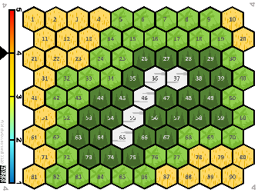 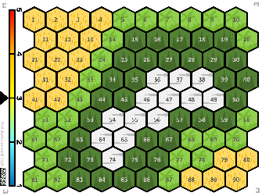 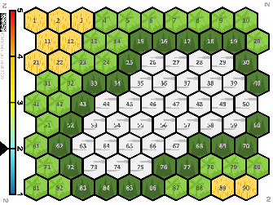 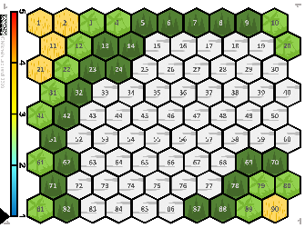

*Habitat boards from 1 (hottest, top right), to 5 (coldest, bottom right)*

There are 5 levels of temperature (bar on the left) each one associated to a specific combination of the 4 habitats (“habitat boards”, numbered from one to five). Every now and then the climate changes, and the species may find themselves in a new habitat.

# GENOME BOARD AND MUTATION CARDS

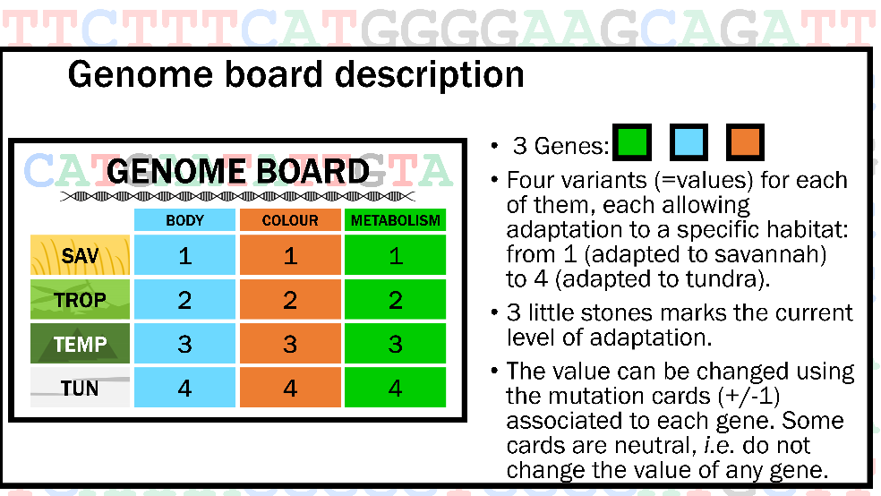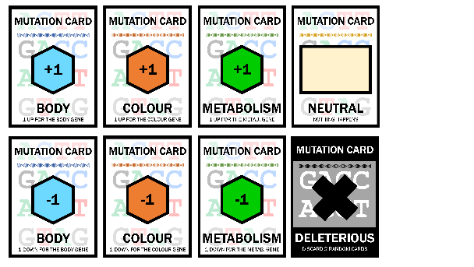

*Genome board and mutation cards*

Can species live everywhere? No!

Their DNA (genome board) contains three genes, coding for three characters: fur colour and type, metabolism, and shape/size of the body. Each of them has four variants (=values) allowing adaptation to different habitats: from 1 (adapted to savannah) to 4 (adapted to tundra). The level of adaptation should be indicated using the markers.

At the beginning, while the species lives in the savannah each gene is set to the variant that allows them to be adapted to that habitat (number 1).

Luckily, during each turn your species collect mutations (mutation cards) that, when needed, allow you to change the gene value (+/-1) in order to adapt to other habitats and survive in them. Be careful though, lots of mutation cards are neutral, *i.e.* do not change the value of any gene. There is also a deleterious mutation, that makes you discard two cards at random.

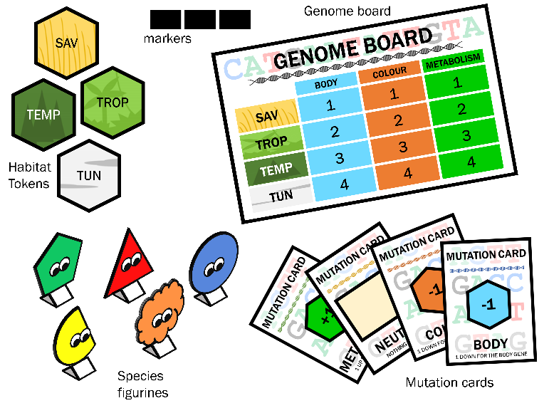In order to survive in any given environment your species must possess at least two of the gene variants associated to the habitat itself.

# PREPARATION

Each player gets:

* a species figurine,
* a savannah token,
* 2 mutation cards,
* a genome boards
* three markers

# START

The deck of mutation cards is shuffled and placed face down on the table to form the draw pile. The deleterious mutation card is put at random in this deck facing up. Some space must be left for a pile of discarded cards.

The game starts from habitat board 3, each player puts their species figurine in a cell of their choice within the savannah and places the three markers on 1 for all genes in the genome board.

Sharing a cell is not possible.

The younger player starts, the game goes clockwise.

# AT EACH TURN

The player picks a mutation card (to be kept covered). If the player has more than 5 cards at the end of their turn, one must be put in the discard pile, facing up (ask your neighbour to choose it at random from your hand).

If the player picks a deleterious mutation card, he/she must discard two random cards immediately (again, you should ask your neighbour to pick these from your hand).

The player rolls the dice, if the value is:

1,2,3: their species cannot move, and the turn goes to the next player.

4,5,6: their species has to move to a neighbouring unoccupied cell of choice.

It is never possible to share a cell.

# ADAPTATION

When the player wants to move their species to a different habitat it needs to adapt, i.e. having the value associated with the new habitat type for at least two genes. These values can be changed using mutation cards (specific for each gene) giving +1 or -1 as needed. There is no limit on the number of mutation cards that can be played from in each turn.

Each time a card is used it should be put, face up, on the discarded pile. When there are no more cards available from the draw pile, the discard pile is shuffled and put back as draw pile.

Each time a player’s species successfully adapts and occupies a new habitat, a token for that habitat is given to the player. Each player can only have one token per habitat, so if a species re-adapts to a habitat it has lived in before, the player is not given another token.

**Preadaptation:** If the player wants to use up a card (if they are at risk of having too many cards for example) or if they want to prepare for adapting to a new habitat, he/she can change the value of a single gene without affecting their species ability to survive where they are, as long as the other two genes are still adapted to the occupied habitat.

# CLIMATE CHANGE

At the end of each round, once all the players have had a turn, the dice must be thrown. If a 4, 5, or 6, is rolled, then the climate changes. A second roll of the dice decides if the climate goes one step down (1-3) or up (4-6). Then the board is changed to the relevant new one, and all species must be place in the same numbered cell occupied before.

If the climate is already 1 or 5 it can only go respectively up and down.

In the round after a climate change, each player that rolls a 1-3 either is adapted to the cell it is in, or should adapt to it with the mutation cards. If it is not possible to adapt, the species go extinct. If the player rolls 4-6 he/she can move up to two steps, but they still need to adapt or already be adapted to the new habitat at the new location in order not to go extinct.

# EXTINCTION

If the species find itself in a habitat to which it is not possible to adapt (e.g. the player has no cards available to allow correct adaptation) it becomes extinct.

If a species becomes extinct, the player must give back all cards and tokens and then reset their genome board/tokens/mutation cards as at the very start of the game, choosing a cell in the savannah to start the game from scratch.

# END OF THE GAME

The winner is player that adapts and travels most successfully, collecting all 4 habitat tokens first.

# CREDITS

This game has been created by

Dr Michela Leonardi(1)

With the help of:

Dr Eleanor Miller (1), Dr Gian Luigi Somma (1), Prof Andrea Manica (1), Prof Elisa Anna Fano (2),

Rosalynd Wade (3)

(1) Evolutionary Ecology Group, University of Cambridge, UK.

(2) Department of Life Sciences and Biotechnology, University of Ferrara, Italy.

(3) Zoology Museum, Cambridge

This work has been funded by the [ERC Consolidator Grant 647787 “LocalAdaptation”](https://cordis.europa.eu/project/id/647787)

This work, including all associated images and text have been published under a Creative Commons licence CC-BY-NC-ND 4.0 <https://creativecommons.org/licenses/by-nc-nd/4.0/>