exam-R-kalman.R

mkalman

Tue Feb 02 20:49:32 2016

## Name: Miklos Kalman  
## KEMBA 2017-II  
library(data.table)  
  
## Transform the mtcars dataset to data.table and store as a new object  
dt <- data.table(mtcars, keep.rownames = TRUE)  
  
## Count the number of cars with less than 4 gears  
dt[gear<4,.N]

## [1] 15

## Count the number of cars with more than 4 gears and less than 100 horsepower  
dt[gear>4 & hp<100,.N]

## [1] 1

## What's the average weight of cars with 4 cylinders?  
dt[cyl==4,mean(wt)]

## [1] 2.285727

## Which car has the best fuel consumption?  
dt[order(mpg, decreasing = TRUE)][1]

## rn mpg cyl disp hp drat wt qsec vs am gear carb  
## 1: Toyota Corolla 33.9 4 71.1 65 4.22 1.835 19.9 1 1 4 1

## Plot the distribution of the number of carburetors  
library(ggplot2)  
ggplot(dt, aes(x = factor(carb) )) + geom_bar()

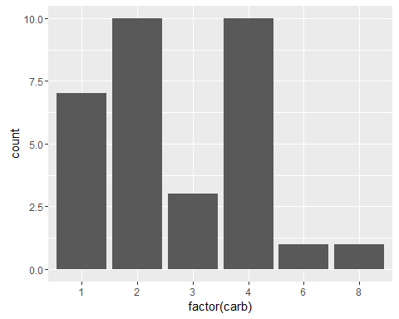

## Plot the distribution of the number of carburetors grouped by gears  
agg = aggregate(carb ~ gear, FUN = mean, data = dt)  
ggplot(agg, aes(x=factor(gear), y=carb))+geom_boxplot()

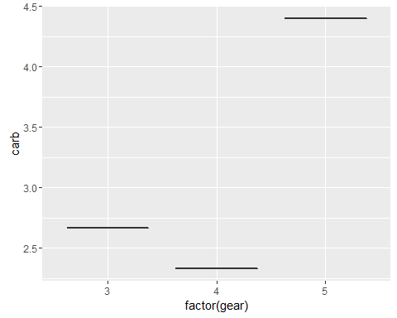

##alternate with boxplot  
ggplot(dt, aes(x = factor(carb), y = gear)) + geom_boxplot()

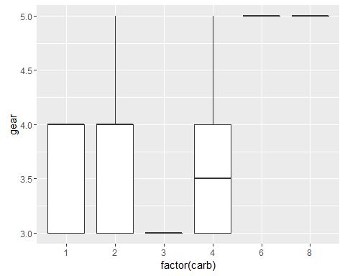

## Plot the average weight grouped by the number of carburetors  
agg = aggregate(wt ~ carb, FUN = mean, data=dt)  
ggplot(agg, aes(x=factor(carb), y=wt))+geom_boxplot()

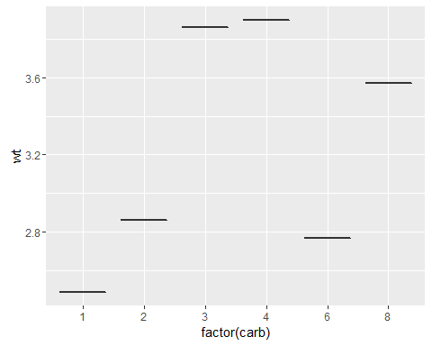

## Plot the weight and horsepower of cars  
plot(wt~hp,dt)  
  
  
## Add a linear trend line to the above plot  
fit <- lm(wt ~ hp, data=dt)  
abline(fit, col = 'red')  
  
  
## Add a 3rd degree polynomial model to the above plot  
fit3 <- lm (wt ~ poly(hp, 3, raw=TRUE) , data=dt)  
  
predfit3 <- predict(fit3)  
points(dt$hp, predfit3, col='blue',pch=19)

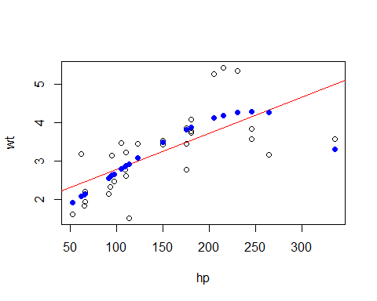

## Fit a linear model on the weight of cars to predict fuel consumption  
fitfuel <- lm(mpg~wt, data=dt)  
  
## What's the estimated fuel consumption of a car with wt = 5?  
predict(fitfuel, newdata = data.frame(wt=5))

## 1   
## 10.56277

## Install the ISLR package and use its Auto for the below exercises  
#install.packages("ISLR")  
library(ISLR)  
## Build and visualize a decision tree to tell if a car was made in America, Europe or Japan  
  
  
dta <- data.table(Auto, keep.rownames = TRUE)  
library(rpart)  
ct<- rpart(factor(origin) ~ mpg+cylinders+displacement+horsepower+weight+acceleration+year,data =dta,minsplit=50)  
  
str(dta)

## Classes 'data.table' and 'data.frame': 392 obs. of 10 variables:  
## $ rn : chr "1" "2" "3" "4" ...  
## $ mpg : num 18 15 18 16 17 15 14 14 14 15 ...  
## $ cylinders : num 8 8 8 8 8 8 8 8 8 8 ...  
## $ displacement: num 307 350 318 304 302 429 454 440 455 390 ...  
## $ horsepower : num 130 165 150 150 140 198 220 215 225 190 ...  
## $ weight : num 3504 3693 3436 3433 3449 ...  
## $ acceleration: num 12 11.5 11 12 10.5 10 9 8.5 10 8.5 ...  
## $ year : num 70 70 70 70 70 70 70 70 70 70 ...  
## $ origin : num 1 1 1 1 1 1 1 1 1 1 ...  
## $ name : Factor w/ 304 levels "amc ambassador brougham",..: 49 36 231 14 161 141 54 223 241 2 ...  
## - attr(*, ".internal.selfref")=<externalptr>

# Visualize the above decision tree  
plot(ct);text(ct)

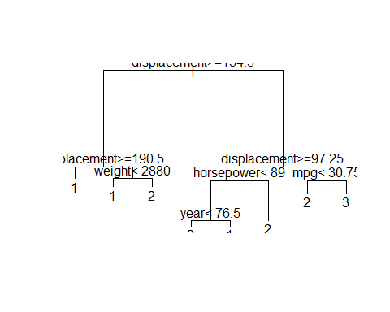

## Apply k-means or hierarchical clustering on the dataset to split the observations into 3 groups  
kc <- kmeans(dta[,1:7], 3)  
str(kc$cluster)

## int [1:7] 3 3 3 2 2 1 1

## Bonus exercise: train a reasonable k-NN or other ML model classifying cars as American VS other origin (target for AUC > 0.95)  
aut<-data.table(Auto)