AP STATISTICS · THE UNIVERSAL STUDY GUIDE
9 Units · 6 FRQs · The Universal Inference Framework · Phrases That Score
Tag legend: [FLOOR—4] = must-have [STRETCH—5] = what gets the 5
PAGE 1 │ MATH OF YOUR TARGET · 9 UNITS · THE INFERENCE FRAMEWORK
THE MATH OF YOUR TARGET — what you need (~70-75% of total)
Section | Weight | Total Available | Get this many | What that takes
MCQ | 50% | 40 questions | 30 / 40 (~75%) | Eliminate, never blank, ~2 min/Q
FRQs 1–5 (short) | 37.5% | 20 raw points (4 each) | 16 / 20 | Each scored 0-4 holistically; aim for 3s and 4s
FRQ 6 (Investigative Task) | 12.5% | ~4 points (weighted) | 3+ / 4 | Multi-part, requires synthesis. Worth more — invest the time.
THE 9 UNITS — by exam weight
# | Unit | Weight | Key topics
1 | Exploring One-Variable Data | 15–23% | Distributions, summary stats, normal model, z-scores
2 | Exploring Two-Variable Data | 5–7% | Scatterplots, regression, r and r²
3 | Collecting Data | 12–15% | Sampling methods, bias, experimental design
4 | Probability & Random Variables | 10–20% | Probability rules, binomial, geometric, normal
5 | Sampling Distributions | 7–12% | Sampling dist. of x̄ and p̂, CLT (the foundation)
6 | Inference for Proportions | 12–15% | 1- and 2-sample z-procedures for p
7 | Inference for Means | 10–18% | 1- and 2-sample t-procedures, matched pairs
8 | Chi-Square Inference | 2–5% | Goodness of fit, independence, homogeneity
9 | Inference for Slopes | 2–5% | Regression t-procedures
Units 1, 6, and 7 are 37–56% of the exam combined. Inference for proportions and means are the FRQ heart.
THE UNIVERSAL INFERENCE FRAMEWORK — STATE → PLAN → DO → CONCLUDE [5]
Every confidence interval, every hypothesis test, on every FRQ, follows this 4-step framework. Memorize it cold.
STATE → Define the parameter IN CONTEXT ("Let p = the true proportion of...").
Write H₀ and Hₐ in terms of the parameter (for tests).
State the significance level α (typically 0.05).

PLAN → Name the procedure ("1-sample t-test for μ").
Check ALL conditions explicitly (random, independence, normal/large).

DO → Show the test statistic formula and computed value.
Report the p-value (or critical value for CI) and df.

CONCLUDE → Make a decision (reject / fail to reject H₀).
State conclusion IN CONTEXT, naming the original variable.
For CIs: "We are X% confident that the true [parameter] is between [low] and [high]."
KEY INSIGHT The 5-vs-4 differentiator: every step must reference the specific context of the problem. Generic answers like "reject H₀" earn no points; "there is sufficient evidence to conclude that the mean recovery time differs from 30 days" earns the full conclusion point.
UNIVERSAL FORMULAS — write these on the formula sheet (memorize anyway)
Z-score: z = (x − μ) / σ (or z = (x̄ − μ)/(σ/√n) for sampling distributions)
Sample SE: SE(x̄) = s/√n SE(p̂) = √[p̂(1 − p̂)/n]
Margin of error: ME = (critical value) × SE
CI: estimate ± ME
Test statistic: (statistic − null value) / SE

Linear regression: ŷ = a + bx | r = correlation, b = r·(s_y/s_x)
r² = proportion of variation in y explained by x

E(X) = Σ x·P(x) Var(X) = Σ (x − μ)²·P(x) SD(X) = √Var(X)
Linear combos: E(aX + bY) = a·E(X) + b·E(Y)
Var(aX + bY) = a²·Var(X) + b²·Var(Y) (only when X, Y INDEPENDENT)

PAGE 2 │ MCQ MASTERY · MASTER VOCABULARY · COMMON TRAPS
MCQ STRATEGY — 40 questions in 90 minutes (~2 min/Q) [4]
- Read carefully — most MCQ traps are subtle. "Mean" vs "median", "sample" vs "population", "random sample" vs "random assignment." One word changes the answer.
- Eliminate impossible answers first. Probabilities outside [0,1]. CIs that don't include the point estimate. Negative SDs.
- Use the formula sheet liberally — it has all probability formulas, distributions, and inference formulas. Don't memorize what's printed.
- For inference MCQs, ask: "is this a CI or a test? proportion or mean? 1-sample or 2-sample?" That decision tree shrinks 4 options to 1-2.
- Trust the framework. Even on MCQ, follow STATE-PLAN-DO mentally — don't just "feel" the answer.
MASTER VOCABULARY — the 28 terms that show up most [4]
Term | Definition / use
Parameter | True value for the population (μ, p, σ). Usually unknown; what we estimate.
Statistic | Value computed from a sample (x̄, p̂, s). What we observe.
Population vs Sample | Population = all units of interest; Sample = subset actually measured.
Random sample | Each unit has equal chance of being selected. Goal: generalize to population.
Random assignment | Subjects randomly assigned to treatments. Goal: establish cause and effect.
Bias | Systematic deviation from truth. Cannot be fixed by larger n.
Standard deviation (s) | Measure of spread. SD has same units as the data.
Standard error (SE) | SD of the sampling distribution of a statistic.
z-score | How many SDs a value is from the mean. z = (x − μ)/σ. Standardized.
Empirical rule | For normal distributions: ~68% within 1σ, 95% within 2σ, 99.7% within 3σ.
Independence | P(A∩B) = P(A)·P(B). Or: knowing A doesn't change P(B).
Mutually exclusive | Cannot occur together: P(A∩B) = 0. Different from independent!
Conditional probability | P(A|B) = P(A∩B)/P(B). "Probability of A given B."
Sampling distribution | Distribution of a statistic over all possible samples of size n.
Central Limit Theorem (CLT) | For large n (typically n ≥ 30), sampling distribution of x̄ is approximately normal regardless of population shape.
Confidence interval (CI) | Range of plausible values for the parameter. Wider = more confident.
Confidence LEVEL | Fraction of intervals (over many repeated samples) that capture the parameter.
Margin of error (ME) | Half-width of CI. ME = critical × SE. Larger n → smaller ME.
Null hypothesis (H₀) | Status quo claim. Always contains equality (p = p₀, μ = μ₀).
Alternative hypothesis (Hₐ) | What we're testing for. One-sided (>, <) or two-sided (≠).
P-value | P(observing data this extreme or more, assuming H₀ true).
Significance level (α) | Threshold for rejecting H₀, usually 0.05.
Type I error | Reject H₀ when it's actually true. Probability = α.
Type II error (β) | Fail to reject H₀ when it's actually false. Probability = β.
Power | Probability of correctly rejecting a false H₀. Power = 1 − β. Higher with: bigger n, larger effect, larger α.
Statistical vs Practical significance | Statistically significant (small p-value) ≠ meaningful in real terms. Large n can make tiny effects significant.
r (correlation) | Strength + direction of LINEAR relationship between 2 quantitative variables. Range: −1 to 1.
r² (coefficient of determination) | Proportion of variation in y explained by linear regression on x.
THE 8 MCQ TRAP PATTERNS [4]
- "95% chance the parameter is in the CI" — WRONG. The parameter is fixed; the CI is random. Correct: "95% of intervals constructed this way capture the parameter."
- Random sampling vs random assignment. Sampling → generalize. Assignment → cause-effect. Different purposes, often confused.
- Independence vs mutually exclusive. Cannot be both (unless P=0). Independent = P(A|B) = P(A). Mutually exclusive = both can't happen.
- Mean vs median. In skewed data, mean is pulled toward the tail. Median is resistant to outliers.
- Correlation vs causation. r ≠ 0 doesn't mean X causes Y. Only randomized experiments establish causation.
- Statistical significance vs effect size. Tiny effect can be "significant" with huge n. Always ask: is the effect meaningful?
- "P-value is the probability H₀ is true." — WRONG. P-value assumes H₀ is true, not measures it.
- Conditions confused with assumptions. Conditions are checked from the data; if they fail, the procedure isn't valid.

UNITS 1–2 │ EXPLORING DATA · one-variable + two-variable
DESCRIBING A DISTRIBUTION — Shape, Outliers, Center, Spread (SOCS) [4]
For ANY one-variable distribution, describe in this order: SOCS — Shape, Outliers, Center, Spread. Always in CONTEXT.
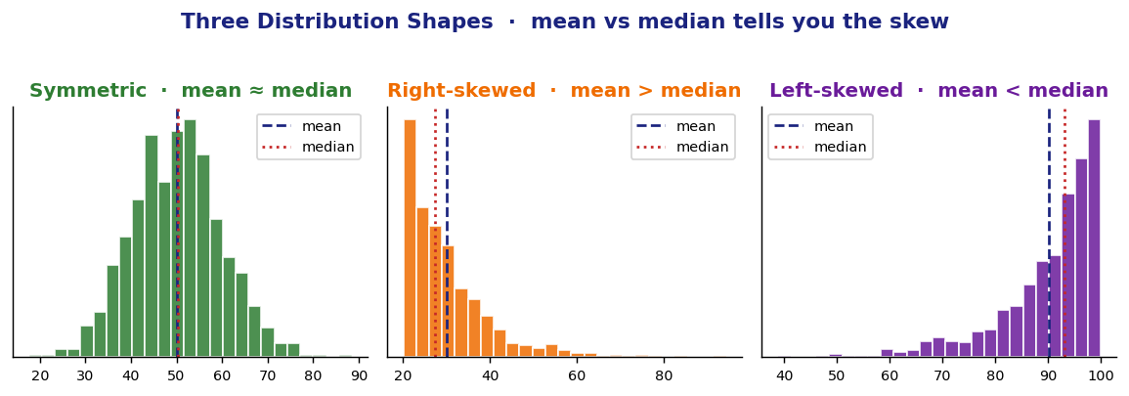
- Shape: symmetric, right-skewed (long right tail), left-skewed, uniform, bimodal.
- Outliers: values unusually far from the bulk. 1.5 × IQR rule: outliers are below Q1 − 1.5·IQR or above Q3 + 1.5·IQR.
- Center: mean (sensitive to outliers) or median (resistant). For skewed data, prefer the median.
- Spread: standard deviation (with mean) or IQR (with median). Both measure variability.
KEY INSIGHT Skew direction is given by the TAIL, not the peak. Long right tail → right-skewed → mean > median.
THE NORMAL DISTRIBUTION — the foundation [5]
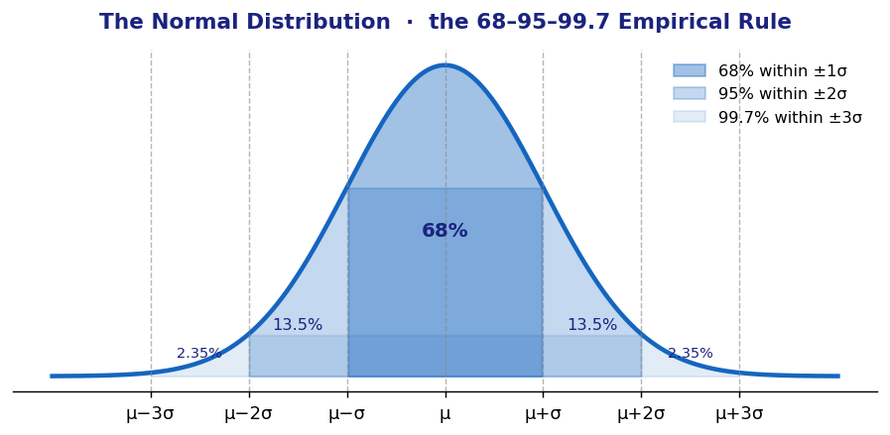
- The empirical (68-95-99.7) rule holds for ANY normal distribution. Use it for quick mental estimates.
- Z-score standardizes: z = (x − μ)/σ. Tells you how many SDs a value is from the mean.
- Use normalcdf and invNorm on calculator. normalcdf(low, high, μ, σ) gives probabilities; invNorm(p, μ, σ) gives the value.
BOXPLOTS + 5-NUMBER SUMMARY [4]
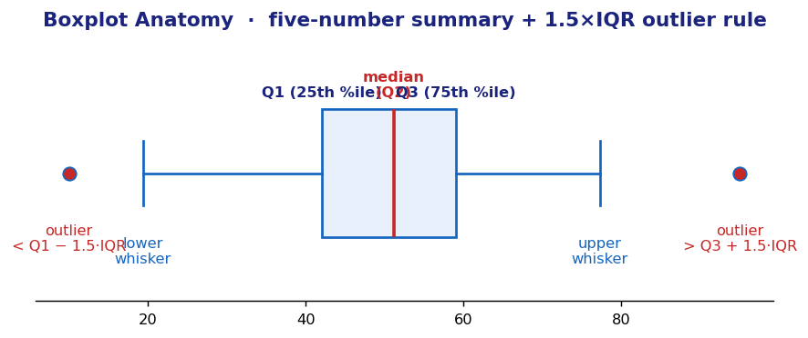
5-number summary: minimum, Q1, median, Q3, maximum. Boxplot displays them visually. Outliers flagged using the 1.5×IQR rule.
UNIT 2 — TWO-VARIABLE DATA (regression) [4]
Linear regression line: ŷ = a + b·x
b (slope) = r · (s_y / s_x)
a (intercept) = ȳ − b·x̄

Correlation coefficient: r ∈ [−1, 1]. Sign = direction; magnitude = strength.
Coefficient of determination: r² = proportion of variation in y EXPLAINED by linear model.
Residual: observed − predicted = y − ŷ
Influential point: large effect on slope/intercept if removed.
KEY INSIGHT r is for LINEAR relationships only. A perfect U-shaped relationship can have r ≈ 0 — doesn't mean no relationship, just no LINEAR one.
WATCH OUT Always check residual plot. If residuals show a curve or fan shape, the linear model is NOT appropriate. Random scatter = good fit.

UNIT 3 │ COLLECTING DATA · sampling methods + experimental design
SAMPLING METHODS — when each is used [4]
Method | Description | Pros / cons
Simple Random Sample (SRS) | Every group of size n is equally likely. | Gold standard — but may not represent subgroups well.
Stratified random sample | Population divided into strata (e.g., by age); SRS within each. | Better representation of subgroups; reduces variability.
Cluster sample | Divide into clusters (e.g., schools); randomly select WHOLE clusters. | Cheaper; less precise than SRS.
Systematic sample | Pick every k-th unit after a random start. | Easy; can introduce bias if there's a pattern.
Convenience sample | Whoever's easiest to reach. | Strongly biased — never use for inference.
Voluntary response | Participants self-select. | Strongly biased — over-represents people with strong opinions.
BIAS — sources to recognize [4]
- Selection bias / undercoverage: certain groups left out of the sample frame.
- Nonresponse bias: chosen subjects don't respond. Different from those who do.
- Response bias: subjects systematically lie/misreport (sensitive questions, social desirability).
- Wording bias: question phrasing pushes answers.
KEY INSIGHT Bias ≠ variability. Bias is systematic deviation; variability is random scatter. Bigger sample size reduces variability but NOT bias.
EXPERIMENTAL DESIGN — the 4 principles [5]
- Control: keep all factors equal except the treatment. Use a control group (no treatment or placebo) for comparison.
- Randomization: randomly assign subjects to treatments. Eliminates confounding — this is what gives experiments cause-effect power.
- Replication: apply each treatment to many subjects. Reduces variability. Different from "replicating the study".
- Blocking: group similar subjects together, then randomize within each block. Reduces variability from a known nuisance variable.
EXPERIMENT TYPES + SPECIAL DESIGNS [5]
- Completely Randomized Design (CRD): Subjects randomly assigned to treatments. Simplest.
- Randomized Block Design: Block subjects by similar characteristic, then randomize within blocks.
- Matched-pairs design: A special block design where each "block" is a single subject (before/after) or a pair of similar subjects (twins). Use paired t-procedures to analyze.
- Blinding: subjects don't know which treatment. Double-blinding: neither subjects nor evaluators know.
- Placebo effect: subjects respond to perceived treatment. Why we use placebos as controls.
- Confounding variable: another variable that affects the response and is associated with the treatment. Randomization eliminates confounding.
KEY INSIGHT The Big Two: Random sampling → generalization to population. Random assignment → cause-and-effect. You need BOTH for the strongest conclusions.

UNIT 4 │ PROBABILITY · RANDOM VARIABLES · DISTRIBUTIONS
PROBABILITY RULES — the 5 you must know [4]
Complement: P(Aᶜ) = 1 − P(A)
Addition: P(A ∪ B) = P(A) + P(B) − P(A ∩ B)
if disjoint: P(A ∪ B) = P(A) + P(B) (since P(A∩B) = 0)
Multiplication: P(A ∩ B) = P(A)·P(B|A)
if independent: P(A ∩ B) = P(A)·P(B)
Conditional: P(A | B) = P(A ∩ B) / P(B)

Independence test: events A, B independent iff P(A|B) = P(A), i.e., P(A∩B) = P(A)·P(B)
RANDOM VARIABLES — discrete vs continuous [4]
Discrete RV (countable values, like # of heads):
E(X) = μ_X = Σ x · P(x)
Var(X) = σ²_X = Σ (x − μ_X)² · P(x)
SD(X) = √Var(X)

Linear combos: E(aX + bY) = a·E(X) + b·E(Y) (always)
Var(aX + bY) = a²·Var(X) + b²·Var(Y) (only when X, Y INDEPENDENT)
Var(X − Y) = Var(X) + Var(Y) (when independent — note PLUS)
THE BINOMIAL DISTRIBUTION — count of successes in n trials [5]
Conditions for binomial (BINS): Binary outcomes, Independent trials, Number of trials fixed, Same probability of success p.
X ~ Binomial(n, p)
Mean: μ = n·p
SD: σ = √(n·p·(1−p))
P(X = k) = C(n,k) · p^k · (1−p)^(n−k)

Calculator: binompdf(n, p, k) for P(X=k)
binomcdf(n, p, k) for P(X ≤ k)
THE GEOMETRIC DISTRIBUTION — trials until first success [4]
Conditions (BITS): Binary, Independent, Trials until first success, Same p.
X ~ Geometric(p)
Mean: μ = 1/p
SD: σ = √((1−p)/p²)
P(X = k) = (1 − p)^(k−1) · p

Calculator: geometpdf(p, k) for P(X=k)
BINOMIAL → NORMAL APPROXIMATION [5]
When `np ≥ 10` AND `n(1−p) ≥ 10`, the binomial distribution is approximately normal with μ = np and σ = √(np(1−p)). This is the basis for proportion inference (Page 7).

UNIT 5 │ SAMPLING DISTRIBUTIONS · the foundation of all inference
[5] This unit explains WHY inference works. Master the concepts here and Units 6-9 become mechanical.
WHAT IS A SAMPLING DISTRIBUTION?
A sampling distribution is the distribution of a STATISTIC (like x̄ or p̂) over ALL possible samples of size n. Not the distribution of one sample — the distribution of the statistic itself across many samples.
THE CENTRAL LIMIT THEOREM (CLT) — the most important theorem [5]
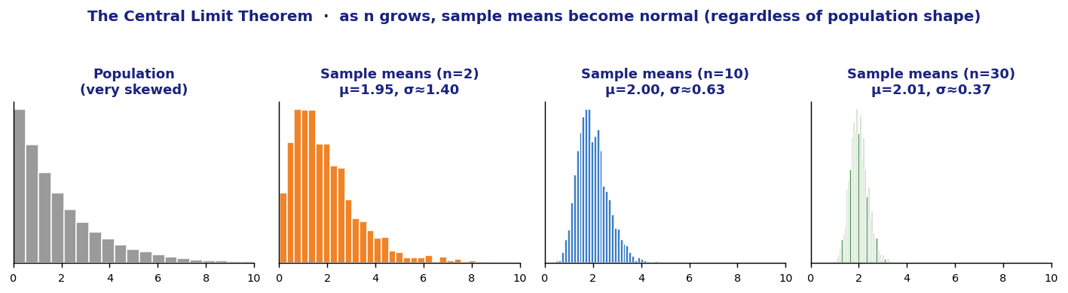
CLT: for large n (typically n ≥ 30), the sampling distribution of x̄ is approximately normal regardless of the population shape. The mean of the sampling distribution equals μ; the standard deviation equals σ/√n.
KEY INSIGHT The takeaway: even with a wildly skewed population, sample means become approximately normal as n grows. This is what makes t-procedures work.
SAMPLING DISTRIBUTION OF x̄ (the sample mean)
If we take samples of size n from population with mean μ and SD σ:
Mean of x̄: μ_x̄ = μ (unbiased)
SD of x̄: σ_x̄ = σ / √n (gets smaller as n grows!)
Shape: approximately normal if either
• population is normal, OR
• n ≥ 30 (CLT)
SAMPLING DISTRIBUTION OF p̂ (the sample proportion)
If we take samples of size n from population with proportion p:
Mean of p̂: μ_p̂ = p (unbiased)
SD of p̂: σ_p̂ = √[p·(1 − p) / n]
Shape: approximately normal if both
• np ≥ 10 AND n(1 − p) ≥ 10
• (Large counts condition)
SAMPLING DIST. OF DIFFERENCES — for 2-sample procedures [5]
Difference of two means (independent samples):
Mean of (x̄₁ − x̄₂) = μ₁ − μ₂
SD = √(σ²₁/n₁ + σ²₂/n₂) (use s₁, s₂ in practice → t-procedures)

Difference of two proportions (independent samples):
Mean of (p̂₁ − p̂₂) = p₁ − p₂
SD = √[p₁(1 − p₁)/n₁ + p₂(1 − p₂)/n₂]
INDEPENDENCE / 10% CONDITION [5]
For sampling without replacement (almost always), observations aren't strictly independent. The 10% condition says: as long as n ≤ 10% of the population, treating observations as independent is OK. Always check this on FRQs.
KEY INSIGHT MENTAL MODEL FOR EVERY INFERENCE PROBLEM: the statistic is a single point on its sampling distribution. The standard error tells you how spread out that distribution is. The critical value tells you how many SEs out you need to go to capture the parameter (CI) or to be unlikely under H₀ (test).

UNIT 6 │ INFERENCE FOR PROPORTIONS · the z-procedures
1-SAMPLE Z-INTERVAL FOR p [5]
CI for p: p̂ ± z* · √[p̂(1 − p̂)/n]

Conditions:
1. Random sample (or random assignment for experiment)
2. Independence: n ≤ 10% of population (10% condition)
3. Large counts: n·p̂ ≥ 10 AND n·(1 − p̂) ≥ 10

CRITICAL VALUES: 90% → z* = 1.645 95% → z* = 1.96 99% → z* = 2.576
1-SAMPLE Z-TEST FOR p [5]
H₀: p = p₀ Hₐ: p ≠ p₀ (or > or <)

Test statistic: z = (p̂ − p₀) / √[p₀(1 − p₀)/n] (uses p₀, NOT p̂, for SE)

Conditions: same 3 above, but use p₀ for large-counts check (n·p₀ ≥ 10, etc.)
2-SAMPLE Z-INTERVAL FOR p₁ − p₂ [5]
CI for p₁ − p₂: (p̂₁ − p̂₂) ± z* · √[p̂₁(1 − p̂₁)/n₁ + p̂₂(1 − p̂₂)/n₂]

Conditions: random samples, independent of each other, both 10% conditions,
both large-counts checks (n₁·p̂₁ ≥ 10, n₁·(1 − p̂₁) ≥ 10, similarly for sample 2)

Decision rule: if 0 NOT in interval → significant difference
2-SAMPLE Z-TEST FOR p₁ − p₂ [5]
H₀: p₁ = p₂ Hₐ: p₁ ≠ p₂ (or directional)

Pooled proportion: p̂_pooled = (x₁ + x₂) / (n₁ + n₂)
Test statistic: z = (p̂₁ − p̂₂) / √[p̂_pooled·(1 − p̂_pooled)·(1/n₁ + 1/n₂)]

Note: for the TEST, use POOLED p̂. For the CI, use UNPOOLED.
WORKED EXAMPLE — 1-sample z-test for p [5]
Problem: A pollster claims 60% of voters approve. In a random sample of 200 voters, 108 approve (54%). Test at α = 0.05.
STATE. Let p = true proportion of voters who approve. H₀: p = 0.60 vs Hₐ: p ≠ 0.60. α = 0.05.
PLAN. 1-sample z-test for proportion. Conditions: (1) random sample ✓ (stated). (2) 10% condition: 200 < 10% of all voters ✓. (3) large counts: 200(0.60) = 120 ≥ 10, 200(0.40) = 80 ≥ 10 ✓.
DO. p̂ = 108/200 = 0.54. SE = √(0.6·0.4/200) ≈ 0.0346. z = (0.54 − 0.60) / 0.0346 ≈ −1.73. Two-sided p-value ≈ 0.084.
CONCLUDE. Since p-value 0.084 > α = 0.05, fail to reject H₀. There is not sufficient evidence at the 5% level to conclude that the true proportion of voters who approve differs from 60%.

UNIT 7 │ INFERENCE FOR MEANS · the t-procedures
[5] When σ is unknown (almost always), we use s instead and a t-distribution. t-distributions have heavier tails than normal — accounts for extra uncertainty from estimating σ.
1-SAMPLE t-INTERVAL FOR μ [5]
CI for μ: x̄ ± t* · (s / √n) df = n − 1

Conditions:
1. Random sample
2. Independence (10% condition)
3. Normal/Large Sample:
• n < 15: data must be approximately normal (no skew, no outliers)
• 15 ≤ n < 30: roughly symmetric, no extreme outliers
• n ≥ 30: CLT applies, any shape OK
1-SAMPLE t-TEST FOR μ [5]
H₀: μ = μ₀ Hₐ: μ ≠ μ₀ (or directional)

Test statistic: t = (x̄ − μ₀) / (s / √n) df = n − 1
2-SAMPLE t-PROCEDURES (independent samples) [5]
CI for μ₁ − μ₂: (x̄₁ − x̄₂) ± t* · √(s²₁/n₁ + s²₂/n₂)
Test stat: t = (x̄₁ − x̄₂) − 0 / √(s²₁/n₁ + s²₂/n₂)

df: use technology (calculator gives Welch-Satterthwaite df). On AP, you may also
use the conservative df = min(n₁ − 1, n₂ − 1).

Conditions: random samples, INDEPENDENT samples (key!), both 10%, both Normal/Large.
MATCHED-PAIRS t-PROCEDURES [5]
Use when: subjects measured twice (before/after) OR subjects matched in pairs (twins). The two samples are NOT independent — they're paired.
COMPUTE DIFFERENCES first: d_i = x_(i,1) − x_(i,2)
Then run a 1-sample t-procedure on the differences (d̄, s_d, n = number of pairs).

CI for μ_d: d̄ ± t* · (s_d / √n) df = n − 1
Test: H₀: μ_d = 0 t = d̄ / (s_d / √n)

RECOGNITION: if you see "before/after" or "twins" or "each subject" → matched pairs.
WHEN TO USE WHICH t-TEST — quick decision tree [5]
Scenario | Use…
Single sample, comparing one mean to a known value | 1-sample t-test
Two INDEPENDENT samples, comparing two means | 2-sample t-test (independent)
Two samples that are PAIRED (before/after, matched twins, repeated measures) | Matched-pairs t-test (1-sample t on differences)

UNITS 8–9 │ CHI-SQUARE INFERENCE · INFERENCE FOR SLOPES
CHI-SQUARE TESTS — three flavors, same statistic [5]
Test statistic: χ² = Σ (Observed − Expected)² / Expected

Always RIGHT-TAILED (large χ² → reject H₀)

Three test types:
1. Goodness of Fit: df = (categories − 1) tests one categorical variable
2. Test for Independence: df = (r − 1)(c − 1) tests TWO variables in ONE sample
3. Test for Homogeneity: df = (r − 1)(c − 1) tests ONE variable across MULTIPLE samples
CHI-SQUARE CONDITIONS [5]
- Random sample (or random assignment for homogeneity).
- Independence: 10% condition.
- Large expected counts: all expected counts ≥ 5. Check this — it's the most-missed condition.
CHI-SQUARE: WHICH TEST IS IT? [5]
Setup | Test
One sample, one categorical variable, comparing to claimed distribution | GOF (e.g., "Are M&M color frequencies as advertised?")
One sample, two categorical variables, asking if they're related | Independence (e.g., "Is gender associated with college major?")
Multiple samples, one categorical variable, asking if distributions are same | Homogeneity (e.g., "Do all 4 hospitals have the same severity distribution?")
INFERENCE FOR SLOPE — t-procedures on regression [5]
Used when you want to test whether the slope of a regression line is significantly different from zero (i.e., whether x is meaningfully related to y).
CI for β: b ± t* · SE_b df = n − 2
Test: H₀: β = 0 t = b / SE_b (where b = sample slope, SE_b = standard error of slope)

Conditions (LINER):
L Linear relationship (check scatterplot)
I Independent observations
N Normally distributed residuals (check histogram of residuals)
E Equal variance of residuals (residual plot has roughly constant spread)
R Random sample
SE_b is given on computer output in regression problems. Look for the column labeled "SE" or "Std. Error" next to the slope coefficient.
TYPE I / II ERRORS + POWER — the conceptual layer [5]
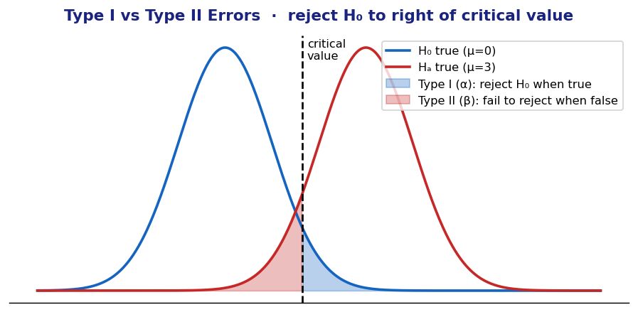
Type I error: reject H₀ when it's actually TRUE. P(Type I) = α
Type II error: fail to reject H₀ when it's actually FALSE. P(Type II) = β
POWER: P(reject H₀ | H₀ false) = 1 − β

POWER INCREASES WHEN:
• Sample size n increases
• True effect size is larger (truth is far from H₀)
• α is larger (e.g., 0.10 vs 0.05)
• Population SD is smaller

PAGE 10 │ FRQ STRATEGY · STATE-PLAN-DO-CONCLUDE templates
FRQ STRUCTURE — 6 questions, 90 min [4]
- FRQs 1-5: short, ~12 min each. Each focused on one or two specific concepts.
- FRQ 6: Investigative Task, ~25 min. Multi-part, requires synthesizing material from across units. Worth more — invest the time.
- Each FRQ scored holistically 0-4 based on Essentially correct (E), Partially correct (P), Incorrect (I) on each part.
UNIVERSAL FRQ DISCIPLINE — non-negotiable for a 5 [5]
- Define the parameter IN CONTEXT every time. "Let p = the true proportion of [specific group] who [specific behavior]." Don't just say "the proportion."
- State H₀ and Hₐ in terms of the parameter (use μ, p, β, etc.), and always relate to the context.
- Check ALL conditions explicitly. Show the calculation: "n·p̂ = 200 × 0.54 = 108 ≥ 10 ✓" — not just "large counts ✓".
- Show the test statistic formula AND the substituted values. Even if calculator gives the answer.
- Conclude in context, naming the original variable. "There is sufficient evidence to conclude that the true mean reaction time of college students is greater than 250 ms."
- For CIs: interpret correctly. "We are 95% confident that the true [parameter] is between [low] and [high] [units]."
THE STATE-PLAN-DO-CONCLUDE TEMPLATE BY TEST TYPE [5]
Test type | STATE / PLAN / DO / CONCLUDE specifics
1-sample z-test for p | STATE: parameter p in context, H₀: p=p₀, Hₐ: p≠/>/< p₀, α. PLAN: 1-sample z-test; check random + 10% + n·p₀≥10 + n·(1−p₀)≥10. DO: z = (p̂−p₀)/√(p₀(1−p₀)/n), p-value. CONCLUDE: decision + context.
1-sample t-test for μ | STATE: parameter μ in context, H₀: μ=μ₀, etc., α. PLAN: 1-sample t; check random + 10% + Normal/Large (verify w/ graph or n≥30). DO: t = (x̄−μ₀)/(s/√n), df = n−1, p-value. CONCLUDE: decision + context.
2-sample t-test | STATE: parameters μ₁, μ₂ in context. H₀: μ₁=μ₂, etc. PLAN: 2-sample t (independent); check both samples random + 10% + Normal/Large; samples INDEPENDENT. DO: t with technology df. CONCLUDE: in context.
Matched-pairs t | STATE: parameter μd (mean of differences). H₀: μd=0. PLAN: paired t-test on differences. Check random pairs + 10% + Normal/Large for differences. DO: t = d̄ / (s_d/√n).
1-prop z-interval | STATE: parameter p, level. PLAN: 1-sample z-interval; check 3 conditions (use p̂ for large counts here). DO: p̂ ± z*·√(p̂(1−p̂)/n). CONCLUDE: "We are X% confident that the true [parameter] is between [low] and [high]."
Chi-square test | STATE: specify GOF/Independence/Homogeneity. State H₀ (no difference / no association / same distribution). PLAN: check random + 10% + all expected ≥ 5. DO: χ² with df, p-value. CONCLUDE: in context.
Slope t-test | STATE: parameter β (slope of regression line in population). H₀: β=0 (no linear relationship). PLAN: check LINER conditions. DO: t = b/SE_b, df = n−2. CONCLUDE: evidence of (no) linear relationship in context.
THE INVESTIGATIVE TASK (FRQ 6) — strategies [5]
- Read the entire problem before starting. Multi-part FRQs build — early parts feed into later parts.
- Each part is scored separately. Even if you can't do part (a), still attempt (b) using a placeholder value.
- The final part often asks something "new" — combining concepts from across units. Stay calm; identify the underlying inference type.
- Time budget: ~25 minutes. Don't blow your budget on one part. Move on if stuck.

PAGE 11 │ 4-vs-5 LADDER · TRAPS · PHRASES THAT SCORE
THE 4-vs-5 LADDER — what the gap looks like [5]
A 4-scorer writes… | A 5-scorer writes…
"Reject H₀." | "Since the p-value 0.012 < α = 0.05, we reject H₀. There is sufficient evidence to conclude that the true mean recovery time differs from 30 days."
"95% confident the true mean is in (X, Y)." | "We are 95% confident that the true mean recovery time for the population of patients is between X and Y days."
"Conditions: random sample ✓, independence ✓, normal ✓" | Shows each: "Random sample stated. n = 25 ≤ 10% of all patients ✓. Histogram is roughly symmetric with no outliers, so Normal condition is met for n = 25 ✓."
States parameter as μ | Defines: "Let μ = the true mean recovery time of all patients receiving this treatment."
Computes test stat | Computes test stat AND shows formula AND substituted values: "t = (x̄ − μ₀)/(s/√n) = (32.4 − 30)/(8/√25) = 1.50"
Reports p-value | Reports p-value AND interprets: "P-value of 0.073 means: assuming H₀ true, there's a 7.3% chance of observing data this extreme or more."
Skips condition checks | Verifies all conditions with explicit calculations and reasoning
Lists outliers as "X is far" | "X = 95 is greater than Q3 + 1.5·IQR = 75 + 1.5·22 = 108 — wait, 95 < 108, so NOT a 1.5×IQR outlier. Rule out outlier-driven results."
THE TOP-15 TRAPS — where strong students slip [5]
- Confidence interval interpretation. NOT "95% chance the parameter is in this CI." CORRECT: "95% of intervals constructed this way capture the parameter."
- P-value interpretation. NOT "probability H₀ is true." CORRECT: "P(observing data this extreme or more | H₀ true)."
- Random sampling vs random assignment. Sampling generalizes to population; assignment establishes causation. Different purposes.
- Independent vs mutually exclusive. Cannot be both (unless one has P=0).
- Failing to define the parameter in context. "Let p = proportion" earns 0; "Let p = the true proportion of [specific group] who [behavior]" earns the point.
- Wrong test for the situation. Especially: 2-sample vs matched pairs, GOF vs Independence, χ² vs t-test. Read the problem carefully.
- Skipping condition checks. Each condition needs its own line of reasoning, not just a checkmark.
- Wrong large-counts condition. For TEST: use p₀ (null value). For CI: use p̂ (sample value).
- Pooling for CI when not appropriate. 2-prop CI uses unpooled SE. 2-prop TEST uses pooled SE.
- Forgetting the 10% condition for sampling without replacement.
- Misinterpreting r and r². r is correlation (linear); r² is proportion of variation explained.
- Linear regression with curved data. ALWAYS check residual plot. Curved residuals = wrong model.
- Statistical vs practical significance. Big n can make tiny differences "significant." Always state effect size.
- Wrong sign on z or t. Test stat sign matters for one-sided tests.
- Calculator answer without setup. Always show the FORMULA before the number — earns the procedure point.
PHRASES THAT EARN POINTS — drop these into FRQs [5]
For CI interpretation: "We are X% confident that the true [parameter, in context, in units] is between [low] and [high]."
For test conclusions: "Since the p-value of [value] is [<,>] α = [level], we [reject / fail to reject] H₀. There is [sufficient / not sufficient] evidence to conclude that [Hₐ in context]."
For p-value interpretation: "Assuming H₀ is true, the probability of observing a sample [statistic] at least as extreme as [value] is [p-value]."
For conditions: "The 10% condition is met because n = [value] is less than 10% of [population, in context]."
For Type II error: "A Type II error in this context would be failing to conclude [Hₐ in context] when in fact [Hₐ is true in context]."
TEST-DAY EXECUTION CHECKLIST [5]
For a 4 — bag ALL of these: ✓ MCQ: 24+ correct ✓ Each FRQ: define parameter, name test, attempt all parts ✓ State conclusion in context
For a 5 — add these on top: ✓ MCQ: 30+ correct ✓ Every FRQ: explicit condition VERIFICATION (not just listing) ✓ Test statistic shown with formula AND substituted values ✓ CI/test conclusions in CONTEXT with units ✓ P-value interpreted correctly (probability assuming H₀) ✓ Investigative Task: complete every part, even with placeholder values
THE ONE THING THAT MATTERS MOST [5]: CONTEXT EVERYTHING. AP Stats grades context as much as procedure. Every parameter, every hypothesis, every condition, every conclusion must reference the specific people/things in the problem with the specific measurement and specific units. Generic answers earn no points.
If you do nothing else: master the STATE-PLAN-DO-CONCLUDE framework (Page 1) and apply it with full context on every FRQ. That's how you get the score you're targeting.

