

COURSE SYLLABUS
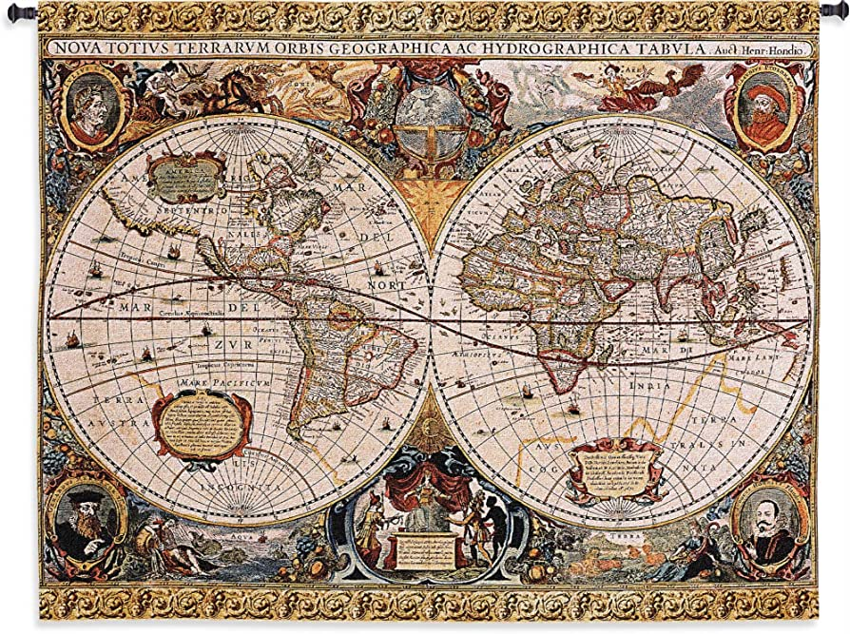

Course Title: Introduction to Humanities
Course Number: HUM 1020
Face to Face Instruction
Semester Code (0615): Semester and Year (Spring 2023)
Semester Dates: January 17 – May 10, 2023

Syllabus Addendum: www.spcollege.edu/addendum

INSTRUCTOR
Name: Michael T. Jahosky
Email: Use E Mail in My Courses to “My Instructor”
Phone: Text me your first and last name, class and section number: 321-234-3282
Office Hours: M/W TBA; Tu/Th 9am-2pm; Friday Virtual Office Hours 9am-1pm
Office Location: Clearwater Campus, CR 187
Instructor Web Page: https://web.spcollege.edu/instructors/id/jahosky.michael and www.mythicmission.com

ACADEMIC DEPARTMENT (contact only if communication with your instructor fails)

Academic Chair: Dr. Kevin Stanley
Office Location: Tarpon Springs Campus, Lyceum 239
Seminole Campus, UP-337
St. Pete Gibbs Campus HS-118
Office Phone Number: (727) 712-5717 (leave voicemail with student ID and identify the course and campus you are referencing)
Email: stanley.kevin@spcollege.edu

Dean: Dr. Barbara Hubbard
Office Location: Clearwater Campus: CR 154-C
Office Phone Number: 727-394-6011
Email: hubbard.barbara@spcollege.edu

COURSE INFORMATION
QM 1.2: Introduce learners to the purpose and structure of the course.
Course Description: This course introduces students to a range of ideas and themes in the humanities from a global perspective through an exploration of different aesthetic approaches across a variety of disciplines in the humanities. Students will explore primary source examples from the visual, performing, and literary arts by describing and analyzing the relationship between form and content and by investigating their social, historical, and cultural contexts to determine their meaning and significance. Topics will include examples from authors, artists, and other creators from a diverse selection of cultures, races, religions, and genders. Areas of study may include, but are not limited to, visual art, music, literature, dance, theater, and film. This course satisfies the Enhanced World View requirement.

Course Goals
QM 2.1, 2.3, 2.5: State clear and measurable course-level learning objectives that are written from the learner’s perspective, that are suited to the level of the course.
Learning Outcomes and Objectives:
1. The student will be able to define and describe the humanities by:
a. applying basic vocabulary for concepts used within the disciplines.
b. distinguishing the similarities and differences among the performing, visual, and literary arts.
c. outlining the purposes and functions of creative works as they change over time.
2. The student will be able to distinguish between a variety of aesthetic theories by:
a. defining and describing “aesthetics” as it relates to the humanities.
b. differentiating between the major aesthetic theories (i.e., representation, expressionist, formalist, etc.).
c. comparing and contrasting mediums and techniques (i.e., prose, painting, film, dance, etc.) used in creative expression.
3. The student will be able to analyze how diverse examples of creative expression communicate aspects of the human condition by:
a. describing the fundamental concerns of creative works studied in the humanities.
b. explaining the relationship between “form” and “content.”
c. comparing and contrasting formal and contextual criticism.
d. compiling and examining secondary source material.
4. The student will be able to apply critical analysis skills to evaluate how meaning is created in diverse creative works in the humanities by:
a. identifying a work’s formal qualities.
b. analyzing a work’s expressive content.
c. interpreting how a work’s social, historical, and political context informs its meaning and purpose.
d. communicating clearly and convincingly through writing how examples of creative expressions convey ideas about the human experience.
Criteria Performance Standard:
Upon successful completion of the course, the student will, with a minimum of 70% accuracy, demonstrate mastery of each of the above stated objectives through classroom or online measures developed by individual course instructors. The writing will meet the criteria of at least Level 3 in the SPC Analytical Rubric for Writing.

QM 2.2, 2.3, 2.5: State clear and measurable module-level learning objectives that are written from the learner’s perspective, that are suited to the level of the course.
Prerequisites: Dev Level 2 Writing and Reading Met
QM 1.6: State any prerequisite knowledge in the discipline or required competencies.

Proctored Testing Information: NONE-All work is done online and/or “in class” if applicable.

REQUIRED TEXTBOOK & OTHER RESOURCE INFORMATION

Required Textbook: The Art of Being Human, 11th edition. Janaro, Richard

PLEASE CHOOSE THE PRINTED COPY OF THE TEXTBOOK. You do NOT need REVEL. Do not choose both. The Rental or Used option is fine for the printed copy.

- REVEL E TEXTBOOK FOR THE ART OF BEING HUMAN
Author, JANARO, RICHARD, 11th Ed., PEARSON

OR

- ART OF BEING HUMAN (USED OR RENTAL) Printed
Author, JANARO, RICHARD, 11th Ed., ISBN: 9780135572207

Bookstore: www.spcollege.edu/textbooks
Library: www.spcollege.edu/libraries

learner support
Accessibility: www.spcollege.edu/dr
QM 7.2: Describe accessibility policies and services.
Academic Support Services: www.spcollege.edu/support
On-Campus Support: www.spcollege.edu/tutoring/#tab=2
Online Support: www.spcollege.edu/tutoring/#tab=3
QM 7.3: Describe how academic support services and resources can help learners succeed in the course and how to obtain it.
Student Services and Resources: www.spcollege.edu/services
QM 7.4: Describe how student services and resources can help learners succeed in the course and how to obtain it.

IMPORTANT DATES
Financial Aid Dates: www.spcollege.edu/pages/dynamic.aspx?id=800
Course Dates: Semester Begins Jan. 17, 2023 – Ends May 10, 2023
Drop Date: Last day to drop course for refund – Jan. 20, 2023
Withdrawal Date for Grade of W: March 29, 2023

ATTENDANCE
The College-wide attendance policy is included in the Syllabus Addendum:
www.spcollege.edu/addendum/#attend
QM 1.4: State or link to course and/or institutional policies with which the learner is expected to comply.
Attendance compliance for this face to face course means: (1) Attending class regularly and signing on to My Courses as needed for relevant announcements and/or assignments; and (2) Submitting assignments as directed, and (3) Not missing more than 4 unexcused classes (without justifiable explanation or documentation).
It is imperative that you BOTH attend class AND sign on to MyCourses regularly; do all of the reading; and do the required work. It is also required that you meet all due dates and deadlines. Read all News items, Email, Calendar items, and other communications from your instructor. The Calendar and Assignment Checklists within each module will help you budget your time to prevent lateness. You should plan on spending at least 3-4 hours per week for the successful completion of this course in addition to attending class. Set aside more time for weeks where a longer writing assignment is due, as there are likely multiple steps to the assignment. This is not a self-paced course.

GRADING
QM 3.1: Implement assessments that measure the stated learning objectives.
QM 3.2: State the course grading policy.
GRADING SCALE:
90-100% A
80-89% B
70-79% C
60–69% D
<60% F

Distribution:

In Class Group Discussions (every Module) 30%
Module Quizzes (in class) 30%
Adventure Map (typed homework) 20%
Aesthetic Experience Essay 10%

Required Class Materials (to purchase and/or download):

1 Notebook for taking notes (any number of subjects is fine—just have enough space for both notes and quizzes)
Pens or pencils
Textbook
The various additional required readings (i.e. Adventure Map Unit 1 readings etc)
Syllabus
Adventure Map
Adventure Map Contract
AE Essay Document

Class Discussions:

Every week of every Unit on Wednesdays or Thursdays (the last lecture day based on your class), we will have class discussion. The first day of the week will always be dedicated to lecture. It is during these lectures where you’ll need to take notes from the PowerPoint to get answers to the Adventure Map questions (you’ll also be doing some of these questions at home on your own). The topics for these discussions are printed within your Adventure Map Units clearly. DO NOT type up any response to the class discussion prompts in your Adventure Map. They’re simply there to remind you of WHAT we’re discussing in class and WHEN. Some of the discussions will require some sort of ASSIGNED reading and/or video to read/watch prior to the class. When directed to do so, please make sure you do---plan ahead. Students will be divided into 5 Groups and will be asked during the first day or before the first day to select a group leader. This individual needs to plan to be in class regularly, responsible, honest, and objective as possible.

The group leader will need to purchase a pack of ruled index cards and you will be tasked with evaluating your fellow group members based on the following rubric:

1. Attendance (2 pts): Is the individual physically present?
2. Attitude (4 pts): Does the student have a positive, eager learning attitude? Are they staying on topic or drifting to off-topic issues?
3. Participation (4 pts): Has the individual contributed at least 2 significant, on-topic points to the discussion?

Group leaders: Please make a note of each person’s score (out of 10) in your notebook so that you have an ongoing record of all discussion scores throughout the semester. Then, at the end of each class discussion, I ask that all group leaders bring me an index card with all the scores on them to submit to me for review. Finally, I will submit your individual discussion grade online. Group leaders must be honest and responsible with these scores, or they will risk failing the class for violating both my and SPC’s Academic Honesty policy.

MODULE QUIZZES:

Quizzes will be administered IN CLASS at the conclusion of every Unit (they may or may not coincide with class discussion days; if they do, we will take the Quiz first). Students will be given 15 minutes to answer 5-10 questions (quiz lengths will vary based on Units). After you’ve finished taking the quiz in your notebook, please swap notebooks with a group member next to you and we will grade them together. Most quizzes will be multiple choice, though some will be true or false or matching. After grading, return notebooks to their rightful owners and then group leaders will take an index card and RECORD everyone’s grade, with everyone’s first and last name (or just last name) on it and turn it in to me at the end of the day.

ADVENTURE MAP:

• Right click on the desktop of your computer and “create new folder”: Title it HUM 1020 Spring 2023
• Download this and ALL class documents to that folder as they are made available to you
• Do this by using Microsoft Word or another similar Word Processor, choose the “Save As” option under “File” and save it to that class folder
• When typing up answers, type DIRECTLY into the document…do not change or modify the document in anyway.
• You will be submitting this SAME document multiple times during the semester to dropboxes. When you submit this document, do NOT split up or modify the document in anyway. Just submit the entire document. You’ll be submitting the same document over and over, with more done each time. This document is essentially a study guide and a portfolio that you can keep when you’ve finished the class.
• Answer lengths will vary based on question type.

Aesthetic Experience Essay:

Late in the semester, you will choose to either visit an art museum at your own expense (there are often student discounts) OR choose to “visit” a museum’s website. In either case, you will select ONE work of art, find FOUR academic sources (I will have a librarian embedded in the class for extra help), and then COMPLETE, by typing, the AE Worksheet. The Worksheet IS the Essay! You’ll fill out all the headers, insert a copy of the work of art as an image, and then TYPE up your essay in 3 parts called “Prompts.” Each prompt is 200 words, and DOES NOT require a separate 4 part Works Cited. At the end of Prompt 3, please insert your full Works Cited. Choose whichever citation style you’re comfortable with, such as Chicago Style or MLA. You’ll then submit the worksheet to a dropbox for a grade. We will be looking at art throughout the semester at various points and learn how to look at art, so consider that an introduction and warm up for this assignment.

LATE WORK POLICY: No late assignments accepted without medical documentation or absolutely reasonable circumstances (i.e. death in the family, serious life change that disrupts your schedule and is demonstrable). See me if in doubt, and we’ll discuss it.

ASSIGNMENTS AND DUE DATES: You will find all due dates on the Adventure Map and/or the Mycourses Calendar.

STUDENTS’ EXPECTATIONS AND INSTRUCTOR’S EXPECTATIONS
QM 1.4: State or link to course and/or institutional policies with which the learner is expected to comply.
QM 5.3: State the plan for response time and feedback on assignments.
QM 5.4: State the requirements for learner interaction.

Online Student Participation and Conduct Guidelines: www.spcollege.edu/addendum/#onlineguide

Academic Honesty: www.spcollege.edu/academichonesty

Communication and Response Times
Both students and instructors will use the Email tool in the Communicate menu in My Courses. Please send your instructor any questions you may have about the course as it proceeds. Your instructor will attempt to answer your questions within 24 hours under normal circumstances. Check the News items on the Course Home page each time you log in for class announcements. Remember that you are encouraged to speak with your instructor before and after class as needed and in the Professor’s office if applicable.

Netiquette (for online) and “In Person” class discussion activity:
When communicating on the Internet or in class, it is essential to observe certain rules of behavior. Effective communications are governed by netiquette (internet etiquette) and common sense “in class”. Netiquette refers to rules of behavior governing the use of all internet services, including communicating with discussion groups, creation of web pages, and connecting to FTP and telnet sites. Some of the basic rules of e-mail netiquette include the following:
- Never say anything you don't want made public. Think before you post a message. Always make sure you really want to send what you have written. Messages may easily be forwarded or saved for retrieval later. E-mail messages are not secure. Most organizations archive all e-mail messages that pass through their servers. Messages may also be intercepted en route.
- Don't post to discussions or use e-mail when you are emotional. If you are angry, you can sound abusive or threatening. Be careful when expressing humor and sarcasm because it can be misinterpreted. With most systems, you can't get the message back after you click the send button.
- Do not use emoticons to express emotion. Emoticons can appear in many different ways depending on the software interface. Use your words carefully and professionally.
See “Netiquette” details in My Courses in the Begin Here tab.
- For “in class” discussions: Be respectful to your classmates and do not use derogatory or offensive language.
QM 1.3: State etiquette expectations for online discussions, email, and other forms of communication.

Turn It In
The instructor of this course may require use of Turnitin.com as a tool to promote learning. The tool flags similarity and mechanical issues in written work that merit review. Use of the service enables students and faculty to identify areas that can be strengthened through improved paraphrasing, integration of sources, or proper citation. Submitted papers remain as source documents in the Turnitin database solely for the purpose of detecting originality. Students retain full copyright to their works. The Turnitin Usage Agreement can be reviewed at: turnitin.com/agreement.asp. Students who do not wish to submit work through Turnitin must notify their instructor via course email within the first seven days of the course. In lieu of Turnitin use, faculty may require a student to submit copies of sources, preliminary drafts, a research journal, or an annotated bibliography. I am NOT using Turn it in.

STUDENT SURVEY OF INSTRUCTION
The Student Survey of Instruction is administered in courses each semester. It is designed to improve the quality of instruction at St. Petersburg College. All student responses are confidential and anonymous and will be used solely for the purpose of performance improvement. Your instructor values and seeks your feedback.

technology
Minimum Technology Requirements: Students need access to the Internet to use MyCourses, the Learning Management System at SPC. MyCourses tutorials are available to students new to this LMS and are located at the beginning of the course. Most features on My Courses are accessible on mobile devices. Students are permitted to use mobile devices for email and discussion as well as course contents, but not quizzes, tests, and essays. FREE COMPUTER ACCESS IS PROVIDED AT MOST SPC CAMPUSES.

Students should know how to navigate the course and use drop boxes to submit assignments as attachments. Essays and essay responses need to be submitted as word attachments (doc or rtf format only, no PDF files) so they can be graded and returned as attachments. If an attachment cannot be opened, students will be required to re-save and re-submit an assignment so it can be evaluated and returned.
QM 1.5: State the minimum technology requirements.

Minimum Technical Skills: To succeed in the course, you must be able (at minimum) to: (1) know how to use a computer and internet; (2) know how to open basic files; (3) know how to use a computer keyboard; (4) know how to use e mail; (5) know how to compose essays using a word processing program (like WORD, etc.).
QM 1.7: State the minimum technical skills of the learner.

Accessibility of Technologies:
MyCourses (Brightspace by D2L) Accessibility Statement: www.brightspace.com/about/accessibility
QM 8.2: Provide information about the accessibility of all technologies required in the course.

Privacy:
MyCourses (Brightspace by D2L) Privacy Statement: www.brightspace.com/legal/privacy
QM 6.5: Provide link to privacy policy for all external tools required in the course.

Technical Support: www.spcollege.edu/helpdesk
QM 7.1: Describe technical support and how to obtain it.

