**网站名称: https://gdp.gotohui.com/data-208**

脚本代码:

var all = [];

var dom = document.querySelectorAll('#gdp_login tbody tr');

var domsix = Array.from(dom).slice(6);

domsix.forEach(item => {

var date = item.getAttribute("index");

var tds = item.querySelectorAll('td');

var dataText = tds[1].innerText;

var data;

var numberData = parseFloat(dataText);

if (!isNaN(numberData)) {

data = numberData;

} else {

data = dataText;

console.warn('无法将 data 转换为数字:', dataText);

}

var obj = {

"date": date,

"hasDate": true,

"data": data

};

all.push(obj);

});

var jsonString = JSON.stringify(all, null, 2);

console.log(jsonString);

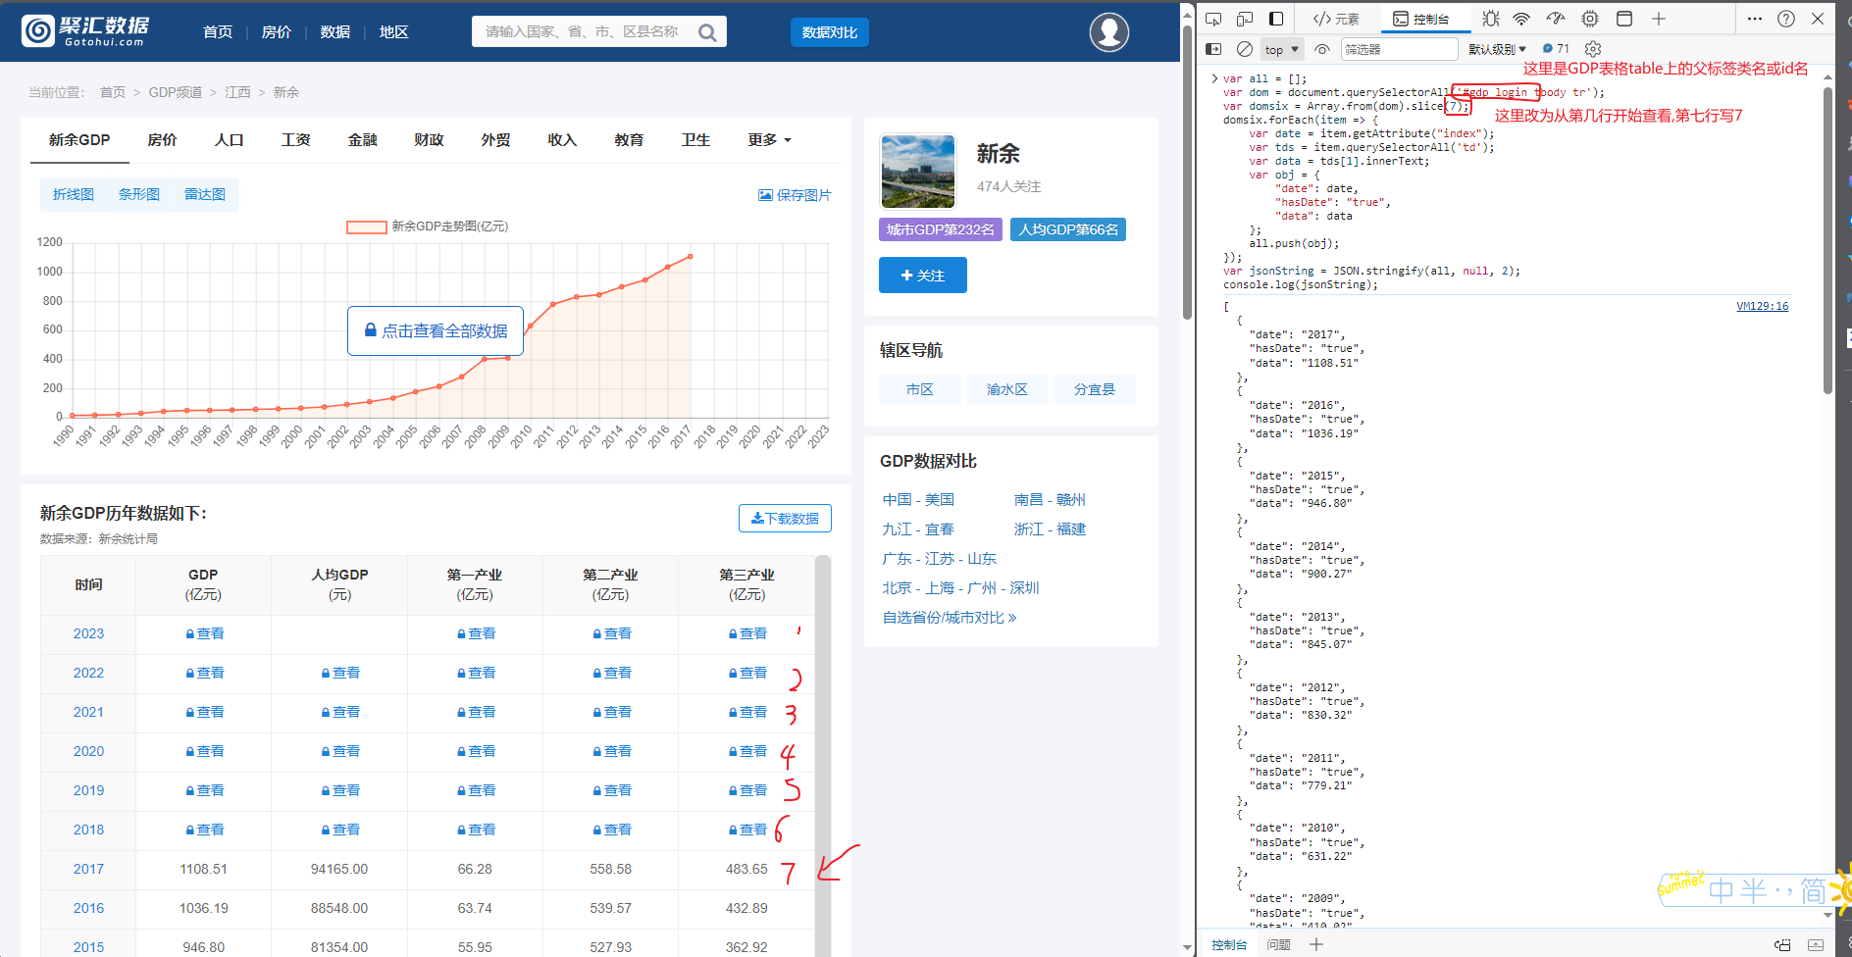

如果是第二种表格样式:

使用如下脚本代码(代码修改规则和上一条表格样式相同):

var all = [];

var dom = document.querySelectorAll('.show-table tbody tr');

var domsix = Array.from(dom).slice(11);

domsix.forEach(item => {

var date = item.querySelectorAll('td')[1].innerText;

var tdsText = item.querySelectorAll('td')[2].innerText;

var data;

var numberData = parseFloat(tdsText);

if (!isNaN(numberData)) {

data = numberData;

} else {

data = tdsText;

console.warn('无法将 data 转换为数字:', tdsText);

}

var obj = {

"date": date,

"hasDate": true,

"data": data

};

all.push(obj);

});

var jsonString = JSON.stringify(all, null, 2);

console.log(jsonString);