**Research Question:  
  
Front end: React vs Vue vs Angular?**

**Word count:**

Table of Contents

Relevant terms 2

Introduction 3

What are Angular, React.js & Vue? 4

Popularity, Community, and ecosystem 4

Philosophy comparison 6

Syntax comparison 7

Choices and results 7

Chosen research methods 7

Results 8

Conclusion and recommendation 9

# Relevant terms

|  |  |
| --- | --- |
| **Term** | **Definition** |
| DOM | The Document Object Model (DOM) is an application programming interface (API) for HTML and XML documents. It defines the logical structure of documents and the way a document is accessed and manipulated. (*What is the Document Object Model?*, 2021) |
| Router | For a Single-page application in the application layer, a router is a library that decides what web page is presented by a given URL. This middleware module is used for all URL functions, as these are given a path to a file that is rendered to open the next page. (*Routers - MDN Web Docs Glossary: Definitions of Web-related terms | MDN*, 2021) |
| Client-side validation | Before submitting data to the server, it is important to ensure all required form controls are filled out, in the correct format. This is called client-side form validation and helps ensure data submitted matches the requirements set forth in the various form controls. This article leads you through basic concepts and examples of client-side form validation. (*Client-side form validation - Learn web development | MDN*, 2021) |
| HTTP client | Most front-end applications need to communicate with a server over the HTTP protocol, to download or upload data and access other back-end services. (*Angular*, 2021) |

# Introduction

Frontend frameworks and libraries are, in most cases, written in JavaScript and are for organizing the functionality, interactivity of your website. (*History of front-end frameworks - LogRocket Blog*, 2018) There are three frameworks for building web applications that every frontend developer has heard about: React, Vue.js, and Angular. Those who have heard of these tools, have also asked themselves, which one is best?

The debate of React vs Angular and recently Vue.js, is an age-old one that recommences every year as each come out with an improved and updated version of their software. This document aims to introduce, explain, and compare each of these front-end frameworks to showcase the use cases and comparison between each, with the hope of allowing you to make an educated decision, in which one is best fit for your particular project/s.

In order to answer the main question, this being which of the aforementioned frameworks is best. This document will first be introducing each framework, providing some context and background behind each one of the projects. Then core differences will be discussed, namely explaining the philosophies of each. The syntax of each will be explored. By the end of the document the differences between should be overviewed.

# What are Angular, React.js & Vue?

Angular, React and Vue are all highly popular JavaScript libraries and frameworks that help developers build complex, reactive, and modern user interfaces for the web. Front-end frameworks declare rules on how developers should structure their HTML, CSS, and JavaScript, to make the application easier to develop. In this manner, frameworks are opinionated—meaning they prefer you to make certain decisions for ease of development. *(Maximilian Schwarzmüller, 2020)* Whilst they can all be used to achieve the same or similar goal, their implementation and adaptation varies. As will be explored and explained throughout.

Even though *React JS* is a library not a framework, henceforth it will be referred to as a framework as well, for clarity.

## Popularity, Community, and ecosystem

**Market popularity and demand**

Using survey results from a developer survey conducted by stack overflow taken in 2019. It the largest and most comprehensive survey of over 90,000 people who code around the world. We may use results found to present a picture over what developers around the world prefer to use. *(Stack Overflow Developer Survey 2019, 2019)*

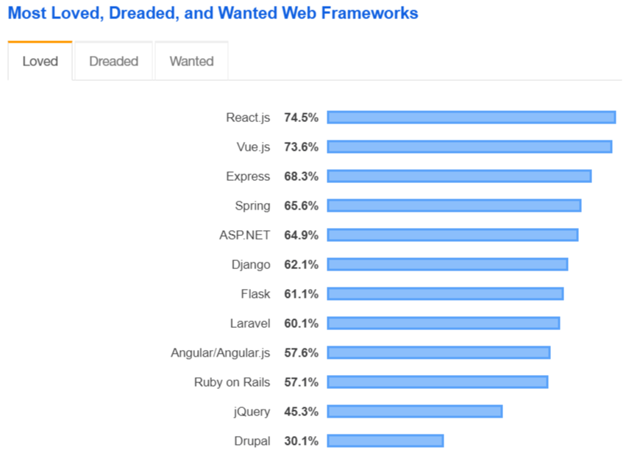

Figure - Most Loved Framework Chart (Stack Overflow Developer Survey 2019, 2019)

The results of this survey would suggest that developers tend to enjoy working with React.js and Vue.js as they both are at the top of the charts of most “loved” web frameworks. Angular on the other hand is placed lower the list. Potentially indicative that the prior two are easier to work with.

Another quantitative indicator that may be used is the npm downloads chart. npm is the package manager for the Node JavaScript platform. It puts modules in place so that node can find them and manages dependency conflicts intelligently. (*npm | npm Docs*, 2021)

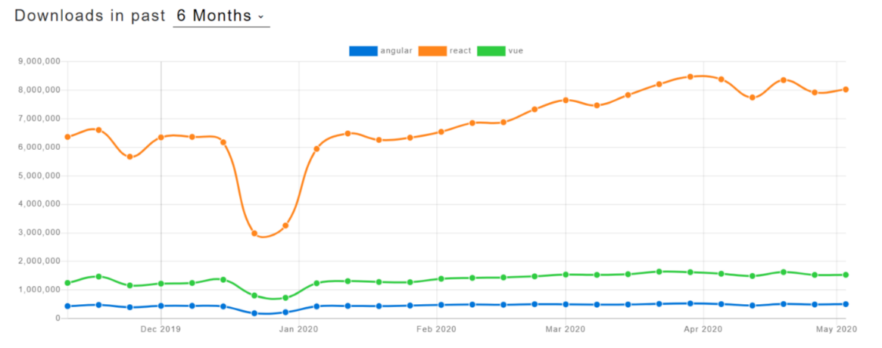

Figure - NPMtrends downloads and GitHub usage (angular vs react vs Vue | npm trends, 2020)

React.js is significantly ahead of its competitors in this respect. These indicators reflect the results of **Stackoverflow’s survey.** Vue.js’s and React.js’s rating is significantly higher than Angular.js’s. *(Musienko, 2021)*

**Community and ecosystem**

When choosing what framework, you want to learn and use, an important factor that should be considered is whether the framework you are using is still being developed and maintained. As you don’t want to be using obsolete and outdated technologies, due to security and extendibility reasons. *(Sawant et al., 2018)* This goes the same for any other third-party library that is used. This however is not an issue for these frameworks as they are all still currently being updated and maintained.

Angular is the oldest of the three frameworks, first showing up in 2010. It is currently being developed and maintained by Google.

React is developed by Meta (Facebook), since 2013. It has grown massively in popularity and amassed a big community.

Vue is the youngest when compared to the other two frameworks but has grown a lot in popularity.

## Philosophy comparison

*Angular -* Angular is the "biggest" framework of the three. It's often referred to as a "platform" rather than a framework. *(Angular, 2021)* Angular comes packed with support for many useful things. This includes controlling the UI, reacting to user input, validating user input in forms, routing, state management sending AJAX HTTP requests, official SLI and much more. *(Maximilian Schwarzmüller, 2020)* All of these features that Angular provides the developer with is with the hopes to make developing without the need for additional libraries. *(Angular, 2021)*

*React –* Reach is a library for rendering content to the DOM and for their subsequent control. React focus is on building user interfaces using components. (*React – A JavaScript library for building user interfaces*, 2021) It also includes "tools" which allow you to choose what should be rendered, and in what way. React does **not** include built-in form validation support, a router, and no HTTP client. To supplement these missing features, one must use other libraries which has caveats, as mentioned before.

*Vue -* Vue is a framework which kind of sits between React and Angular. It's not as "big" as Angular but it definitely includes more features than React does. Vue does give you built-in state management and it also ships with a built-in router. It does, however, not include form validation or HTTP client functionalities. *(Maximilian Schwarzmüller, 2020)*

Just like Angular and React, the core of Vue is combining reusable components to create a user interface. It’s vaguely in between the two.

From this it may seem that Angular should be the first choice as it has in-built tools for almost everything you would need for a project. But doesn’t have to be the case. It entirely depends on the needs of a said project and the better choice may change on the type of project and the projects specific needs. As mentioned, before you may supplement missing features in Vue and React using community made libraries. This does mean however that compatibility may become and issue, and the need for up-to-date support of each of the additional projects.

## Syntax comparison

When it comes to syntax and structuring your code, it’s a matter of personal preference. Some like to use TypeScript while others prefer to use Javascript. As mentioned before Angular is the only one of the three that uses Typescript.

The choice of syntax doesn’t influence performance however, so development time should be considered. If you are not familiar with Typescript that will require you learn that too, though if you are, Vue supports both. (*docs— Vue.js*, 2021)

Considering the learning curves, React being the most popular means that there are a lot of resources on it, as popularity drives the output of educational resources. Though all of the frameworks do have extensive documentation.

# Choices and results

## Chosen research methods

A lot of this document relied on analysis and review of articles and studies written by others. This was important, as when conducting research, one should look for resources compiled by individuals that are highly skilled and knowledgeable in their field. To combat affirmation bias, a source must be looked at critically and with the use of other resources, either enforcing for contradiction of a statement/s.

For certain sections of this document, quantitative data analysis, in the form of questionnaire analysis was used. Namely within the section that discussed community and eco system of the frameworks.

## Results

Looking at each of the frameworks some key points can be extracted:

**Angular –**

* Angular provides a basic framework for developing web applications and manages them without additional libraries.
* Developing in Typescript.
* Developed by Google

**React –**

* Most popular out of the three
* Not an actual framework, merely a library.
* Developed by Meta (Facebook)
* Base React does not come with tools necessary to develop a web application.
* Developing using JavaScript.

**Vue –**

* Developing using Javascript or Typescript.
* Smaller community compared to the other two.
* More base capabilities than React (Router, DOM, ect).

# Conclusion and recommendation

To conclude, knowing that all three frameworks are being actively developed and maintained while features are added or removed as new versions come, you won’t make a mistake regardless of your chosen framework. The most important thing would be to always keep up to date on the newest feature. Each framework respectively has its own pros and cons.

Ultimately, it's best to try each one, as it is very important if you like/enjoy a framework/ library or not. If you like its syntax, its way of approaching things and if you like how, you write code with it. If you **don't like** a technology, you'll not be successful in developing with it.

The recommendation is that there is simply too much overlap over each of the frameworks. There is simply not one that is objectively better than another. Each is better in certain contexts and based on your needs you should be able to instantly see which one might work best for your project. But it doesn’t mean that you cannot achieve your goal regardless of which of the three. Any of the three is a good choice.

Bibliography

*What is the Document Object Model? (2021). W3.org. https://www.w3.org/TR/REC-DOM-Level-1/introduction.html#:~:text=The%20Document%20Object%20Model%20(DOM,document%20is%20accessed%20and%20manipulated.&text=Nevertheless%2C%20XML%20presents%20this%20data,used%20to%20manage%20this%20data.*

*History of front-end frameworks - LogRocket Blog*. (2018, October 16). LogRocket Blog. https://blog.logrocket.com/history-of-frontend-frameworks/

‌Maximilian Schwarzmüller. (2020, March 19). *Angular vs React vs Vue - My Thoughts*. Academind.com; Academind. https://academind.com/tutorials/angular-vs-react-vs-vue-my-thoughts#framework-backgrounds

*Angular*. (2021). Angular.io. https://angular.io/docs

*React – A JavaScript library for building user interfaces*. (2021). Reactjs.org. https://reactjs.org/

‌*Routers - MDN Web Docs Glossary: Definitions of Web-related terms | MDN*. (2021, October 8). Mozilla.org. https://developer.mozilla.org/en-US/docs/Glossary/routers

‌*Client-side form validation - Learn web development | MDN*. (2021, October 8). Mozilla.org. https://developer.mozilla.org/en-US/docs/Learn/Forms/Form_validation

‌*Stack Overflow Developer Survey 2019*. (2019). Stack Overflow. https://insights.stackoverflow.com/survey/2019#most-loved-dreaded-and-wanted

‌*npm | npm Docs*. (2021). Npmjs.com. https://docs.npmjs.com/cli/v6/commands/npm

‌Musienko, Y. (2021, September 24). *title*. Merehead; Merehead. https://merehead.com/blog/angular-vs-react-vs-vue-best-choice-2021/

‌

Sawant, A. A., Huang, G., Vilen, G., Stojkovski, S., & Bacchelli, A. (2018). Why are Features Deprecated? An Investigation Into the Motivation Behind Deprecation. *2018 IEEE International Conference on Software Maintenance and Evolution (ICSME)*. https://doi.org/10.1109/icsme.2018.00011

‌

Versioning

|  |  |  |
| --- | --- | --- |
| **Version** | **Issue date** | **Changes** |
| 1.0 | 11/01/2022 | Finished |

‌

‌