Mikołaj Wojtysiak-Wawrzyniak 239114

The previous knowledge based on statistical data and logically deducted probabilities resulted in a network with such parameters for the Alarm node.

We can see that the Alarm is quite sensitive to earthquakes as it sounds in 1 in every 5 earthquakes.

Now we gather field data for the Alarm.

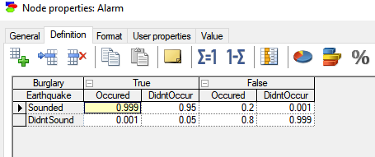

Now we gather field data for the Alarm.

We can see that after new data was added to the previous knowledge, the network has updated its parameters. The alarm is not so sensitive to earthquakes as we thought before – it sounds roughly 4% less often in case of an earthquake.

For burglaries, it is slightly less accurate too, but considering the previous accuracy of 95% the new accuracy of 94,7% is not a significant change.

