AutoScanner:
Portable photometric 3D object scanning

Mikola Lysenko
Chris Hopman

Introduction:
The primary impetus behind this project is the recent work in mesh-free analysis by Freytag et al. [1]. With their software, Scan'n'Solve, it is possible to directly perform finite element analysis on arbitrary scanned data. In order to promote the use of these techniques, Prof. Vadim Shapiro has volunteered to send some students to field test Scan'n'Solve at the Getty museum on real sculptures. The results of this analysis would then be useful for determining potential stress points when shipping or storing statues, which could potentially save priceless works of art. To complete this plan, the only remaining hurdle is data acquisition.
This situation imposes a number of difficult requirements on the scanning solution. It must be portable, and should be easily transported on an airplane; it must be fast, as we hope to produce the analysis on-site; and it must be cheap, as the budget for this project is fairly limited. Because we both work for Prof. Shapiro and needed a class project, we decided to take on this problem directly using what we learned about photogrammetry in CS766. Our goal is to implement a system for scanning static 3D objects using only materials we can obtain freely from various organizations around campus. If successful, Prof. Shapiro has promised to send us to the Getty museum to scan the sculptures and perform the necessary analysis.

Previous work:
At the moment, there exist an enormous number of commercial systems for performing 3D reconstruction. Unfortunately, most of these require expensive hardware and would be difficult to carry to the test site. A common tactic in these systems is to place markers or use structured light to track features on the scan target. In either of these methods, it would be necessary to bring additional supplies which could prohibitively increase costs, scanning time and transportation difficulties.
Instead of using marker based cues, we have instead decided to try for a purely photometric approach. To do this, there are two basic problems which must be solved: structure from motion and multiview stereo. The basic Structure from Motion (SfM) problem is to obtain a set of reliable camera calibration parameters from a collection of photographs. SfM is a fairly old problem in computer vision and has been well studied in literature. One of the most fundamental techniques is the 8-point algorithm by Longuet-Higgins[3]. Together with bundle adjustment [4] and some type of feature tracking [5], these form the basis for modern camera tracking systems.
The point correspondences obtained from SfM are generally too sparse to be useful for analysis purposes. Instead, we use the camera calibration with the original images to obtain an accurate, dense representation through multiview stereo. One of the simplest approaches to multiview stereo is Kutulakos & Setiz' photohull algorithm[7]. Given a suitable matching process, the photohull always yields a provably optimal upper bound on the volume enclosing the shape. However, this volume is often noisy and in practice may be sensitive to sensor calibration errors. More recent works regularize the reconstruction problem using a variety of filters and numerical techniques to obtain better results [8,9].
The combination of loose SfM with tight multiview stereo is not a new idea. The system which most closely resembles our approach is the work by Pollefeys et al. on hand-held camera scanning [2]. Likewise, there are commercial systems such as ShapeCapture [6] which are readily available (for a substantial price.) Yet despite the fact that all of the essential components necessary to solve this problem are known, to our knowledge there do not exist any freely available open source applications which solve this problem.

Method:
To solve for SfM, our program uses the Bundler system by Snavely et al. [12]. We first load the video using OpenCV, chop it into frames, pass them to the bundler script, then parse the results back into the camera data. Some user assistance is currently required at this point to throw out bad frames created by mismatches in Bundler. To get good results from Bundler, we had to turn off the options for radial distortion correction and variable focal length.
Once we have good camera data, we then run the photohull algorithm on the resulting set of images to obtain a volumetric representation of the object. This algorithm was implemented in Phase 1, and summarized in the previous report:

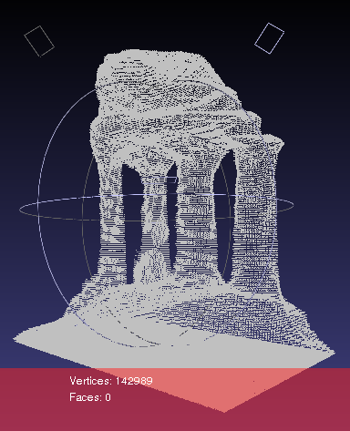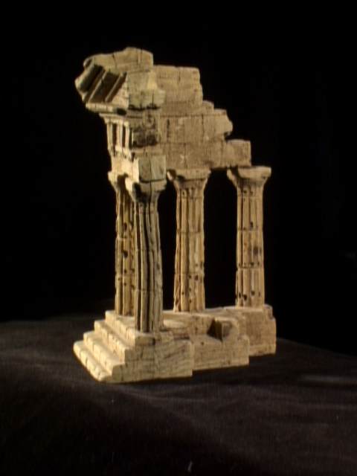
Figure 1: Photohull results from the Univ. Washing GRAIL temple benchmark.

The code for our project may be obtained from www.code.google.com/p/autoscanner. At the moment, it is not really ready for public consumption as configuration is quite difficult (due to dependencies on Bundler, Blitz++, OpenCV etc.) In the future, we hope to improve our distribution, and perhaps put together a simple redistributable binary for users around the world to try out our software.

Results:
To test our system, we scanned a seated subject using a standard digital camera obtained from the ME media department. Once seated, we moved the along a half-circle path in front of the subject, recording a :30 video clip. This video clip was then passed through our system to obtain camera calibration and ultimately a volume. The total processing time of the algorithm is difficult to estimate as the camera data had to be manually edited to remove some bad camera views. Nonetheless, these results are promising and demonstrate the feasibility of a system similar to this. The results are more carefully illustrated in Fig. 2.

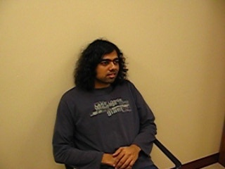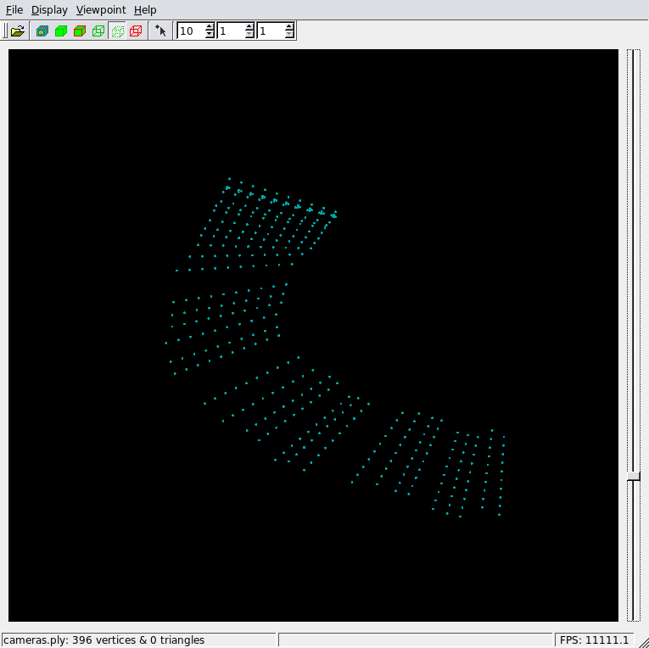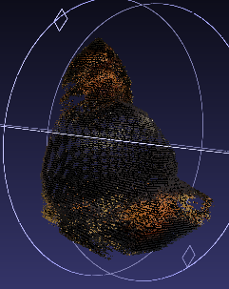
Figure 2: Left to Right; an image of the subject, the camera path graphed in 3D, the reconstructed point cloud.

Issues:
At the moment, the biggest problem in our current system is the unreliable structure from motion. Part of the problem may be due to the use of SIFT for feature tracking, which . We conjecture that better results should be possible with optical flow[10], given that we are using a video for data, though it does remain to be seen how best to handle the case where the camera path may cross itself multiple times. Another interesting approach is the reconstruction work by Martinec, which solves some of the robustness problems by grouping locally similar images into single epipolar geometries, which reduces total calibration error[11].
Although volumetric methods such as level sets, graph cuts and photohull are conceptually simple, in practice they are not as good as depth stereo. One major problem is that in order to use volumetric methods it is necessary to infer some geometric information from SfM beforehand. At the minimum, it is necessary to find some bounding box enclosing the region of interest, and in the case of level sets or graph cuts it is also necessary to mark at least one interior point. It is also up to the user to specify various tweak parameters such as resolution and matching thresholds which strictly speaking are not needed to perform a point membership classification. With depth maps, methods, these concerns may be largely avoided, while simultaneously reducing both space and computation costs.

Conclusion:
Our project demonstrates the feasibility of an automatic scanner, and with some work can potentially reach a very high level of automation. Within the strict time budget, we have met most of our goals and hopefully will have a totally automatic system soon.

References:

[1] M. Freytag, V. Shapiro, and I. Tsukanov, Field Modeling with Sampled Distances, Computer Aided Design, Volume 38, Issue 2, Pages 87-100. 2006

[2]M. Pollefeys, L. Van Gool, M. Vergauwen, F. Verbiest, K. Cornelis, J. Tops, R. Koch, “Visual modeling with a hand-held camera”, International Journal of Computer Vision 59(3), 207-232, 2004

[3] H. Christopher Longuet-Higgins. "A computer algorithm for reconstructing a scene from two projections". Nature 293: 133–135. 1981

[4] B. Triggs; P. McLauchlan and R. Hartley and A. Fitzgibbon "Bundle Adjustment — A Modern Synthesis". ICCV '99: Proceedings of the International Workshop on Vision Algorithms: 298-372, Springer-Verlag. 1999.

[5] D. Lowe. "Object recognition from local scale-invariant features". Proceedings of the International Conference on Computer Vision 2: 1150–1157. 1999.

[6] http://www.shapecapture.com/

[7] K. N. Kutulakos, S. M. Seitz. “A Theory of Shape by Space Carving” International Journal of Computer Vision, v. 38, n. 3, pp. 199-218, 2002.

[8] N. Campbell, G. Vogiatzis, C. Hernández and R. Cipolla. “Using Multiple Hypotheses to Improve Depth-Maps for Multi-View Stereo”. In Proceedings IEEE European Conference of Computer Vision (ECCV), 2008.

[9] Y. Furukawa and P. Jean. “Accurate, Dense, and Robust Multi-View Stereopsis”, Submitted to PAMI, August 2008.

[10] S. S. Beauchemin , J. L. Barron. “The computation of optical flow”. ACM New York, USA. 1995

[11] D. Martinec and T. Pajdla. “Robust Rotation and Translation Estimation in Multiview Reconstruction”. CVPR 2007, IEEE, Minneapolis, MN, USA, June 2007.

[12] N. Snavely, S.M. Seitz, R. Szeliski. “Photo Tourism: Exploring image collections in 3D”. ACM Transactions on Graphics (Proceedings of SIGGRAPH 2006), 2006

