Tortoise SVN Tutorial

# Creating a branch

When you’re creating a branch, what you’re essentially doing is copying trunk (at whatever revision you want, but usually it will be from latest) into your own directory where you can work on it and commit you’re changes without affecting trunk.

1. 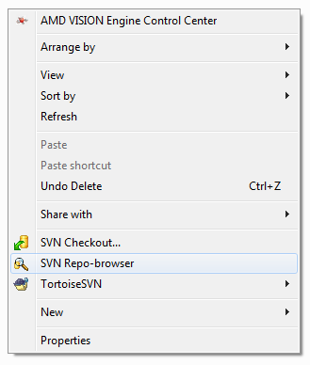Open up a windows explorer (Windows Key + E) and right click on any empty space.
2. You should see some options from Tortoise SVN. Click on “SVN Repo-browser”.
3. A little window pops up asking for the repository URL. The URL for our project is located here: <http://code.google.com/p/asteroidz/source/checkout>. It’ll give you some instructions there, but don’t worry about that. What’s important is that URL. So in the pop up, put in our project URL: **https**://asteroidz.googlecode.com/svn/trunk/
4. Now Tortoise SVN should ask for your username and password. Your username is the email you gave me when I added you as a committer. You should have an account on code.google.com with that email. Check your profile for your Google code password. It’s auto generated so just copy and paste it into the password field.
5. 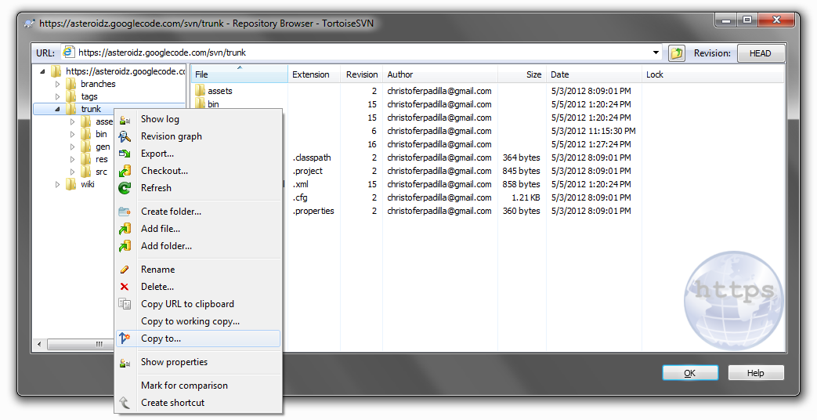You should now see a little explorer window like the one shown above. This is basically all our files stored on the repository. The trunk folder has all of our main code that we’ll use to run our game. This is what you need if you want to work on any part of the game code. Right click on it and click “Copy to…”.
6. 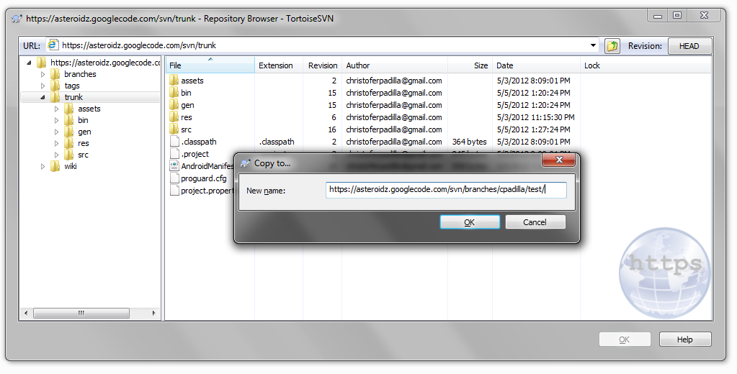Now enter the URL of the folder you want to copy it to. You should have your own folder set up under /branches, in my case, mine is called cpadilla. I don’t have a folder called test in cpadilla, but if I type in the URL as shown above, it’ll create that folder for me. You can call your folder whatever you want. If you don’t have a folder under branches, you can easily make on by right clicking on the folder and selecting the “Add folder” option. When you make any changes, you’ll also be asked to put in a little log message. You should also put something in, even if it’s something short like, “Adding branch”.

# Checking out a project

Now that you have a copy of the project in your branch, you’ll probably want to start working on it and junk.

1. Open up a windows explorer (Windows Key + E) and right click on any empty space.
2. Click on “SVN Checkout…”
3. 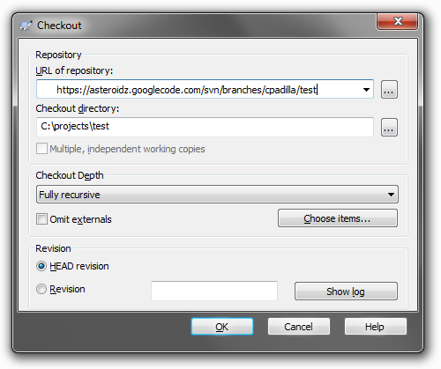A new window should pop up. By default, the URL of the place you want to check out a project form should be trunk. Change the directory to the location of your branch you want to checkout your project from. We’ll use the one we created in the last example. Underneath that is the Checkout directory. This is where the actually project will be saved on your computer. I created a folder called projects under C:\ where I checkout all my subversion projects to. I’d recommend you do this as well, but you can save it wherever you want on your computer.

# Importing a new project into Eclipse

Although your project is stored on your computer, you probably won’t see it right away on eclipse.

1. Open up Eclipse
2. Choose a workspace (wherever. if you have it set manually, that’s great; if you just leave it at it’s default place, that’s great too).
3. Right click on any empty space in the Package Explorer and choose “Import…” or in the menu bar go to File -> Import…
4. 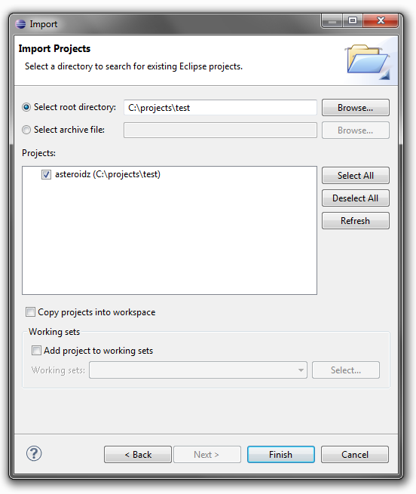Under “Select root directory:” enter in the local address or browse for where your folder for your project is. In the case of the last example, it was saved under C:\projects\test. Click Finish and you should have it in your Package Explorer ready to run!

NOTE: You may occasionally see a little warning sign at the top saying: “Some projects cannot be imported because they already exist in the workspace” That’s probably because you already have the asteroidz project in your Package Explorer from a previous revision. It’s okay to just delete the asteroidz folder in your Package Explorer and then import the new project.

# Committing Changes

So now that you’ve been working on your project you want to save your work in your branch. You’ll see that after you’ve made some modifications to the code, your folder will have a red exclamation mark, signifying a difference in the project code and the code still saved on the repository.

1. Select the folder.
2. 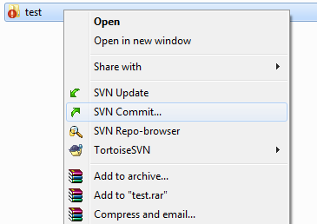Right click on the folder. You should now see some new options. Click on “SVN Commit…”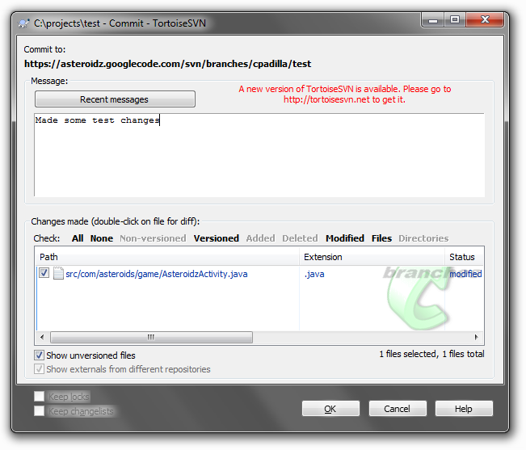
3. A new window should appear that looks like the one above. Here is where you can see all of the files that you changed as well as a little text field for you to write what you changed and how you changed it (modified, added, deleted). You should always leave a message, even if it’s short. Once you’ve done that, go ahead and click OK.

NOTE: Sometimes you may see things included in the change section that you didn’t mess with. Sometimes it’s stuff that gets changed automatically to reflect your changes, and some stuff is auto generated. I’m not an expert on it all either, so just make a good judgment call on whether to include it or not. Like I think an .apk file is generated if you run it on your phone so that it can be downloaded on it, but you don’t need to commit that.

# Submitting your changes for code review (WORK IN PROGRESSS)

Now that you’ve finished what you were working on and it’s all committed to your branch, you’ll probably want to see your changes added to the game. In order to do that you’ll have to submit your code for code review to make sure you haven’t done anything horribly wrong in your code, whether it be an unnoticed bug, or an unwanted game design change.

1. ~~To begin with, make sure your project is ready to be reintegrated into trunk. Although your folder may have a green check mark next to it, it doesn’t necessarily mean trunk hasn’t been changed from the version of trunk you pulled from when you started your branch. You’ll need to merge your project with trunk so that way your project is ready to be smoothly integrated back into trunk. To do this, select your project.~~
2. ~~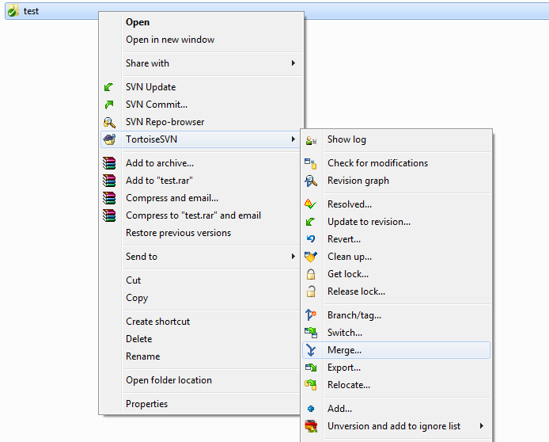Right click on it and go to TortoiseSVN -> Merge…~~
3. ~~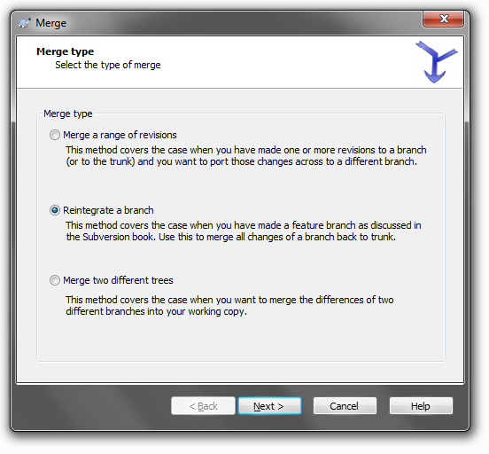A new window should appear. Select the second option, “Reintegrate a branch”~~
4. ~~Click Next.~~
5. ~~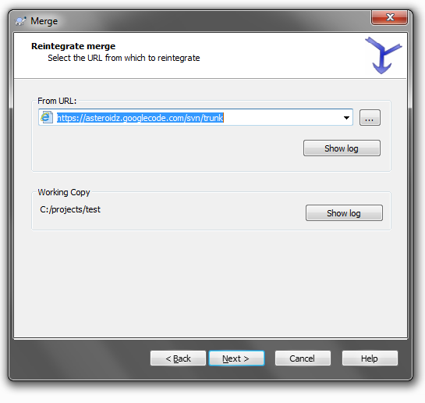In the “From URL:” field, you should put in the URL of the trunk, since that’s what we’re merging our branch with. The Working Copy field should show the directory of your project, which is what we’re merging into.~~
6. ~~Click Next.~~
7. ~~…Oh wait…~~