Q1)

I decided to use logistic regression for my classifier. For this type of classifier, it is important to preprocess features. I used the ‘StandardScaler’ tool for feature normalisation as this centers the data and scales it, so each feature contributes to the decision boundaries proportionally. This is especially important as different medical features make be measured differently and so may be on very different numerical ranges. Along with this, I mapped the two different diagnosis to binary labels (0 & 1).

For model evaluation, as there was no train:test split, I decided to use cross-validation for evaluation. I specifically used the ‘StratifiedKFold’ tool as stratified folds will maintain class balance (percentage of samples) in each fold, which may prevent bias, considering the imbalanced dataset.

For hyperparameter tuning, I used the ‘GridSearchCV’ tool with a parameter grid to perform a grid search across various configurations. My main focus was on trying various class weights, such as a normal balanced one as well as assigning more weight to malignant cases due to the importance of identifying these when classifying cancer. I assess whether a result is good by via score consisting of 70% recall and 30% precision which allows for high recall without sacrificing too much precision. From this the best parameters found are:

- Regularization strength (C): 0.1
- Class weights: {0: 1, 1: 2}
- Penalty: L2 regularization
- Solver: LBFGS

Of note, LBFGS if effective for small datasets like the one given and {0:1, 1:2} is making the model twice as sensitive to malignant cases.

Q2)

For cancer detection, making sure to identify malignant cases is the most important as missing these can result in death, whilst a false positive would just result in some wasted resources. This means reducing false negatives / maximising recall, even at the cost of some precision.

An F1 score consists of the mean of recall and precision, and so an F1 close to 1 means great model performance across recall and precision.

As can be seen in the classification report, the uncalibrated model achieves a F1 score as well as an accuracy of 0.98 and a precision score of:
- 0.99 for benign cases,
- 0.97 for malignant cases,
and achieves a recall score of:
- 0.98 for benign cases,
- 0.98 for malignant cases.

These scores are to be expected, as I focused on increasing the recall of malignant cases, even at the cost of malignant precision.

As can be seen in the classification report, the calibrated model achieves a F1 score as well as an accuracy of 0.99 and a precision score of:
- 0.99 for benign cases,
- 0.99 for malignant cases,
and achieves a recall score of:
- 0.99 for benign cases,
- 0.98 for malignant cases.

This shows some marginal improvement over the uncalibrated model. From this we can also see that improving recall is harder than improving precision, due to the difficulty of detect rare and important event like malignant tumours without losing too much precision. The recall can be further improved by adjusting the threshold, as discussed in Q4 (at heavy cost to precision).

Q3)

To increase recall, I focused my tuning on the recall score whilst maintaining a reasonable precision. To do this, a created a custom scoring function that gives the recall score a weight of 0.7 and precision a weight of 0.3. As part of this tuning, I tried various class weights (balanced, higher weight for malignant cases, etc.), a range of regularisation strengths (to strike a balance between complexity and generalisability) and I tried multiple different regularisation penalties to see which one minimises overfitting. As a result, the final calibrated model achieved a recall of 0.98 for the malignant class.

Q4)

Model calibration consists of aligning the model’s predicted probabilities with the true probabilities. I tested two calibration methods, sigmoid and isotonic. Sigmoid calibration resulted in a model that had a malignant precision of 1.00 and a recall of 0.96 whilst isotonic had a precision of 0.97 and a recall of 0.98. Due to the importance of recall, I decided to use isotonic calibration.

You can change how predictions map to the two classes by changing the threshold, I demonstrated this at various levels:
- 0.1 (higher recall)
- 0.01 (extreme recall)
- 0.001 (extreme sensitivity to malignant cases)
- 0.9 (higher precision)
- 0.99 (extreme precision)
- 0.999 (ultra conservative)

From this we can see that lower thresholds increase recall, whilst lower thresholds increase precision. This produces a flexible tool that can be adjusted based on what it is being used for / clinical requirements.

Below I’ve included a couple of plots as well as a copy of the code from the included Jupyter Notebook. The provided Jupyter Notebook, contains plots demonstrating the changing of thresholds.

Confusion Matrix of Uncalibrated Model:
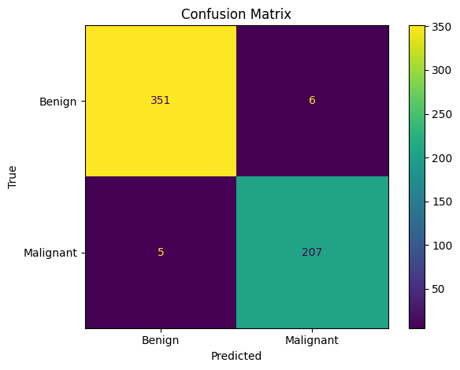

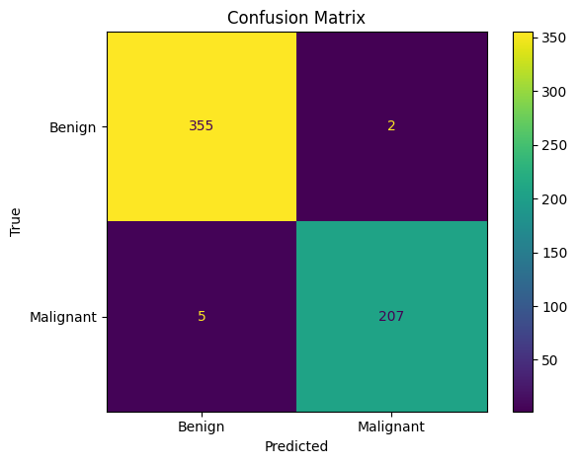
Confusion Matrix of Calibrated Model:

Decision Boundaries of Calibrated Model:

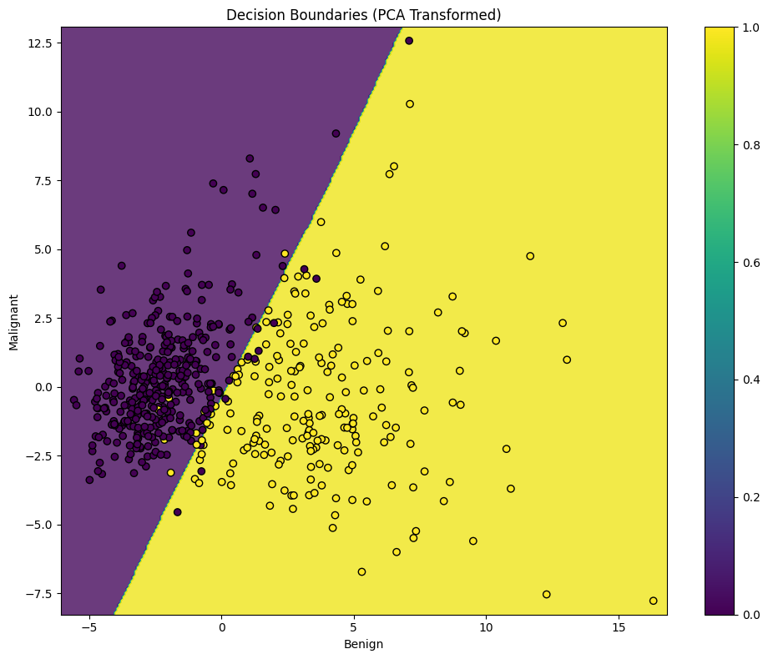

Precision-Recall Curve of Calibrated Model:
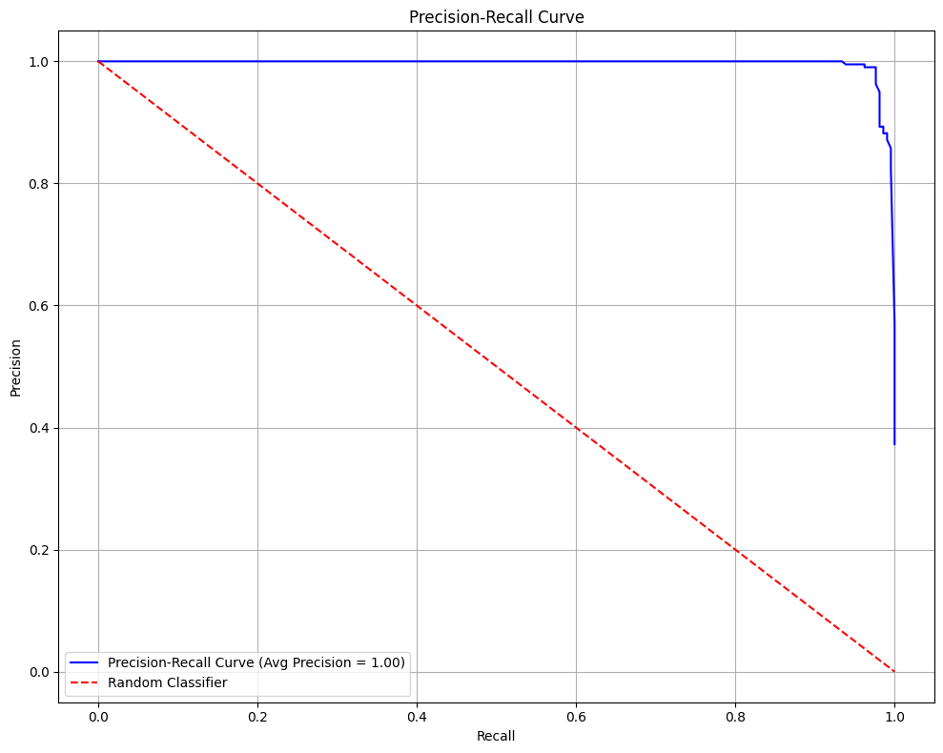

Code:

from ucimlrepo import fetch_ucirepo

# fetch dataset
breast_cancer_wisconsin_diagnostic = fetch_ucirepo(id=17)

# data (as pandas dataframes)
X = breast_cancer_wisconsin_diagnostic.data.features
y = breast_cancer_wisconsin_diagnostic.data.targets

import numpy as np
import pandas as pd
import matplotlib.pyplot as plt

from sklearn.model_selection import StratifiedKFold, GridSearchCV
from sklearn.preprocessing import StandardScaler
from sklearn.linear_model import LogisticRegression
from sklearn.decomposition import PCA
from sklearn.calibration import CalibratedClassifierCV
from sklearn.metrics import (
classification_report,
confusion_matrix,
ConfusionMatrixDisplay,
make_scorer,
precision_recall_curve,
average_precision_score,
precision_score,
recall_score,
f1_score,
)

class BreastCancerModel:
def __init__(self, X, y, test_size=0.3, random_state=42):
self.random_state = random_state

# handle pandas data types
if isinstance(y, pd.DataFrame):
y = y['Diagnosis'].map({'M': 1, 'B': 0})
elif isinstance(y, pd.Series):
y = y.map({'M': 1, 'B': 0})

# normalise (center and scale to unit variance)
self.scaler = StandardScaler()
X_scaled = pd.DataFrame(
self.scaler.fit_transform(X),
columns = X.columns,
index = X.index
)

# store scaled data
self.X = X
self.X_scaled = X_scaled
self.y = y

# use custom scorer with 70/30 split of recall and precision
def _custom_scoring(self, y_true, y_score):
y_pred = (y_score >= 0.5).astype(int)
recall = recall_score(y_true, y_pred, zero_division=0)
precision = precision_score(y_true, y_pred, zero_division=0)
f1 = f1_score(y_true, y_pred, zero_division=0)
return 0.7 * recall + 0.3 * precision # can change split and/or add f1

def _tune(self, model, param_grid):

# use stratified 5-fold cross-validation
cv = StratifiedKFold(n_splits=5, shuffle=True, random_state=self.random_state)

custom_scorer = make_scorer(self._custom_scoring, needs_proba=True)
grid_search = GridSearchCV(model, param_grid, cv=cv, scoring=custom_scorer, n_jobs=-1)

grid_search.fit(self.X_scaled, self.y)

print("Best Parameters:", grid_search.best_params_)
print("Best Recall Score:", grid_search.best_score_)

return grid_search.best_estimator_

def train_model(self):

# parameter grid of parameters to test
param_grid = {
'C': np.logspace(-4, 3, 8),
'class_weight': [None, 'balanced', {0:1, 1:2}, {0:1, 1:3}, {0:2, 1:1}, {0:3, 1:1}],
'penalty': ['l2'],
'solver': ['lbfgs', 'liblinear', 'saga']
}

# tune model
model = self._tune(LogisticRegression(random_state=self.random_state, max_iter=20000), param_grid)

return model

def calibrate_model(self, model, method='sigmoid'):
calibrated_model = CalibratedClassifierCV(model, cv=5, method=method)
calibrated_model.fit(self.X_scaled, self.y)
return calibrated_model

# adjust thershold (bigger -> more precise)
def adjust_classification_threshold(self, model, threshold=0.5):
def custom_predict(X):
proba = model.predict_proba(X)[:, 1]
return (proba >= threshold).astype(int)

return custom_predict

def plot_confusion_matrix(self, model, predict_func=None):

# allows for plotting calibrated
if predict_func:
y_pred = predict_func(self.X_scaled)
else:
y_pred = model.predict(self.X_scaled)

cm = confusion_matrix(self.y, y_pred)

# make plot
plt.figure(figsize=(10, 8))
disp = ConfusionMatrixDisplay(confusion_matrix=cm, display_labels=['Benign', 'Malignant'])
disp.plot()
plt.title('Confusion Matrix')
plt.xlabel('Predicted')
plt.ylabel('True')
plt.tight_layout()
plt.show()

# print classification report
print("Classification Report for Matrix above:")
print(classification_report(self.y, y_pred, target_names=['Benign', 'Malignant'], zero_division=0, labels=[0, 1]))

def plot_decision_boundaries(self, model):
# PCA for 2d
pca = PCA(n_components=2)
X_pca = pca.fit_transform(self.X_scaled)

# meshgrid
x_min, x_max = X_pca[:, 0].min() - 0.5, X_pca[:, 0].max() + 0.5
y_min, y_max = X_pca[:, 1].min() - 0.5, X_pca[:, 1].max() + 0.5
xx, yy = np.meshgrid(np.linspace(x_min, x_max, 300), np.linspace(y_min, y_max, 300))

# Predict for each point in the mesh
Z = model.predict(pca.inverse_transform(np.c_[xx.ravel(), yy.ravel()]))
Z = Z.reshape(xx.shape)

# Plotting
plt.figure(figsize=(10, 8))
contour = plt.contourf(xx, yy, Z, alpha=0.8, levels=np.linspace(Z.min(), Z.max(), 20))
scatter = plt.scatter(X_pca[:, 0], X_pca[:, 1], c=self.y, edgecolor='black')

plt.title('Decision Boundaries (PCA Transformed)')
plt.xlabel('Benign')
plt.ylabel('Malignant')
plt.colorbar(scatter)
plt.tight_layout()
plt.show()

def plot_precision_recall_curve(self, model):

y_scores = model.predict_proba(self.X_scaled)[:, 1]
precisions, recalls, thresholds = precision_recall_curve(self.y, y_scores)
avg_precision = average_precision_score(self.y, y_scores)

plt.figure(figsize=(10, 8))
plt.plot(recalls, precisions, color='blue', label=f'Precision-Recall Curve (Avg Precision = {avg_precision:.2f})')
plt.plot([0, 1], [1, 0], linestyle='--', color='red', label='Random Classifier')

plt.title('Precision-Recall Curve')
plt.xlabel('Recall')
plt.ylabel('Precision')
plt.legend(loc='lower left')
plt.grid(True)
plt.tight_layout()
plt.show()

def main(X, y):
analyser = BreastCancerModel(X, y)
model = analyser.train_model()
calibrated_model = analyser.calibrate_model(model, method='isotonic') # isotonic tends to result in better recall, sigmoid for precision

print("Confusion Matrix of Uncalibrated Model:")
analyser.plot_confusion_matrix(model)
print("Confusion Matrix of Calibrated Model:")
analyser.plot_confusion_matrix(calibrated_model)
print("Decision Boundaries:")
analyser.plot_decision_boundaries(calibrated_model)
print("Precision-Recall Curve:")
analyser.plot_precision_recall_curve(calibrated_model)

# example: adjusting threshold to increase precision or recall
# lower threshold = more recall, higher threshold = more precision
higher_recall = analyser.adjust_classification_threshold(calibrated_model, threshold=0.1)
print("Confusion Matrix with Higher Recall Threshold:")
analyser.plot_confusion_matrix(calibrated_model, predict_func=higher_recall)

even_higher_recall = analyser.adjust_classification_threshold(calibrated_model, threshold=0.01)
print("Confusion Matrix with even Higher Recall Threshold:")
analyser.plot_confusion_matrix(calibrated_model, predict_func=even_higher_recall)

extreme_recall = analyser.adjust_classification_threshold(calibrated_model, threshold=0.001)
print("Confusion Matrix with Extreme Recall Threshold:")
analyser.plot_confusion_matrix(calibrated_model, predict_func=extreme_recall)

higher_precision = analyser.adjust_classification_threshold(calibrated_model, threshold=0.9)
print("Confusion Matrix with Higher Precision Threshold:")
analyser.plot_confusion_matrix(calibrated_model, predict_func=higher_precision)

even_higher_precision = analyser.adjust_classification_threshold(calibrated_model, threshold=0.99)
print("Confusion Matrix with even Higher Precision Threshold:")
analyser.plot_confusion_matrix(calibrated_model, predict_func=even_higher_precision)

extreme_precision = analyser.adjust_classification_threshold(calibrated_model, threshold=0.999)
print("Confusion Matrix with even Higher Precision Threshold:")
analyser.plot_confusion_matrix(calibrated_model, predict_func=extreme_precision)

main(X, y)

