Welcome Screen (1)

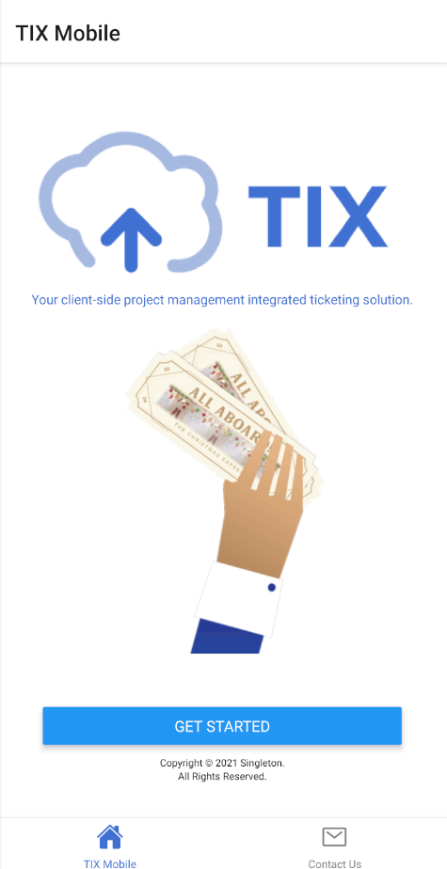

Contact Us Screen (2)

Login Screen (3)

Registration Screen (4)

Terms and Conditions Screen (5)

Home Screen (6)

Settings Screen (7)

New Request Screen (8)

View Requests Screen (9)

View Request {Id} Screen (10)

