|  |  |  |  |  |  |  |
| --- | --- | --- | --- | --- | --- | --- |
| Table 1. λ1 vs. Peak spawning age (mode). | | | | | | |
|  |  | estimate | std.error | t value | p.value | sig§ |
| k = 0 | (Intercept) | 0 | 0 | NA | NA |  |
| k = 0.2 | (Intercept) | 0.604294 | 0.06107 | 9.895182 | 5.74E-08 | *** |
|  | slope | 0.036534 | 0.010056 | 3.63317 | 0.002453026 | ** |
| k = 0.5 | (Intercept) | 0.796049 | 0.072246 | 11.01863 | 1.37E-08 | *** |
|  | slope | 0.024517 | 0.011896 | 2.060905 | 0.057092437 |  |
| k = 0.8 | (Intercept) | 0.925697 | 0.081444 | 11.36612 | 9.04E-09 | *** |
|  | slope | 0.015182 | 0.013411 | 1.132086 | 0.275372139 |  |
| k = 1 | (Intercept) | 0.996873 | 0.08695 | 11.46492 | 8.04E-09 | *** |
|  | slope | 0.009744 | 0.014317 | 0.680552 | 0.506525004 |  |

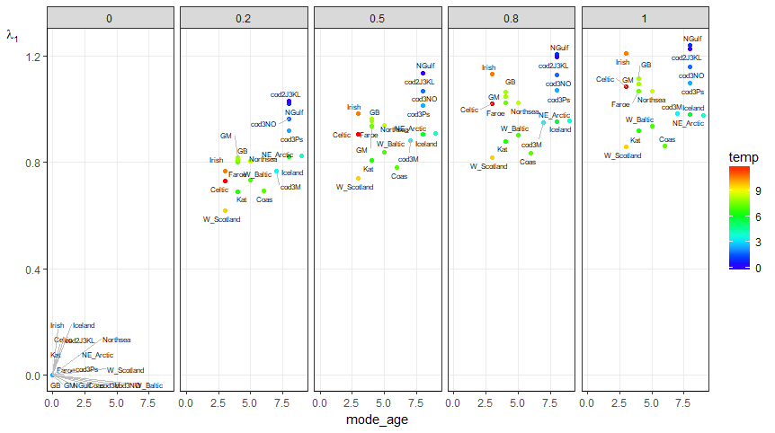

|  |  |  |  |  |  |  |
| --- | --- | --- | --- | --- | --- | --- |
| Table 2. Mean of λ1 values vs k. This regression removes the mean λ1 at k = 0 because all values of λ1 are NA (or zero) when k = 0. If the regression includes mean λ1 at k = 0 then there is no significant change in mean λ1 with k. | | | | | | |
|  |  | estimate | std.error | t value | p.value | sig |
|  | (Intercept) | 0.767284 | 0.022831 | 33.60637 | 0.000884 | *** |
|  | slope | 0.297741 | 0.032869 | 9.058418 | 0.011969 | * |

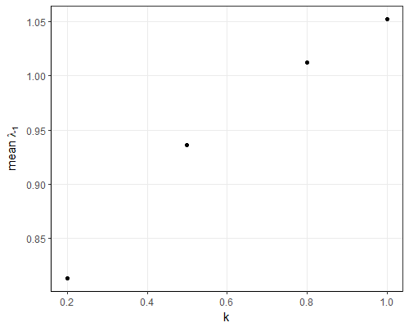

|  |  |  |  |  |  |  |
| --- | --- | --- | --- | --- | --- | --- |
| Table 3. Standard deviation of λ1 values vs k. This regression removes the mean λ1 at k = 0 because all values of λ1 are NA (or zero) when k = 0. If the regression includes mean λ1 at k = 0 then there is no significant change in mean λ1 with k. | | | | | | |
|  |  | estimate | std.error | t value | p.value | sig |
|  | (Intercept) | 0.110792 | 0.003421 | 32.38315 | 0.000952 | *** |
|  | slope | 0.007954 | 0.004925 | 1.614864 | 0.247702 |  |

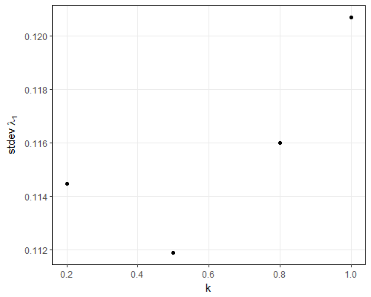

|  |  |  |  |  |  |  |
| --- | --- | --- | --- | --- | --- | --- |
| Table 4. Damping ratio, , vs CV of spawning biomass distribution. There is a significant relationship between the damping ratio and CV of the spawning biomass distribution at each k value. | | | | | | |
|  |  | estimate | std.error | t value | p.value | sig |
| k = 0 | (Intercept) | 0 | 0 | NA | NA |  |
| k = 0.2 | (Intercept) | 0.995131 | 0.052153 | 19.08113 | 6.23E-12 | *** |
|  | slope | -0.40233 | 0.11993 | -3.35469 | 0.004343356 | ** |
| k = 0.5 | (Intercept) | 1.002068 | 0.062504 | 16.03198 | 7.56E-11 | *** |
|  | slope | -0.52027 | 0.143735 | -3.61965 | 0.002521952 | ** |
| k = 0.8 | (Intercept) | 1.002088 | 0.065108 | 15.39127 | 1.35E-10 | *** |
|  | slope | -0.56971 | 0.149721 | -3.80511 | 0.001725103 | ** |
| k = 1 | (Intercept) | 1.001879 | 0.066103 | 15.15632 | 1.68E-10 | *** |
|  | slope | -0.59337 | 0.15201 | -3.9035 | 0.001411111 | ** |
|  |  |  |  |  |  |  |

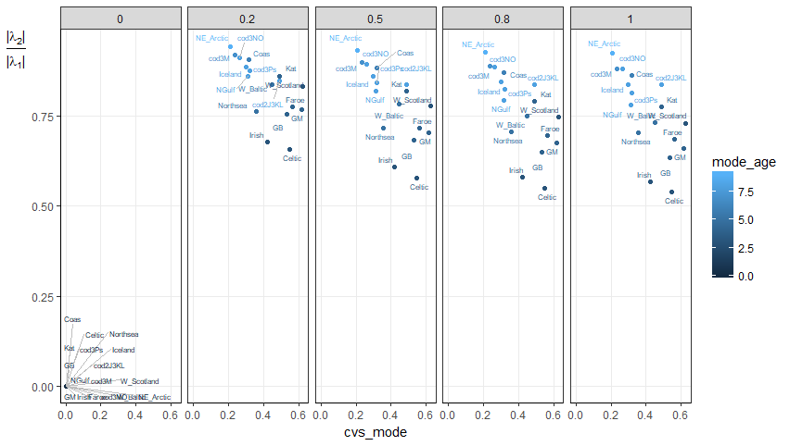

|  |  |  |  |  |  |  |
| --- | --- | --- | --- | --- | --- | --- |
| Table 5. CV vs STDEV in the spawning biomass distribution. There is no significant relationship between CV and standard deviation of the spawning biomass distribution. | | | | | | |
|  |  | estimate | std.error | t value | p.value | sig |
|  | (Intercept) | 0.349383 | 0.134189 | 2.603669 | 0.019952732 | * |
|  | slope | 0.030324 | 0.060463 | 0.501531 | 0.62327826 |  |

§Strength of significance level is noted with *** when 0 < p value <= 0.001, ** when 0.001 < p value <= 0.01, and * when 0.01 < p value <= 0.05.