|  |  |  |  |  |  |  |
| --- | --- | --- | --- | --- | --- | --- |
| Table 1. λ1 vs. CV of spawning biomass distribution. λ1 does not depend on CV for each k value. | | | | | | |
|  |  | estimate | std.error | t value | p.value | sig§ |
| k = 0 | (Intercept) | 0 | 0 | NA | NA |  |
| k = 0.2 | (Intercept) | 0.933003 | 0.089135 | 10.4673 | 2.73E-08 | *** |
|  | slope | -0.29008 | 0.204974 | -1.41521 | 0.177433 |  |
| k = 0.5 | (Intercept) | 1.005108 | 0.090838 | 11.06489 | 1.30E-08 | *** |
|  | slope | -0.16686 | 0.208889 | -0.79881 | 0.436869 |  |
| k = 0.8 | (Intercept) | 1.040719 | 0.095858 | 10.85692 | 1.68E-08 | *** |
|  | slope | -0.0685 | 0.220434 | -0.31075 | 0.760269 |  |
| k = 1 | (Intercept) | 1.056878 | 0.100046 | 10.56388 | 2.42E-08 | *** |
|  | slope | -0.01063 | 0.230066 | -0.04623 | 0.96374 |  |

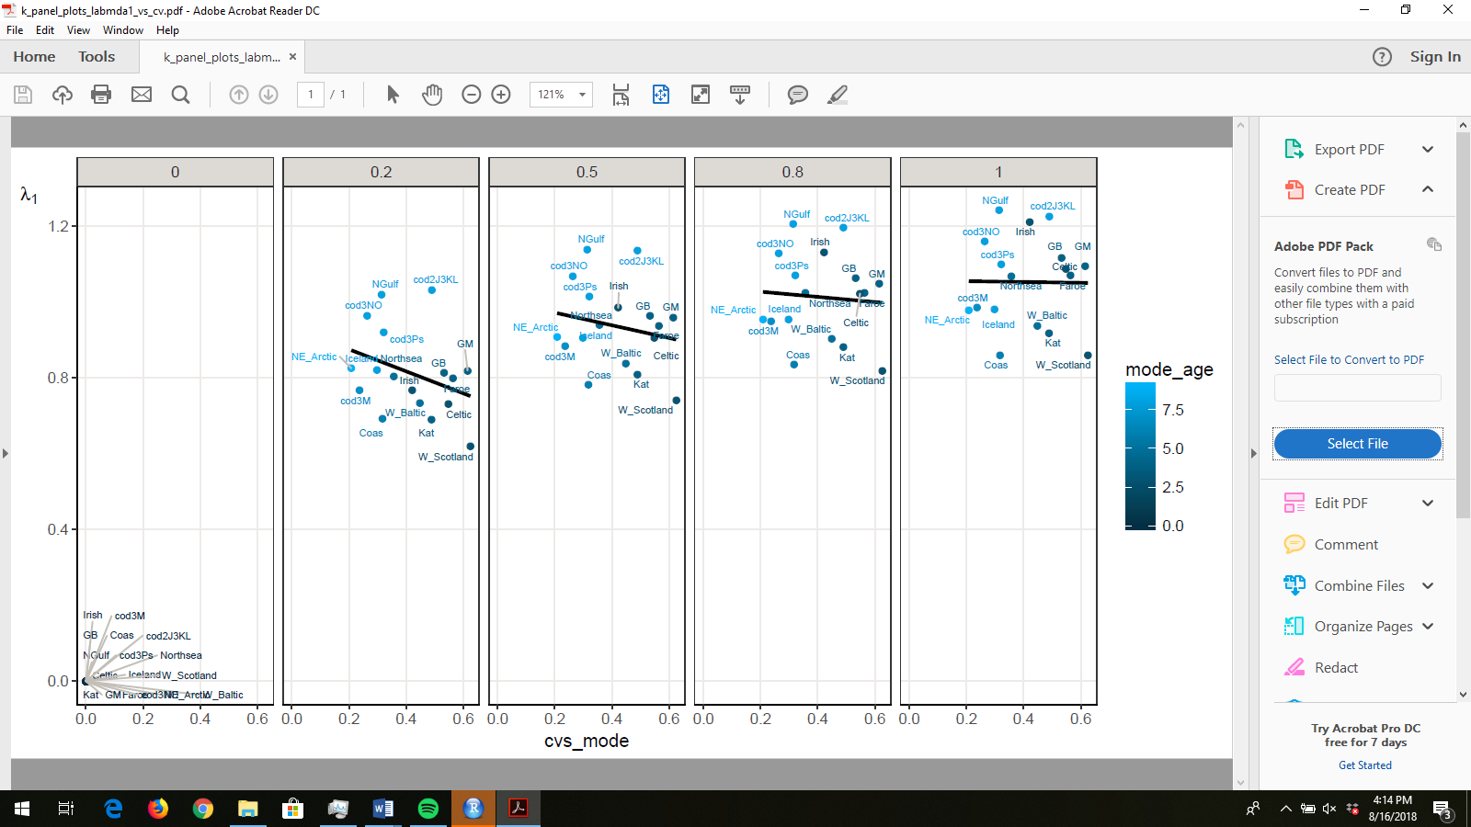

|  |  |  |  |  |  |  |
| --- | --- | --- | --- | --- | --- | --- |
| Table 2. Mean λ1 vs k. This regression removes ${\overline{λ}}_{1}$ at k = 0 because all values of λ1 are NA (or zero) when k = 0. If the regression includes ${\overline{λ}}_{1}$ at k = 0 then there is no significant change in ${\overline{λ}}_{1}$ with k. Mean λ1 depends on k | | | | | | |
|  |  | estimate | std.error | t value | p.value | sig |
|  | (Intercept) | 0.767284 | 0.022831 | 33.60637 | 0.000884 | *** |
|  | slope | 0.297741 | 0.032869 | 9.058418 | 0.011969 | * |

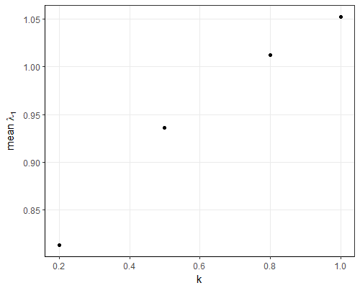

|  |  |  |  |  |  |  |
| --- | --- | --- | --- | --- | --- | --- |
| Table 3. Standard deviation of λ1 vs k. This regression removes the mean λ1 at k = 0 because all values of λ1 are NA (or zero) when k = 0. If the regression includes mean λ1 at k = 0 then there is no significant change in mean λ1 with k. Standard deviation of λ1 does not depend on k. | | | | | | |
|  |  | estimate | std.error | t value | p.value | Sig |
|  | (Intercept) | 0.110792 | 0.003421 | 32.38315 | 0.000952 | *** |
|  | slope | 0.007954 | 0.004925 | 1.614864 | 0.247702 |  |

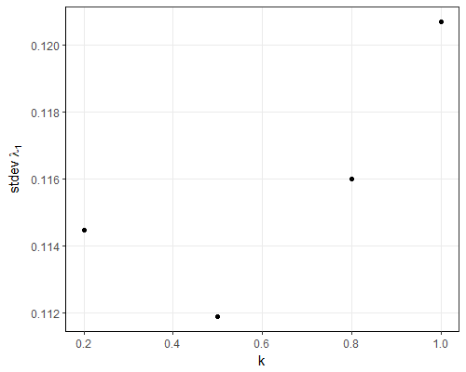

|  |  |  |  |  |  |  |
| --- | --- | --- | --- | --- | --- | --- |
| Table 4. The inverse of the damping ratio, , vs CV of spawning biomass distribution. 1/damping ratio depends on CV of the spawning biomass distribution at each k value. | | | | | | |
|  |  | estimate | std.error | t value | p.value | sig |
| k = 0 | (Intercept) | 0 | 0 | NA | NA |  |
| k = 0.2 | (Intercept) | 0.995131 | 0.052153 | 19.08113 | 6.23E-12 | *** |
|  | slope | -0.40233 | 0.11993 | -3.35469 | 0.004343356 | ** |
| k = 0.5 | (Intercept) | 1.002068 | 0.062504 | 16.03198 | 7.56E-11 | *** |
|  | slope | -0.52027 | 0.143735 | -3.61965 | 0.002521952 | ** |
| k = 0.8 | (Intercept) | 1.002088 | 0.065108 | 15.39127 | 1.35E-10 | *** |
|  | slope | -0.56971 | 0.149721 | -3.80511 | 0.001725103 | ** |
| k = 1 | (Intercept) | 1.001879 | 0.066103 | 15.15632 | 1.68E-10 | *** |
|  | slope | -0.59337 | 0.15201 | -3.9035 | 0.001411111 | ** |
|  |  |  |  |  |  |  |

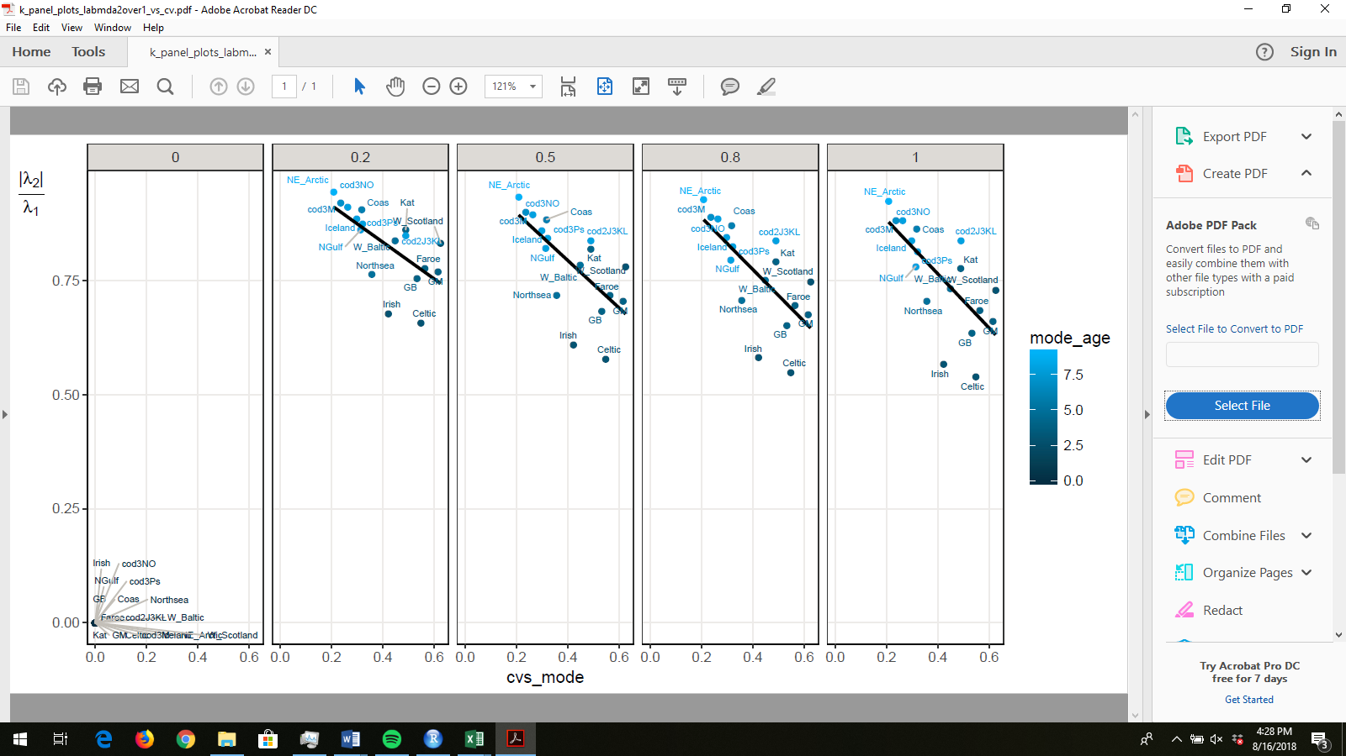

Figure 4(b). Does mean 1/rho (1/damping ratio) depend on k? Ans: yes

|  |  |  |  |  |  |
| --- | --- | --- | --- | --- | --- |
|  | estimate | std.error | t value | p.value | sig |
| (Intercept) | 0.079561 | 0.005849 | 13.60178 | 0.005362 | ** |
| slope | 0.036598 | 0.008421 | 4.346147 | 0.049076 | * |

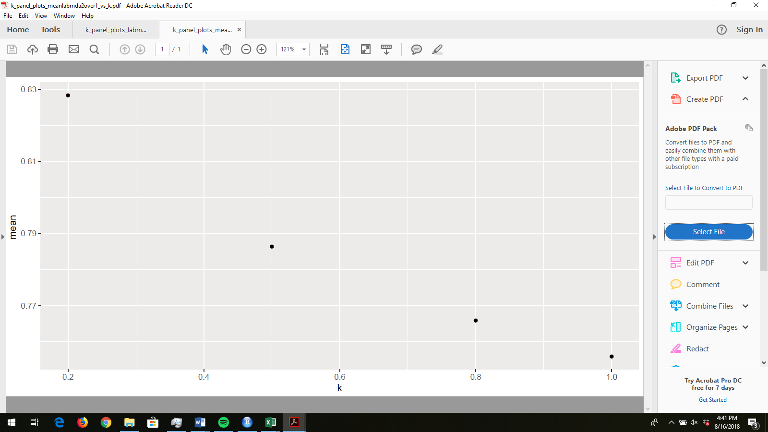

|  |  |  |  |  |  |  |
| --- | --- | --- | --- | --- | --- | --- |
| Table 5 | Does variation in the CV of the spawning biomass distribution depend on mode or stdev? Ans: mode | | | | | |
|  |  | estimate | std.error | t value | p.value |  |
| Stdev | (Intercept) | 0.349383 | 0.134189 | 2.603669 | 0.019953 | * |
|  | slope | 0.030324 | 0.060463 | 0.501531 | 0.623278 |  |
| Mode | (Intercept) | 0.700571 | 0.060297 | 11.61864 | 6.71E-09 | *** |
|  | slope | -0.05013 | 0.009929 | -5.0491 | 0.000144 | *** |

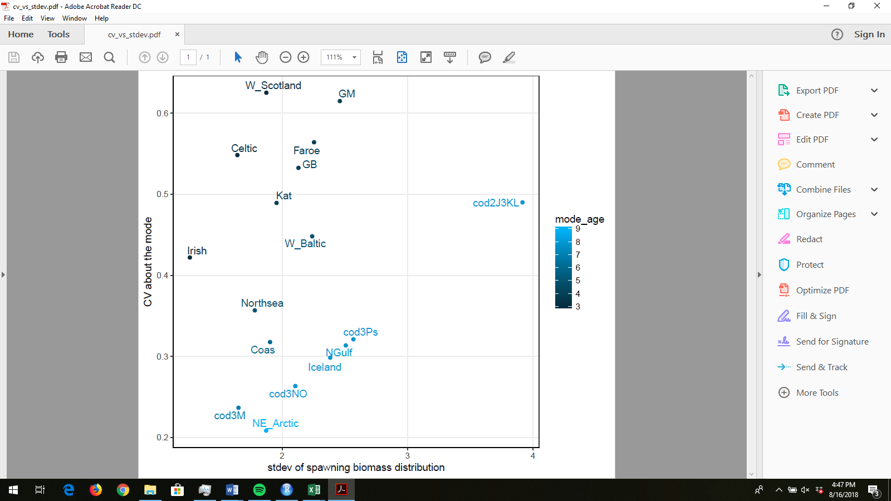 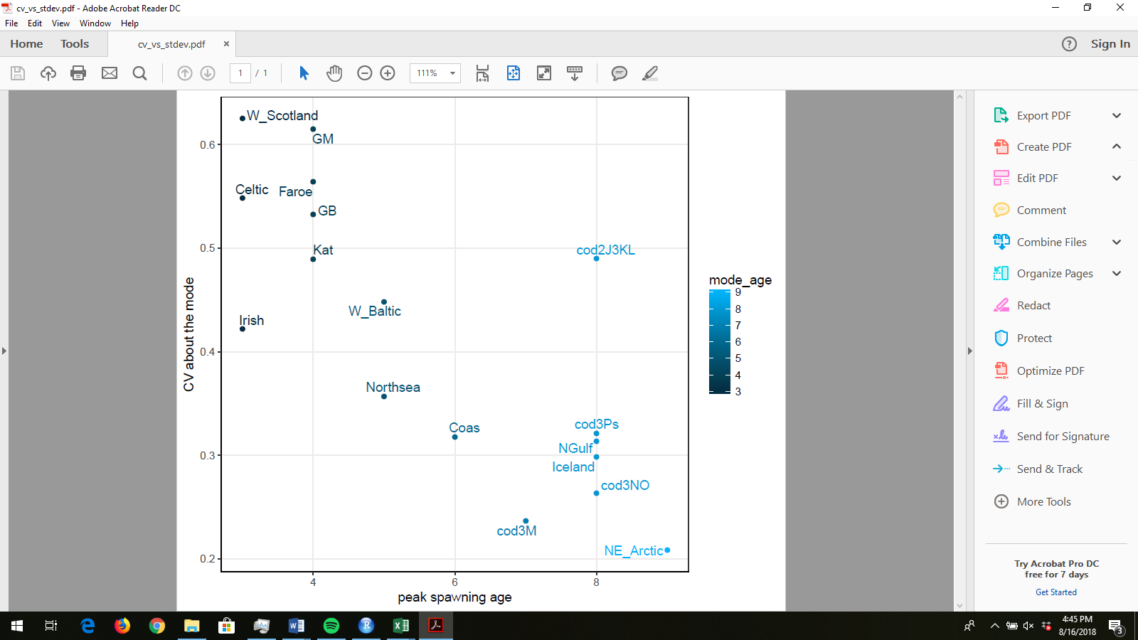

§Strength of significance level is noted with *** when 0 < p value <= 0.001, ** when 0.001 < p value <= 0.01, and * when 0.01 < p value <= 0.05.