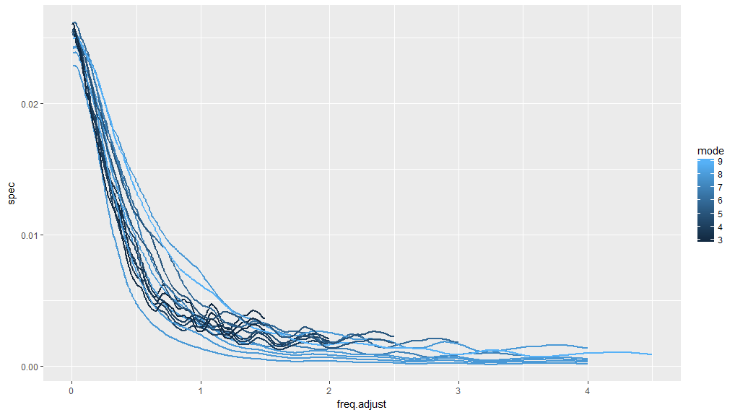

Figure 1. Power spectral density curves for all cod populations corresponding to a slope of k = 0.2. Line color represents age at peak spawning biomass (i.e., the mode).

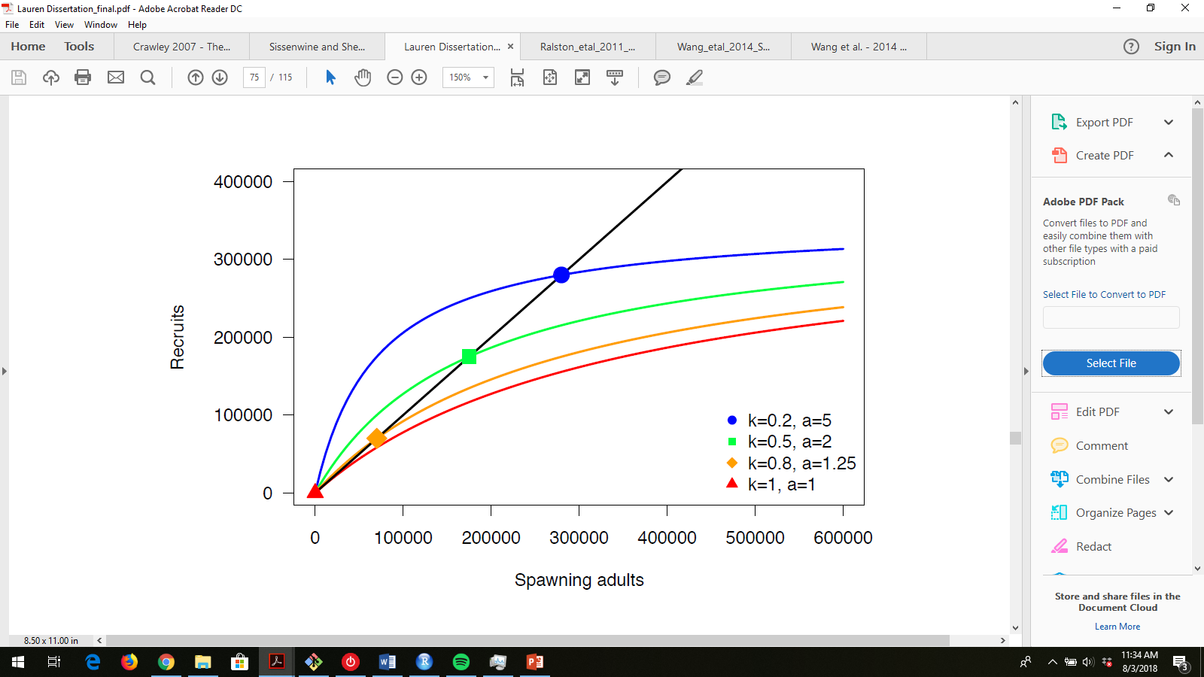

Figure 2. This is Fig 9 in chapter 2 of Lauren’s dissertation, pasted here for reference.