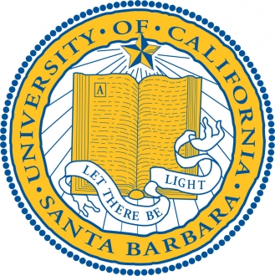

University of California

Santa Barbara

**CS 160: Translation of Programming Languages**

Spring 2019