ARTICLE

**Phenotypical**

Sandy Kroh 2,3, Anna Pascual-Reguant, Artür Manukyan, Ralf Uecker 2,3, Robert Günther, Lars Philipsen, Ralf Köhler, Peggy, Raluca A. Niesner, Anja E. Hauser 2,3

The

**Subject Terms**

2 Charite – Universitätsmedizin Berlin, Department of Rheumatology and Clinical Immunology, 10117 Berlin, Germany. 3 Immune Dynamics, Deutsches Rheuma-Forschungszentrum (DRFZ), a Leibniz Institute, Charitéplatz 1, 10117 Berlin, Germany.

**INTRODUCTION**

**T**he

ILCs and ILC subtypes

Lung gut axis

Spatial analysis

Pascual-Reguant et al described human ILCs to localize in fibrovascular niches in inflamed tissues such as the tonsil (REF).

* Adventitial cuffs (Molofsky)

**Combining cyclic IF with a systemic inflammation model to study ILCs niches in murine lung and SI tissues**

As innate immune cells, ILCs are potent sensors of changes in their microenvironment and are able to shape their surrounding by the potent secretion of cytokines. This makes a spatial characterization of ILCs in the context of inflammation desirable. For this, we decided to use the multiplex histology technique multi epitope ligand cartography (MELC).

First, we designed an antibody panel for MELC with the aim of identifying ILCs, their subtypes, as well as other immune and non-immune cell types that would enable subsequent spatial neighborhood analysis of ILCs (Fig. 1A). As general inclusion markers for ILCs, we established CD127 and CD90.2. The ILC signature transcription factors TBET, GATA3, and RORγt, as well as the NK cell transcription factor EOMES were included to differentiate between ILC1s, ILC2s, ILC3s, and NK cells, respectively. Although we tested various GATA3 antibodies, the resulting staining was either weak or unreliable. As ILC2s are described as the predominant ILC subtype in murine lung, and with this, it is important to reliably include GATA3 in the panel, we decided to use a GATA3eGFP reporter mouse strain. Combining the GATA3eGFP reporter with an anti-GFP antibody resulted in reliable staining of GATA3 in murine lung and intestinal tissues. Additionally, we established other markers that have been previously described in the context of ILC biology, such as KLRG1, ICOS, NKp46, CCR6, and AREG. CD3, B220, Kappa/IRF4, and CD68/CD11c were included in the panel to identify T cells, B cells, plasma cells, and myeloid cells, and to distinguish them from ILCs. To differentiate T helper from T cytotoxic cells, CD4 and CD8a was used. The proliferation marker Ki67 was included as well as MHCII as a marker for antigen-presentation. We also established various structural markers including epithelial and stromal markers, such as EMCN, CD31, LYVE1, and EpCAM. Nuclei markers were included in the panel, so that DAPI was stained in the first cycle of MELC, while Sytox Green was stained in the last round of acquisition, and hence, could be used to evaluate tissue quality and integrity of each experiment.

As ILCs only constitute around 0.15 % of the immune cell compartment in murine lung (Sadeghalvad et al. 2023) and as we were not only interested in the spatial distribution of ILCs under healthy conditions, but also if and how a potential ILC niche is influenced by an inflammatory stimuli, we decided to combine MELC with a systemic inflammation model based on consecutive IL-33 i.p. injections that has been described to trigger a strong type 2 response in various organs and activate ST2+ ILC2s (REF). In preliminary experiments, we acquired a small MELC dataset of murine lung samples 3, 6, and 28 days after IL-33 application and saw a high increase in ILC2s at day 3 of IL-33 application (data not shown). Therefore, and as ILCs are innate immune cells, that are tissue-resident and potent sensors of their surrounding, we decided to focus on very early time points of inflammation, namely day 1, 2, and 3 after the onset of inflammation using IL-33. 12- to 14-week-old females of GATA3eGFP reporter mice were i.p.-injected with 300 ng IL-33 on up to three consecutive days, organs were isolated 24 hours after the last dose of IL-33 and prepared for MELC (Fig. 1B).

Taken together, we established a 40-marker MELC panel in murine lung tissue and combined this with a systemic inflammation model based on consecutive IL-33 injections where we focused on very early time points after the onset of inflammation. Using the microscopy-based method MELC.

**Major immune and non-immune cells are annotated from cyclic IF data using the Seurat workflow**

We acquired MELC data of murine lung samples 1, 2, and 3 days after IL-33 application as well as healthy controls. Analysis was performed as described in the methods part. Dimensionality reduction and cluster analysis of the lung data resulted in three clusters for the first level of annotation (AL1) and were annotated based on the respective feature profiles (Fig. 2A). Thereby, immune cells showed high levels of the pan-leukocyte marker CD45, as well as different markers for T cells, B cells, Plasma cells, and myeloid cells, such as CD3, B220, Kappa, CD68. The cluster annotated as stromal cells was high in endothelial and fibroblast-associated markers EMCN, CD31, LYVE1, PDPN, Sca1, and PDGFRa, while the cluster annotated as epithelia was marked by a high level of EpCAM and CD138.

For visual validation, the annotated cell types, namely immune cells (Darkcyan), stromal cells (Darkmagenta), and epithelia (Gold), of each FOV were depicted in x and y (Fig. 2 B) and were compared to the respective MELC IF overlays of CD45 (Cyan), CD31 (Magenta), and EpCAM (Yellow) showing correlating distribution patterns (Fig. 2C).

**Three ILC subtypes are resolved and ILC2s represent the predominant subtype in murine lung tissue**

To increase the granularity, we re-analyzed the clusters by only including markers that were associated with the respective cell type of interest in the dimensionality reduction and cluster analysis. For example, for the re-analysis of the immune compartment, only immune markers from the MELC panel were included. This approach enabled us to separate a CD3- CD127+ CD90.2+ cluster of ILCs that additionally had high levels of GATA3eGFP and KLRG1, from other immune cell types like T helper cells, T cytotoxic cells, myeloid cells, and B cells & plasma cells in AL2 (Fig. 3A). Furthermore, we were able to identify three ILC subtypes and annotate the clusters based on their feature profiles as NK cells/ILC1s, ILC2s, and ILC3s (Fig. 3B). Additionally, visual validation was performed (Fig. 3C-E). All three clusters showed high levels of GATA3eGFP (Fig. 3B). The cluster annotated as ILC2s had high levels of both CD127 and CD90.2, as well as the highest level of GATA3eGFP and additionally high levels of KLRG1 (Fig. 3B, Fig. 3C). NK cells/ILC1s only partly showed CD127 and CD90.2 but were marked by high levels of EOMES and TBET (Fig. 3B, 3D). The cluster annotated as ILC3s had levels of CD127, CD90.2, RORγt and partly TBET.

We also performed re-clustering of the stromal compartment which resulted in three subtypes: EMCN+ CD31+ blood vessels, LYVE1+ CD90.2+ lymphatics, and a CD45- IRF4+ cluster (data not shown). In summary, we were able to identify 11 different immune and non-immune cell types in murine lung MELC data, including the ILC subtypes NK cells/ILC1s, ILC2s, and ILC3s (Supplementary Fig. 1).

**Lung ILC2s are the predominant ILC subtype in murine lung and only increase at IL-33 day 3**

We first quantified the total count, as well as the proportions of the identified ILC subtypes within the immune and the ILC compartment under healthy conditions (Fig. 4A-C). The median number of identified ILC2s per FOV was 11, while the median number of NK cells/ILC1s was 8 (Fig. 4A). ILC3s were the rarest ILC subtype and were only detected in one FOV under healthy conditions (Fig. 4A). Both within the immune compartment and the ILC compartment, ILC2s represented the predominant ILC subtype, and the frequency of ILC3s was less than 1 % (Fig. 4B-C).

Next, we quantified the cellular distribution at different time points of IL-33 application (Fig. 4D-I). Comparing the time points after IL-33 application to the controls revealed a small significant increase in the total count of the analyzed cells per FOV in general at IL-33 day 1 (Fig. 4D), as well as the immune cells (Fig. 4E), and ILCs (Fig. 4F). However, a strong significant increase compared to the healthy tissue was observed after three doses of IL-33 day.

Looking at the ILC compartment, the total counts of NK cells/ILC1s (Fig. 4G), ILC2s (Fig. 4H), and ILC3s (Fig. 4I) significantly increased at IL-33 day 3 compared to the healthy control. There was no significant change in the frequencies within the ILC compartment, except for the ILC3 frequency significantly increasing by 8 percent points to a median of 8 % at IL-33 day 2 compared to healthy controls where the median was 0 % (data not shown).

The data confirmed that ILC2s represented the predominant ILC subtype in murine lung tissue. The application of IL-33 significantly triggered the accumulation of cells in general, immune cells and ILC subtypes in the lung at IL-33 day 3.

**Spatial analysis reveals accumulation of ILC2s in peri-lymphatic niches shared with myeloid cells in the lung**

Next, we wanted to analyze spatial alterations of the different ILC subtypes at different points after IL-33 application and see whether the inflammatory stimuli affected the distributions of ILC subtypes within the tissue.

We performed co-enrichment analysis of the identified ILC subtypes with all other identified cell types using Giotto (REF) and VoltRon (REF).

* ILC2s sit close to endothelial structures high in LYVE1 and CD90.2
* Co-enrichment analysis confirmed peri-lymphatic localization of ILC2s
* Co-enrichment of ILC2s with myeloid cells and ILC2s
* SPIAT

**Lung NK cells/ILC1s and intestinal NK cells/ILC1s/ILC3s accumulate in peri-vascular tissue areas**

While

**ILC2s and a mixed cluster of NK cells/ILC1s/ILC3s are resolved in murine SI tissues**

We

**DISCUSSION:**

**Establishing MELC and IL-33 systemic inflammation model**

, a field of view with a size of 665 x 665 µm normally showed around

850 total cells and approximately 250 immune cells meaning that only 2 to 3 ILCs per captured

area were expected (assuming homogeneous distribution). ILC2s

, and with this, only

around one ILC2 would be expected to be detected in all three acquired areas of each mouse –

again, simplifying and assuming homogeneous distribution of ILC2s.

**Data analysis, cell type annotation and validation**

Epithelial cluster expresses EpCAM and CD138. CD138 in murine lung can be expressed by epithelial cells

**Quantification of ILCs in lung**

**Spatial analysis of ILC subtypes in lung**

**MATERIAL AND METHODS**

**Mice**

GATA3eGFP mice

**Tissue Preparation for MELC**

Fresh frozen tissue was cut 5 µm thick with a NX80 cryotome (ThermoFisher, Waltham, Massachusetts, USA) on 3-aminopropyltriethoxysilane (APES)-coated cover slides (24 × 60 mm; Menzel-Gläser, Braunschweig, Germany). Samples were fixed for 10 min at room temperature using a freshly opened EM grade PFA ampulla (methanol- and RNAse-free; Electron Microscopy Sciences, Hatfield, Philadelphia, USA) diluted to 2%. After washing three times with PBS, samples were permeabilized with 0.2% Triton X-100 in PBS for 10 min at room temperature. Subsequently, a blocking step with 10% goat serum and 1% BSA in PBS was performed for at least 20 min. Afterwards, a fluid chamber holding 100 μl of PBS was created using “press-to-seal” silicone sheets (Life technologies, Carlsbad, California, USA; 1.0 mm thickness) with a circular cut-out (10 mm diameter), which was attached to the coverslip, surrounding the sample.

For every MELC run, a bottle of fresh PBS with 1% BSA and 0.02% Triton X-100 was used. The sample was placed on the sample holder and fixed with adhesive tape followed by accurate positioning of the binning lens, the light path, as well as Köhler illumination of the microscope.

**MELC image Acquisition**

**MELC Antibody Panel**

**Image Pre-processing**

**Pixel classification using Ilastik**

**Segmentation and feature extraction using CellProfiler**

**Data tidying**

Thresholding

Data imputation

**Dimensionality reduction, cluster analysis, and cell type annotation**

**Spatial neighborhood analysis**

SPIAT

Giotto & VoltRon

**Reporting summary**

**REFERENCES**

**ACKNOWLEDGEMENTS**

We would like to thank x for helpful discussions. This study was supported by a grant from the DFG to A.E.H and ECRT (Einstein Centrum für Regenerative Therapien) to A.A. The authors affiliated with Charité for the duration of this study acknowledge that Charité is a corporate member of Freie Universität Berlin and Humboldt-Universität zu Berlin.

**AUTHOR´s CONTRIBUTIONS**

A.A., S.K. and A.E.H. conceptualized the study. P.B. and M.K. provided samples. A.A., S.K, H.G. and R.U. performed experiments. A.A., S.K., A.E.H. analyzed the data and interpreted the results and wrote the manuscript. A.A., S.K., A.E.H., H.D. discussed the results and reviewed the manuscript.

**FUNDING**

DFG (Anja fragen, wir haben kein DFG Funding)

**COMPETING INTERESTS**

The authors declare no competing interests

**ADDITIONAL INFORMATION**

**Supplementary Information**

**Correspondence** and requests for materials should be addressed to A.E.H

**Peer review information**

**Reprints and permission information** is available at

**Publisher´s note**

**Open Access**

**Figure 1**

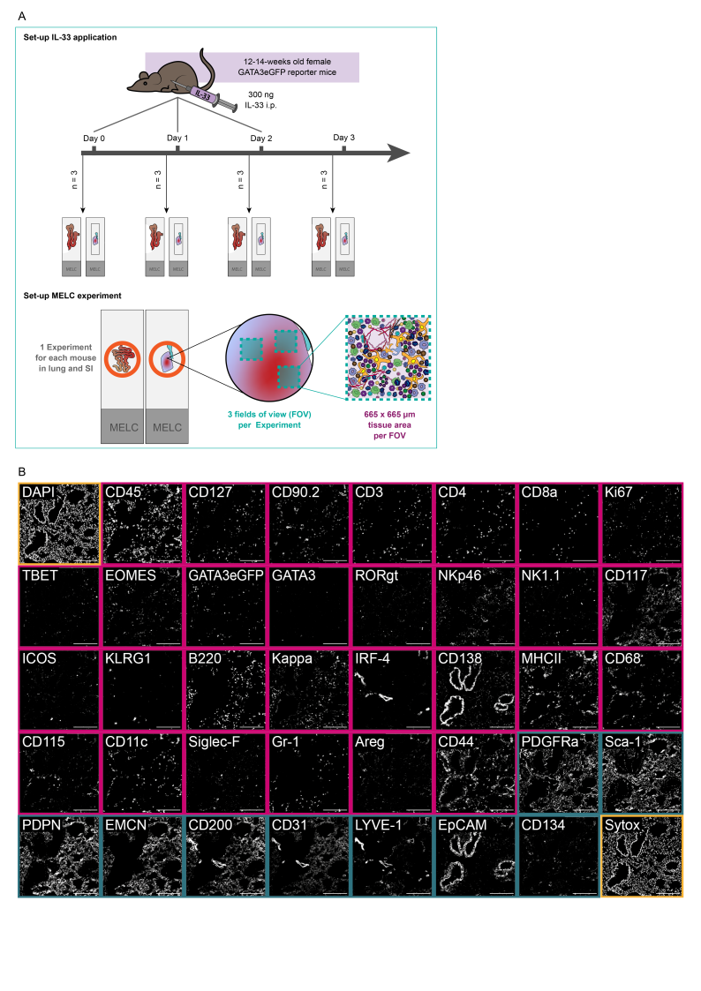

**(A)** Schematic of the experimental set-up of the IL-33 systemic inflammation model and the MELC experiment. In short, 12-14-week-old GATA3eGFP reporter mice were i.p. injected with 300 ng IL-33 on up to 3 consecutive days. 24 h after the last dose, organs were harvested and processed for cyclic IF (MELC). In each MELC experiment, three regions of interest (fields of view = FOV) were acquired, each measuring 665 x 665 µm. **(B)** Overview of an established 40-marker panel in an exemplary tissue region of murine lung. Each image shows the same tissue region stained for diverse immune markers (magenta) and structural markers (darkcyan), as well as nuclei stains (yellow). Scale bar represents 200 µm.

**Supplementary figure 1**

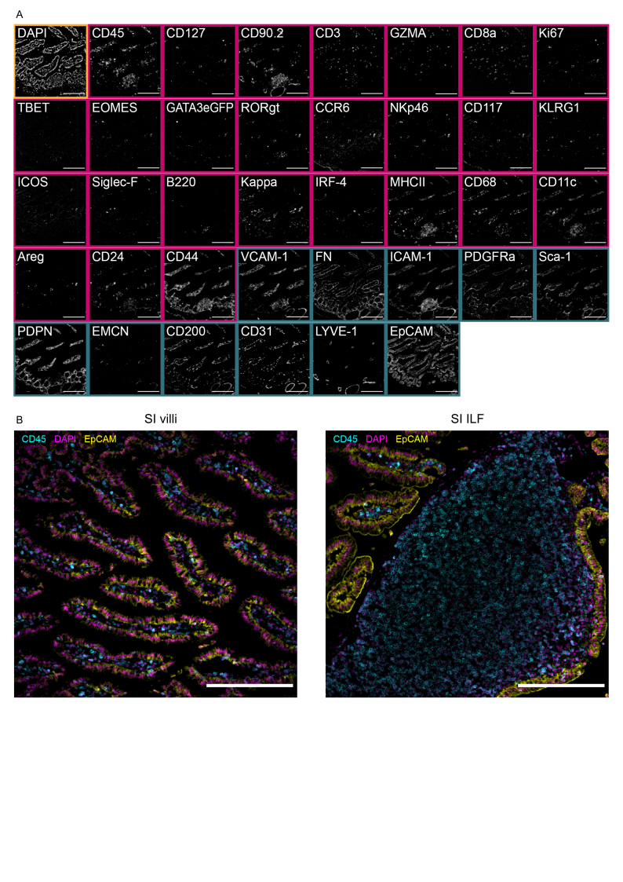

**(A)** Overview of an established 38-marker panel in an exemplary tissue region of murine small intestine. Each image shows the same tissue region stained for diverse immune markers (magenta) and structural markers (darkcyan), as well as the nuclei stain DAPI (yellow). **(B)** IF overlays of the pan-immune marker CD45 (Cyan), the nuclear stain DAPI (Magenta), and the epithelial marker EpCAM (Yellow) acquired by MELC in the small intestine. Small intestinal tissue regions were categorized into SI villi and SI ILF based on the predominant tissue structures visible in the acquired images. Scale bar represents 200 µm.

**Figure 2**

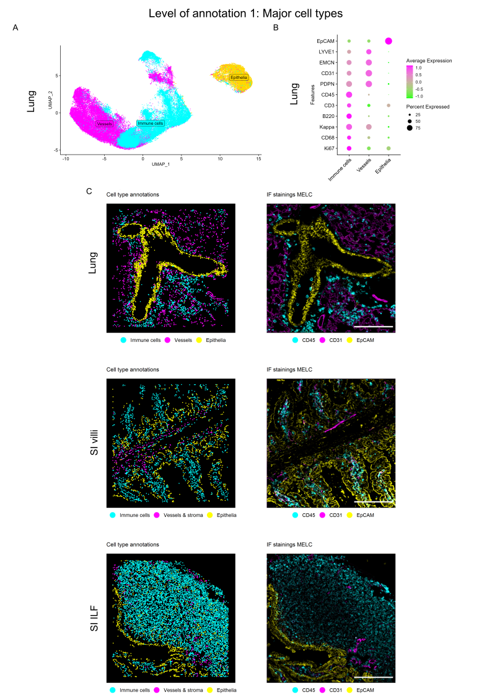

**(A)** UMAP representation of the first level of annotation (AL1) in murine lung tissue showing the three clusters annotated as Immune cells, vessels, and epithelia based on the feature profiles shown in the dot plot below. **(B)** Dot plot **(C)** Annotated clusters of AL1 mapped in X and Y next to the respective immunofluorescence (IF) overlay of correlating marker stainings for a representative field of view (FOV) of lung (upper panel), SI villi (middle panel), and SI ILF (lower panel). Annotations are colored by cell type with immune cells (Cyan), vessels (Magenta), and epithelia (Yellow), and correlate with CD45 (Cyan), CD31 (Magenta), and EpCAM (Yellow). Scale bar: 200 µm.