

|  |  |
| --- | --- |
| **Module** | SEPR |
| **Year** | 2019/20 |
| **Assessment** | 2 |
| **Team** | MiKroysoft |
| **Members** | Daniel Crooks, James Rand, Irene Sarigu, Alfie Jennings, Charlotte Clark, Jasper Law |
| **Deliverable** | Player Manual |
| **Website** | <https://mikroysoft.github.io/> |

**KROY!**

These are the characters present in the game.

You are the good fire engine, trying to save York.

The aliens are your enemy, you need to destroy as many of

them as possible without causing damage to your truck

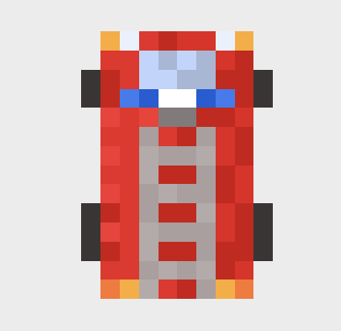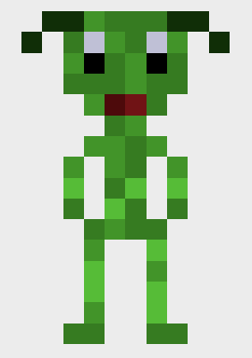

As a fire engine you need to be careful of three things: your health (yellow bar),  
your fuel level (pink bar) and your water level (blue bar)

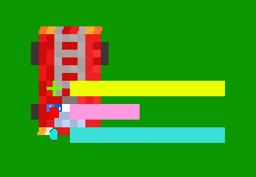

These are the Alien Bases. They’ll fire bullets at your fire engine causing it   
damage. You need to try to attack them making sure your health level doesn’t drop too much.

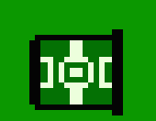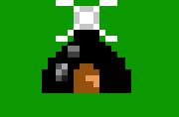

**Mechanics of the game**At the start of the game you’ll be presented with the starting screen.  
 To start the game click on the “Play!” button.

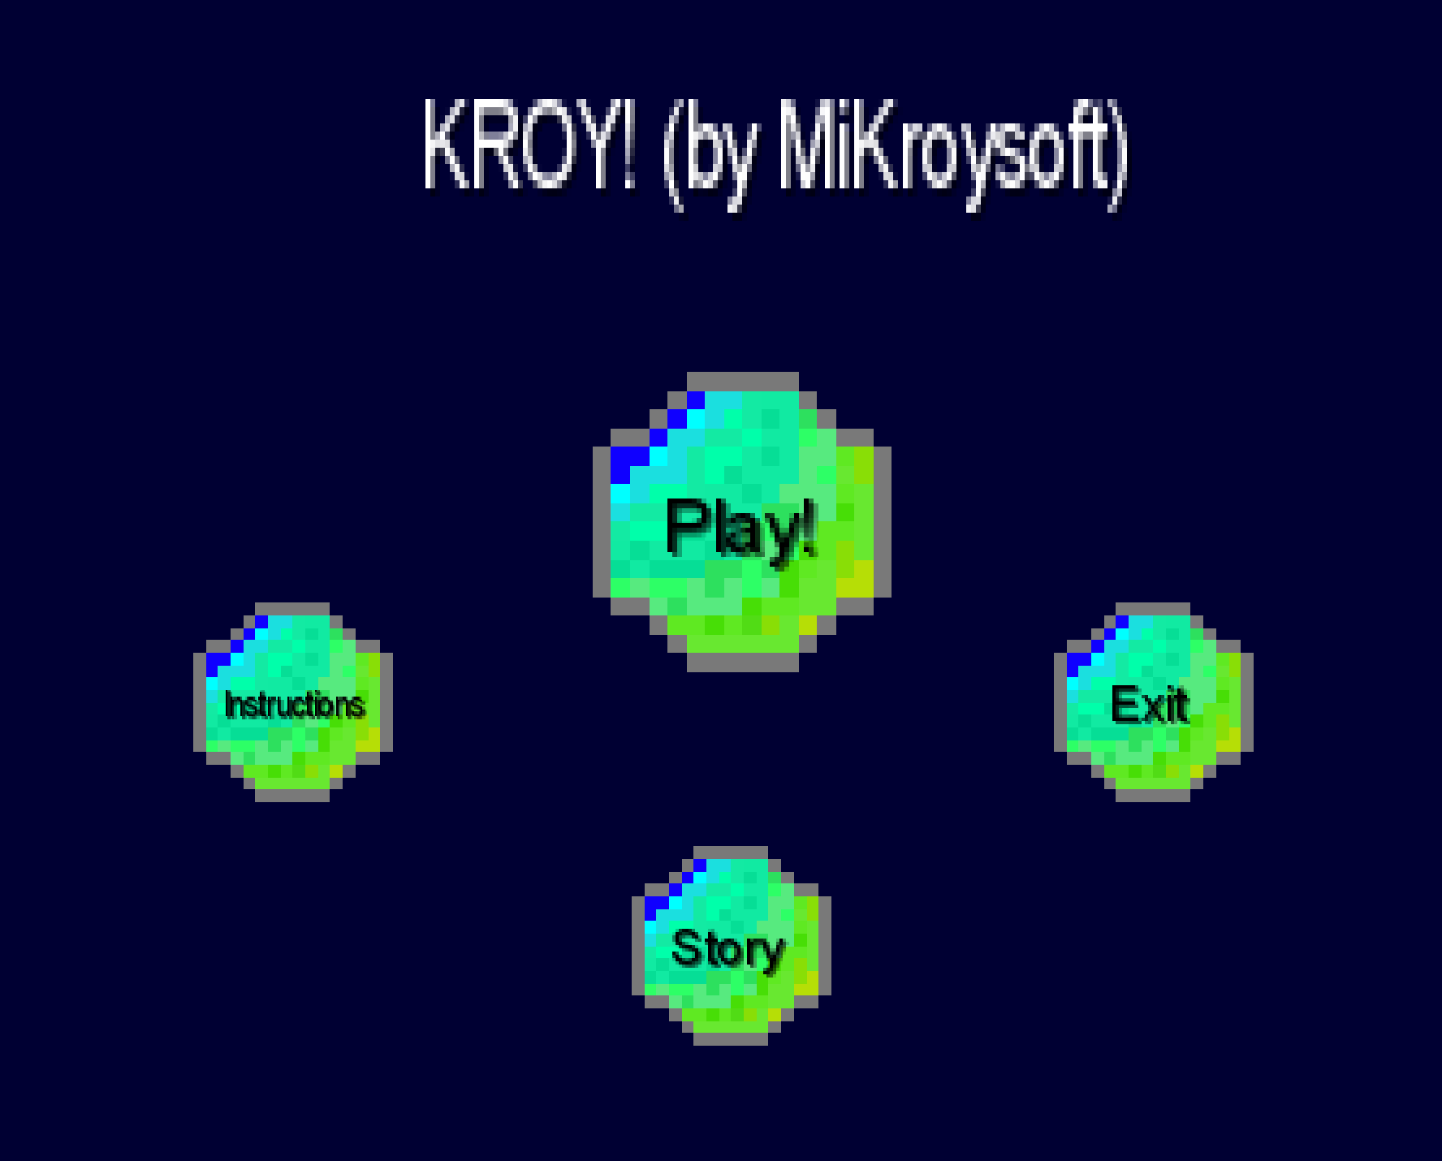

You’ll be presented with the game screen

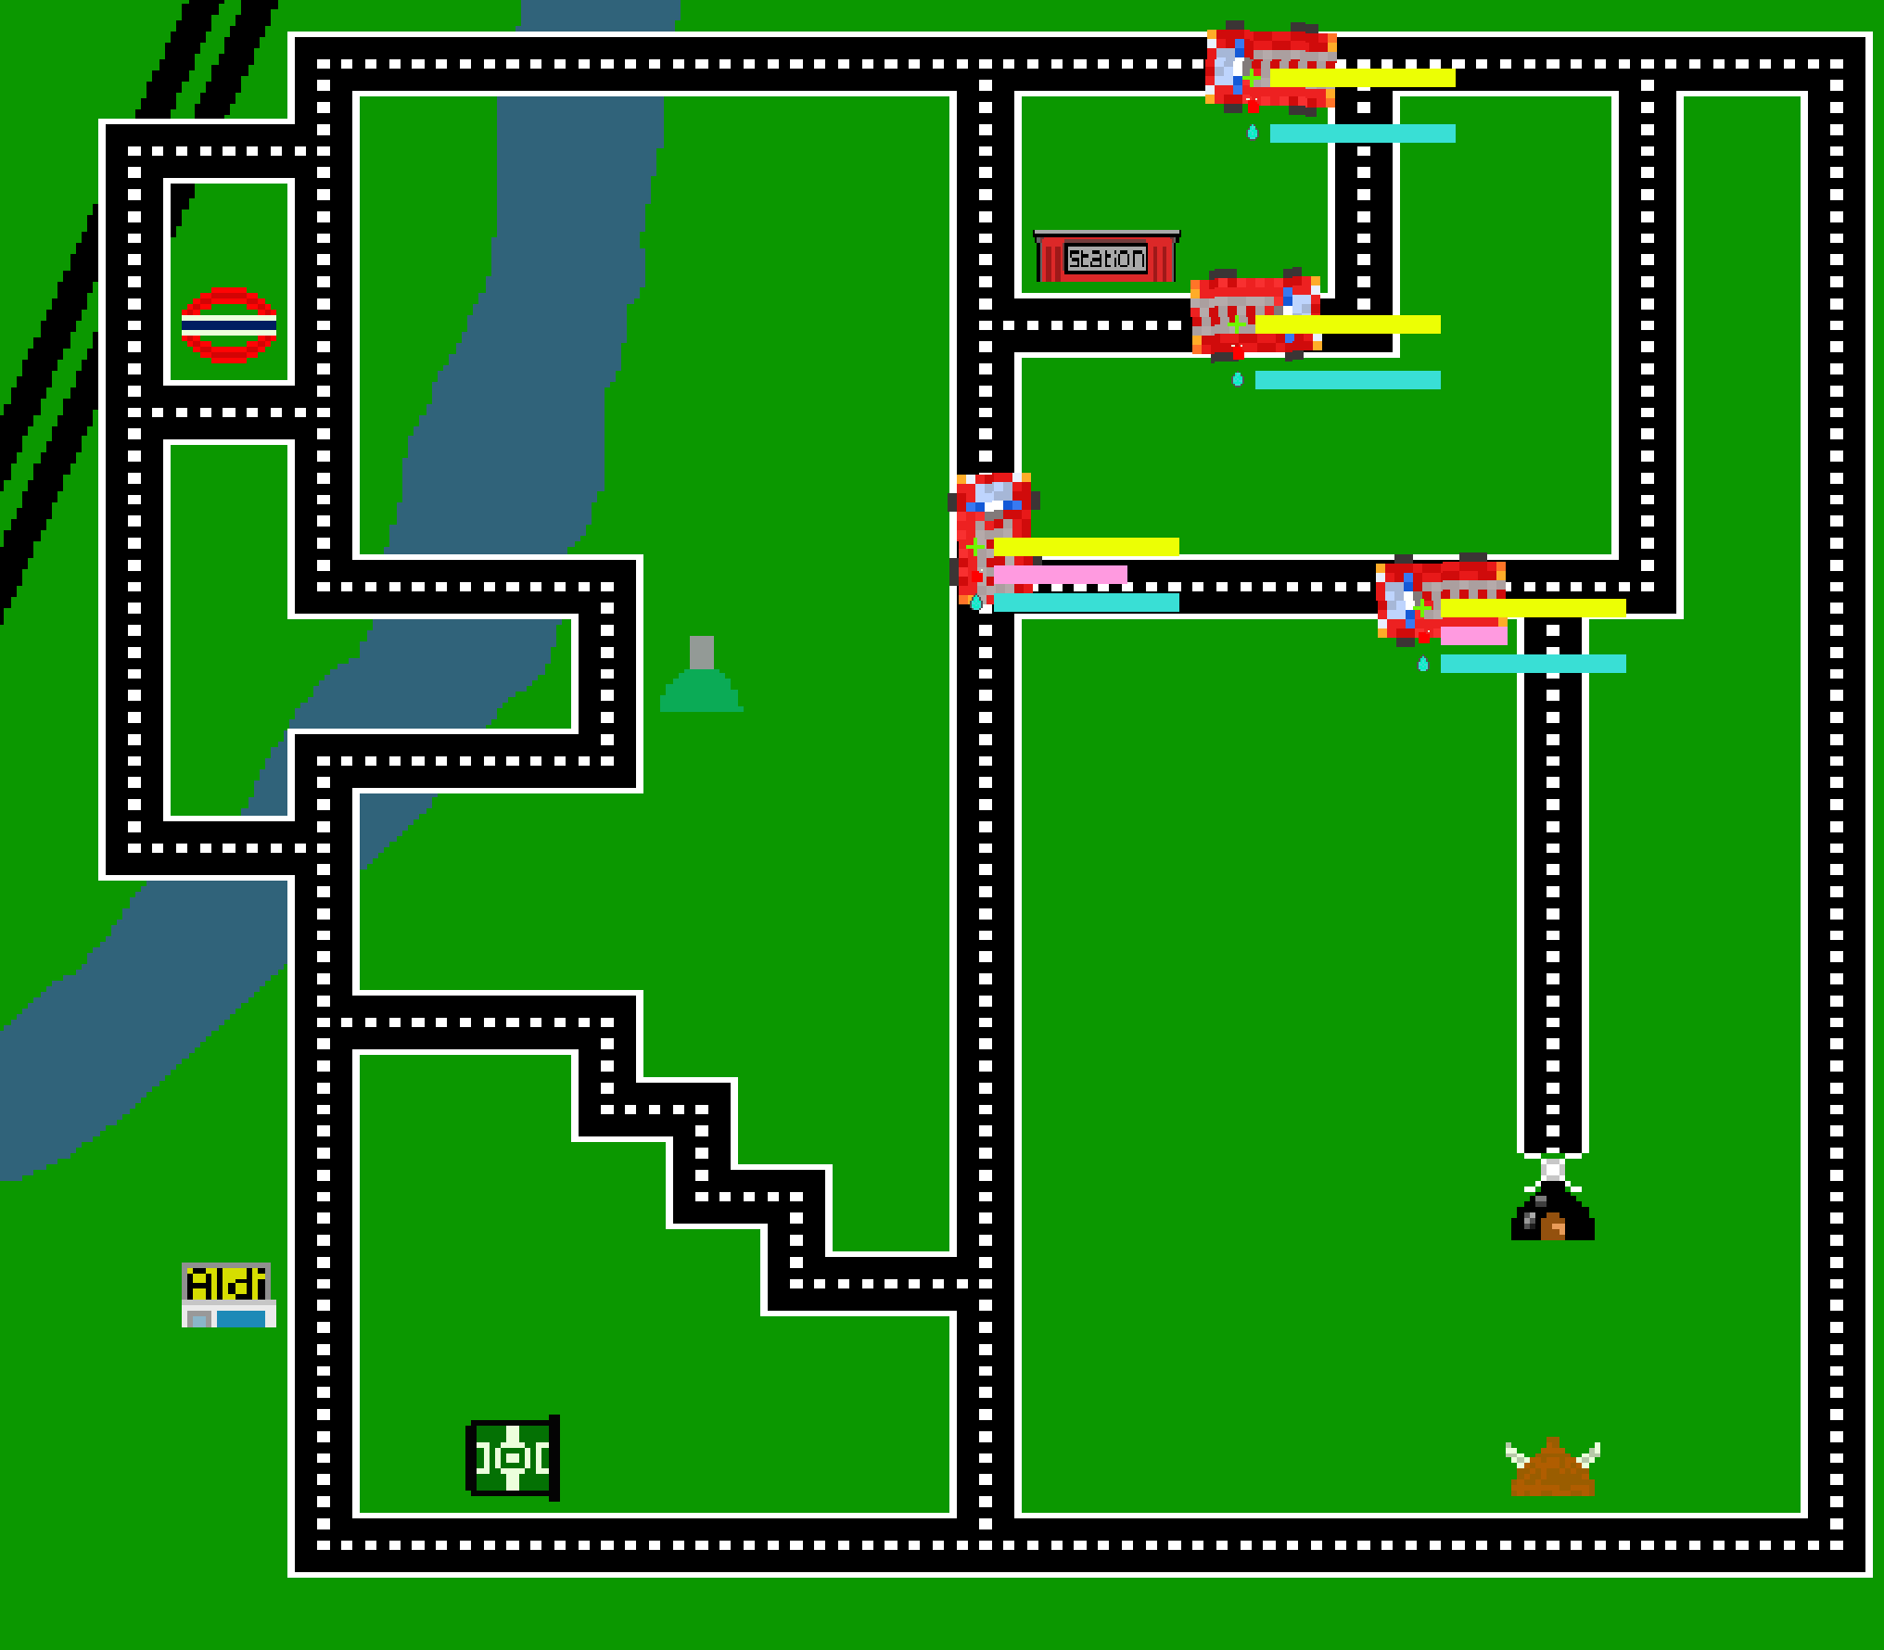

You can now start playing! Enjoy



You won!



You lost!