Our mission is to organize the world’s information and make it universally accessible and useful. – Google (Mission Statement)

**Google-SWOT Analysis**

**Principle of Management**

Name: M. Iftikhar Uddin Khan Sami

Registration number: 022- 16- 113275

Submission on: Thursday, April 23, 2020

Facilitator’s name: Ms. Sana Saeed

Contents

Company Profile: 1

SWOT Analysis: 2

Strength: 2

Weakness: 2

Opportunities: 3

Threats: 3

References: 3

# Company Profile:

**Company Name:** Google Inc.

**Industry:** Technology

**Founders:** Larry Page, Sergey Brin

**Parent Organization:** Alphabet Inc.

**Founded in:** September 1998

**CEO:** Sundar Pichai (Oct 2, 2015– till date)

**Revenue:** 66,001,000,000 USD (2014) - *Source: Wikipedia*

**Total Assets:** 131,133,000,000 USD (2014) - *Source: Wikipedia*

**Products:** Youtube, Google Drive, Gmail, Google Map, Google Cloud, Android, Google Classroom, Google Chrome, etc.

**Business rivals:** Microsoft, Apple, Amazon, Samsung and others.

# SWOT Analysis:

## Strength:

* **Android OS-** Android OS, developed in 2008, is one of the most commonly used platform for most smartphone users. The arrival of Android also create a huge no of jobs like android app developers, app testers, UI/UX designers for apps.

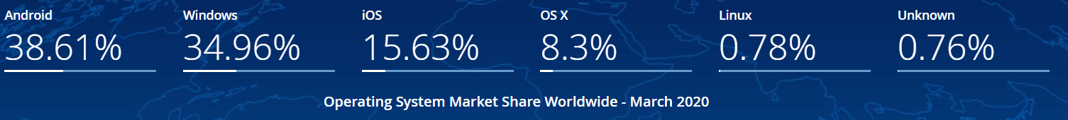

Figure 1 <http://gs.statcounter.com/os-market-share>

* **Tools for various platforms-** Google has a vast variety of products for any type of consumers. Like, Google classroom for education sector, Business apps for business personals, and Development applications for developers (eg. Android Studio).
* **Web Search**- Google, also we can say the King of Search Engine due to a huge number of active searching. Before Google, Yahoo is the most important considerable search engine of all time. but the arrival of Google search Engine grab not only Yahoo also it grab the market share and audience of Bing, Baidu, MSN and others

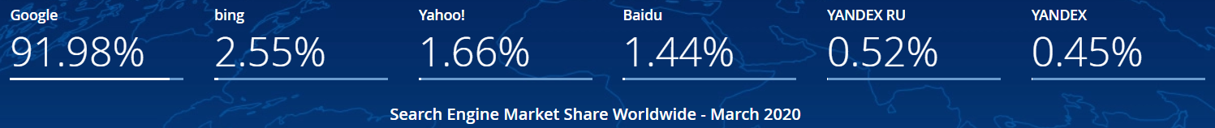

Figure 2 <https://gs.statcounter.com/search-engine-market-share>

* **Browser Market share-** Chrome browser, like web search, has the highest market share in Browser’s usage. Chrome is released in 2008 while Safari (released in 2003) and Firefox (released in 2002). But Chrome is successful to grab the market share of the most famous browsers of time

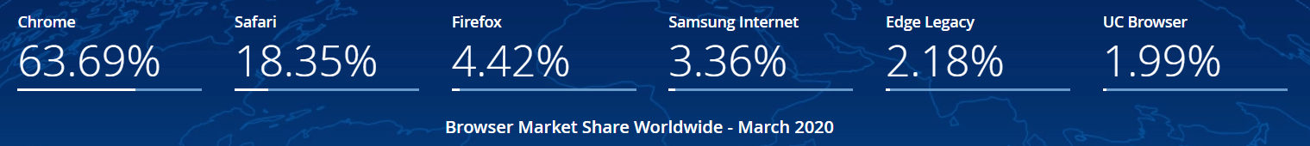

Figure 3 <https://gs.statcounter.com/browser-market-share>

## Weakness:

* **Privacy concerns-** Despite being no. 1 in various domains, A huge number of users on Google have trust issues or concerns to share personal data which is a question mark on Google.
* **Low audience in developing countries-** Google has less number of active users from developing countries as compared to developed ones. Maybe Google cloud wifi project can be a solution to bring more users online.
* **Boycott from Major Advertisers on Hate speech-** According to an article in Forbes which was published in 2017, That boycott encompassed some of the world’s biggest consumer advertisers like Procter & Gamble, Verizon, and Johnson & Johnson. More than 250 companies joined.

## Opportunities:

* **Alliances with Smartphone makers-** For Grass root level penetration, Google can make alliance with Mobile makers and offer its service free for doctors, developers, financers, educationists, etc.
* **Wearable and Gadgets-** Like Apple, Google also has a record in producing gadgets like Google glasses, chrome cast devices, but watches of Google are not as popular as Samsung, Xiaomi, Apple, etc. Google can improve it’s service in order

## Threats:

* **Government Policies-** Policiesof government in a developed country can result a threat for Google as well. As an Example, Huawei faced a ban in USA, Google is not allowed to deliver service in China. As Government policies are created, designed and changed any time, so there is a uncertainty situation for Google as well.
* **Business rivals-** All tech giants are in threat of each other, which means they have fear from others research, development, patents, new technology, launching of new product. As an Example, foldable smartphones technology is the research in progress by Huawei and Samsung, but prediction says that Samsung will be the first to unveil the first ever foldable phone and grab the whole market share from Samsung. Now the Competition is among MobileOS platforms that whose OS will be equipped with the first foldable smartphone – Google(Android) or Apple (iOS) or any other.

# References:

* <https://stats.areppim.com/stats/stats_mobiosxsnapshot.htm>
* <https://hostingtribunal.com/blog/operating-systems-market-share/#gref>
* <https://gs.statcounter.com/os-market-share>
* <https://gs.statcounter.com/search-engine-market-share>
* <https://gs.statcounter.com/browser-market-share>
* [Forbes Article](https://www.forbes.com/sites/davidschrieberg1/2017/03/23/u-s-u-k-boycott-of-google-and-youtube-by-major-advertisers-spreading-over-hate-content/#2be102547eb9)
* <https://www.tomsguide.com/us/foldable-phones-release-date,news-28705.html>
* <https://www.cnbc.com/2018/11/01/start-up-beats-major-players-to-launch-worlds-first-foldable-smartphone.html>
* [https://wearos.Google.com/#hands-free-help](https://wearos.google.com/#hands-free-help)