**Mikhaela Patricia R. Cruz IV-BCSAD**

**SOCCIP**

**Self-Introduction Exercise**

Hello, my name is Mikhaela Patricia R. Cruz. I am 20 years old and I am majoring/specializing in Application Development. My hometown is Cavite City and I really appreciate it there because I met amazing people who helped me shaped my values. I always dreamed that someday I would graduate and find a meaningful career, and that dream has been slowly coming true. I feel excited and determined about it now! Some things I like to do include watching films and nature resets. There are many things I am good at and one of them is organizing and problem-solving with discipline. I did a really interesting thing once and that was dyeing my hair a different color each month. My family consists of my parents, my uncle, one sibling, one niece, and one nephew. If I could change one thing about myself it would be not holding onto past hurts for too long. Still, I am really glad to be here right now because it means I’m still growing despite challenges. I would really like to get together with anyone who be interested in sharing authentic conversations, attending concerts, or just enjoying nature. The one thing I want to be remembered for is my perseverance and how I turned struggles into motivation. As far as future plans are concerned, I hope to be a successful professional who blends discipline with vision while living authentically someday.

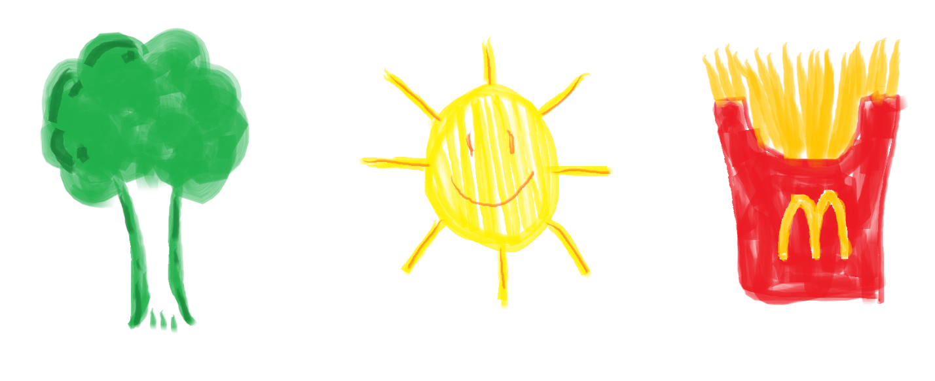**Draw the first 3 objects that you have in mind**